1.

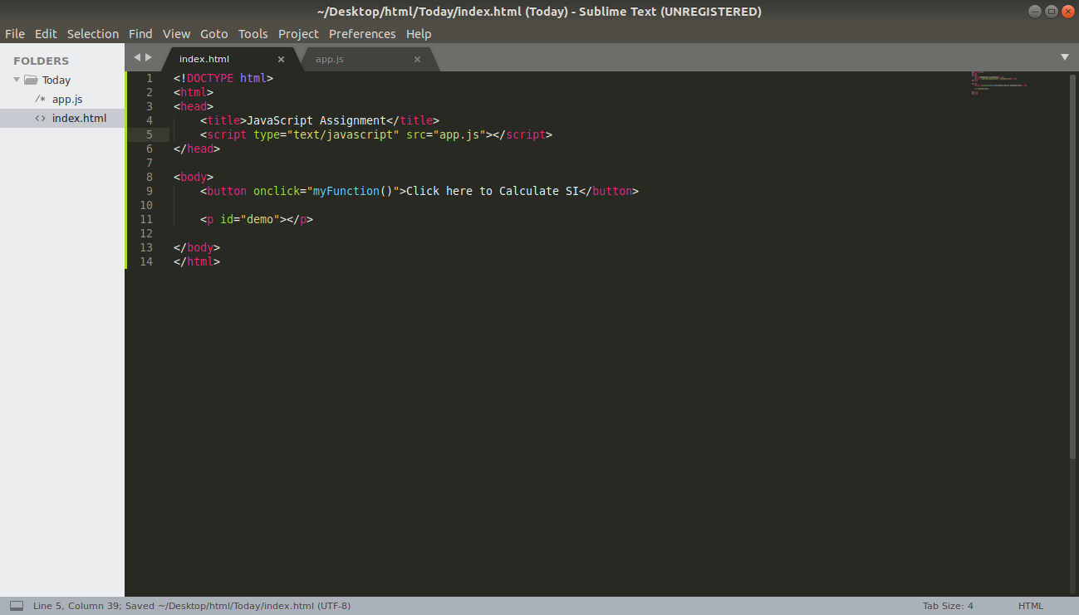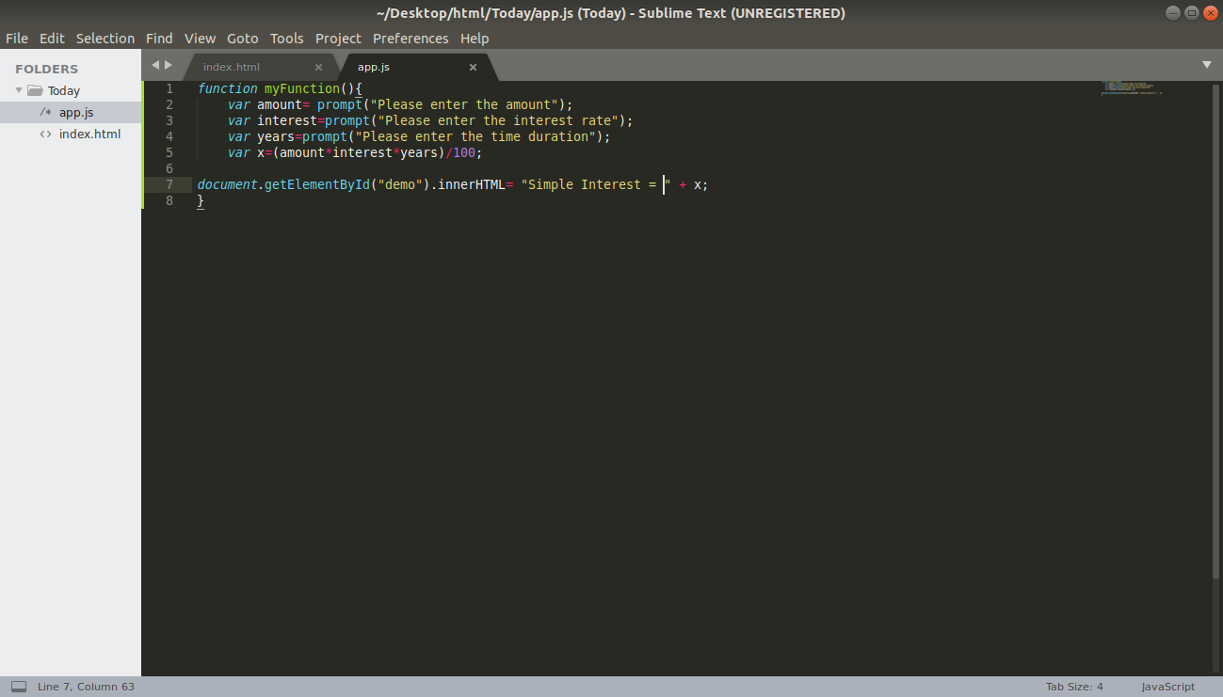

2.

function palindrome(){

var text= prompt("Please enter the string");

if(text !== null){

text=text.toLowerCase().replace(/[^a-zA-Z0-9]+/g,'');

}

if(text===null){

console.log("Nothing found");

return false;

}

for( var x=0; x<text.length; x++){

if(text[x]!=text[text.length-x-1]){

document.getElementById("palin").innerHTML=text + " not a palindrome";

return false;

}

}

document.getElementById("palin").innerHTML=text + " is a palindrome";

return true;

}



3. function area_circle(){

var radius = prompt("Enter the radius of circle");

let area = (radius * radius * Math.PI);

document.getElementById("display").innerHTML= area + "sq meters";

}



4.

const mainObj = {

a:2 , b:5, c:3, d: { x:7, y:4},

}

const objCopy= { };

function copy(mainObj){

let key;

for(key in mainObj){

objCopy[key]=mainObj[key]; //copies each property to objCopy

}

return objCopy;

}

console.log(copy(mainObj));

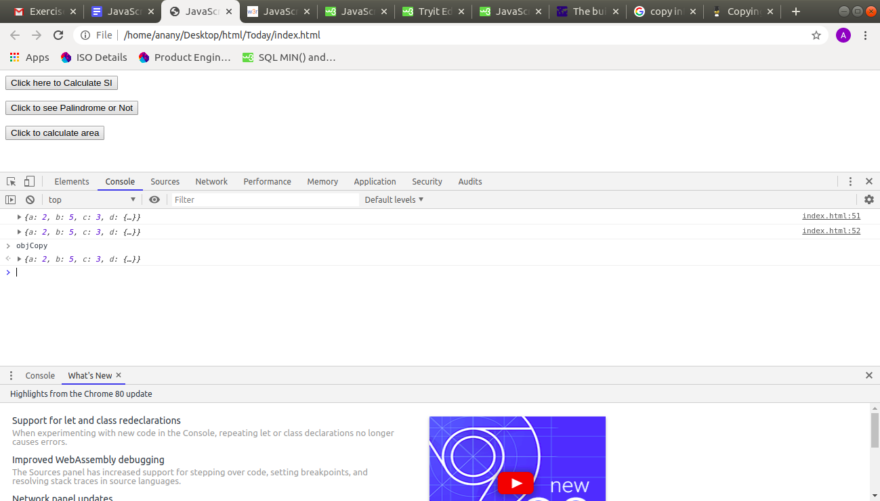

5.

var employees= [

{name: "Ananay", age: 19, DOB: '25-10-1997', salary:5500},

{name: "Messi", age: 29, DOB: '21-10-1992', salary: 5000},

{name: "Yusuf", age: 22, DOB: '11-10-1993', salary: 3000},

{name: "Ram", age: 19, DOB: '25-10-1994', salary: 10000},

{name: "Yogesh", age: 20, DOB: '25-10-1990', salary: 2000}

];

console.log(employees);

b)

var updated_emp = employees.filter(function (item) {

return item.salary>5000;

})

console.log(updated_emp);

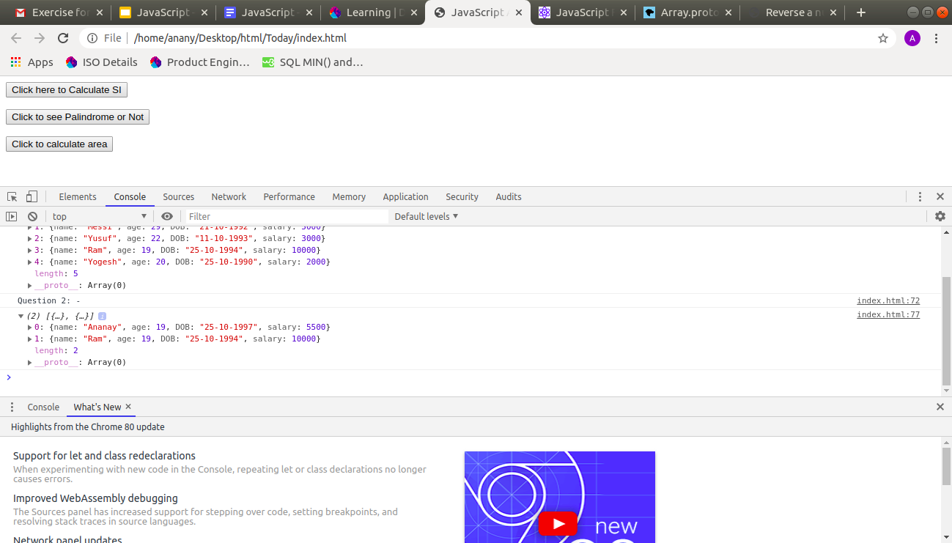

c)

let groupedData = employees.reduce((e, d) => {

if (Object.keys(e).includes(d.age)) {

return e;

}

e[d.age] = employees.filter(g => g.age === d.age);

return e;

}, {});

console.log(groupedData);

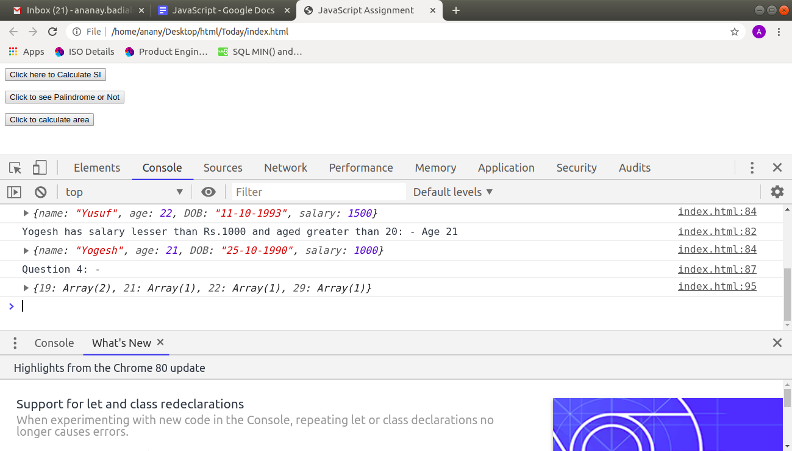

d)

employees.filter(function(item){

if(item.salary<1000 && item.age>20){

console.log(item.name+" has salary lesser than Rs.1000 and aged greater than 20: - Age "+ item.age);

item.salary *= 5;

console.log(item);

}

})

