create table employee(emp_id varchar(10),emp_name varchar(30),dept varchar(30),salary int,primary key (emp_id));
insert into employee(emp_id,emp_name,dept,salary) values (1,'David smith','HR',5000);
insert into employee(emp_id,emp_name,dept,salary) values (2,'omar','marketing',6000);
insert into employee(emp_id,emp_name,dept,salary) values (3,'cristano','production',7000);
insert into employee(emp_id,emp_name,dept,salary) values (4,'anand','sales',5000);
insert into employee(emp_id,emp_name,dept,salary) values (5,'hans','HR',8000);
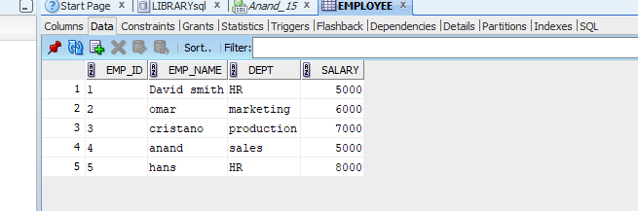
select * from employee where salary > 7000;
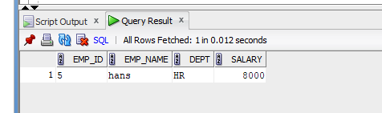
update employee set salary = 8200 where emp_name='David smith';
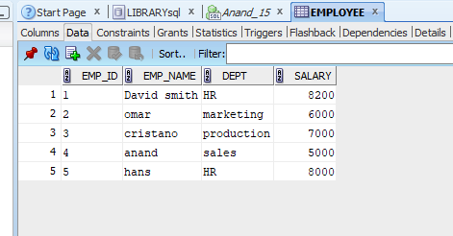
insert into employee values(6,'Dannel harris','production',6700);
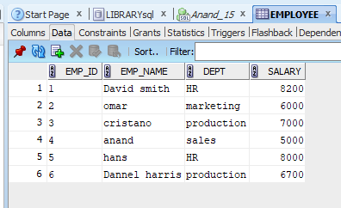
delete from employee where emp_id=3;
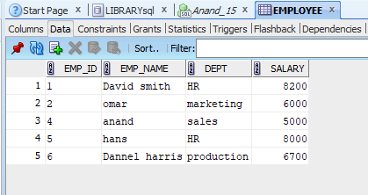
SELECT * FROM employee where emp_name not like 'D%' and emp_name not like 'o%';
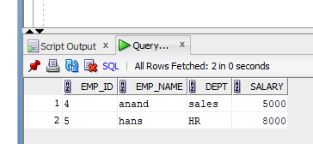
select dept, sum(salary) from employee group by dept;
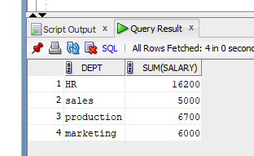
update employee set salary=salary*1.05 where dept= 'production';
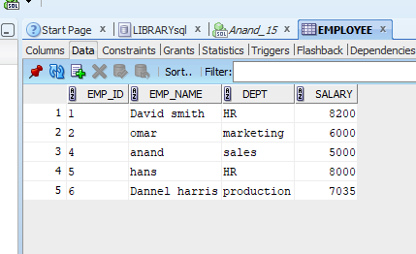
delete from employee where salary < 7000;
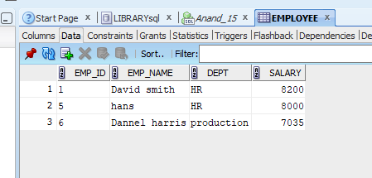
insert into employee values (7,'amal','marketing',5000);
update employee set salary=8200 where dept= 'marketing';
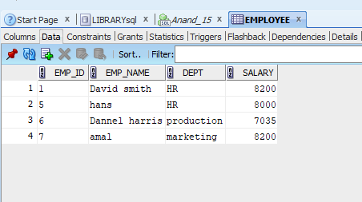
select emp_name,salary from employee where salary=( select min(salary) from employee);
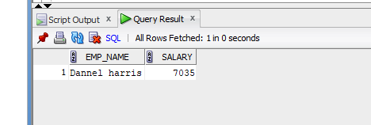
SELECT * FROM employee where emp_name like 'a%';
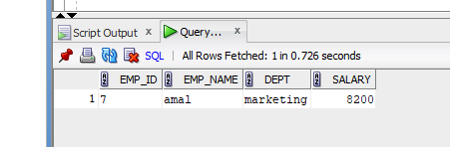
SELECT * FROM employee where emp_name like '%it%';
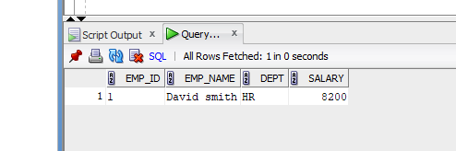
select distinct upper(dept) from employee;
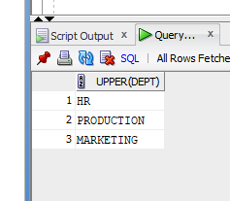
select * from employee where lower(dept) like 'm_r%ket%';
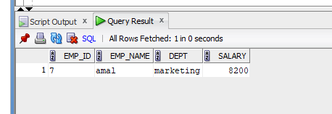
select distinct dept, reverse(upper(dept)) as reversed from employee;
