Name – Anand Kumar Maurya
Reg. no. 2025CA014
MCA, I sem

Q1. Write a C program to copy a file into another using system calls.

Code -

#include <stdio.h>
#include <stdlib.h> // For exit()

int main(int argc,char *argv[])
{
FILE *fptr1, *fptr2;
int c;

// Open one file for reading
fptr1 = fopen(argv[1], "r");
if (fptr1 == NULL)
{
printf("Cannot open file %s\n", argv[1]);
exit(1);
}

// Open another file for writing
fptr2 = fopen(argv[2], "w");
if (fptr2 == NULL)
{
printf("Cannot open file %s\n", argv[2]);
exit(1);
}

// Read contents from file
while ((c = fgetc(fptr1)) != EOF)
{
fputc(c, fptr2);
}

printf("Contents copied to %s\n", argv[2]);

fclose(fptr1);
fclose(fptr2);
return 0;
}

Output -

Q2. Write a C program that reads a file and writes in the reverse order.

Code -

#include <stdio.h>
#include <stdlib.h>

int main() {
FILE *source, *target;
char source_file[100], target_file[100];
long file_size;
char ch;

// Input file names
printf("Enter source file name: ");
scanf("%s", source_file);

printf("Enter target file name: ");
scanf("%s", target_file);

// Open source file in read mode
source = fopen(source_file, "r");
if (source == NULL) {
printf("Error: Cannot open source file.\n");
exit(1);
}

// Open target file in write mode
target = fopen(target_file, "w");
if (target == NULL) {
printf("Error: Cannot create target file.\n");
fclose(source);
exit(1);
}

// Move pointer to end of file
fseek(source, 0, SEEK_END);
file_size = ftell(source); // Get total size

// Read characters from end to start
for (long i = file_size - 1; i >= 0; i--) {
fseek(source, i, SEEK_SET); // Move to i-th position
ch = fgetc(source); // Read that character
fputc(ch, target); // Write to target file
}

printf("File copied in reverse order successfully.\n");

fclose(source);
fclose(target);
return 0;
}
Output -
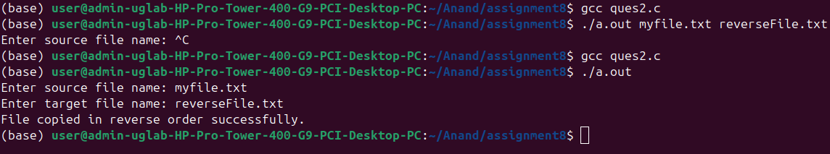

Q3. Write a C program to print all error messages.

Code -

#include <stdio.h>
#include <string.h>
#include <errno.h>

int main() {
int i;

printf("List of all system error messages:\n\n");

for (i = 0; i < 134; i++) {
printf("Error %d: %s\n", i, strerror(i));
}

return 0;
}

Output -
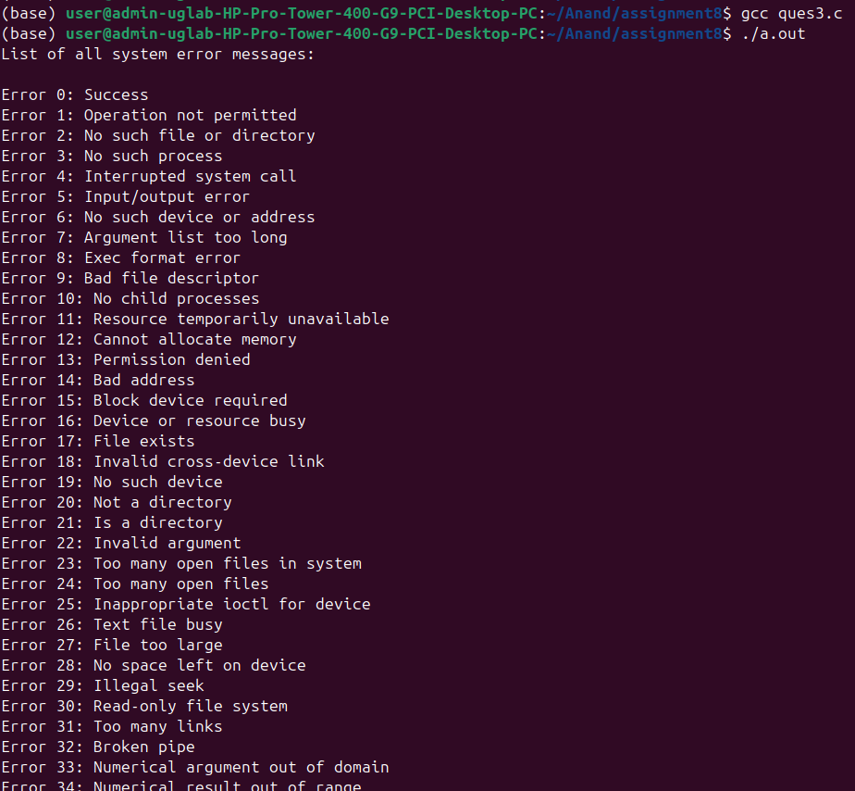
Q4. Write a C program to list only directories.

Code-

#include <stdio.h>
#include <dirent.h>
#include <sys/stat.h>
#include <string.h>

int main() {
char path[1024];
struct dirent *entry;
struct stat info;

// Ask user for directory path
printf("Enter directory path: ");
scanf("%s", path);

DIR *dir = opendir(path);
if (dir == NULL) {
perror("Unable to open directory");
return 1;
}

printf("\nDirectories inside '%s':\n", path);

while ((entry = readdir(dir)) != NULL) {
char fullpath[4096];

// Skip current (.) and parent (..)
if (strcmp(entry->d_name, ".") == 0 || strcmp(entry->d_name, "..") == 0)
continue;

// Create full path for stat()
snprintf(fullpath, sizeof(fullpath), "%s/%s", path, entry->d_name);

// Get file info
if (stat(fullpath, &info) == 0) {
if (S_ISDIR(info.st_mode)) {
printf("📁 %s\n", entry->d_name);
}
}
}

closedir(dir);
return 0;
}

Output -
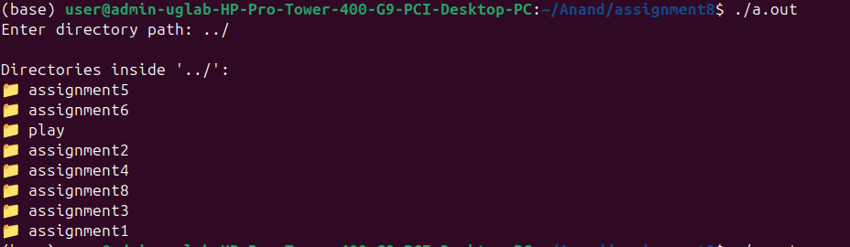

Q5. Write a C program to check all 12 permission bits of a file.

Code-

#include <stdio.h>
#include <sys/stat.h>
#include <stdlib.h>

int main() {
char filename[200];
struct stat fileStat;

printf("Enter filename: ");
scanf("%s", filename);

// Get file information
if (stat(filename, &fileStat) < 0) {
perror("Error accessing file");
exit(1);
}

printf("\nPermissions for %s:\n", filename);
printf("---------------------------\n");

// Special bits
printf("Set-user-ID (SUID): %s\n", (fileStat.st_mode & S_ISUID) ? "ON" : "OFF");
printf("Set-group-ID (SGID): %s\n", (fileStat.st_mode & S_ISGID) ? "ON" : "OFF");
printf("Sticky bit: %s\n", (fileStat.st_mode & S_ISVTX) ? "ON" : "OFF");

printf("\nUser permissions:\n");
printf(" Read: %s\n", (fileStat.st_mode & S_IRUSR) ? "YES" : "NO");
printf(" Write: %s\n", (fileStat.st_mode & S_IWUSR) ? "YES" : "NO");
printf(" Execute: %s\n", (fileStat.st_mode & S_IXUSR) ? "YES" : "NO");

printf("\nGroup permissions:\n");
printf(" Read: %s\n", (fileStat.st_mode & S_IRGRP) ? "YES" : "NO");
printf(" Write: %s\n", (fileStat.st_mode & S_IWGRP) ? "YES" : "NO");
printf(" Execute: %s\n", (fileStat.st_mode & S_IXGRP) ? "YES" : "NO");
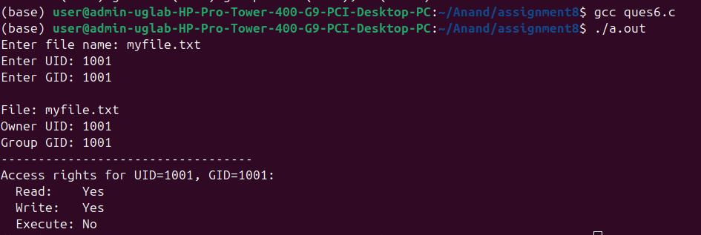
printf("\nOthers permissions:\n");
printf(" Read: %s\n", (fileStat.st_mode & S_IROTH) ? "YES" : "NO");
printf(" Write: %s\n", (fileStat.st_mode & S_IWOTH) ? "YES" : "NO");
printf(" Execute: %s\n", (fileStat.st_mode & S_IXOTH) ? "YES" : "NO");

return 0;
}

Output -

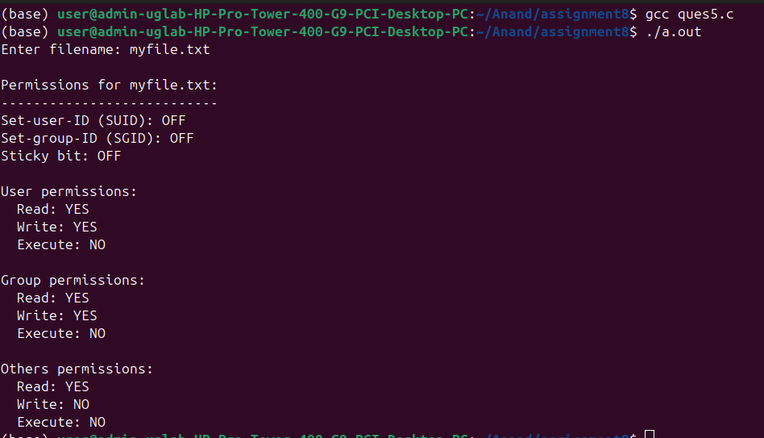
Q6. Write a C program to determine a file’s access rights using UID and GID.

Code-

#include <stdio.h>
#include <sys/stat.h>
#include <unistd.h>
#include <stdlib.h>

int main() {
char filename[200];
uid_t uid;
gid_t gid;
struct stat fileStat;

// Get input
printf("Enter file name: ");
scanf("%s", filename);

printf("Enter UID: ");
scanf("%u", &uid);

printf("Enter GID: ");
scanf("%u", &gid);

// Get file information
if (stat(filename, &fileStat) < 0) {
perror("Error accessing file");
exit(1);
}

printf("\nFile: %s\n", filename);
printf("Owner UID: %u\n", fileStat.st_uid);
printf("Group GID: %u\n", fileStat.st_gid);
printf("----------------------------------\n");

// Determine which set of permissions apply
mode_t mode = fileStat.st_mode;
int can_read = 0, can_write = 0, can_exec = 0;

if (uid == 0) { // Root user
can_read = can_write = can_exec = 1;
}
else if (uid == fileStat.st_uid) { // File owner
can_read = (mode & S_IRUSR) ? 1 : 0;
can_write = (mode & S_IWUSR) ? 1 : 0;
can_exec = (mode & S_IXUSR) ? 1 : 0;
}
else if (gid == fileStat.st_gid) { // Group member
can_read = (mode & S_IRGRP) ? 1 : 0;
can_write = (mode & S_IWGRP) ? 1 : 0;
can_exec = (mode & S_IXGRP) ? 1 : 0;
}
else { // Others
can_read = (mode & S_IROTH) ? 1 : 0;
can_write = (mode & S_IWOTH) ? 1 : 0;
can_exec = (mode & S_IXOTH) ? 1 : 0;
}

printf("Access rights for UID=%u, GID=%u:\n", uid, gid);
printf(" Read: %s\n", can_read ? "Yes" : "No");
printf(" Write: %s\n", can_write ? "Yes" : "No");
printf(" Execute: %s\n", can_exec ? "Yes" : "No");

return 0;
}

Output -

