­­­­

Atma Ram Sanatan Dharma College  
University of Delhi

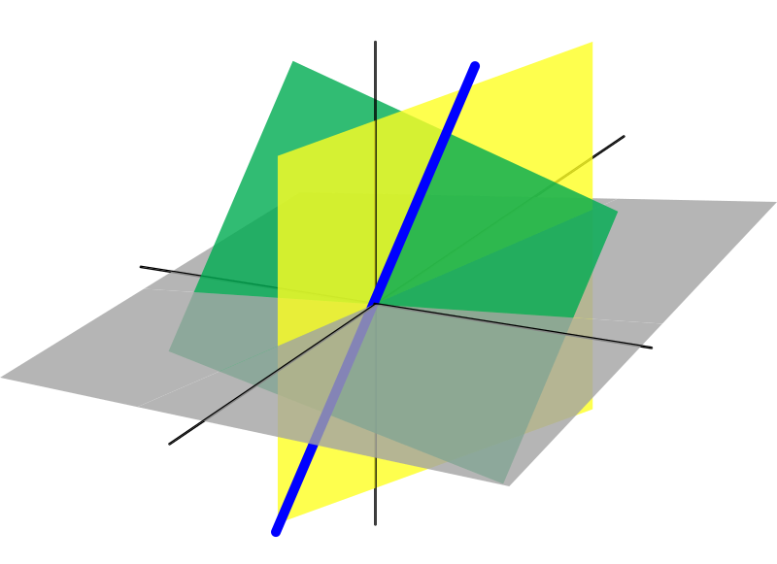

Linear Algebra

Assignment for Paper Code 32355202

Submitted By  
Sudipto Ghosh  
College Roll No. 19/78003  
BSc (Hons) Computer Science

Submitted To  
Mr Anant Tiwari   
Department of Mathematics