Customer Relationship Management (CRM)

Core Components of a CRM System

1.Customer details

customer profiles with personal details, contact information, and history

- Contact Management

Organize and track contact details for customers, leads, and partners

- Lead & Opportunity

Track leads through different sales stages.

- Sales

sales tasks like follow-ups, quote generation, and pipeline tracking.

Visualize sales pipelines and forecast revenue.

- Task & Activity

Assign tasks to team members, schedule meetings, and set reminders.

Track progress and deadlines for ongoing customer activities.

- Document

Upload, store, and manage important customer-related documents.

Ensure compliance with document verification (e.g., KYC in financial services).

- Analytics & Reporting

Generate reports on sales performance, customer behavior, and support metrics.
Use dashboards to monitor KPIs and make data-driven decisions.

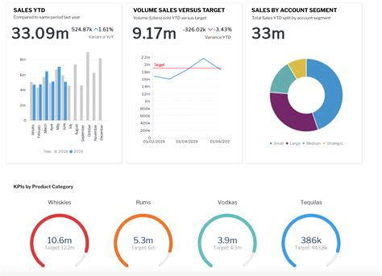

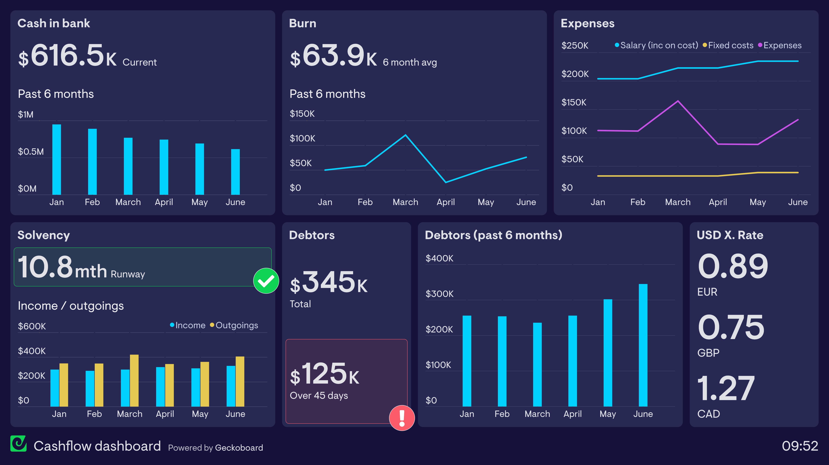

Another Example Image

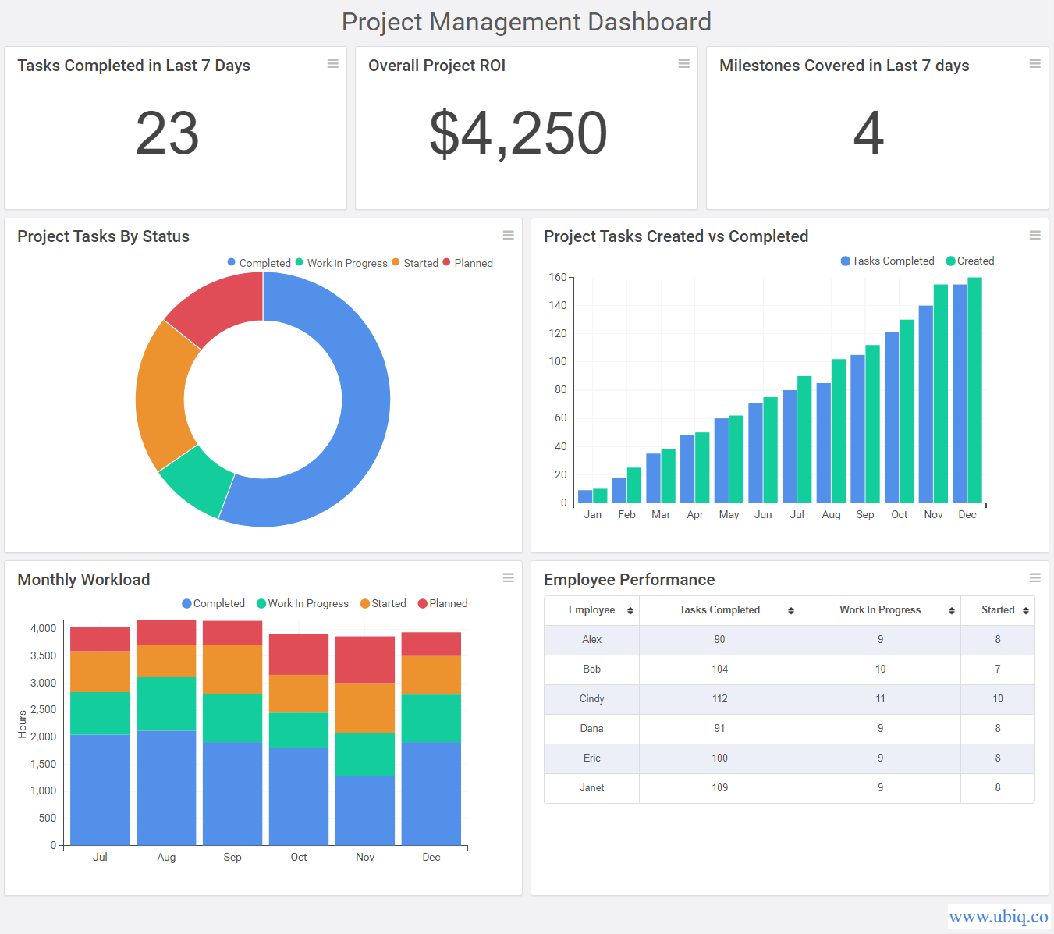

- Support & Service

Manage support tickets, FAQs, and customer feedback.

Track issue resolution times and customer satisfaction.

- CRM Features

- Loan Application Tracking: Monitor loan statuses, approvals, and disbursements.

- Payment History & Schedules: Keep a record of EMIs, repayments, and pending dues.

- Credit Score Integration: Fetch and display credit scores for loan evaluation.

- Compliance Management: Handle KYC/AML requirements and documentation.

- Early Payment & Discount Negotiation: Automate early repayment options with discounts.

Customer Data Management APIs

- Customer Information APIs: Manage customer profiles, contact details, and interaction history.
- Contact Management APIs: Handle lists of contacts, segmentation, and bulk imports.
- Identity Verification APIs: Integrate with KYC (Know Your Customer) services to verify customer identity.

2. Sales & Lead Management APIs
- Lead Generation APIs: Capture leads from websites, forms, and marketing campaigns.
- Opportunity Management APIs: Track deals, stages, and revenue forecasts.
- Pipeline Management APIs: Visualize and manage sales pipelines.

3. Communication & Notification APIs
- Email APIs: (e.g., SendGrid, Mailgun) for sending automated emails and newsletters.
- SMS APIs: (e.g., Twilio, Nexmo) for sending alerts, OTPs, and notifications.
- Voice & Chat APIs: (e.g., Twilio Voice, WhatsApp Business API) for integrated communication.
- Push Notification APIs: Notify users about application updates or customer interactions.

4. Financial & Payment APIs (Important for LMS Integration)
- Payment Gateway APIs: (e.g., Stripe, PayPal) for processing payments and loan disbursements.
- Currency Exchange APIs: (e.g., Open Exchange Rates) for handling global transactions.
- Credit Scoring APIs: (e.g., Experian, Equifax) to assess borrower creditworthiness.

5. Analytics & Reporting APIs
- Business Intelligence APIs: Generate visual reports and dashboards.
- Google Analytics API: Track user engagement and behavior in the CRM portal.
- Custom Reporting APIs: Export data in CSV, Excel, or PDF formats.

6. Authentication & Security APIs
- OAuth & JWT APIs: For secure user authentication and authorization.
- SSO Integration: Support single sign-on through platforms like Okta or Azure AD.
- Encryption & Compliance APIs: Ensure data privacy and regulatory compliance.

7. Integration & Workflow APIs
- ERP Integration APIs: Connect with enterprise systems for seamless data flow.
- Marketing Automation APIs: Sync with platforms like HubSpot or Marketo.
- Calendar & Task Management APIs: (e.g., Google Calendar, Outlook Calendar) to schedule meetings and reminders.

8. Loan Management-Specific APIs (For your LMS Integration)
- Loan Application APIs: Submit, track, and manage loan applications.
- Repayment Schedule APIs: Retrieve EMI plans and payment statuses.
- Document Verification APIs: Integrate with services for document scanning and validation.
- Early Payment Discount APIs: Manage early repayment negotiations and discounts.

Example Scenario for Your CRM in LMS:
- Customer Data API: To fetch customer profiles in the CRM module.
- Loan Application API: To show the customer's current loan status.
- Notification API: To alert customers about upcoming EMI deadlines.
- Document Management API: To upload and verify KYC documents.
- Credit Score API: To evaluate customer loan eligibility.

