LMS Run Book

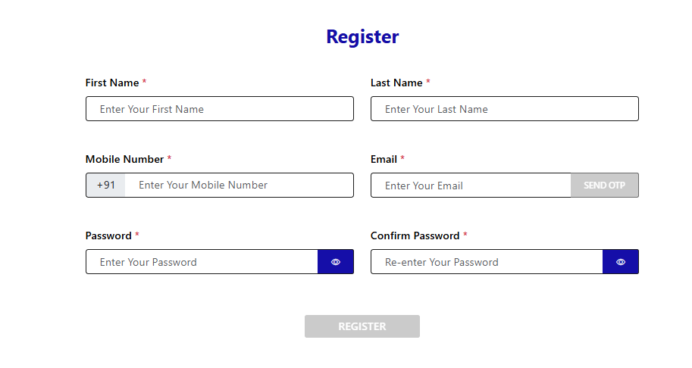

Fields in the Registration Form:
- First Name *
  - Input placeholder: Enter Your First Name
- Last Name *
  - Input placeholder: Enter Your Last Name
- Mobile Number *
  - Prefix: +91
  - Input placeholder: Enter Your Mobile Number
- Email *
  - Input placeholder: Enter Your Email
  - Button: SEND OTP (currently disabled or inactive)
- Password *
  - Input placeholder: Enter Your Password
  - Eye icon (👁) for show/hide toggle
- Confirm Password *
  - Input placeholder: Re-enter Your Password
  - Eye icon (👁) for show/hide toggle

Register Button
- Label: REGISTER
- Currently disabled (grayed out)

Possible Features/Validations Expected
- All fields marked * are mandatory.
- The Send OTP button for email might activate after a valid email is entered.
- The Register button likely becomes active only after:
  - All required fields are filled.
  - Passwords match.
  - OTP (if required) is validated.
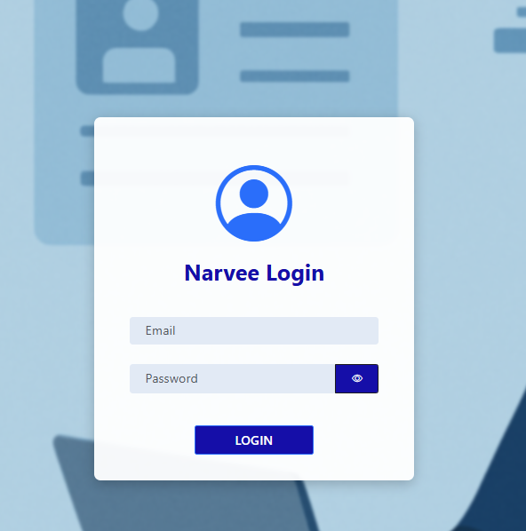

Narvee Login Screen Overview

UI Components:
- Profile Icon (top center):
  - User avatar icon, visually centered at the top.
- Title:
  - Narvee Login — prominently styled in bold blue font.
- Input Fields:
  - Email:
    - Placeholder: Email
    - Expected to accept user email for login.
  - Password:
    - Placeholder: Password
    - Eye icon (👁): Toggles visibility of the entered password.
- Login Button:
  - Label: LOGIN
  - Styled in dark blue
  - Will be enabled only when both fields are filled.

Expected Functionality:
- Input Validation:
  - Valid email format required.
  - Password length check (e.g., min 6-8 characters).
- Login Button Activation:
  - Becomes clickable only after valid email & password inputs.
- Authentication Logic (likely backend):
  - On click of LOGIN, a request will be sent to an API (e.g., POST /login) with credentials.
  - On success: Redirect to dashboard or home page.
  - On failure: Show error like "Invalid credentials."

Run Book LMS (Loan Management System)
HRM Information

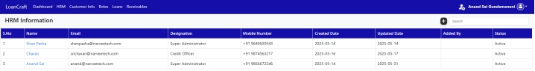

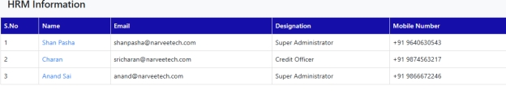

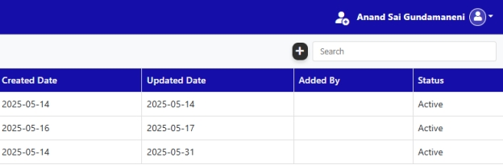
- HRM (Human Resource Management)

Header Section (Top Bar)
- Logo & Name: On the far left, it says LoanCraft — likely the application or system name.
- Navigation Menu: Contains links to different modules:
  - Dashboard
  - HRM
  - Customer Info
  - Roles
  - Loans
  - Receivables
- User Info (Top Right):
  - Shows the logged-in user: Anand Sai Gundamaneni
  - User icon next to the name

2. Title Section
- Title: HRM Information — This section is showing employee or user information related to HR.

3. Search & Add Button
- Add Button (➕): Used to add a new HRM entry.
- Search Bar: Allows users to search/filter the HRM entries.

4. Data Table
This table contains information about HRM users. Each row represents one user. The table has the following columns:
Column | Explanation
S.No | Serial Number (1, 2, 3...)
Name | Name of the HRM user (clickable links, possibly to view details)
Email | Email address of the user
Designation | Job title (e.g., Super Administrator, Credit Officer)
Mobile Number | Contact phone number (Indian format)
Created Date | When the user entry was created
Updated Date | When the user entry was last updated
Added By | Not filled for all users, likely the admin who added the user
Status | User's current status (all show Active)

5. Table Content
Here are the 3 entries shown:

Entry 1
- Name: Shan Pasha
- Email: shanpasha@narveetech.com
- Designation: Super Administrator
- Mobile: +91 9640630543
- Created/Updated: 2025-05-14
- Status: Active

Entry 2
- Name: Charan
- Email: sricharan@narveetech.com
- Designation: Credit Officer
- Mobile: +91 9874563217
- Created: 2025-05-16
- Updated: 2025-05-17
- Status: Active

Entry 3
- Name: Anand Sai
- Email: anand@narveetech.com
- Designation: Super Administrator
- Mobile: +91 9866672246
- Created: 2025-05-14
- Updated: 2025-05-31
- Status: Active
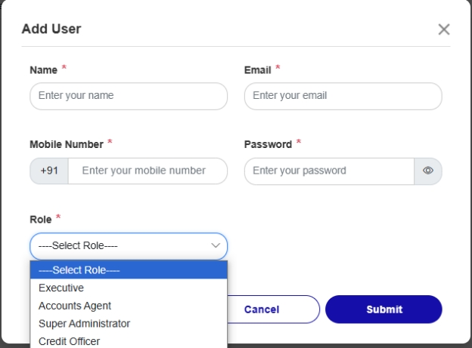

- ADD User
"Add User" – This indicates that the purpose of the form is to create a new user account in the system

Input Fields (User Details):
Each field marked with a red asterisk (*) is required.

a. Name
- Placeholder: Enter your name
- Accepts the full name of the user.

b. Email
- Placeholder: Enter your email
- Accepts the user's email address (likely needs to be unique).

c. Mobile Number
- Prefixed with +91 (India's country code).
- Placeholder: Enter your mobile number
- Accepts the user's contact number.

d. Password
- Placeholder: Enter your password
- Input is masked for privacy.
- An eye icon is present, likely to toggle visibility (show/hide password).

3. Role Selection (Dropdown Menu)

Dropdown Label:
- "Role" (Required)

Dropdown Options:
- ----Select Role---- (Default, non-selectable placeholder)
- Executive
- Accounts Agent
- Super Administrator
- Credit Officer
This determines the access level or permissions the user will have in the system.

4. Action Buttons:

a. Cancel
- Likely closes the form without saving any data.
- Styled with an outline (suggesting secondary action).

b. Submit
- Submits the form data to create a new user.
- Styled with a solid blue button (indicating primary action).

5. Close Icon (Top-Right Corner)
- An “X” icon to close the modal without using the Cancel button.

Summary:
This "Add User" form collects necessary details to register a new user in the system. The fields include:
- Name
- Email
- Mobile Number
- Password
- Role

Customer Information

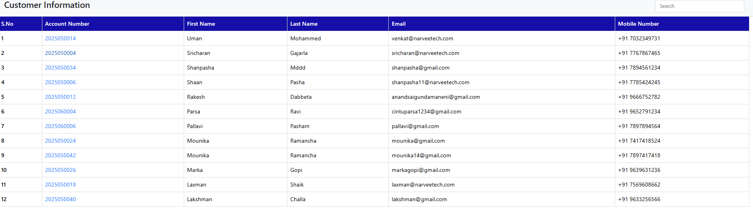

Column Name | Description
S.No | Serial number
Account Number | Unique ID per user
First Name | Customer’s first name
Last Name | Customer’s last name
Email | Contact email
Mobile Number | Contact number (with country code)

Search Feature:
- Top-right corner has a Search box.
- Expected to filter table rows dynamically based on input (e.g., by name, email, or number).

Possible Functional Enhancements:
- Searchable Table:
  - Use Angular ngFor + filter pipe or JavaScript filtering logic.
- Pagination:
  - Add pagination controls if records are many.
- Sorting:
  - Clickable column headers to sort data (ascending/descending).
- Edit/Delete Actions:
  - Add action buttons (✏️ / 🗑) to allow managing customer records.
- Export Options:
  - Add buttons for exporting data to Excel/CSV/PDF.
Roles Information Table Overview
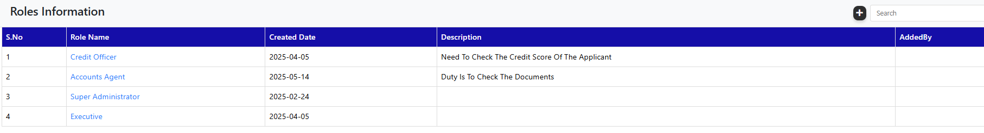

Column Name | Description
S.No | Serial number
Role Name | Designation or role title (clickable links)
Created Date | Date the role was created
Description | Details about responsibilities
AddedBy | Currently blank, should display who added the role

UI/UX Features Observed:
- Search Bar: Top-right corner for filtering roles.
- Add Button: Floating-style + button for adding new roles.
- Clickable Role Names: Looks like the role names are links—may lead to detailed view or edit screen.

Suggested Enhancements:
- Populate AddedBy Column:
  - Should show username or admin email who created the role.
- Edit/Delete Icons:
  - Add actions (✏️ / 🗑) at row-end for managing roles.
- Modal or Page Redirect on Role Click:
  - Display more details or open a role-edit form.
- Empty Description Fallback:
  - Use text like "No description provided" if blank.
- Sorting & Pagination:
  - Sort by name/date and paginate when more records exist.

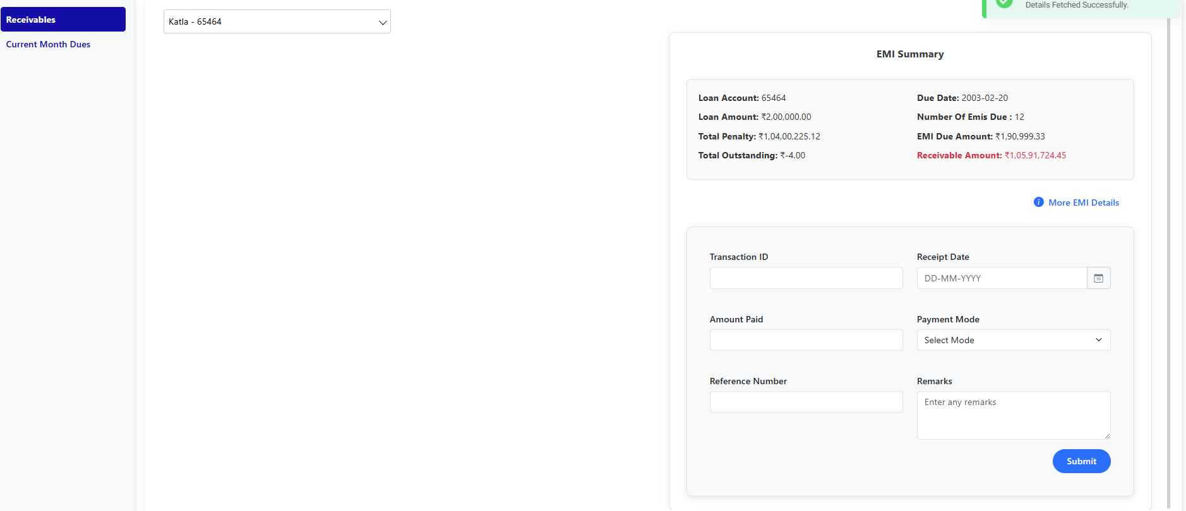
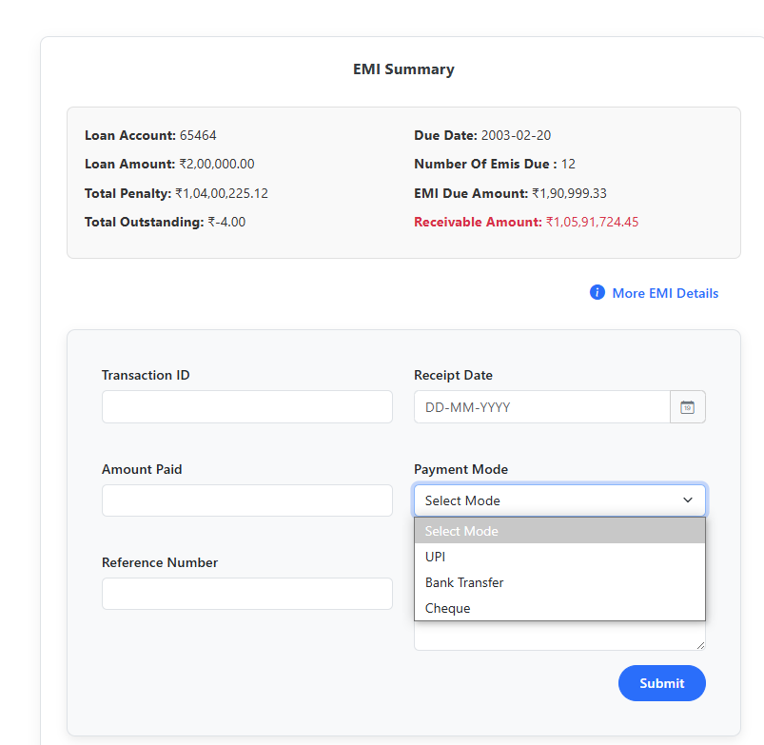
Receivables and EMI Collection Entry

EMI Collection Screen - Summary

🔷 Left Panel:
- Receivables Navigation
  - Highlights current section (Receivables)
  - Option for "Current Month Dues"

🔷 Top Dropdown:
- Selected customer: Katla - 65464

Field | Value
Loan Account | 65464
Loan Amount | ₹2,00,000.00
Total Penalty | ₹1,04,00,225.12 (unusually high)
Total Outstanding | ₹-4.00 (should not be negative)
Due Date | 2003-02-20 (may be incorrect / outdated)
Number of EMIs Due | 12
EMI Due Amount | ₹1,90,999.33
Receivable Amount | ₹1,05,91,724.45 (in red: critical)
Receivable seems excessive, indicating either:
- Long unpaid duration
- Compounding penalties
- Possible data corruption (due to negative Total Outstanding)

Payment Entry Form
Fields:
- Transaction ID
- Receipt Date (with Date Picker)
- Amount Paid
- Payment Mode (Dropdown)
- Reference Number
- Remarks (Text Area)
- Submit Button (Bottom right)

Current Month Dues
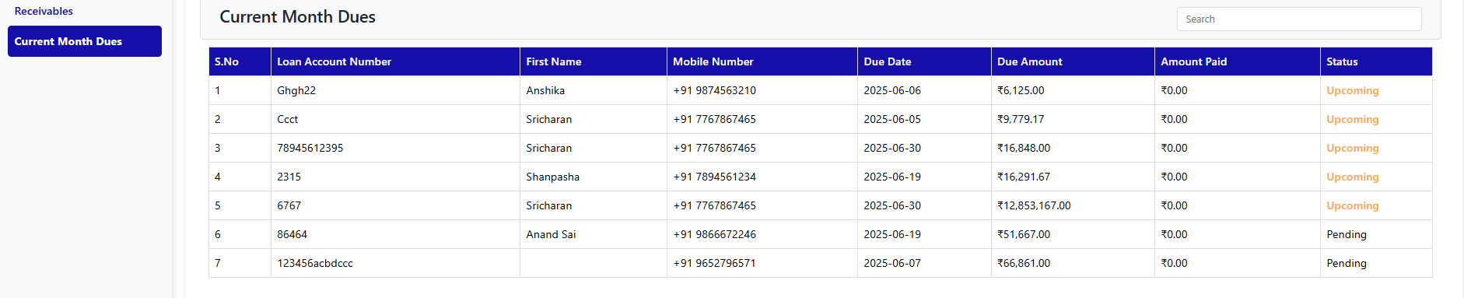
Current Month Dues Table Summary
Column | Description
S.No | Serial number of the record
Loan Account Number | Unique loan ID (some are not numeric)
First Name | Borrower's first name
Mobile Number | Contact number
Due Date | Date when EMI is due
Due Amount | Amount to be collected
Amount Paid | ₹0.00 for all currently
Status | Upcoming or Pending

Issues Noted

Data Validity Concerns
- Loan Account Numbers like Ghgh22, Ccct, and 123456acbdccc are inconsistent — consider enforcing numeric or UUID format.
- Duplicate mobile numbers for "Sricharan" (possibly multiple loans?) — UI should differentiate by loan ID.
- Due Amount of ₹12,853,167.00 is extremely high — likely a data entry or interest compounding error.

Status Labeling
- Upcoming: likely based on future due date.
- Pending: possibly overdue or already due today.

