Name: Anand Ramnarain

Student Number: 2486020

Group Members: Anand Ramnarain

Project Type: 2D Platformer JavaScript Game

Project Name: Hacker Vs Cyberspace

Assignment Name: Exam

Due Date: 4th November 2024

Link To Deployed Project: [Click Here](https://anand-ramnarain-27.github.io/Hacker_Vs_CyberSpace/)

**Description**

Overview:

In my game, HACKER VS CYBERSPACE, players take on the role of a skilled hacker navigating a cyberpunk-inspired world. The game’s goal is to infiltrate a massive, multi-level system while overcoming various obstacles, defences, and challenges. The gameplay combines elements of platforming and puzzle-solving, with a focus on using special abilities strategically to bypass security systems.

Key Features:

1. Level Structure and Progression:

- The game consists of 20 levels.

- Players progress upward, moving from level to level. Each level is carefully designed with unique challenges and requires specific strategies to clear.

- Upon completing a level, players seamlessly transition to the next, with the game's camera cantering on each new floor.

2. Core Abilities and Mechanics:

- EMP Ability: Pressing the ‘E’ button activates an EMP pulse, temporarily disabling lights, cameras, and guards for 5 seconds. This ability is crucial for stealthy movement and is governed by a cooldown timer of 2 minutes to ensure strategic use.

- Gravity Inversion: Players can also invert gravity by pressing the ‘G’ button, flipping the gameplay dynamics and opening up new paths or solutions to level puzzles. This ability has a cooldown of also 2 minutes and a limited duration of 5 seconds.

- Matrix Rain and Visual Effects: I was inspired by matrix aesthetics, as my game features a “Matrix Rain” effect, as in the background there are lines of random code symbols falling across the screen. These visual effects contribute to the hacking theme and immerse players in a high-tech atmosphere.

3. Difficulty System:

- My game includes adjustable difficulty settings, which players can toggle before starting a run.

- There is also a difficulty prompt feature to make players aware that they can change the difficulty.

- I also made it so that completing the game on higher difficulty settings unlocks trophies, which are saved locally.

4. Player Interface and Visuals:

- I wanted the game to have a minimalist HUD that displays important stats, including current level, time, and status of special abilities.

- There are also visual cues, such as dust particles and title screen animations, that add to the polished feel of the game. These animations include an intro sequence, main title shake effects, and screen transitions for starting and ending the game.

- I also worked on adding mobile controls which use touch-based controls for movement, jumping, and activating special abilities. Making it so it can be played on multiple devices.

5. Responsive Game Flow:

- My game provides players with clear visual feedback on their progress and actions. For instance, there are indicators for when the EMP or gravity inversion is in use or on cooldown.

- Since the game is like a best-your-time game, players are encouraged to replay and improve their speed. The game tracks the best time and difficulty for each run, encouraging speedrunning and mastery.

So my game, HACKER VS CYBERSPACE, combines cyberpunk and Tron visuals with platforming and puzzle-solving mechanics. The integration of special abilities like EMP and gravity inversion adds layers of strategy, requiring players to think carefully about when and how to use them. The progression through levels and difficulty-based trophies offers replay value and challenges for different types of players.

Inspirations/Sources:

Game:

My game draws its core gameplay inspiration from Super Meat Boy, Broforce and Arcade beat you score/time game. Like Super Meat Boy, I wanted to combine the intense, challenging platforming mechanics with a strong emphasis on precise control and quick decision-making, encouraging players to learn from their mistakes and master each level. Additionally, Broforce brings a chaotic, over-the-top dynamic that makes every move feel impactful, which what I incorporated. The fast, fluid movement add to the thrill of Broforce, and while my game is more structured and precise, the emphasis on smooth, responsive movement is a shared goal.

Ultimately, my game is a blend of these influences, emphasizing fast-paced, competitive gameplay, where mastering movement and timing is crucial. Even though I’ve shifted away from the high-score chase of arcade classics, the competitive nature is still there. So, players will now strive to beat their best times and perfect their runs through increasingly challenging cyberspace levels. This keeps the game engaging, repayable, and rewarding for those who enjoy the thrill of competition.

Art:

In terms of visuals, I wanted to create a cyberpunk retro aesthetic inspired by iconic works like Tron and The Matrix. The neon-lit environments and dark, tech-infused atmosphere evoke the stylized, futuristic world of Tron, with glowing accents and vibrant colours creating an immersive cybernetic landscape. Meanwhile, The Matrix inspires a rain effect that adds a layer of gritty ambience, enhancing the sense of a digital, almost dystopian reality. These visual influences together create a setting that feels both futuristic and nostalgic, grounding the gameplay in a vivid, atmospheric world.

Goal:

Personal Goals:

My personal goals for this project were to focus on advancing both my technical and creative skills, emphasizing improvement in programming, especially in JavaScript for game development, and refining my ability to create immersive environments through visual and sound design. Consistency in my work approach is key, as I aim to progress steadily, complete milestones on time, and maintain my cyberpunk/Tron theme across my project. Another critical goal is to actively incorporate feedback from playtesting into my design, especially when refining mechanics and addressing bugs, to ensure my project reflects a high standard and evolves based on player input.

Project Goals:

For my game, Hacker Vs. Cyberspace, my primary project goals centre on crafting an engaging and immersive experience through polished mechanics and visuals that support the cyberpunk theme. Gameplay must feel smooth and intuitive, with responsive controls and well-balanced difficulty. I aim to establish a unique style with Tron-inspired graphics and a consistent cyberspace theme. Technically, my goals include a seamless implementation of core abilities like EMP and gravity inversion, ensuring they enhance the experience without causing performance issues. Completing each milestone as planned is essential for the project’s timely delivery and overall quality.

Rubric

**Personal Development Rubric (50%)**

|  |  |  |
| --- | --- | --- |
| **Criterion** | **Goal** | **Weighting** |
| **Skill Improvement** | I want to see the improvement in my programming and art skills, so I further myself and learn to use more advance techniques | **20%** |
| **Creating an immersive Experience** | Develop an immersive cyberspace environment through engaging sound design, compelling visual effects, and innovative mechanics. Ensure that the player feels integrated into the game's cyberspace theme. | **15%** |
| **Commitment & Consistency** | I want to be more consistent in my work, by actively work on this project, meeting all milestones and trying to keep a consist theme within this project no matter no hard I find certain aspects. | **5%** |
| **Feedback & Incorporation** | I want to try to actively get more feedback from my playtesting session to improve my game and skills. To incorporate that feedback into my project | **10%** |

**Project Rubric (50%)**

|  |  |  |
| --- | --- | --- |
| **Criterion** | **Goal** | **Weighting** |
| **Gameplay Experience** | Ensure the gameplay is engaging, smooth, and free of significant lag or glitches. The game should provide a polished experience with clear, responsive controls and enjoyable mechanics. | **15%** |
| **Graphics & Art Style** | Maintain a consistent visual style that aligns with the cyberspace theme, creating a cohesive and visually appealing experience. The graphics should contribute to the overall atmosphere of the game. | **15%** |
| **Technical Implementation** | Effectively utilize JavaScript and other technologies to ensure the game operates r. This includes implementing the difficulty modes, timer feature, and any other technical aspects smoothly. | **15%** |
| **Achievement of Project Milestones** | All project milestones achieved on time | **5%** |

Goal: Why I Choose These Rubrics

Personal Development Rubric

The Personal Rubric provides an objective assessment with clear criteria for evaluating my progress in skill improvement, creativity in creating an immersive experience, commitment, problem-solving, and feedback. This clarity ensures consistency in evaluations over time for me. By focusing on targeted feedback, the rubric helps identify strengths and areas for improvement, allowing concentrated efforts on specific skills, forcing me to incorporate the feedback I get into my project and find new ways to implement it as usually, I end up ignoring the feedback and just go and do what I want to. It also shows my goals clearly which also serves as motivation to achieve higher performance levels. Additionally, this rubric offers a comprehensive evaluation, covering various aspects of my personal development to ensure a well-rounded assessment and so I can improve on areas which I feel I need to focus on in my work.

Project Rubric

The Project Rubric ensures alignment with initial project goals, such as delivering smooth gameplay, sticking to the chosen art style, and implementing technical solutions. It allows me to track and focus on my milestones, ensuring the timely completion of key project stages as I usually get distracted in my work and don’t finish what I need to. Having an aspect of graphics and art in my rubric makes sure I will at least try to create art even though it is a small amount because I know I am not the best at art but it allows me to still try to make something and expand my boundaries to take my art skills somewhat further. The technical implementation, will enable me to have performance evaluations to ensure the game's reliability and player satisfaction so there is minimum lag/glitches. This will allow for continuous improvement which is important in iterative development, providing feedback on different aspects of the project and identifying specific issues that need addressing, whether technical, artistic, or related to user experience.

Playtesting Report:

Playtesting Report: Glitch Effect Feedback and Adjustments

Date: 23 - 30 October

Version: Glitch Effect Version

Objective:

The objective of this playtesting session was to evaluate the level design difficulty, detect major bugs, and test the special abilities (focusing on cooldown times, usability, and effectiveness). I wanted feedback on whether the gameplay felt balanced, engaging, and manageable.

Participants:

Five participants were involved in this remote playtest. Two participants were new to gaming, and the remaining three were more experienced. I also incorporated feedback from my Crit 3 marker.

Playtest Setup

This was a remote playtesting session where I sent out either a link or a build of the game for participants to try. Four participants play tested on a laptop, and one on a mobile.

Glitch Effect Feedback

Videos of Glitch Effect Issues:

Player Feedback:

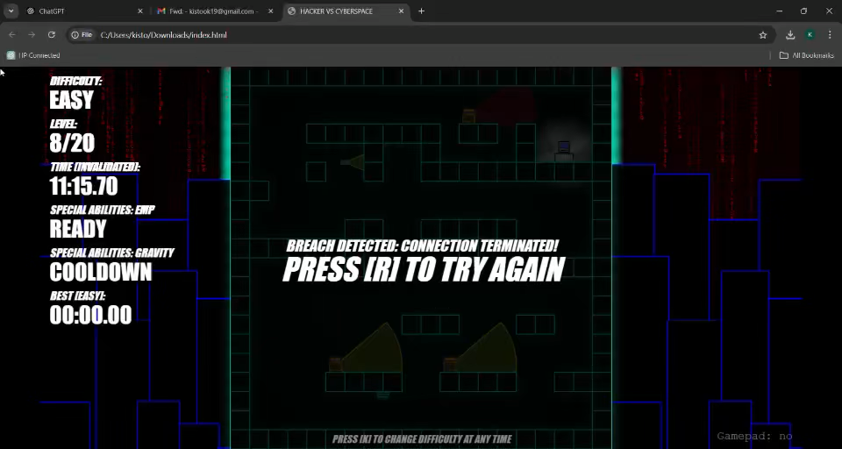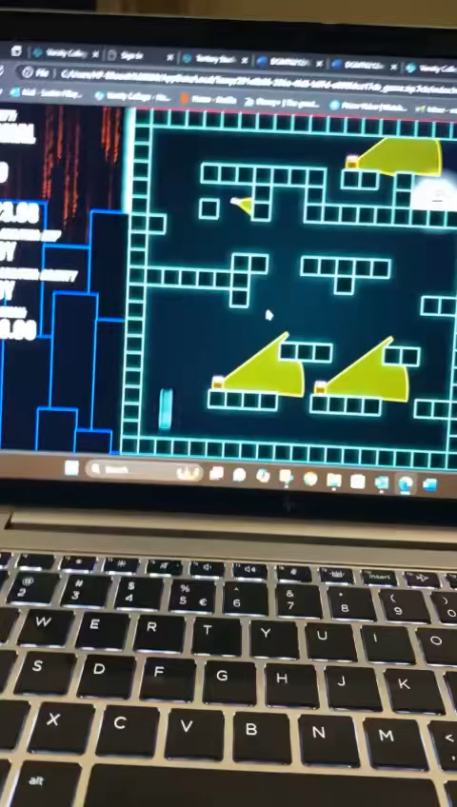In this session, participants generally enjoyed the early levels. However, as they progressed, the glitch effect I implemented began to create significant issues. The effect caused unintended behaviour, which became the primary focus of feedback, overshadowing other gameplay aspects. The following issues were raised, leading me to halt the playtest temporarily and investigate further:

- Level 3: The glitch effect would trigger if the player moved too quickly, causing unintended teleportation.

- Level 5: Several issues arose:

- Teleportation to the top-left corner of the screen bypassed obstacles.

- Players would spawn close to the computer, bypassing sections of the level.

- Rapidly clicking against the left wall led to random teleports.

- Standing still for extended periods caused random glitch effects, disrupting gameplay flow.

One participant suspected these might be performance issues, noting:

> “The game works very smoothly. I honestly think that these bugs are purely performance-based issues; whatever detection methods you're using is switching off now and then."

Another participant suggested a possible solution:

> "Maybe have a timer to show when you’re glitching?"

My Notes:

Upon testing further, I observed that the glitch effect became unreliable, with repeated activations that didn’t follow the intended sequence. Attempts to implement a timer, as suggested, only partially resolved the issue. The glitch effect continued to trigger erratically and detracted from the overall gameplay experience.

Final Decision:

After further experimentation and taking participant feedback into account, I decided to remove the glitch effect entirely. It was causing more disruption than intended, detracting from the experience rather than enhancing it.

Playtesting Without Glitch Effect

Version: Final

Following the removal of the glitch effect, I re-sent the game for another round of playtesting.

Objective:

The objective of this playtesting session was to evaluate the gameplay experience without the glitch effect, allowing players to focus on all aspects of the game without disruptions. We gathered feedback on level design, game performance, special abilities, and audio.

Feedback Overview

Participant Feedback on Overall Gameplay

One participant offered high praise for the game, saying:

> “Hacker Vs. CyberSpace is an impressive and immersive project that showcases creativity and skill in game design. The cyber-themed world is engaging, with sleek visuals and gameplay that strike a solid balance between strategy and action. Navigating through the cyber traps and obstacles is challenging and rewarding, with each level offering fresh experiences to keep players hooked.”

This feedback from the participant gives strong encouragement to me and the game’s design and adds valuable context to the report.

Level Design:

Players provided positive feedback on the level progression and design:

- “I like that the first levels slowly introduce new elements and teach the user what they are capable of or what obstacles there might be.”

- “The game feels challenging enough and motivates the player to keep engaging.”

- “It’s challenging but not impossible—and it’s really fun.”

- “The level designs are sick and enjoyable to play.”

- “Level design is very smooth and easy to manoeuvre through, especially on normal difficulty.”

Performance:

With the glitch effect removed, players reported smooth performance across devices, with no further technical issues. Just on mobile devices the controls aren’t the best and it is a bit off but it is the best I could get it to function.

Major Concerns

1. Jumping Mechanics Bug:

- Feedback:

- Participant 1: “At some spots, I can just jump, like wall climb basically.”

- Participant 2: “If you spam jump while against a wall, you climb straight up.”

- Developer Notes:

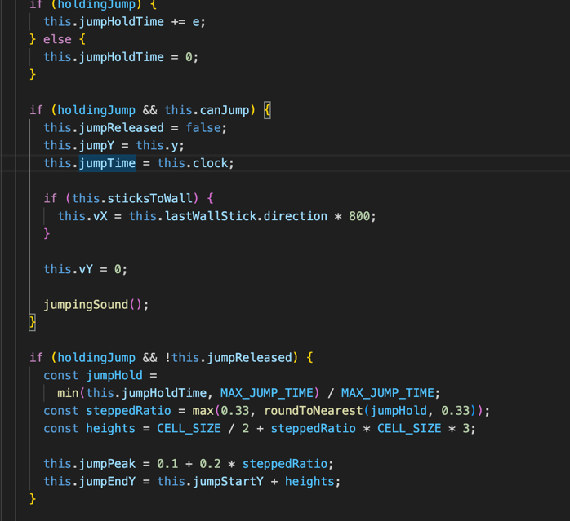 I investigated this issue, but due to how the jump mechanic is coded, removing this “wall-climb” bug would disable wall-jumping entirely. It checks if the player must have released the jump key, If the player is rising, they cannot jump again unless they are sticking to a wall and if the player must have recently landed or been close to a wall they can jump from. I tried adding or changing different aspects of this but nothing worked, as it is caused as it sees the player is close to a wall so it allows the jump to happen.

2. Special Abilities:

- My goal was for players to use abilities as a supportive tool rather than a necessity, adding strategic depth. However, feedback showed varied perspectives:

- An inexperienced player noted, “I spent quite a while on one level without it.”

- Others indicated they could complete levels without the abilities but found them helpful.

- Cooldown Feedback:

When asked if the cooldown and use time should be adjusted, all five participants agreed they’d like to use abilities more frequently. However, upon asking if a reduced cooldown would increase reliance, feedback was divided:

- 2 participants (inexperienced players): Yes, they’d rely on it more.

- 2 participants (experienced players): No, it wouldn’t change their reliance.

- 1 participant: Indecisive.

I decided to maintain the current cooldown and use time (5-second usage with a 2-minute cooldown) to keep abilities as a strategic tool, aligning with my design goals.

- Control Adjustments:

An experienced player suggested using more conventional key bindings for abilities, noting, “E is close, but G is slightly out of the way. I kept pressing Q out of muscle memory.”

In response, I added ‘Q’ as an alternative key for gravity manipulation, allowing for more accessible controls while retaining the option of using keys that reflect the ability name.

3. Restart Mechanic:

- Crit 3 Marker Feedback: “I noticed the user can press the space bar, not just [R], to restart the level.”

This design choice allows mobile players to restart easily as well.

Audio and Sound Design Feedback

Crit 3 Marker Feedback:

- “The sound effects and dust effects add extra layers to the game. Could these elements be added to the intro? And maybe a grander, more satisfying sound for the breach?”

Participant Feedback on Background Music:

- “Maybe add ambient background music so it’s not as silent; the effect sounds are good.”

When asked about the breach sound effect, participants provided mixed feedback:

- 4 participants: Appreciated the current sound effect, feeling it adds a sense of continuity and prompts players to anticipate the next challenge.

- 1 participant: Suggested a more upbeat sound to mark the achievement of completing a level.

- Developer Decision:

I chose to keep the breach sound effect as it serves as a reminder of ongoing progression, maintaining the suspenseful tone.

Background Music Decision:

Background music was suggested twice, but I decided not to include it. Relying on sound effects alone enhances the stealth-action and cyberpunk aesthetic of the game. This approach creates a grounded, directly engaging experience, aligning with the stealth emphasis and cyberpunk feel of the game.

The feedback from this final playtesting session was instrumental in helping me refine and polish the game to meet player expectations and enhance overall gameplay. By addressing the glitch effect issues, refining mechanics like jumping and abilities, and balancing audio elements, I was able to create a more streamlined and engaging experience. This input guided the final adjustments, ensuring that the game aligned with the intended challenge, aesthetic, and user experience. Thanks to these insights, the game is ready for deployment, and I’m excited to share the completed version with players.