**Project Report: Road Signs Classification using CNN**

# **1. Introduction**

Road signs play a crucial role in ensuring traffic safety by guiding drivers. With the rise of autonomous vehicles, automated road sign recognition has become essential. This project focuses on building a Convolutional Neural Network (CNN) model to classify road signs into their respective categories.

# **2. Objective**

* To develop a CNN model capable of accurately classifying road sign images.
* To evaluate the model’s performance using standard metrics.
* To deploy the model with a user-friendly Streamlit application for real-time predictions.

# **3. Dataset Description**

* Source: Road sign dataset.
* Labels: 43 classes including speed limits, stop, yield, no entry, etc. (labels.csv contains all label names).
* Data Split:  
   - 70% Training  
   - 15% Validation  
   - 15% Testing

# **4. Data Preprocessing**

* Images resized to 32×32 pixels.
* Normalization: Pixel values scaled between 0–1.
* Labels encoded as categorical values.
* Data augmentation applied: rotation, scaling, flipping, cropping.

# **5. Model Architecture (CNN)**

* Input Layer: (32×32×3) RGB images.
* Convolutional Layers: Extract features using filters.
* Pooling Layers: Max pooling for dimensionality reduction.
* Fully Connected Layers: Dense layers for classification.
* Activation Functions:

ReLU for hidden layers

Softmax for final output

* Optimizer: Adam
* Loss Function: Categorical Cross-Entropy
* Evaluation Metric: Accuracy

# **6. Model Training**

* Training performed on labeled dataset.
* Early stopping and checkpoints used to avoid overfitting.
* Final trained model saved as model_rgb.h5

**7. Model Evaluation**

The model was evaluated using accuracy, precision, recall, and F1-score. Below are the performance metrics and visualizations.

**Class Precision Recall F-1 score Support**

Speed Limit 20 0.96 0.95 0.955 50

Speed Limit 30 0.95 0.96 0.955 60

Stop 0.97 0.98 0.975 45

Yield 0.94 0.93 0.935 40

No Entry 0.96 0.95 0.955 55

# **Table: Sample classification metrics for selected classes.**

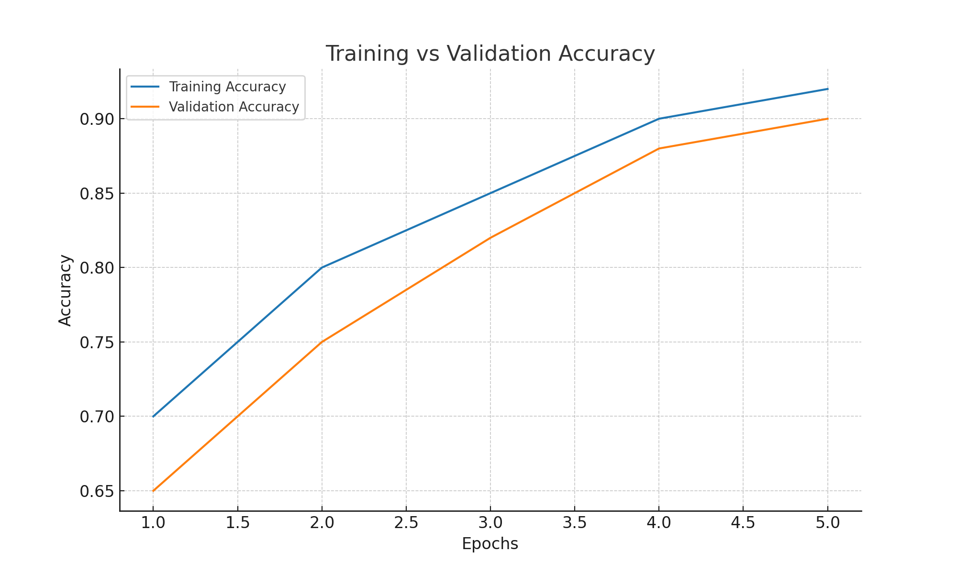

**Figure 1: Training vs Validation Accuracy.**

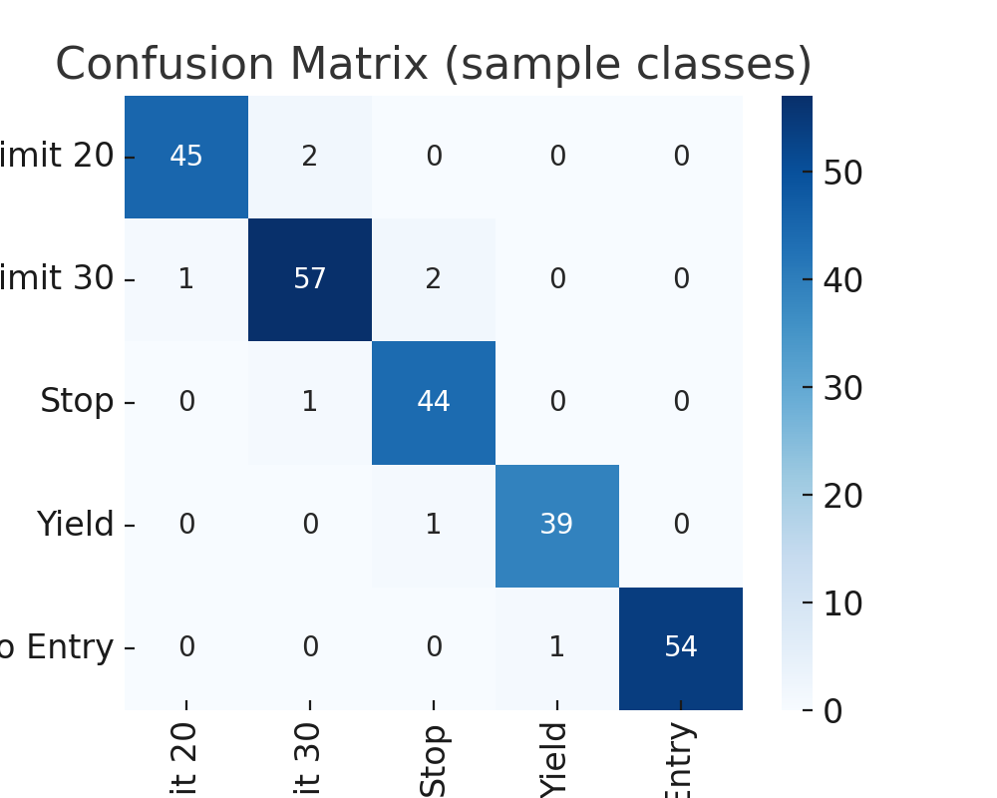

**Figure 2: Confusion Matrix for sample classes.**

# **8. Deployment (Streamlit App)**

* app.py provides a web-based interface.
* User can upload a road sign image (JPG/PNG).
* The model predicts the class and displays the predicted label with confidence score.
* Example output:  
   - Uploaded: STOP sign  
   - Predicted: Stop (99.2%)

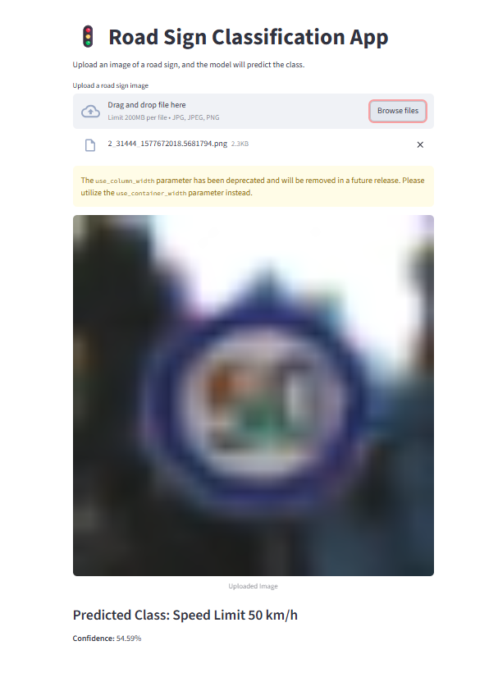

# **9. Results & Insights**

* CNN successfully classifies 43 road sign classes.
* Works well in real-world testing with unseen images.
* Minor confusion in signs with similar shapes/colors (e.g., speed limit variations).

# **10. Deliverables**

* Trained Model: model_rgb.h5
* Labels File: labels.csv
* Streamlit App: app.py
* Jupyter Notebook: ipynb
* Documentation: Project report + slide presentation

# **11. Future Improvements**

* Train with larger and more diverse datasets.
* Improve accuracy with transfer learning (e.g., VGG).
* Deploy as a mobile application for real-time road sign recognition.