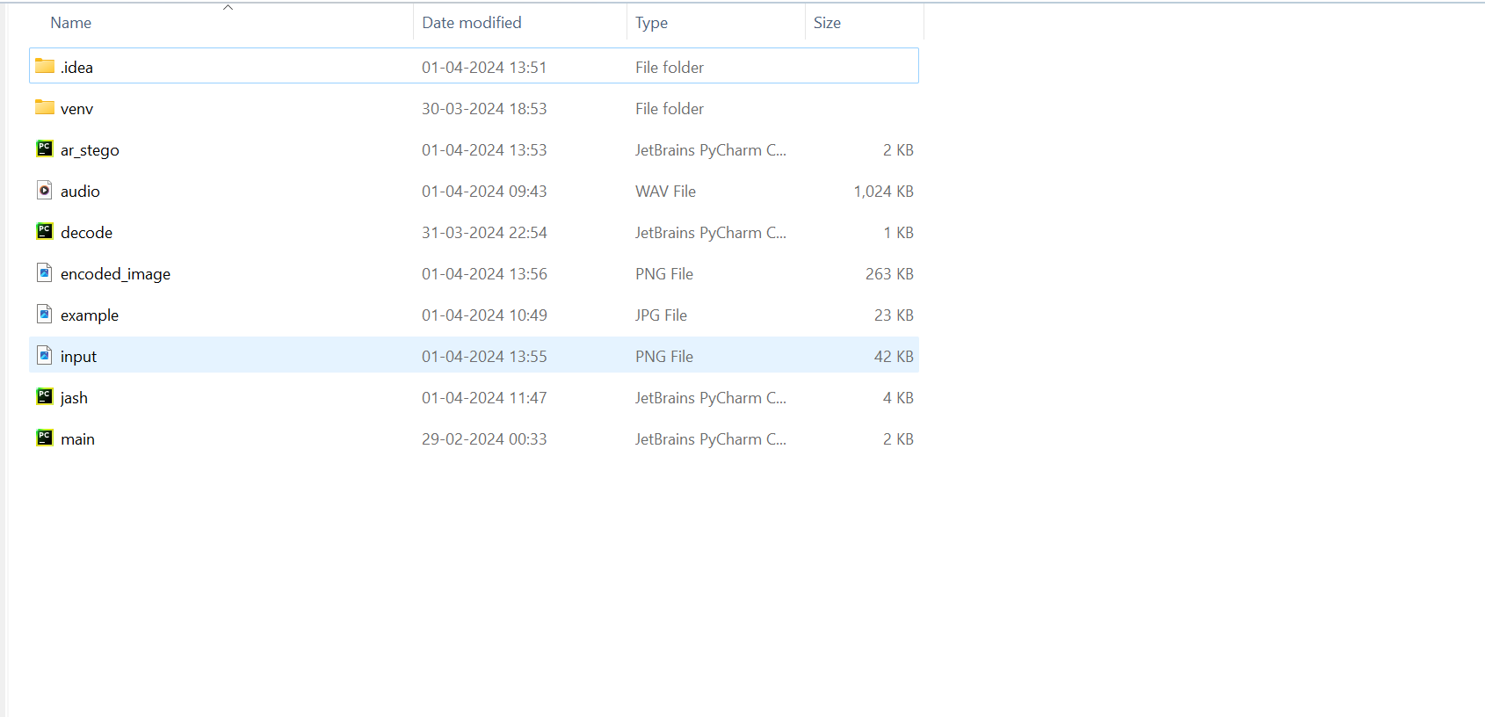After executing the stegno.py it will generate new image **encoded_image** file**.**

After that run the second file **“decode.py”** it will generate the secret message let us see the output screenshot below!

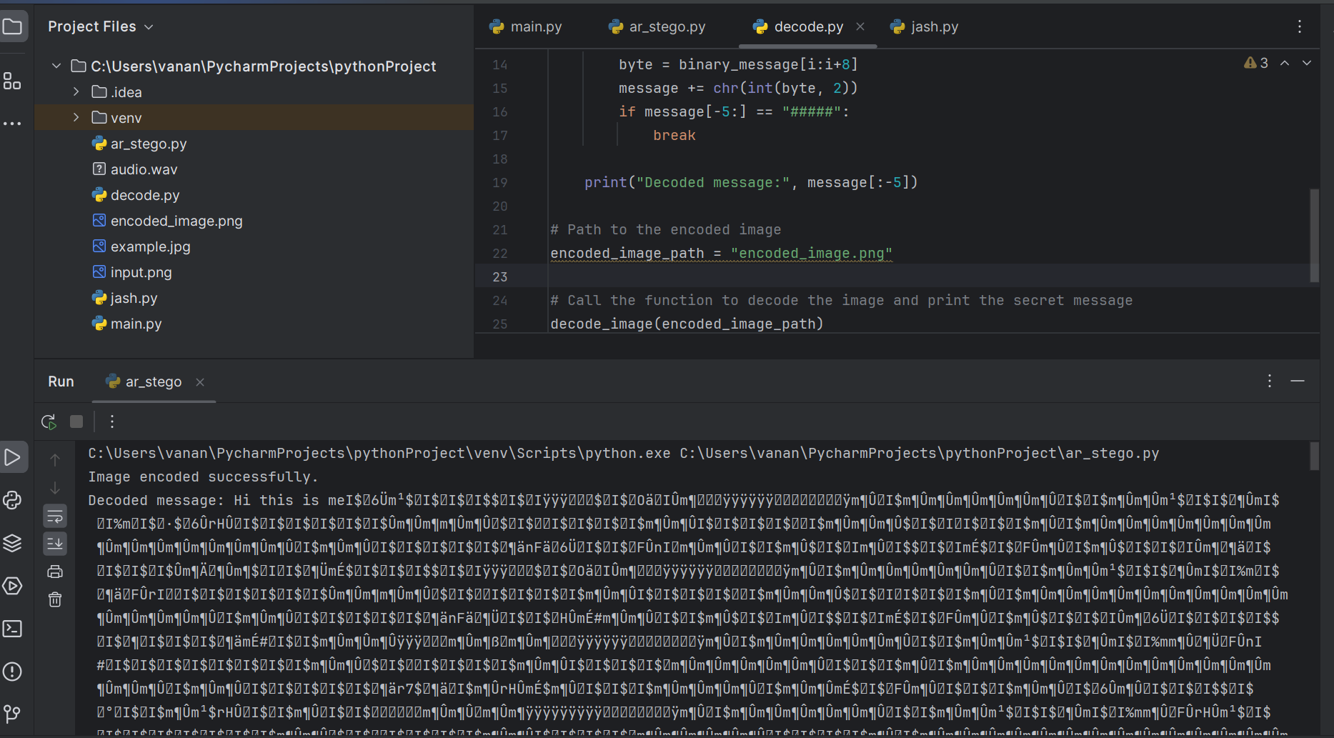

It shows the output **“Hi this is me”**