**ASSIGNMENT on APPLET**

**Q1.Write a program to create an applet which should display your name in the given below screen shot**

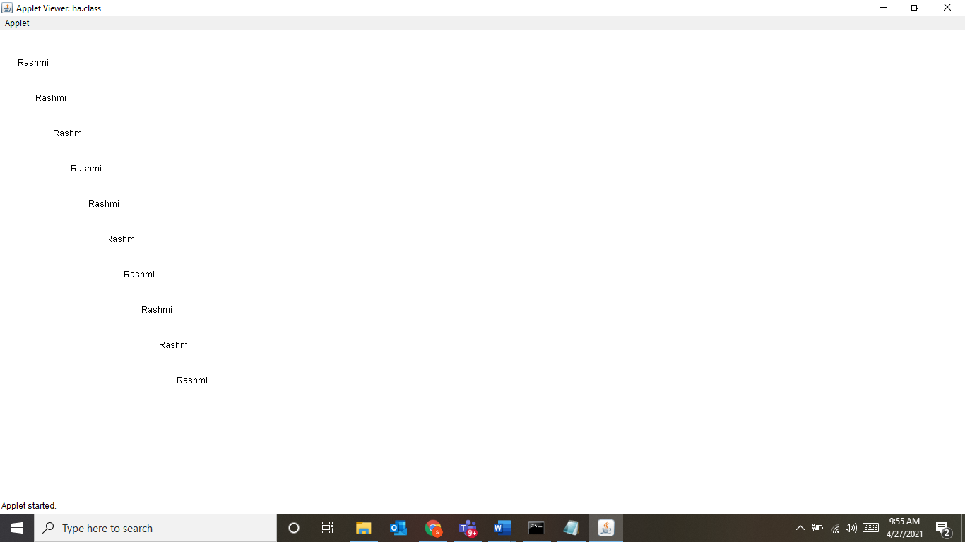

Q2. What are applets? Differentiate between applets and application

Q3. Explain the use of overriding the following methods for an applet

Init(), stop(),start(),paint(),destroy()