**Exercise 7D:** Running multiple containers using docker-compose

* N Anand (22BD1A6615)
* Createa new directory called ‘my_docker_project’ and create a docker-compose.yml in it. Paste the code into the file.

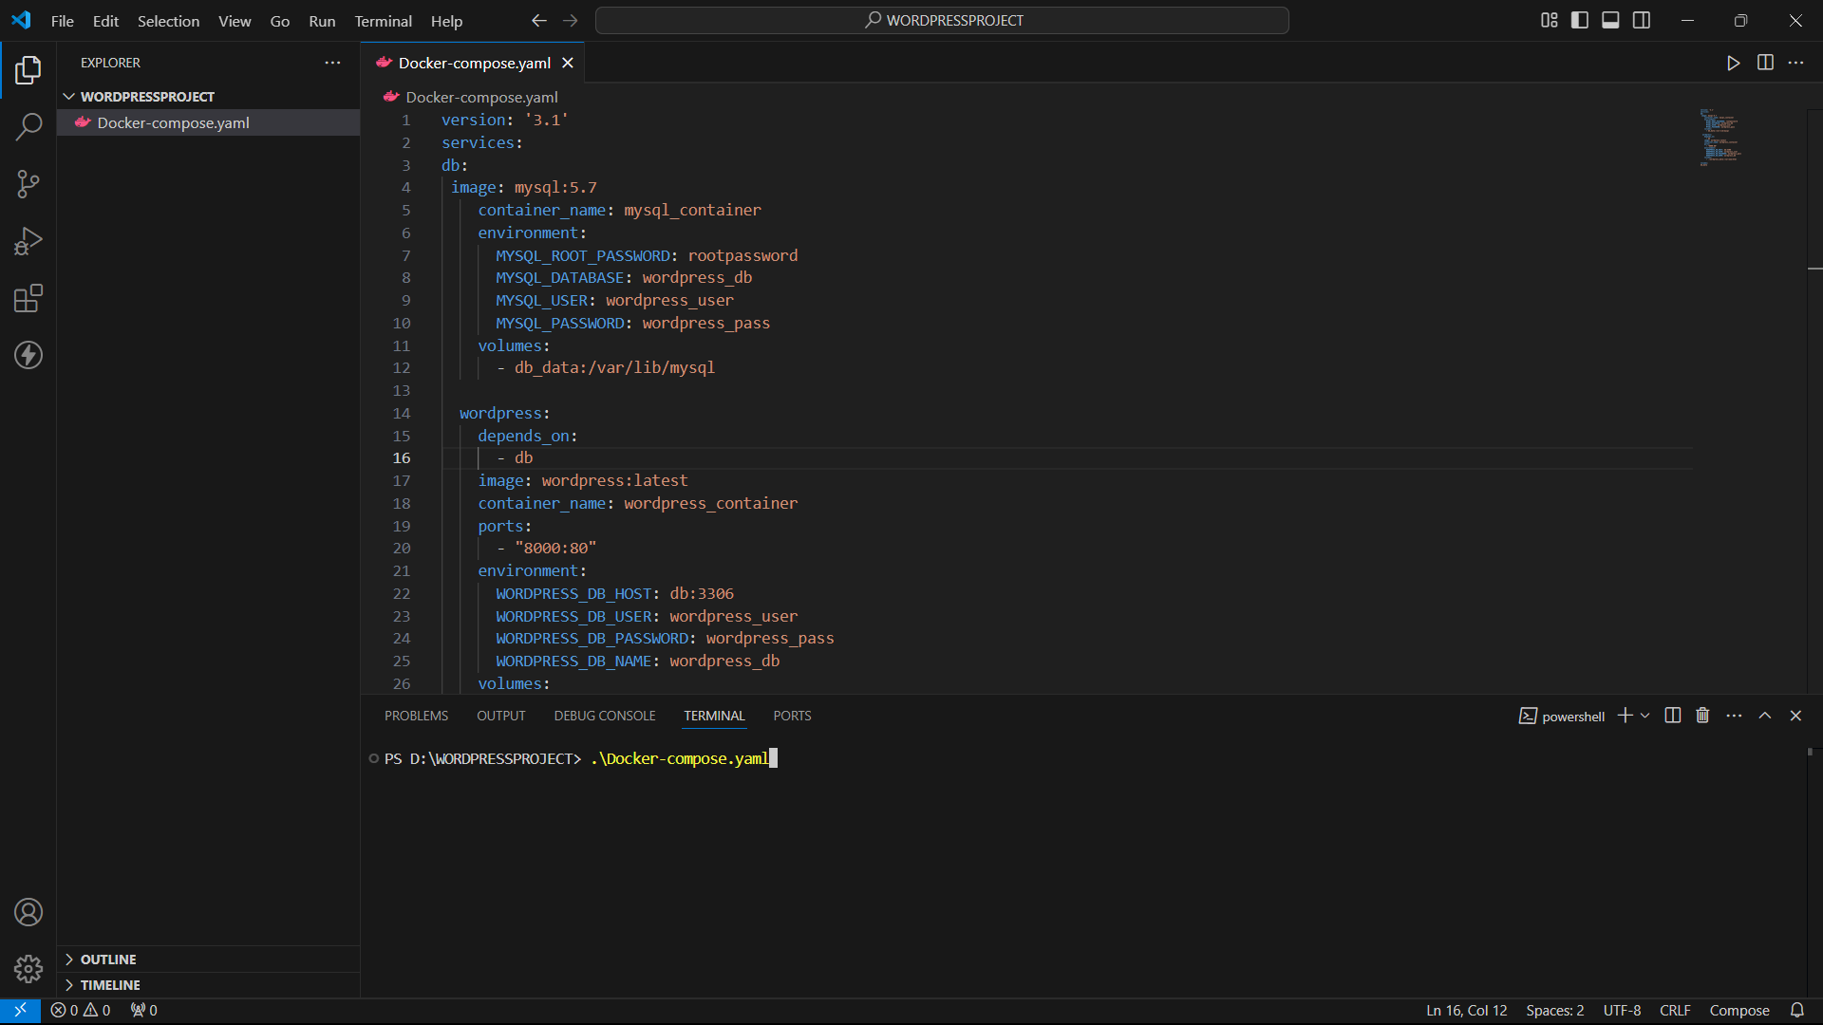

* Run ‘docker-compose up -d’ .

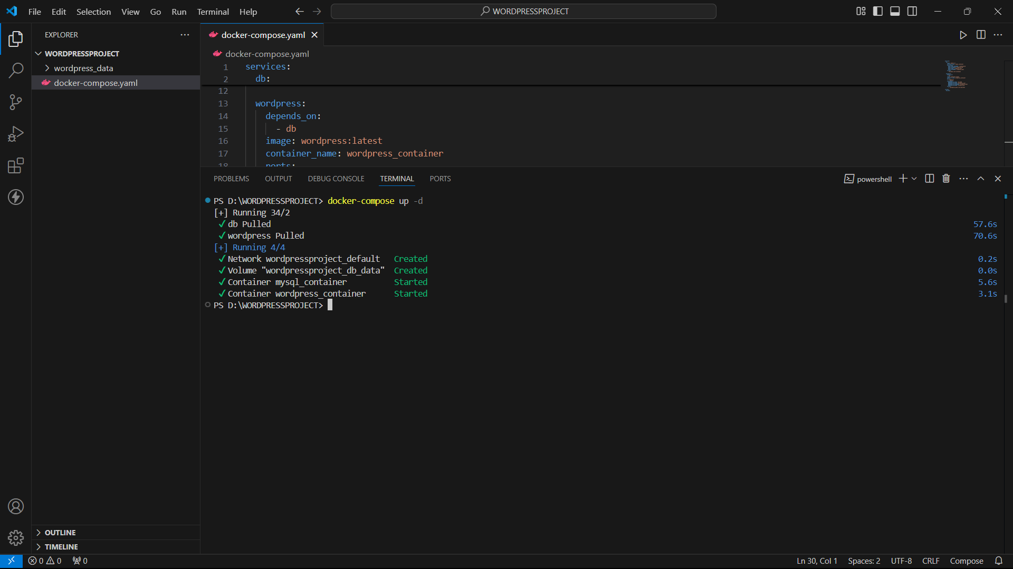

* Go to localhost:8000. You will see the wordpress intro screen. Enter details and log in. Enter name, password, email, site name.

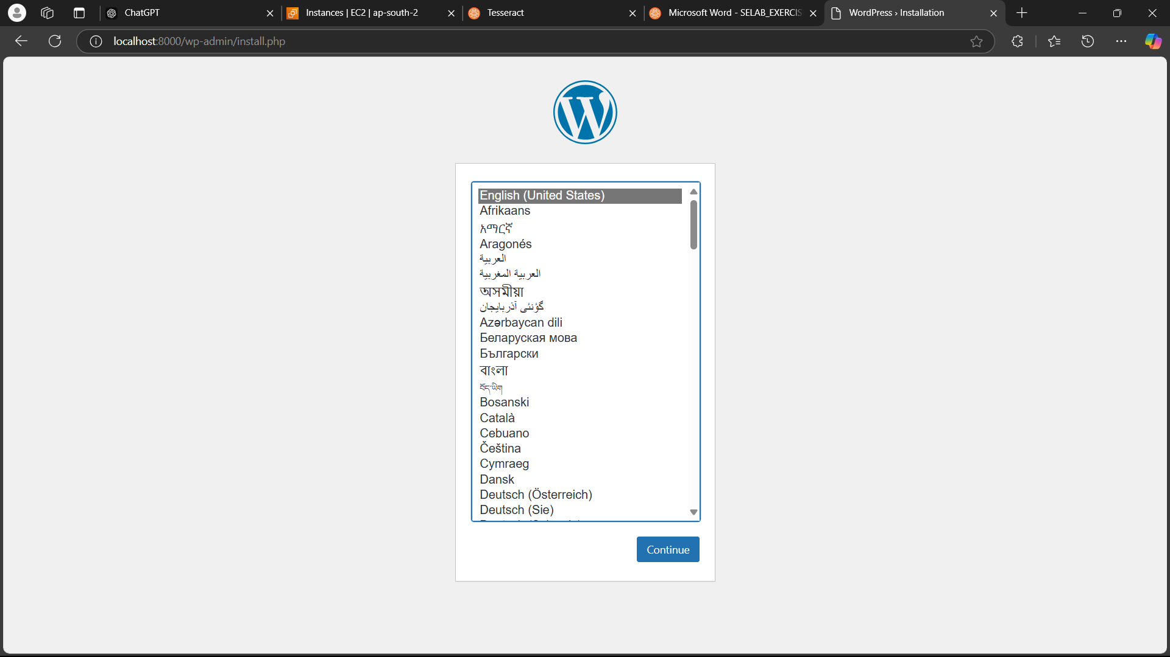

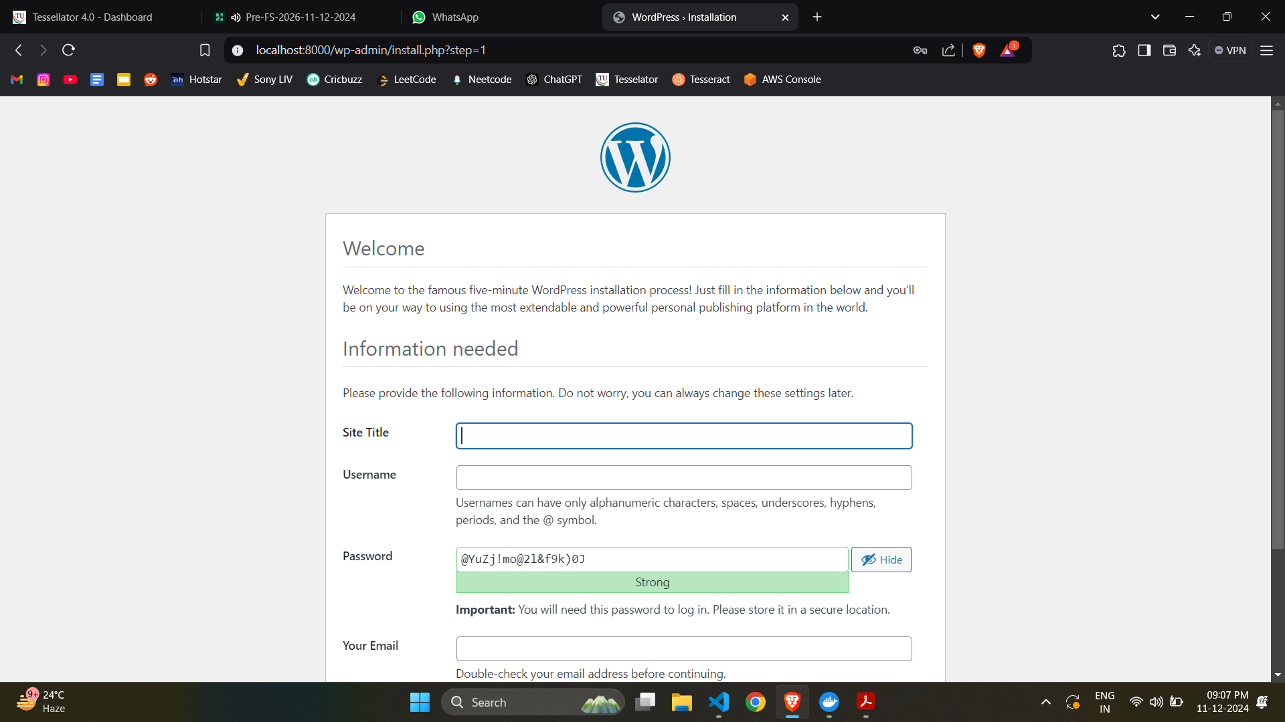

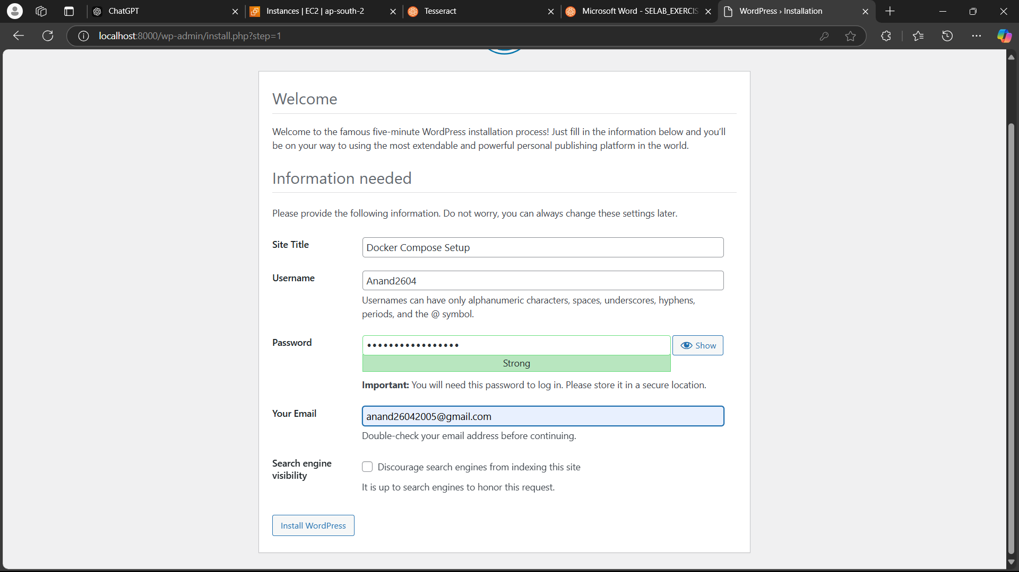

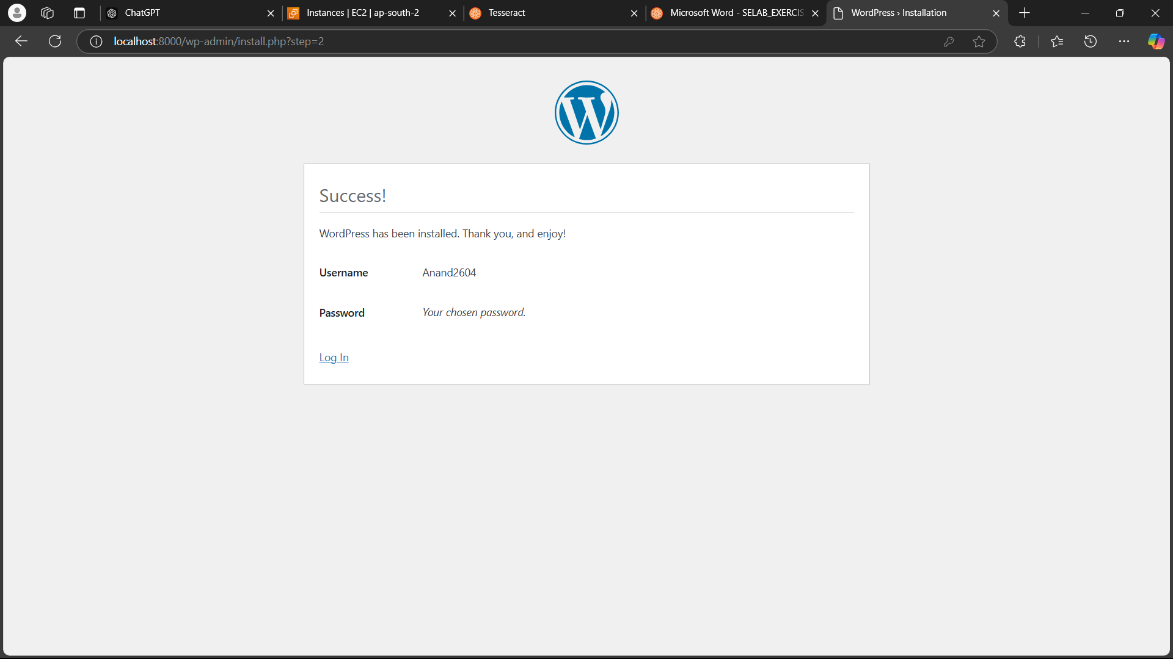

* Log in using the entered credentials.

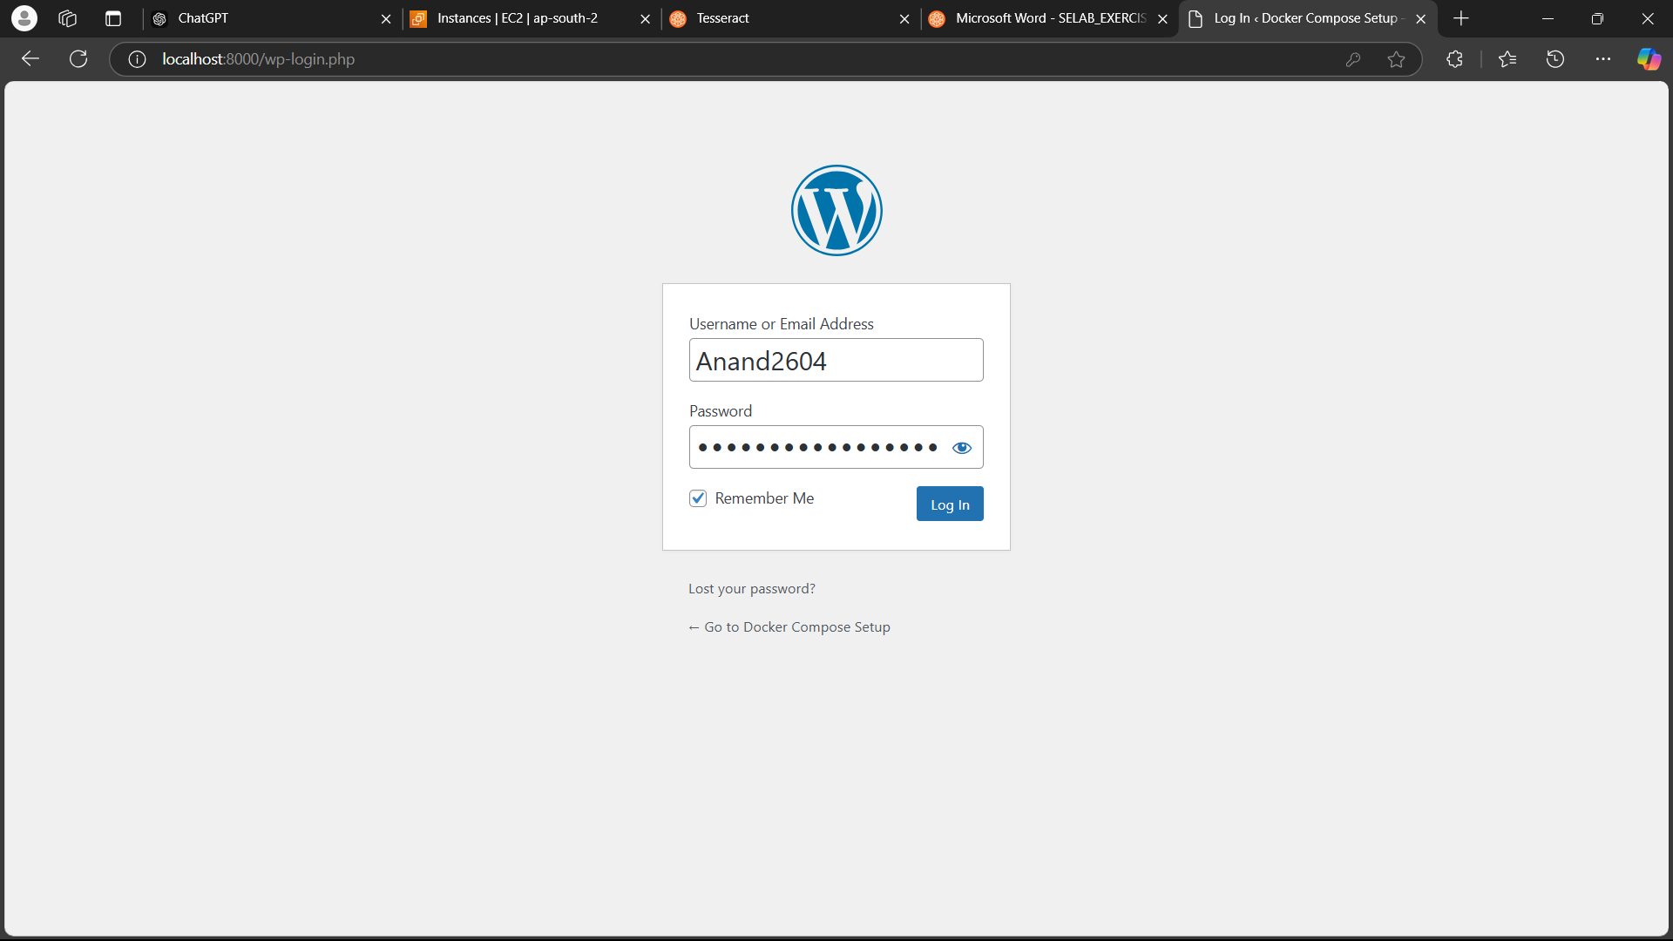

* You will see the hello-world screen.

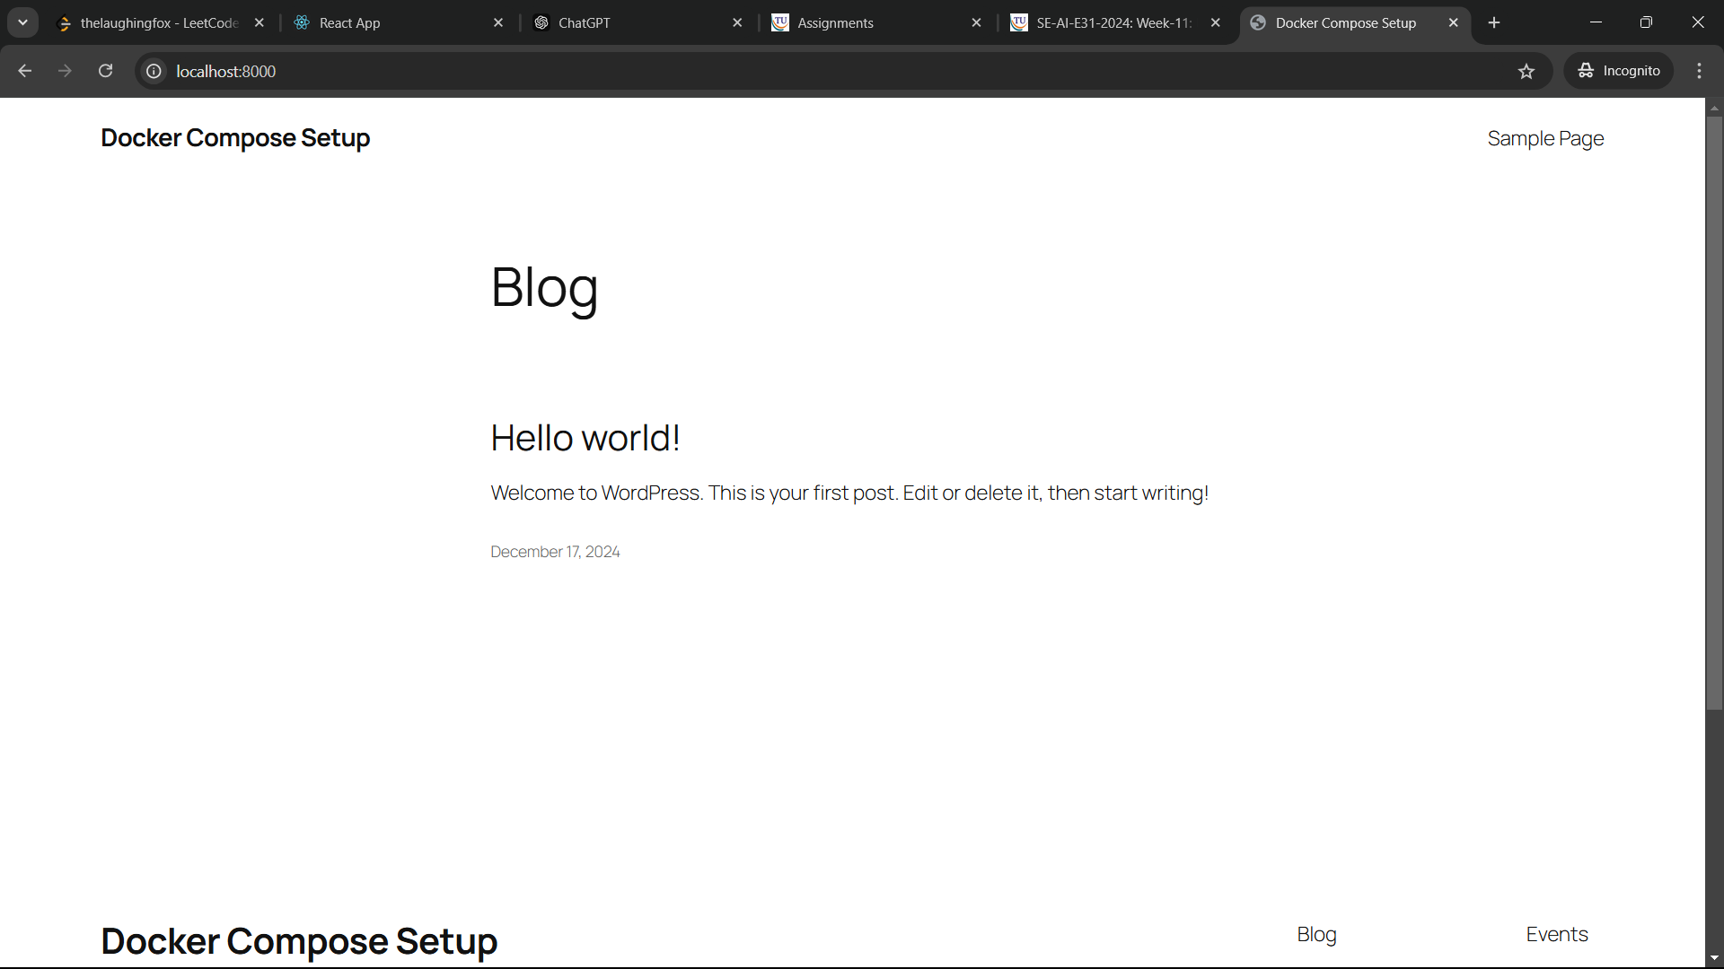

* Run docker-compose stop to stop the containers.

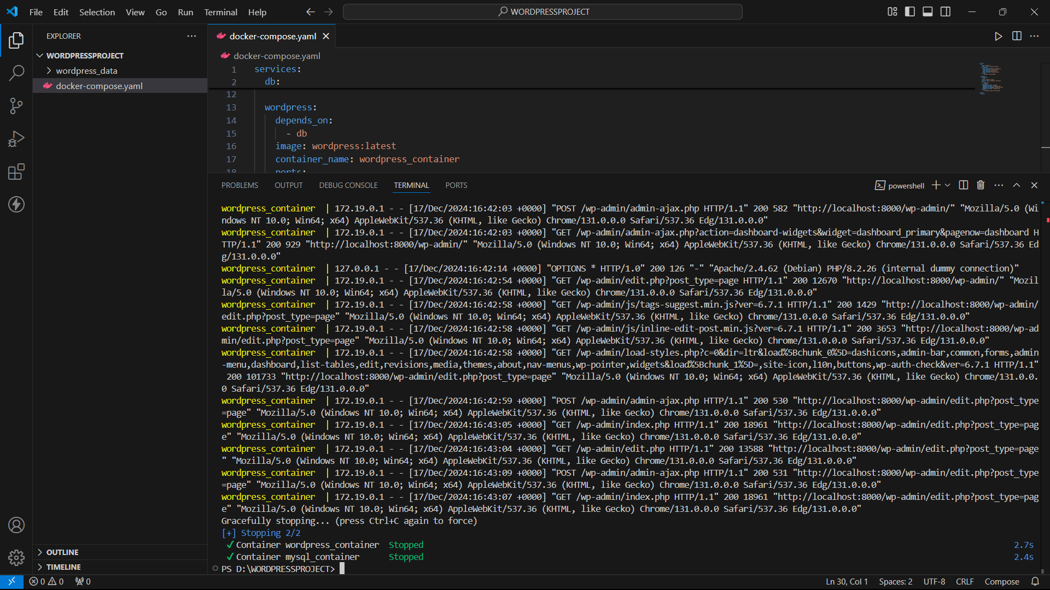

* You can use docker-compose start to start the containers again.

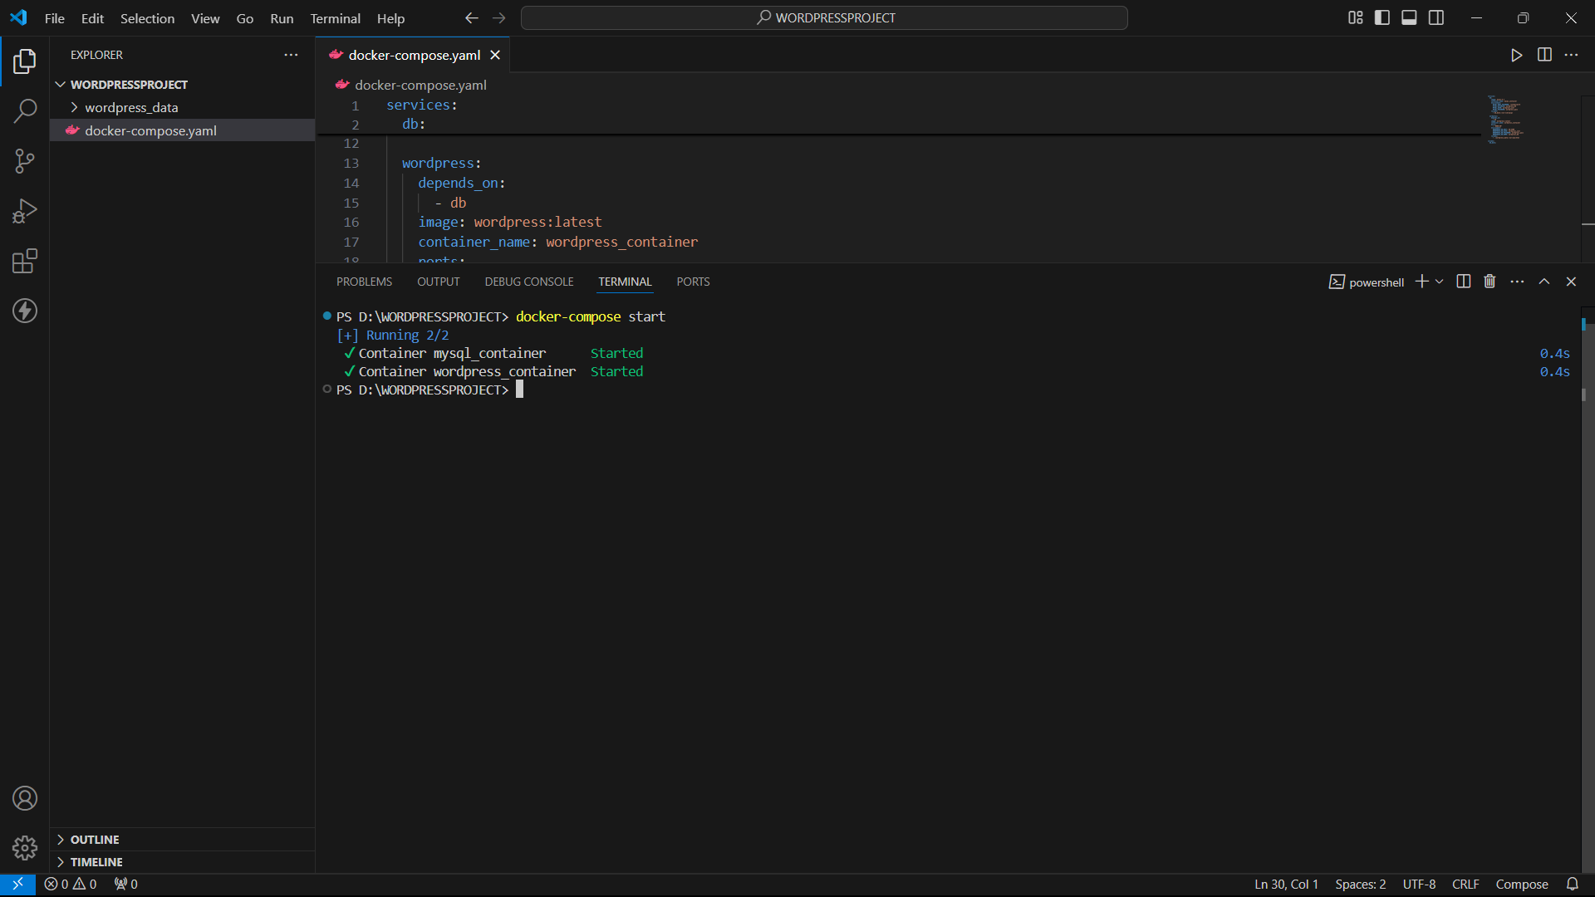

* Run docker-compose down to stop and remove everything.

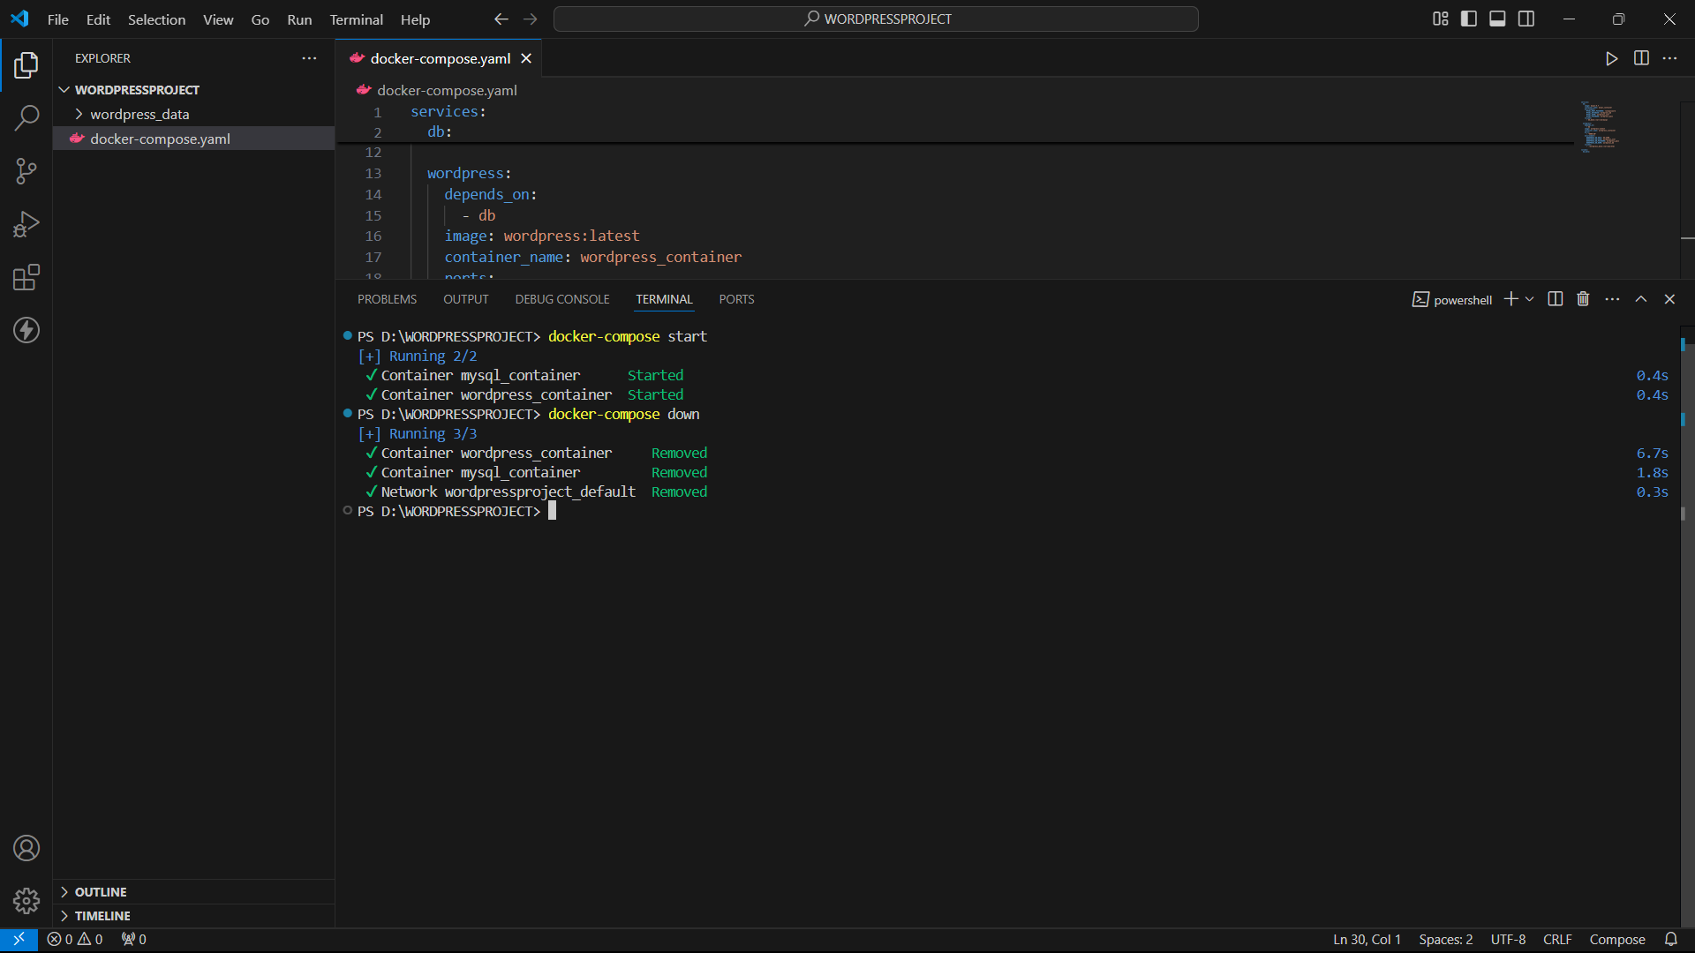

**Exercise 7E:** Deploying And Scaling Applications Using Minikube

* Start Minikube using “minikube start”.

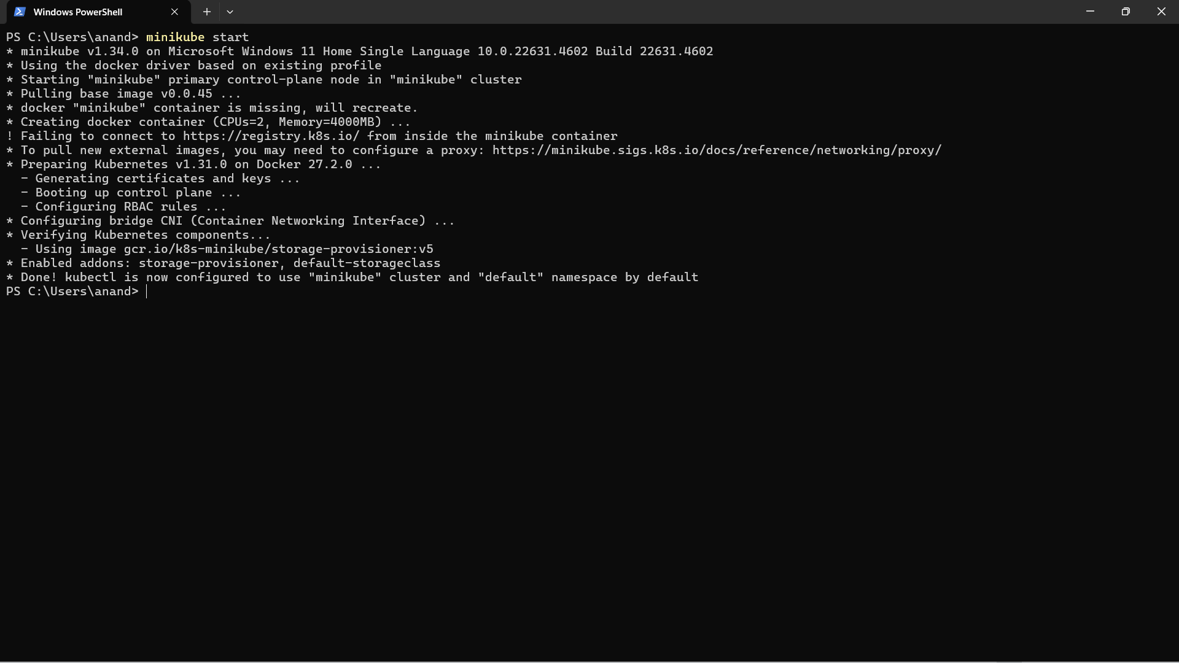

* Create the Nginx Deployment using the following command.

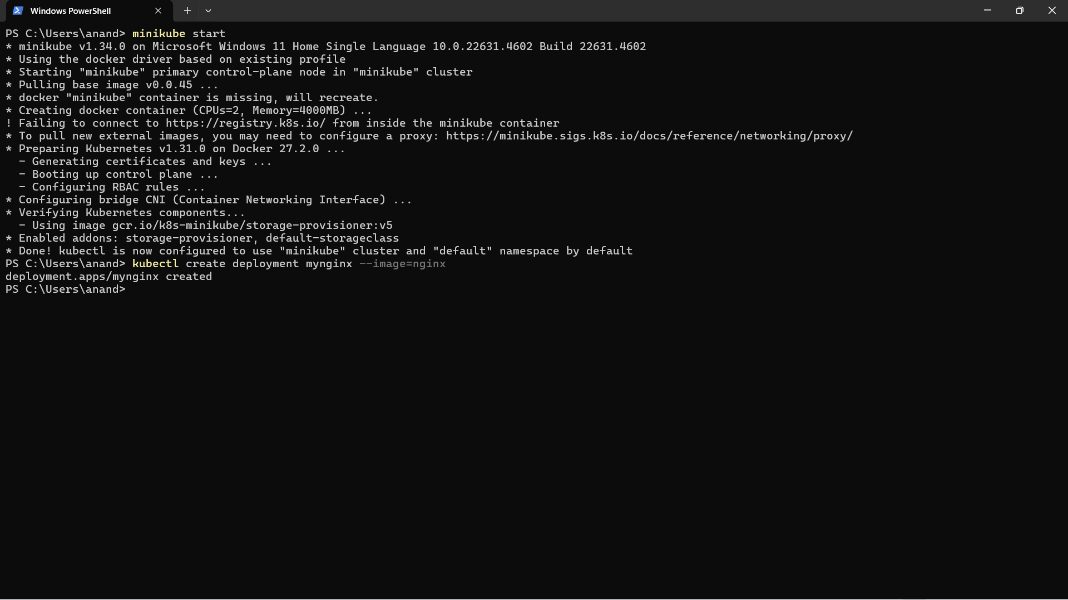

* Verify the deployment was created successfully.

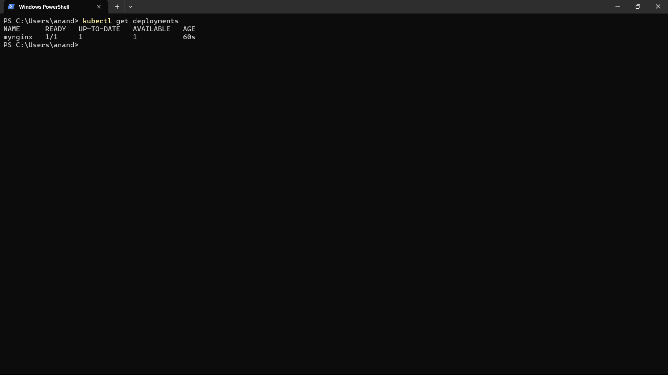

* Expose the Nginx Deployment to the Outside World using the following command.

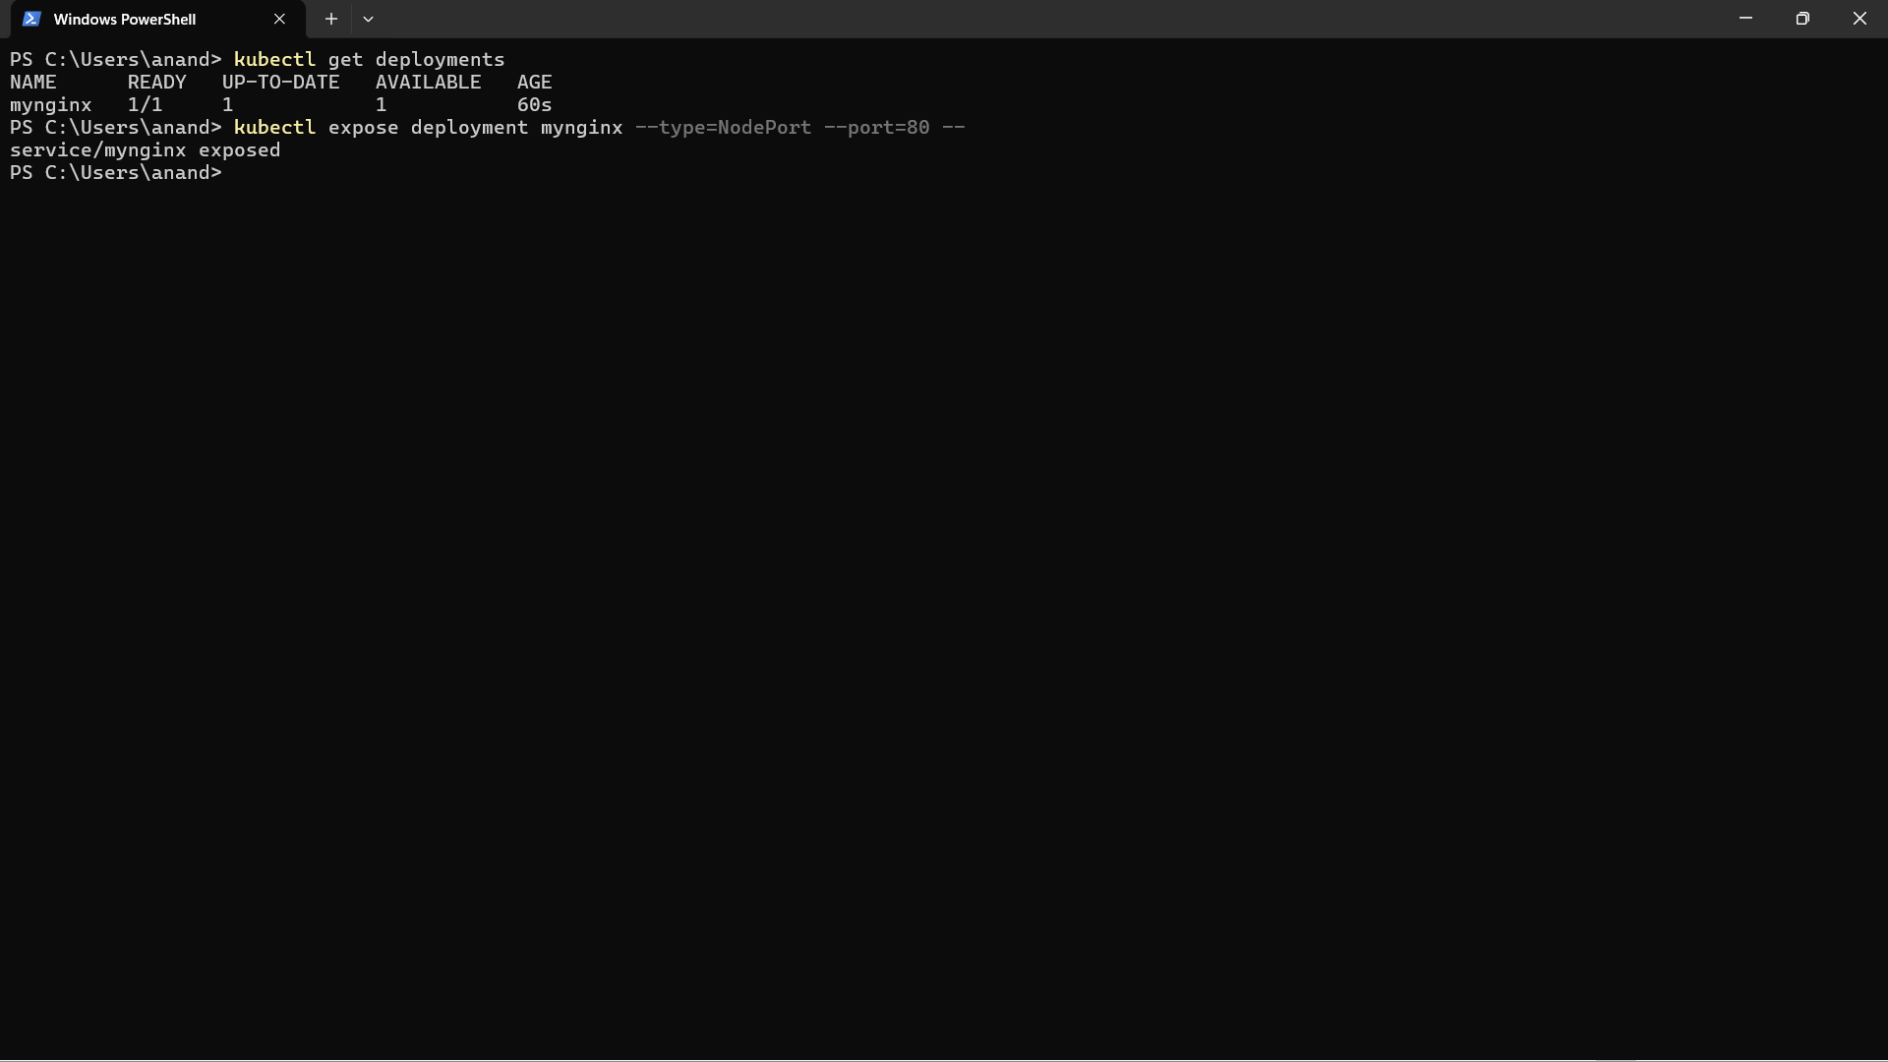

* Scale the deployment and make multiple copies using the following command.

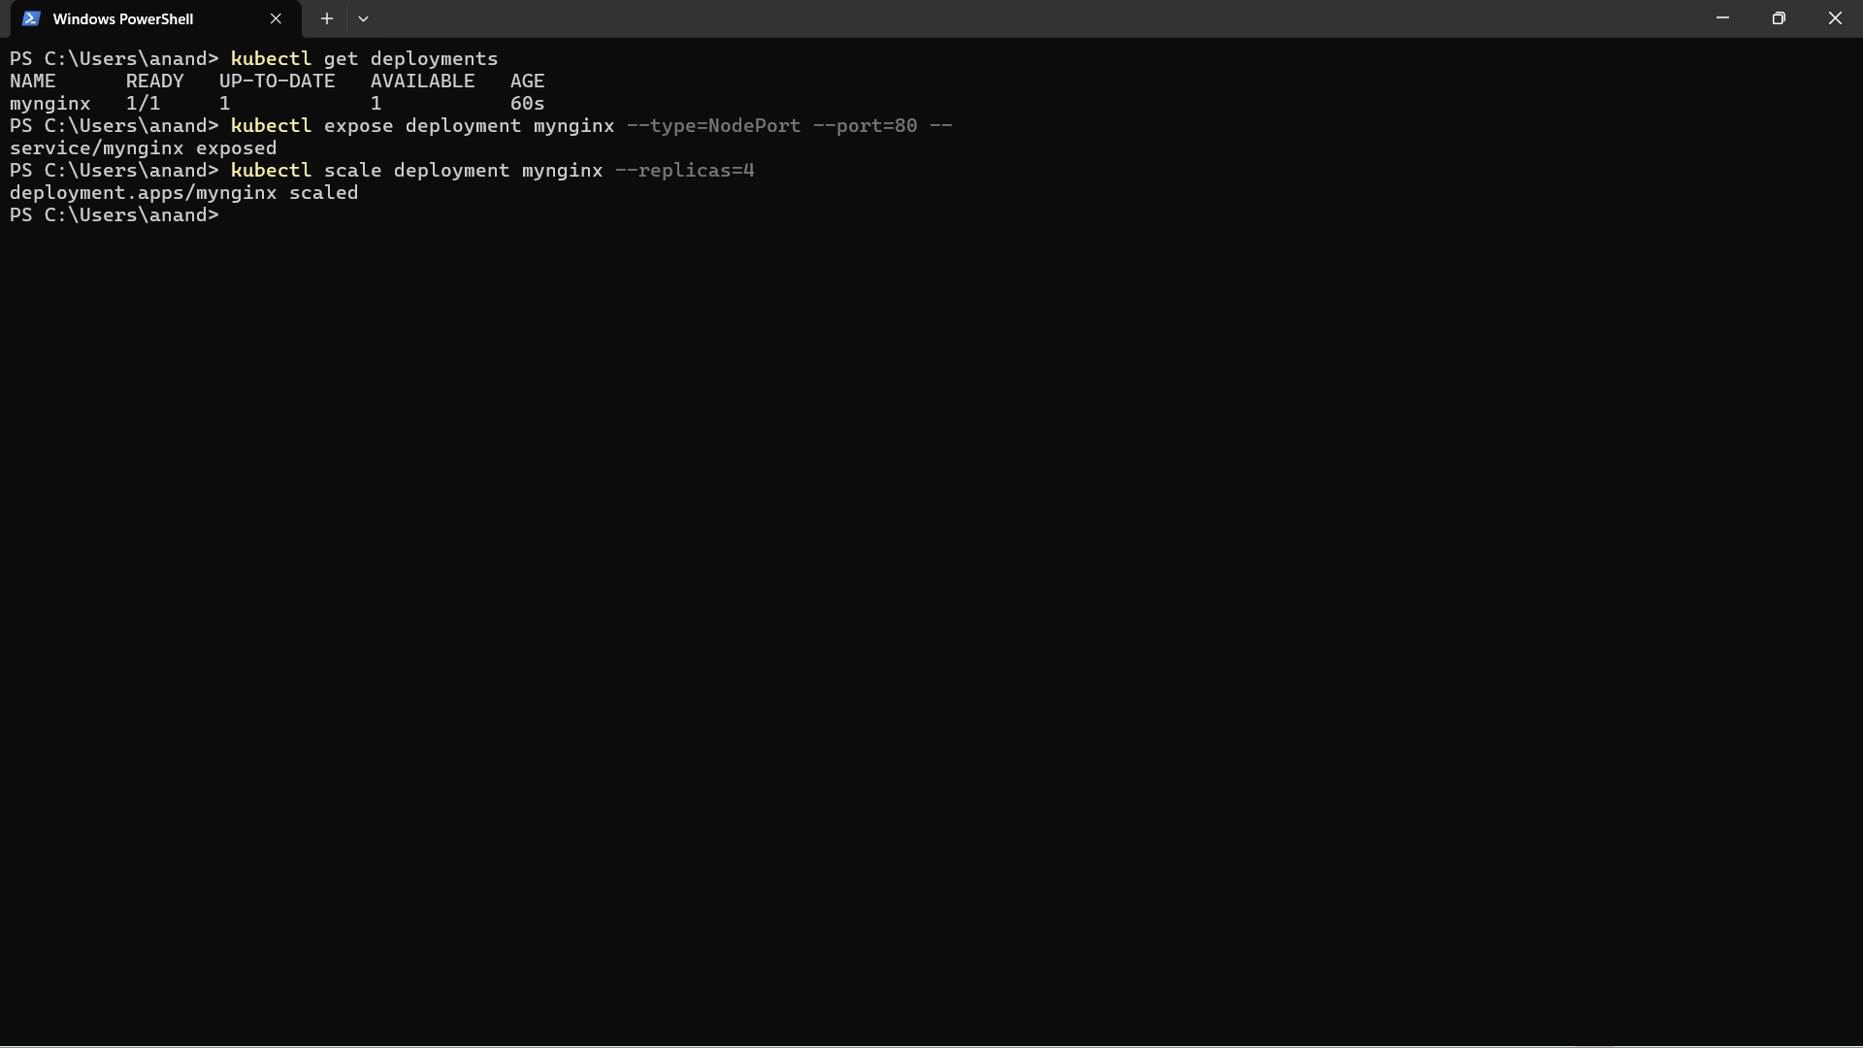

* Forward port 8081 on your local machine to port 80 inside the Nginx container using the following command. We can also using minkube tunnel alternatively:

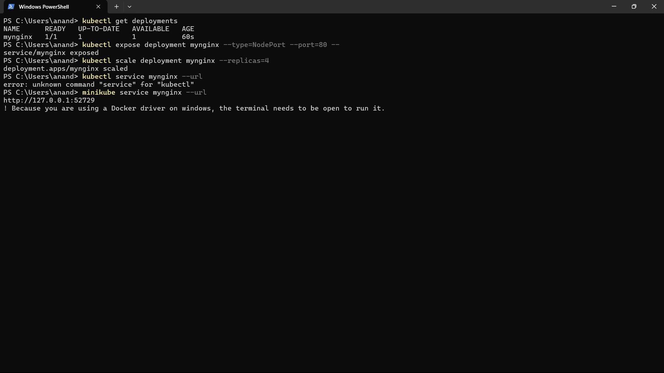

* Open the URL in the browser. You should see the nginx screen.

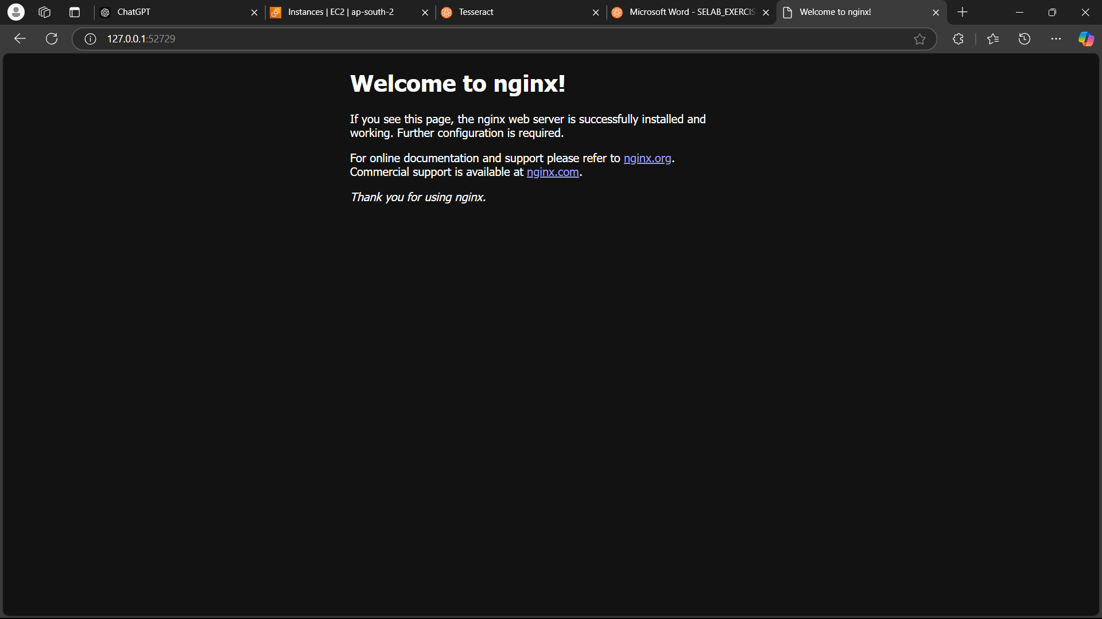

* Stop the nginx deployment and service:

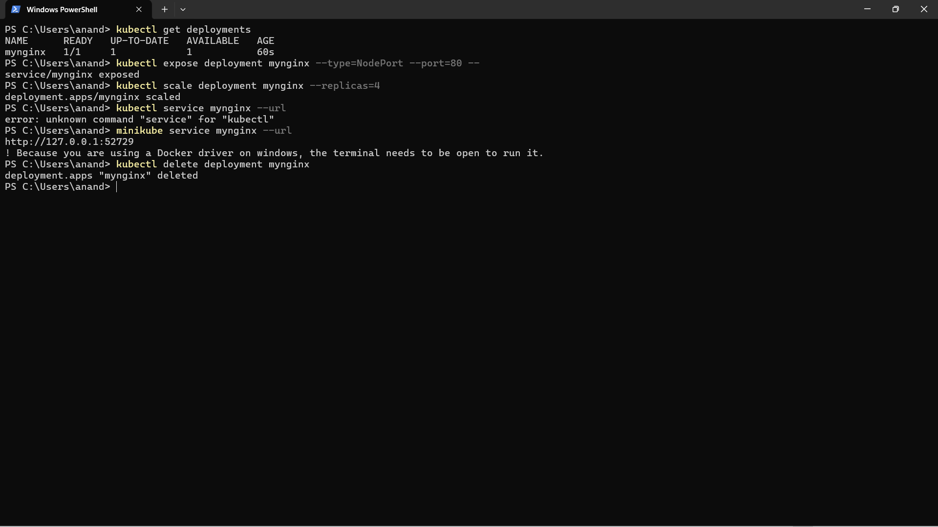

* Run ”minikube start” and “minikube delete” to stop minikube and delete everything.

