1.Open bitbucket.org and log in using our bit bucket office account.

2.After login the Bitbucket open like this,

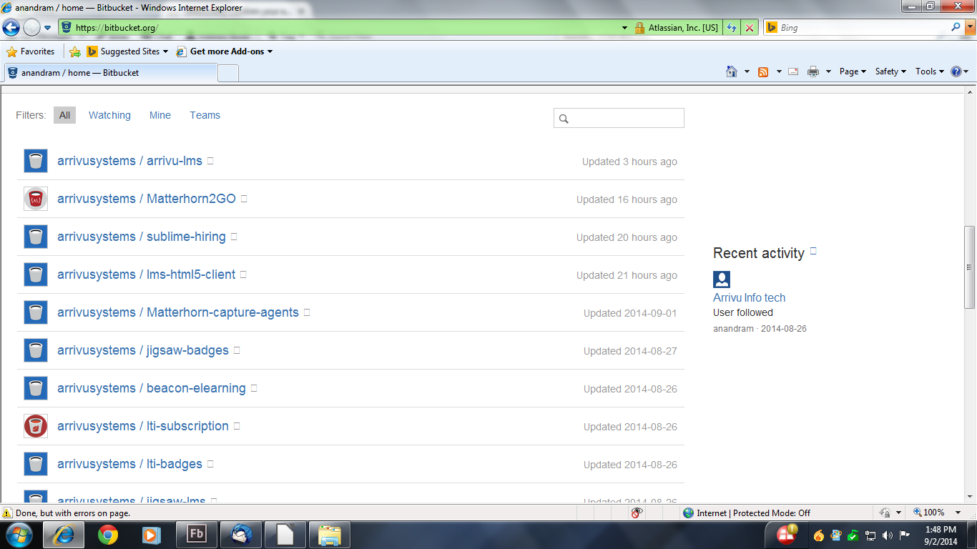
3.Select arrivusystems/Matterhorn2GO

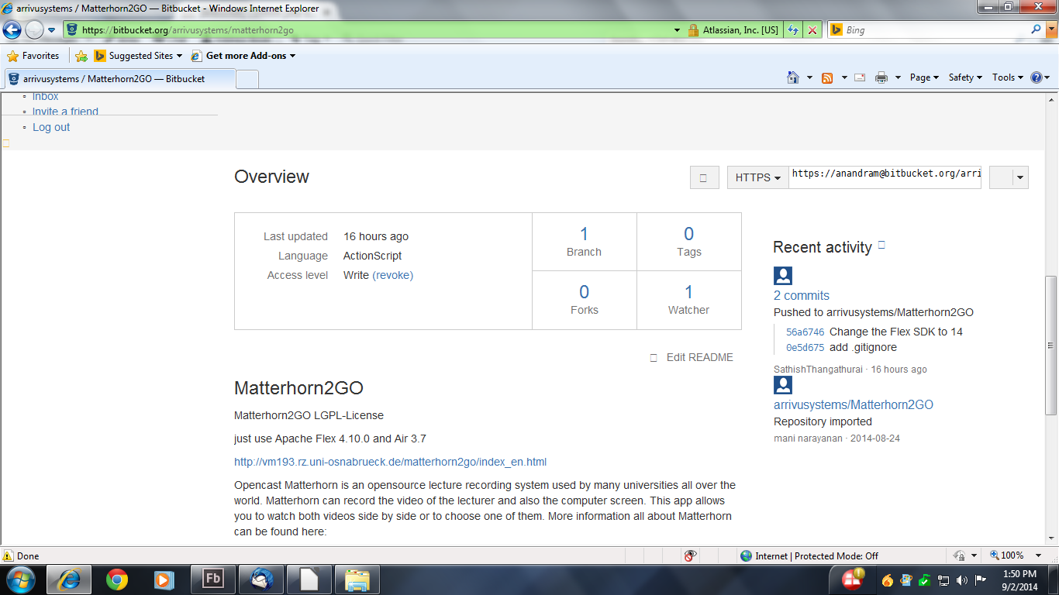
4.Create Environment workspace folder in your machine for example c:/Environment/workspace

5.Open GitBash from start menu and goto workspace drive and getting clone copy of Matterhorn2go
Module.

6. After Git Bash ask BitBucket password given your Office BitBucket account password and press enter and now you get clone copy of source code .

7.After cloning check the code to your workspace like c:/Enivronment/workspace

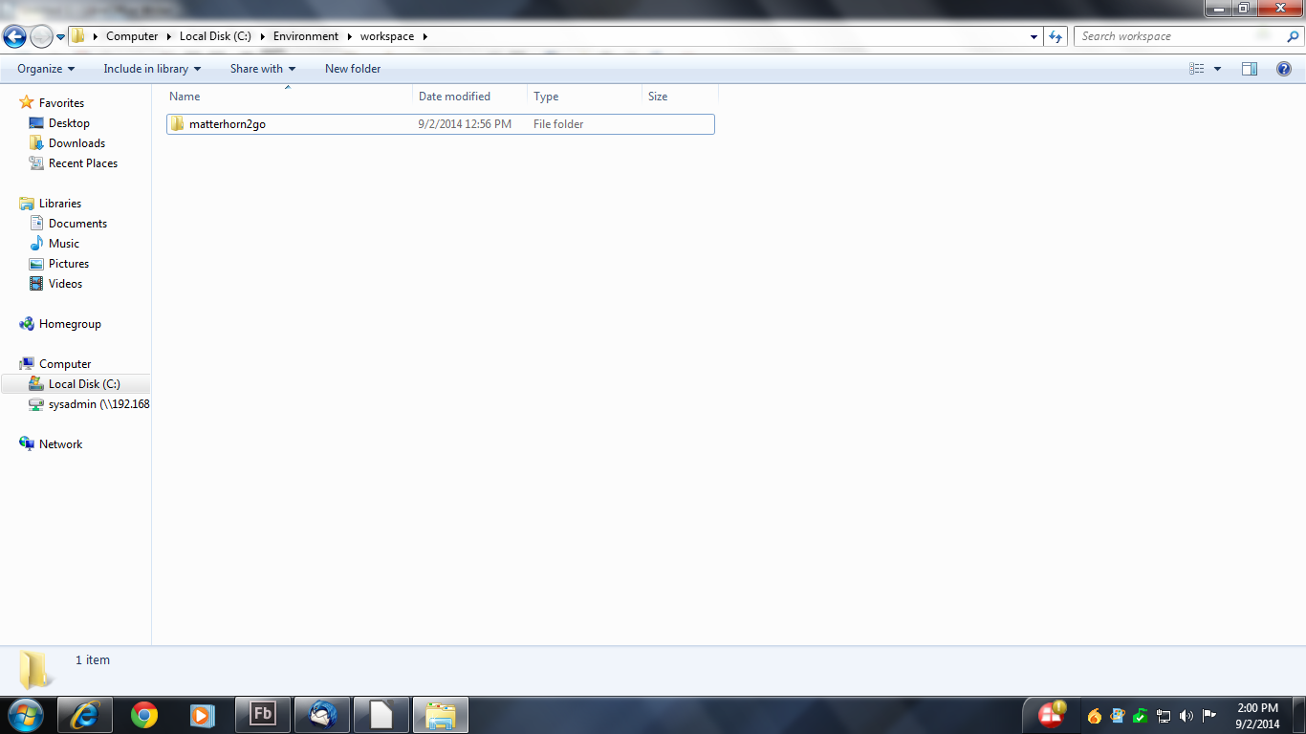
8.After click start menu and select Adobe Flash Builder.

9.After selection the page open like this,

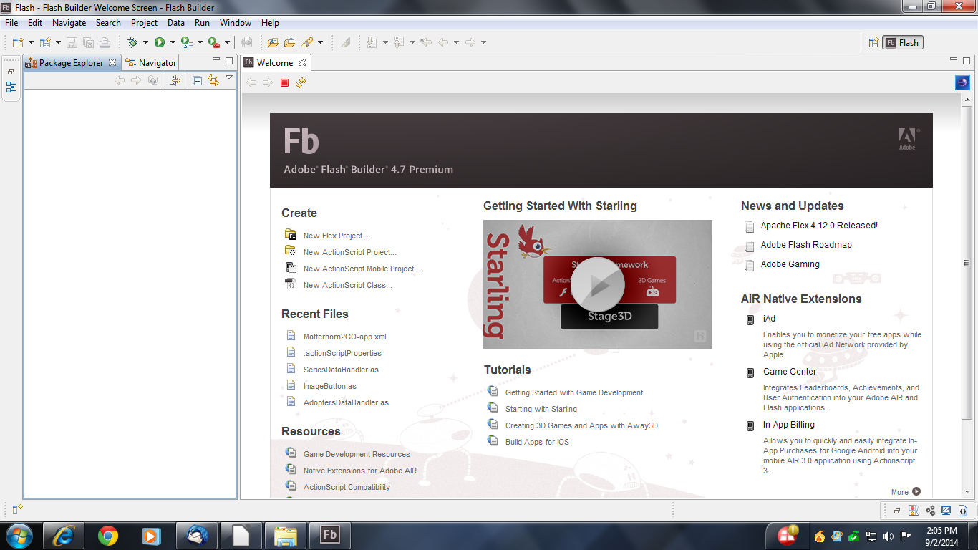

10.Then Right click and select import option one page is open like this,

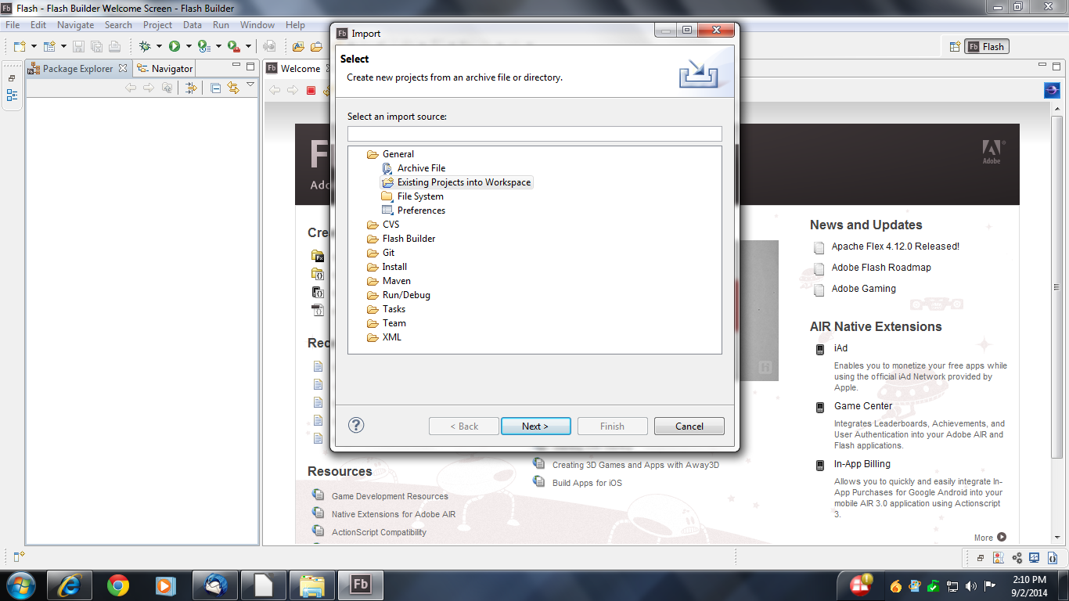
11.And select General → Existing Project into Work Space and click Next.

12.After click Next one window is open and select root directory(Select Your workspace module path a.e.Matterhorn2Go module path)

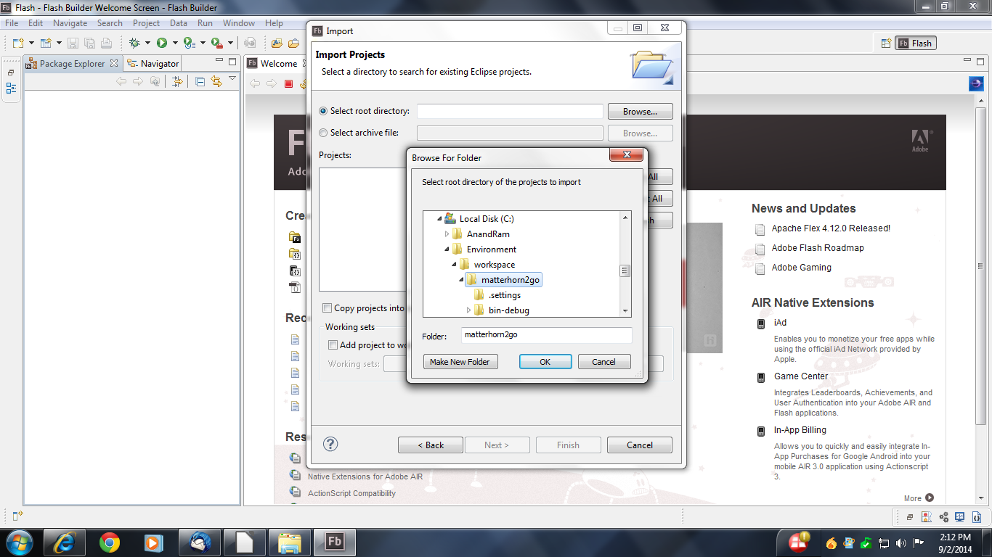

13.Click ok.

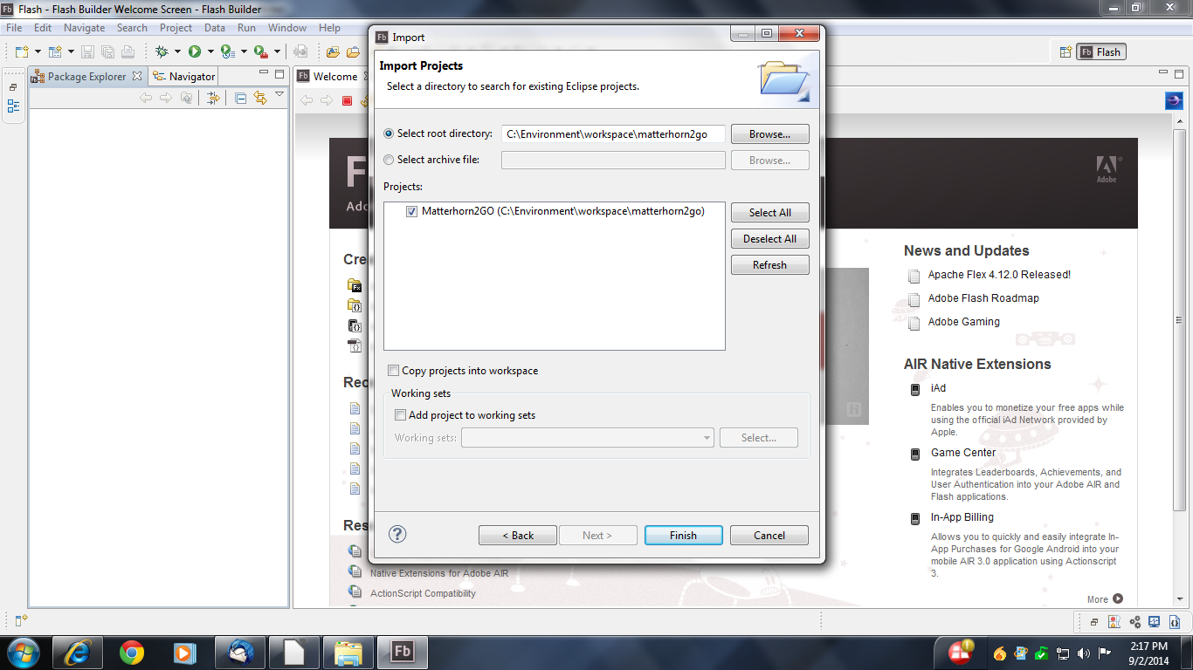
14.Select module and click Finish.

15.Matterhorn2go module is imported from workspace path.

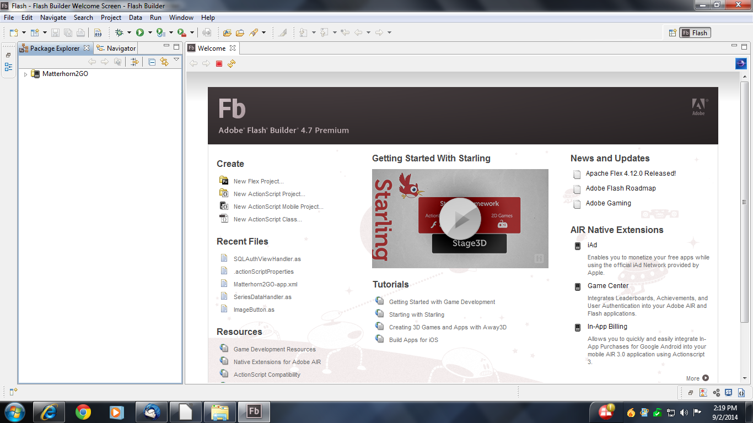

16.After that want to set SDK so Select module and Right Click → Flex Compiler and use a specific SDK and select SDK name from drop down box.

17.Open the actionScript.properties file and edit the Adobe Air swc library path a.e.Give Adobe Air installation directory path.

18.Then right click module and RunAs → MobileApplication

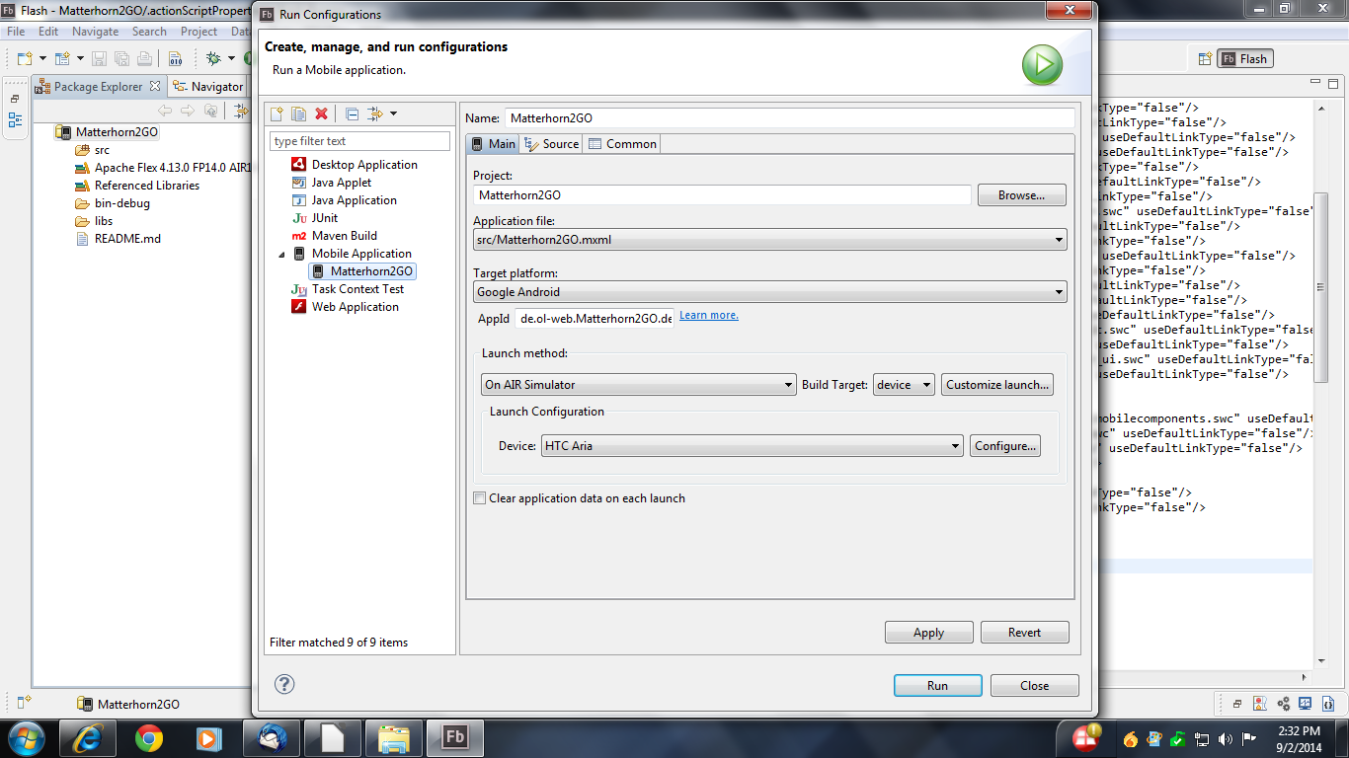
19.Select TargetPlatform,LaunchMethod and Device.After Selected click Apply and Run.

20.Now its given sample output.

