**A Mini Project Report**

**On**

**Parking Management System**

**Submitted By:**

Ashutosh Dash (A15)

&

Anand Desai (A10)

Academic Year: 2020 – 2021



Shree Chanakya Education Society

**Indira College of Commerce and Science, Pune**

**Vice Principal & (H.O.D) Guided By**

Prof. Shivendu Bhushan Prof. Shubhangi Chavan

and

Prof. Divya Chitre

**Index**

|  |  |  |  |
| --- | --- | --- | --- |
| **Sr.No** |  | **Particular** | **Page No.** |
| **A)** |  | **Introduction** | 4 - 7 |
|  | 1) | Title of Project | 4 |
|  | 2) | Existing System | 5 |
|  | 3) | Proposed System | 6 |
|  | 4) | Advantages of Proposed System | 6 |
|  | 5) | Feasibility Study | 7 |
|  | 6) | Hardware/Software Requirement | 7 |
| **B)** |  | **Analysis** | 8 - 12 |
|  | 1) | ERD | 8 |
|  | 2) | DFD | 9 |
|  | 3) | CLD | 10 |
|  | 4) | First Level DFD | 10 |
|  | 5) | File Design / Normalized database | 11 |
|  | 6) | Data Dictionary | 12 |
| **C)** |  | **Design** | 13 |
|  | 1) | Input screen (Without Data) | 13 |
|  | 2) | Input screen (With Data) | 13 |
| **D)** |  | **Code Design (Sample code)** | 14 - 16 |
| **E)** |  | **Limitations of System** | 17 |
| **H)** |  | **Bibliography** | 17 |

**Acknowledgement**

We would like to express our sincere and heartfelt gratitude to our institution” Indira College of Commerce and Science” which provided us with excellent opportunity to achieve our most cherished goal in life to become Bachelor degree in BCA(Science)

We are extremely grateful to our respected Vice Principal and HOD Prof. Shivendu Bhushan for providing excellent academic environment which has made this endeavour possible.

We take this opportunity to express our deep sense of gratitude to our guides Prof. Shubhangi Chavan and Prof. Divya Chitre for their resplendent idea and constant encouragement in making this project unmitigated success. Their thoughtfulness and understanding was vast and thoroughly helpful in successful completion of project. Our sincere thanks to all our faculties and non-teaching staff for their at most co-operation.

Finally we proudly thank our parents and friends for their constant support and priceless guidance in throughout this endeavour.

Ashutosh Dash

Anand Desai

# **Introduction**

Parking management system for managing the records of the incoming and outgoing vehicles in a parking space. It’s an easy way for some employees to retrieve the data if the vehicle user has been visited through a number then they can get that data.

Nowadays in many public places such as malls, multiplex systems, hospitals, offices, market areas there is a crucial problem of vehicle parking. The vehicle parking area has many lanes/spots for car parking. So to park a vehicle one has to look for all the lanes. Moreover, this involves a lot of manual labour and investment. Instead of the vehicle caught in towing the vehicle can park on safety and security at a low cost.

The parking control system has been generated in such a way that it is filled with many secure devices such as parking control gates, toll gates, time and attendance machine, car counting system etc. These features are hereby very necessary nowadays to secure your car and also to evaluate the fee structure for every vehicle’s entry and exit The objective of this project is to build a Vehicle Parking management system that

enables the time management and control of vehicles using number plate recognition.

The system will track the entry and exit of cars, maintain a listing of cars within the

parking lot, and determine if the parking lot is full or not. It will determine the cost of per vehicle according to their time.

# **Existing System**

In the existing system, a vehicle owner used to drive his/her vehicle into a parking area of a public place like a mall, etc. There an employee used to be present whose job was to give a ticket to the customer and collect the required amount from the customer when leaving the premise. Although computers are used in such a system but, the contribution is very little as it is needed. Not only it results in tedious work handling, but we also face human errors. In order to address such issues, we need a new system which not only works primarily under automation but also helps in keeping a record of each and every parking to ensure the completion of transactions on time.

In some parts of the world, a smart parking system has been introduced where an incoming vehicle’s number plate gets scanned by the scanner present in the gate. After getting scanned, the details of the owner of the vehicle gets displayed on the display in front of the gate. The computerized system will assign an available parking spot. But, here also the mode of cashless payment is mostly absent along with a feature of advanced booking.

This report is based on personal observations made by us during our casual visits in such public places in various metropolitan cities like Pune, Bengaluru, Delhi, etc. The report threw light towards certain urgent issues raised by this existing system.

# **Disadvantages of Existing System**

1. Since, the transaction process is carried out by a human, often it is observed that there are numerous mistakes made by them in events like calculating change.

2. Due to increasing traffic, there is an insufficiency of parking spots in most of the places and hence, it becomes increasingly difficult for humans to manage the parking spaces.

3. Nowadays, there is a demand of cashless payments but, such technology has not been fully available in this sector yet.

# **Proposed System**

The aim of our proposed system is to develop a system which like the existing 'Smart Parking System', provides a computerized parking system along with a feature called as 'Advanced Parking Booking'. A customer will go to their preferred wallet app. Then, he/she will click on our system's icon to get to our webpage. On clicking the icon, a login page will get opened where the user has to provide their credentials to log in to their account. In case, the user is not an existing member, an option for creating an account will also be available.

After logging in, the user will enter into a booking page where he/she will book for parking by filling certain fields like city, mall, start date and time, end date, and time. The system will automatically detect the mode of payment (wallet) by tracking how the user visited the webpage.

The system will then generate an online receipt confirming the booking. On reaching the end time, the user will receive a notification regarding it and will provide an option to continue by paying an extra amount based on per hour rate.

# **Advantages of Proposed System**

1. It provides a hassle-free method to book parking in advance.

2. Even in the case of on-spot parking, the feature of cashless payment along with cash payment is available near the 'OUT' gate with a QR Code display, a total amount display, and an employee for collecting cash, if cash method is chosen.

# **Feasibility Study**

## **Econmical Feasible:**

**Economic feasibility attempts to weigh the cost of developing and implementing a new system,**

**against the benefits that would accurate from having the new system in place. A simple economic analysis that gives the actual comparison of costs and benefits is much more meaningful in this case. In addition, this proves to be a useful point of reference to compare actual costs as the project progresses. There could be various types of benefits of account of parking automation. These could include increased customer satisfaction, improved accuracy of operation, better documentation and record-keeping, faster retrieval of information.**

## **Operational Feasible:**

**Operational feasibility is a measure of how well a proposed system solves the problems. It reviews the willingness of the organization to support the proposed system. Adopting the automated parking management system will maximize efficiency of the parking system and services and it also improves users and clients experience and satisfaction. Automated parking management system would will share real time parking information to clients and users.**

## **Technical Feasible:**

Technical feasibility considers the technical requirements of the proposed automated system. The current technical resources(hardware, software, etc.) need to be updated and added according to the proposed system requirements. This involves financial considerations to accommodate technical enhancements.

# **Software and Hardware Requirements**

|  |  |
| --- | --- |
| **Software Requirement** | |
| Operating System | Microsoft Windows |
| **Software** | |
| Front - End Software | HTML, Bootstrap (enhanced CSS), JavaScript |
| Back - End Software | Oracle 10G |
| **Hardware Requirement** | |
| Processor | Intel Core i3 1.80GHz |
| Ram | 2GB or More |
| Monitor | LCD monitor |
| Keyboard | Normal keyboard |
| Mouse | Compatible mouse |

**Analysis**

# **Entity Relationship Diagram (ERD)**

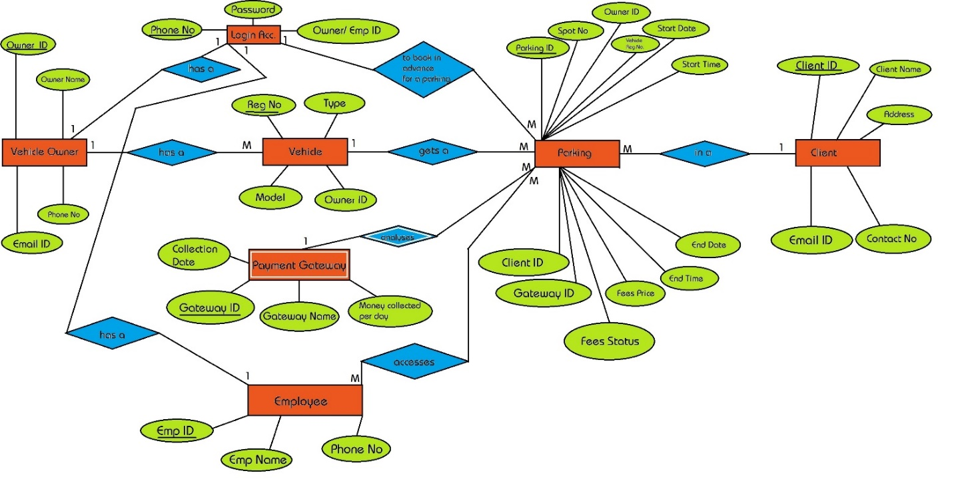

# **Data Flow Diagram (DFD)**

## **CONTEXT LEVEL DIAGRAM**

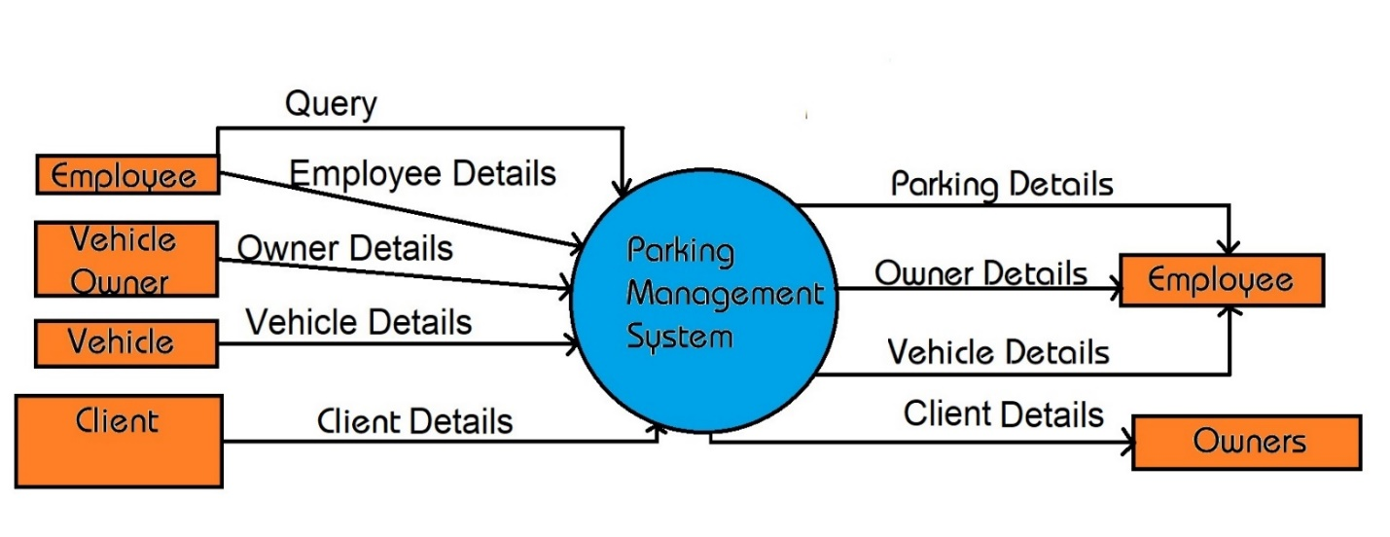

## **FIRST LEVEL DIAGRAM**

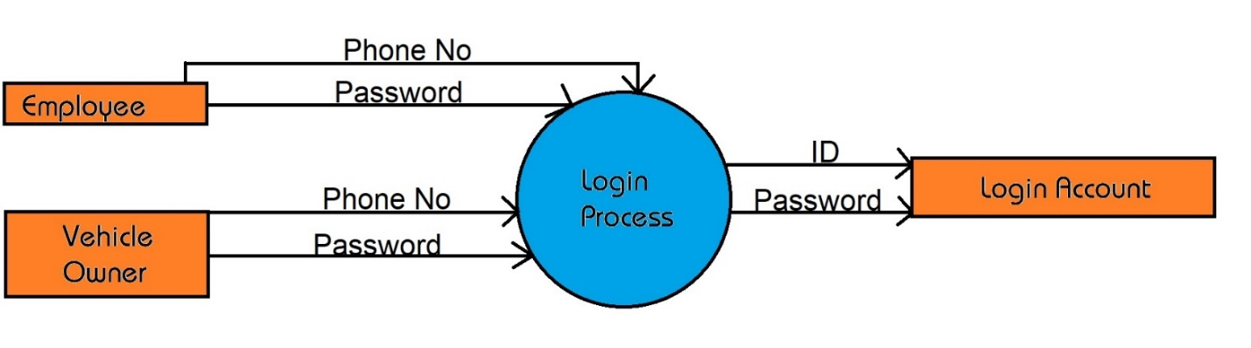

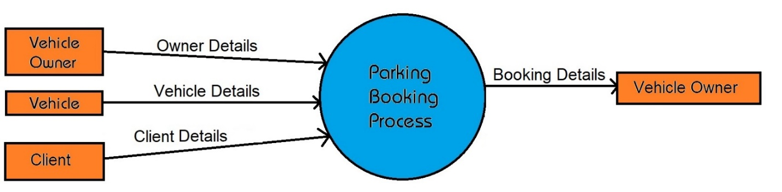

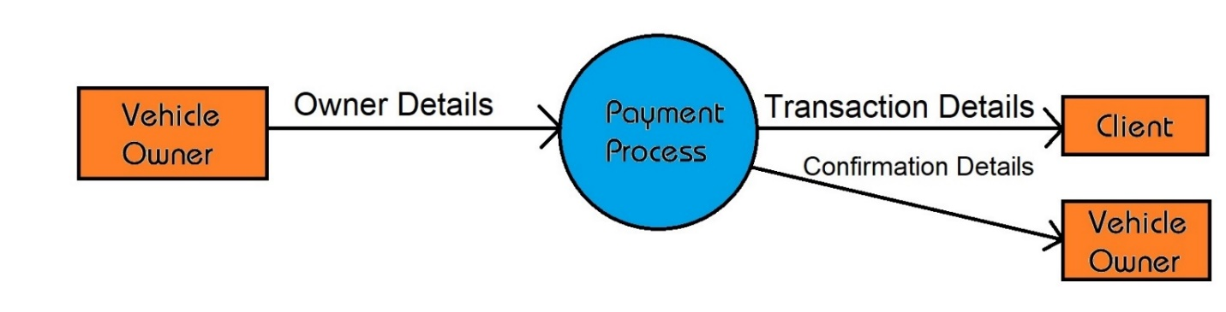

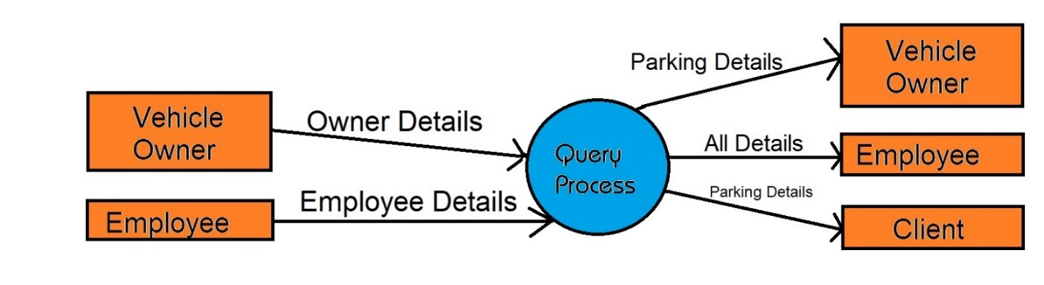

# **File Design/ Normalized Database**

## **Table Name: Employee**

|  |  |  |  |  |
| --- | --- | --- | --- | --- |
| Sr. No. | Fields Name | Datatype | Width | Constraint |
| 1 | Emp_ID | Varchar2 | 8 | Primary Key |
| 2 | Emp_Name | Varchar2 | 30 | Not Null |
| 3 | Phone_No | Number | 10 | Not Null |

## **Table Name: Vehicle_Owner**

|  |  |  |  |  |
| --- | --- | --- | --- | --- |
| Sr. No. | Fields Name | Datatype | Width | Constraint |
| 1 | Owner_ID | Varchar2 | 8 | Primary Key |
| 2 | Owner_Name | Varchar2 | 30 | Not Null |
| 3 | Phone_No | Number | 10 | Not Null |
| 4 | Email_ID | Varchar2 | 20 | Not Null |

## **Table Name: Login**

|  |  |  |  |  |
| --- | --- | --- | --- | --- |
| Sr. No. | Fields Name | Datatype | Width | Constraint |
| 1 | Phone_No | Number | 10 | Primary Key |
| 2 | Password | Varchar2 | 20 | Not Null |
| 3 | ID | Varchar2 | 8 | Not Null |

## **Table Name: Vehicle**

|  |  |  |  |  |
| --- | --- | --- | --- | --- |
| Sr. No. | Fields Name | Datatype | Width | Constraint |
| 1 | Reg_No | Varchar2 | 20 | Primary Key |
| 2 | Type | Varchar2 | 10 | Not Null |
| 3 | Model | Varchar2 | 10 | Not Null |
| 4 | Owner_ID | Varchar2 | 8 | Foreign Key |

## **Table Name: Payment_Gateway**

|  |  |  |  |  |
| --- | --- | --- | --- | --- |
| Sr. No. | Fields Name | Datatype | Width | Constraint |
| 1 | Gateway_ID | Varchar2 | 8 | Primary Key |
| 2 | Gateway_Name | Varchar2 | 10 | Not Null |
| 3 | Collection_Perday | Number | 10 | Not Null |
| 4 | Collection_Date | Date | - | Not Null |

## **Table Name: Client**

|  |  |  |  |  |
| --- | --- | --- | --- | --- |
| Sr. No. | Fields Name | Datatype | Width | Constraint |
| 1 | Client_ID | Varchar | 8 | Primary Key |
| 2 | Client_Name | Varchar2 | 10 | Not Null |
| 3 | Address | Varchar2 | 150 | Not Null |
| 4 | Contact_No | Number | 10 | Not Null |
| 5 | Email_ID | Varchar2 | 20 | Not Null |

## **Table Name: Parking**

|  |  |  |  |  |
| --- | --- | --- | --- | --- |
| Sr. No. | Fields Name | Datatype | Width | Constraint |
| 1 | Parking_ID | Varchar2 | 8 | Primary Key |
| 2 | Spot_No | Varchar2 | 5 | Not Null |
| 3 | Owner_ID | Varchar2 | 8 | Foreign Key |
| 4 | Reg_No | Varchar2 | 20 | Foreign Key |
| 5 | Start_Date | Date | - | Not Null |
| 6 | Start_Time | Time | - | Not Null |
| 7 | End_Date | Date | - | Not Null |
| 8 | End_Time | Time | - | Not Null |
| 9 | Fees_Price | Number | 10 | Not Null |
| 10 | Fees_Status | Varchar2 | 10 | Not Null |
| 11 | Gateway_ID | Varchar2 | 8 | Foreign Key |
| 12 | Client_ID | Varchar2 | 8 | Foreign Key |

# **Data Dictionary**

|  |  |  |  |  |  |  |
| --- | --- | --- | --- | --- | --- | --- |
| Sr. No. | Fields Name | Datatype | Width | Constraint | Table Name | Data Description |
| 1 | Owner_ID | Varchar2 | 8 | Primary Key | Vehicle_Owner | Owner ID |
| 2 | Owner_Name | Varchar2 | 30 | Not Null | Vehicle_Owner | Owner’s Name |
| 3 | Phone_No | Number | 10 | Not Null | Vehicle_Owner | Owner’s Phone Number |
| 4 | Email_ID | Varchar2 | 20 | Not Null | Vehicle_Owner | Owner’s Email ID |
| 5 | Phone_No | Number | 10 | Primary Key | Login | User’s Phone No |
| 6 | Password | Varchar2 | 20 | Not Null | Login | User’s Password |
| 7 | ID | Varchar2 | 8 | Not Null | Login | User’s ID |
| 8 | Reg_No | Varchar2 | 20 | Primary Key | Vehicle | Vehicle’s Registration No |
| 9 | Type | Varchar2 | 10 | Not Null | Vehicle | Vehicle Type |
| 10 | Model | Varchar2 | 10 | Not Null | Vehicle | Vehicle Model |
| 11 | Client_ID | Varchar2 | 8 | Primary Key | Client | Client’s ID |
| 12 | Client_Name | Varchar2 | 30 | Not Null | Client | Client’s Name |
| 13 | Address | Varchar2 | 150 | Not Null | Client | Client’s Address |
| 14 | Contact_No | Number | 10 | Not Null | Client | Client’s Contact No |
| 15 | Email_ID | Varchar2 | 20 | Not Null | Client | Client’s Email ID |
| 16 | Emp_ID | Varchar2 | 10 | Primary Key | Employee | Employee’s ID |
| 17 | Emp_Name | Varchar2 | 30 | Not Null | Employee | Employee’s Name |
| 18 | Phone_No | Number | 10 | Not Null | Employee | Employee’s Phone No |
| 19 | Gateway_ID | Varchar2 | 8 | Primary Key | Payment_Gateway | Gateway’s ID |
| 20 | Gateway_Name | Varchar2 | 10 | Not Null | Payment_Gateway | Gateway’s Name |
| 21 | Money Collected per day | Number | 10 | Not Null | Payment_Gateway | Amount Collected per day |
| 22 | Collection Date | Date | - | Not Null | Payment_Gateway | Date of collection |
| 23 | Parking_ID | Varchar2 | 8 | Primary Key | Parking | Parking ID |
| 24 | Spot_No | Varchar2 | 5 | Not Null | Parking | Parking Spot No |
| 25 | Start_Date | Date | - | Not Null | Parking | Date of Start |
| 26 | Start_Time | Time | - | Not Null | Parking | Time of Start |
| 27 | End_Date | Date | - | Not Null | Parking | Date of End |
| 28 | End_Time | Time | - | Not Null | Parking | Time of End |
| 29 | Fees_Price | Number | 10 | Not Null | Parking | Amount calculated |
| 30 | Fees_Status | Varchar2 | 10 | Not Null | Parking | Status of Payment |

**Design**

# **Input Screen (without data)**

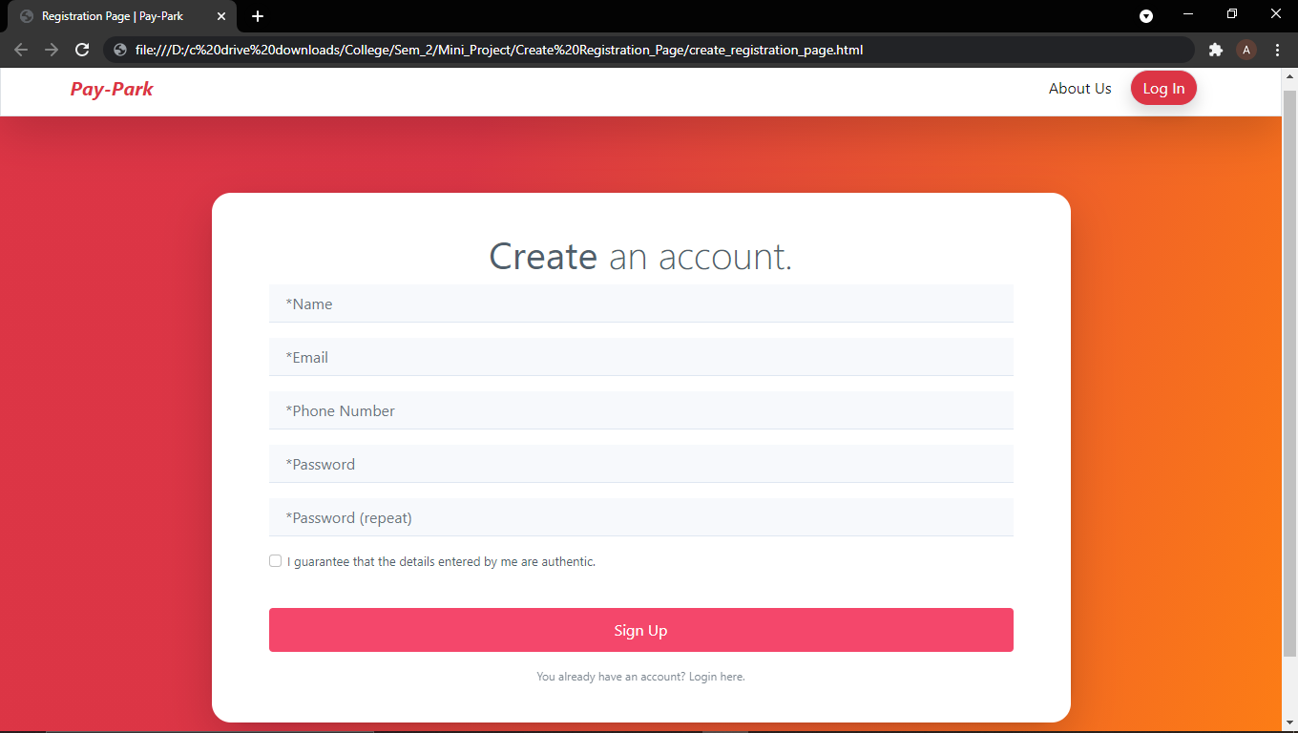

# **Input Screen (with data)**

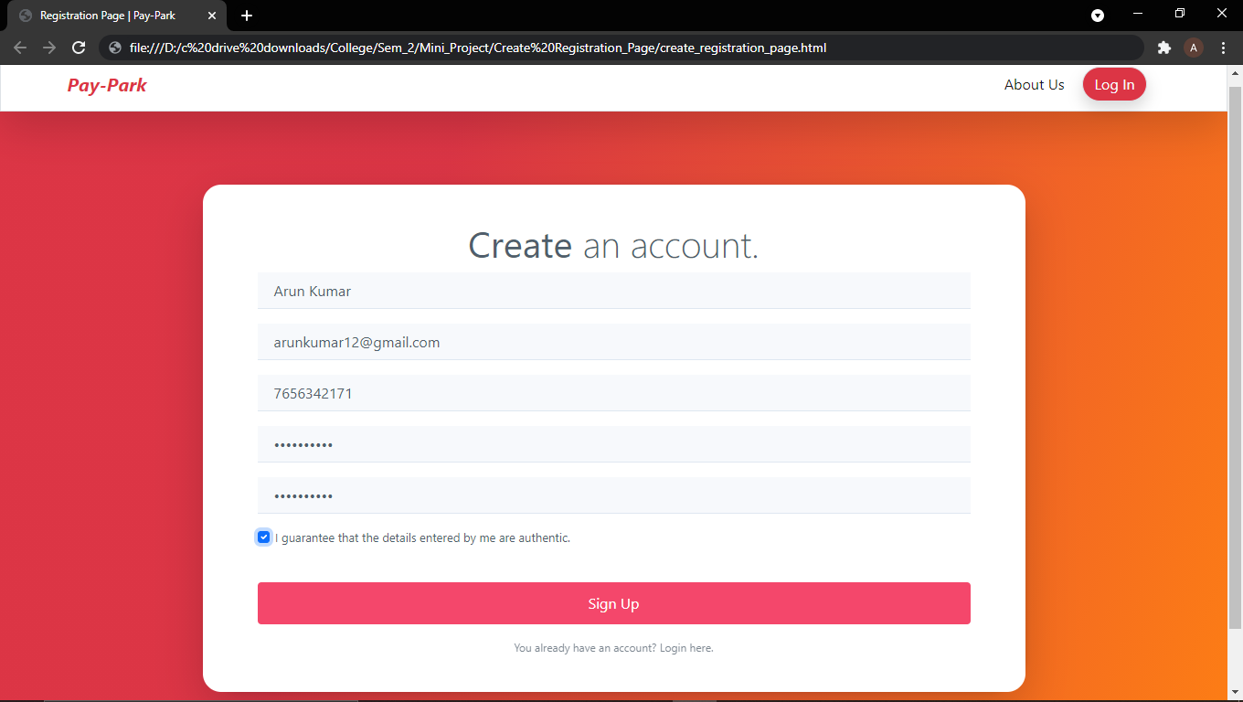

**Code Design**

<!DOCTYPE html>

<html lang="en">

<head>

<meta charset="utf-8">

<meta name="viewport" content="width=device-width, initial-scale=1.0, shrink-to-fit=no">

<title>Registration Page | Pay-Park</title>

<link rel="stylesheet" href="assets/bootstrap/css/bootstrap.min.css">

<link rel="stylesheet" href="assets/css/Registration-Form-with-Photo.css">

<link rel="stylesheet" href="assets/css/styles.css">

</head>

<body>

<nav class="navbar navbar-light navbar-expand-md border rounded-0 shadow-lg navigation-clean-button" style="height: 60px;">

<div class="container"><a class="navbar-brand" href="file:///D:/c%20drive%20downloads/MAVERICK/College/Sem_2/Mini_Project/About%20Us/home_page1.html" style="margin-left: -40px;font-style: italic;font-weight: bold;color: var(--bs-red);">Pay-Park</a><button data-bs-toggle="collapse" class="navbar-toggler" data-bs-target="#navcol-1"><span class="visually-hidden">Toggle navigation</span></button>

<div class="collapse navbar-collapse d-lg-flex" id="navcol-1">

<ul class="navbar-nav me-auto">

<li class="nav-item"></li>

<li class="nav-item"></li>

</ul>

<span class="navbar-text"><a href="file://D:\c%20drive%20downloads\MAVERICK\College\Sem_2\Mini_Project\About%20Us\AboutUs.html" style="text-decoration:none;"> About Us</a></span><span class="navbar-text actions"><a class="btn btn-light border rounded-pill shadow action-button" role="button" href="file://D:/c%20drive%20downloads/MAVERICK/College/Sem_2/Mini_Project/User_Login_Page/user_login_page.html#" style="background: var(--bs-red);margin-left: 20px;color: var(--bs-light);margin-right: -25px;">Log In</a>

</span>

</div>

</div>

</nav>

<section class="register-photo" style="background: linear-gradient(109deg, var(--bs-red), var(--bs-red) 32%, var(--bs-orange));">

<div class="form-container">

<form class="shadow-lg" method="post">

<h6 class="display-6 text-center"><strong>Create</strong> an account.</h6>

<div class="mb-3"><input class="form-control" type="text" name="Name" placeholder="*Name" autocomplete="on" inputmode="text" required=""></div>

<div class="mb-3"><input class="form-control" type="email" name="email" placeholder="*Email" required="" inputmode="email"></div>

<div class="mb-3"><input class="form-control" type="tel" name="Phone number" placeholder="*Phone Number" required=""></div>

<div class="mb-3"><input class="form-control" type="password" name="Password" placeholder="*Password" required=""></div>

<div class="mb-3"><input class="form-control" type="password" name="password-repeat" placeholder="*Password (repeat)" required=""></div>

<div class="mb-3">

<div class="form-check"><label class="form-check-label"><input class="form-check-input" type="checkbox" required="">I guarantee that the details entered by me are authentic.</label></div>

</div>

<div class="mb-3"><a href="file://D:/c%20drive%20downloads/MAVERICK/College/Sem_2/Mini_Project/Parking%20page-Places/parking_places.html" style="text-decoration:none;"><button class="btn btn-primary d-block w-100" type="button">Sign Up</button></a></div>

<a class="already" href="file://D:/c%20drive%20downloads/MAVERICK/College/Sem_2/Mini_Project/User_Login_Page/user_login_page.html">You already have an account? Login here.</a>

</form>

</div>

</section>

<!--<script src="assets/bootstrap/js/bootstrap.min.js"></script>

</body>

</html>

**Limitations of System**

1. Since the entire system is in automation, it does not provide employment to people.
2. It may have technical abnormalities due to which, even though on a very rare occasion, the system may malfunction.

**Bibliography**

* <https://getbootstrap.com>
* <https://www.w3schools.com>
* <https://www.mapout24.com/smart-parking-solution/>