**CRYPTOGRAPHY CASE STUDY REPORT**

Date: 17/11/2020

**Name: Anand Devarajan**

**Roll No: CB.EN.U4CSE18207**

**Description of dataset and columns chosen**

The dataset chosen for the case study is about banking details about a person. (300 rows and 5 columns chosen)

The five columns chosen for the case study based on the priority and encryption algorithm used are

|  |  |  |
| --- | --- | --- |
| Priority | Column Name | Encryption Algorithm |
| 1 | CVV | AES Encryption |
| 2 | Account Number | RSA Encryption |
| 3 | Phone Number | Vigenere Cipher |
| 4 | Name | Blowfish Encryption |

5th Column is userID which acts as an unique key.

**Why each columns security is important**

* CVV

CVV should have more security because it is required to complete a transaction and to have protection from scams

I used AES encryption algorithm to encrypt the cvv number of all the persons since it is the strongest encryption algorithm

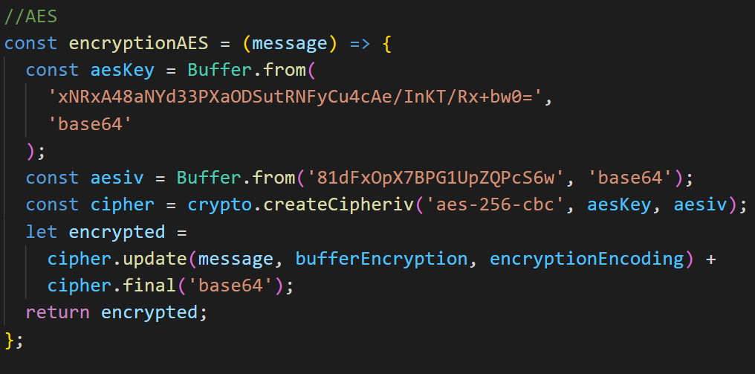

* Card Number

Card Number is a medium through which customer establishes connection with the bank. Such details need security for protection from hackers. Here I used RSA for encrypting card details of person

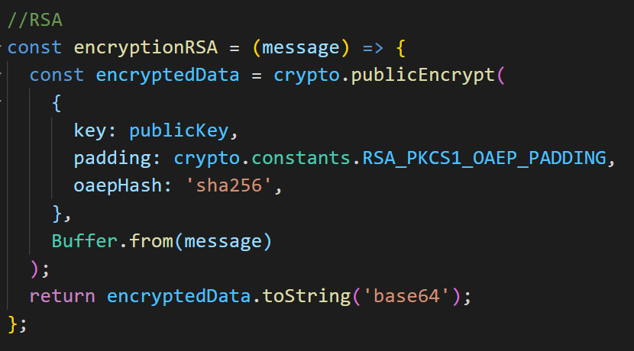

* Email

By storing encrypted email in database . It will be difficult for hackers or spammers to send phishing / malwares or spam mails

Here I used vigenere cipher to encrypt the email of persons in database

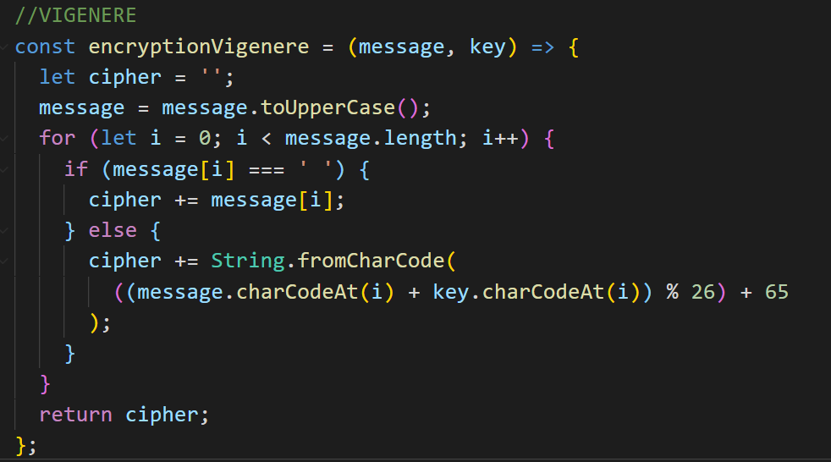

* Name

For encrypting the name I used hashing algorithm known as Blowfish encryption algorithm

Here Bcrypt function uses Blowfish algorithm

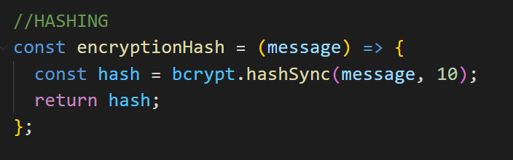

**Plaint Text .csv file**

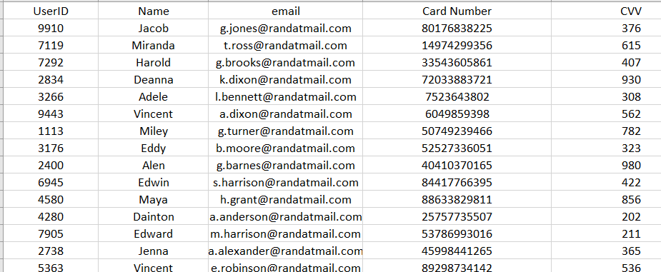

**Output**

**Cipher Text .csv file**

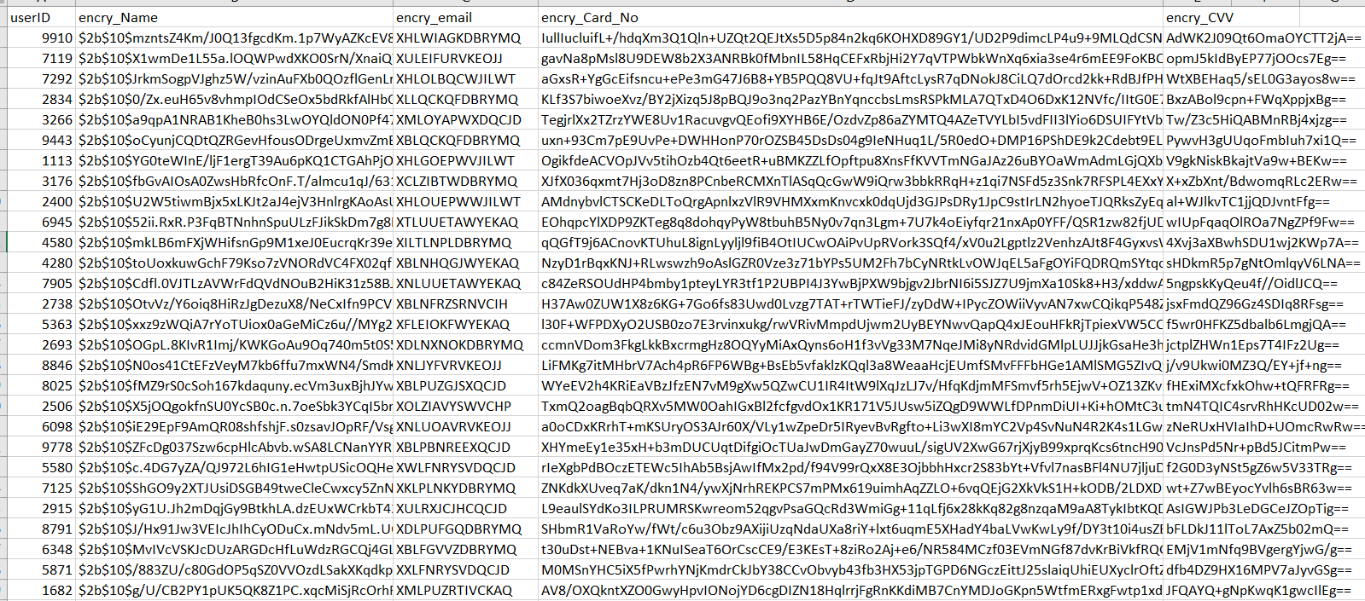

**The output of total time taken for 5 different tries is given below**

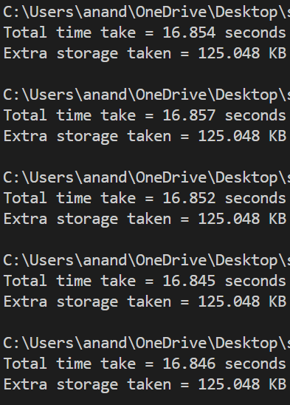

**So the average time taken**

= (16.854 + 16.857 + 16.852 + 16.845 + 16.846)/5 = **16.85 seconds**

**Extra Storage Taken** =  **125.048 KB**

Link contains **PT** and **CT .csv** Files and Code for generating the above outputs

<https://drive.google.com/drive/folders/1hHlMyQwdNEN1QfHG5qTEgCPkZka3XwA2?usp=sharing>