Assessment Documentation

Architecture Decisions & Rationale
- Framework: Built using Playwright + TypeScript for powerful cross-browser automation with native support for parallelism, rich locators, and flexible fixtures.
- Design Pattern: The framework follows a strict Page Object Model (POM) structure to separate test logic from element selectors and actions. This promotes code reusability and maintainability.
- Fixtures: Custom Playwright fixtures are used to inject page objects, manage browser contexts, and define modular setup logic.
- Test Utilities: Common utilities like `expectPageToMatchEndpoint` and `validateElementText` are centralized for consistency.
- Test Data: Menu items, endpoints, and expected titles are stored in JSON for easy parametrization and environment-specific overrides.

How to Run Tests (Locally)

Local Execution
npm install
npx playwright install
npx playwright test # Run all tests (headless)
npx playwright test --headed # Headed mode
npx playwright test tests/assessment.spec.ts # Run specific test file
npx playwright show-report # View HTML report

Test Result Logs – Cross Browser (Chromium , Edge )
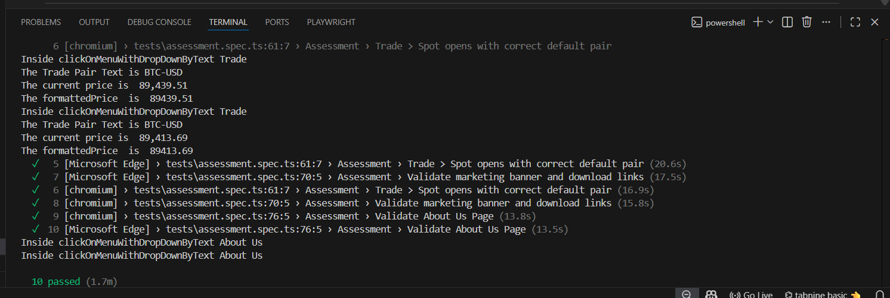

Allure Report on GitHub CI Execution:

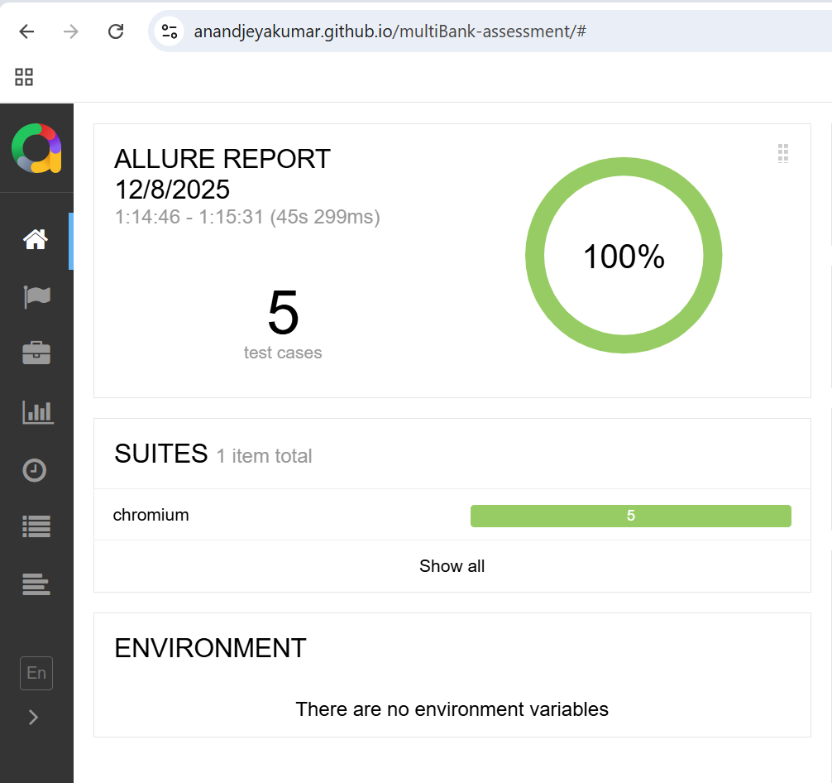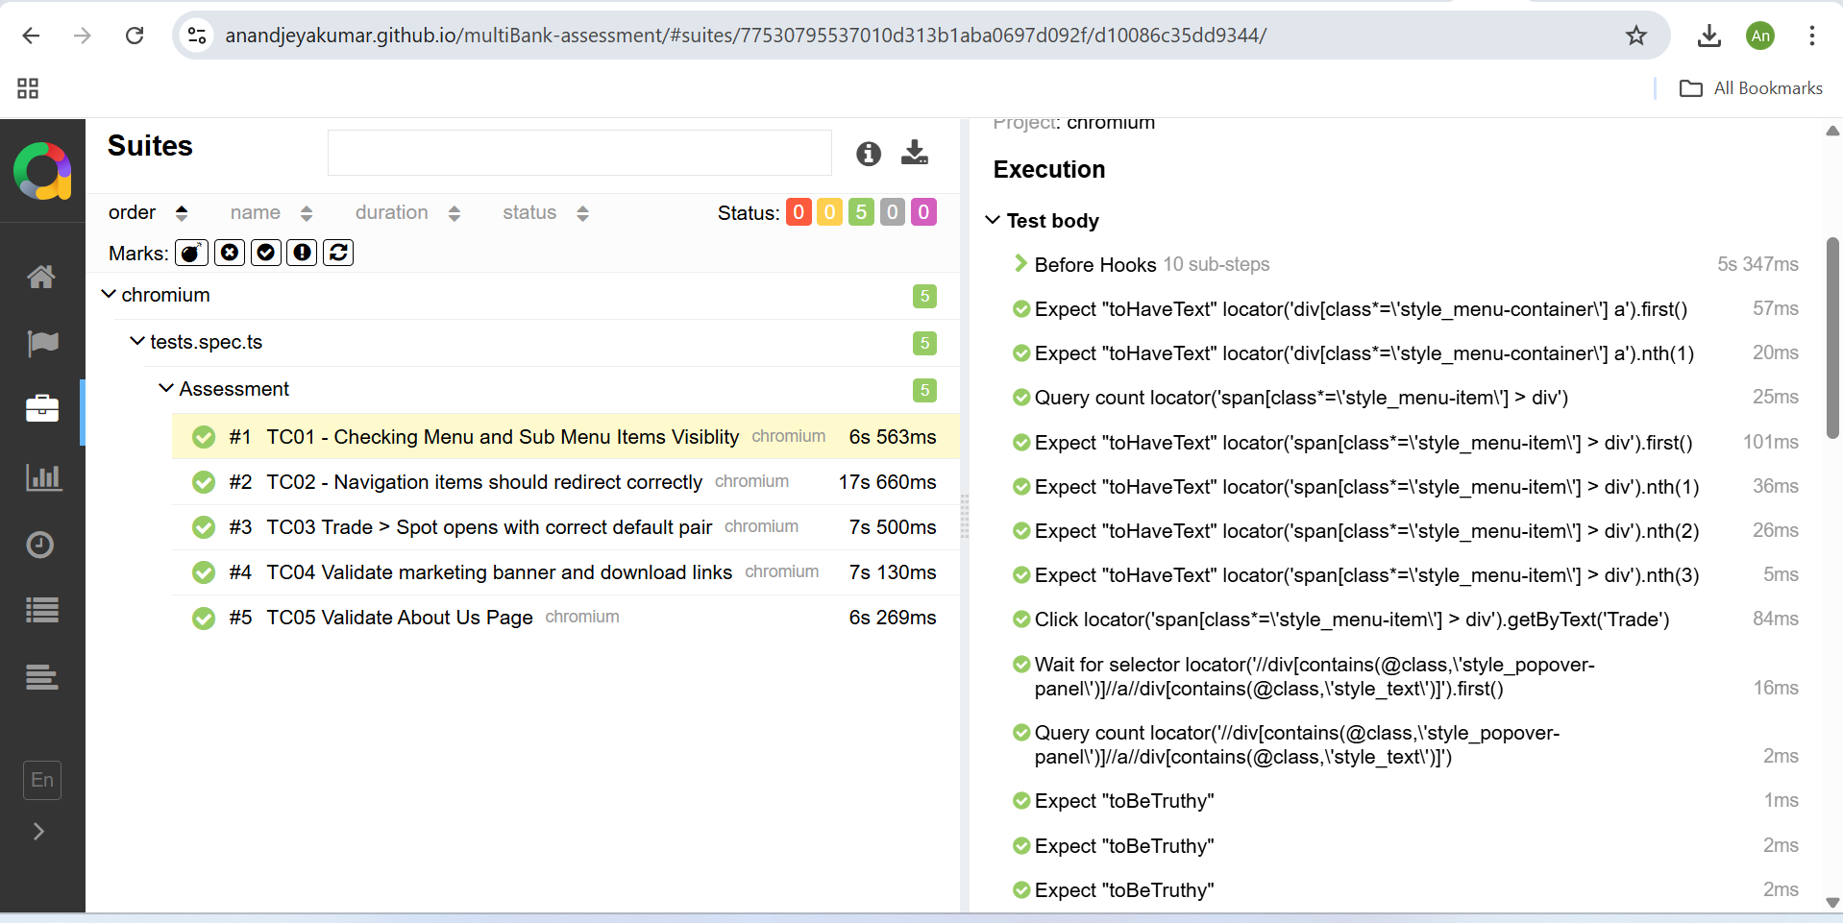

GitHub Actions CI
This framework is integrated with GitHub Actions CI/CD, allowing you to:
- Choose the browser
- Select specific branches for execution
- Generate Allure reports automatically
- Publish results to GitHub Pages
✅ View latest run: Allure Report – GitHub Pages:
https://anandjeyakumar.github.io/multiBank-assessment/

Key Findings — About Us Redirection Discrepancy
During local and CI runs, an inconsistency was observed:
- Local (Chromium): Clicking About Us > Why MultiBank redirects to "Master the Market" page.
- CI (GitHub Actions / Chromium): Same interaction redirects to the correct About Us page.
Hence, I'm not able to access the About Us page seen in CI locally, and the expected DOM elements differ. However, I have automated the page that loads consistently in local runs. Requesting confirmation on the expected behavior and page naming.
Screenshots attached below:
Local:
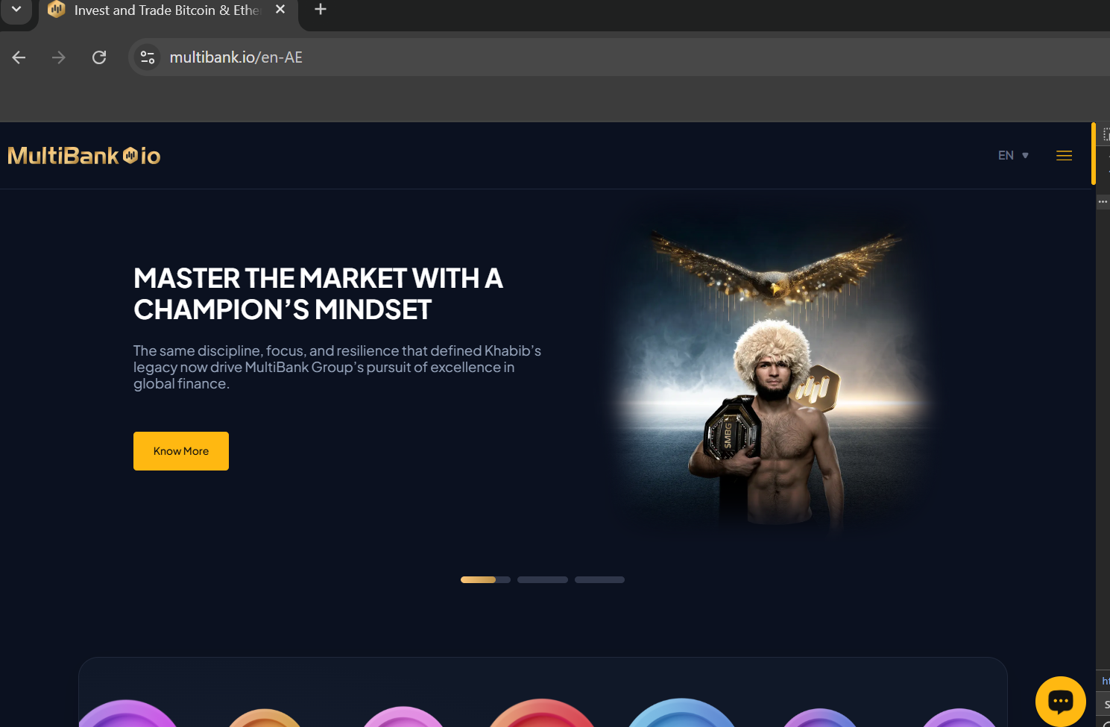
CI:

Potential Root Causes:
- Environment-specific redirection rules
- Caching or CDN behavior differing by IP/location

Maintenance & Extensibility
To maintain and extend:
- Add new page objects in pages/ and expose methods for actions/assertions
- Add new tests in tests/ with corresponding fixtures
- Add test data in testData/*.json for easy parameterization
- Update utility functions in utils/ for new validators or wait strategies
- Update playwright.config.ts for project-wide settings (timeout, retries, browser config)

