**Ad server**

Ad serving describes the technology and service that places advertisements on web sites.

An ad server is the server which enables it.

We choose Revive because it is open-source and free.

1. **Minimum requirements of revive ad server**
2. An internet server (IIS, Apache etc. ...)
3. PHP 5.3.x +
4. A database program (MySQL 4.1,PostgresSQL 8.1)

Most recent versions of the above programs are recommended.

**2) Installation of revive ad server (Windows OS in a client machine)**

* **Enabling IIS**

1. Go to “Control Panel\All Control Panel Items\Programs and Features”.
2. Click the “Turn Windows features on or off” link in the side pane.
3. Turn on IIS (Internet Information Server) in “Windows Feature” dialog box by checking the box to next to it.
4. Click on Start button🡪Run.
5. Type “inetmgr” and press enter.
6. In the subsequent window that appears, in the “Actions” pane click “Start”.

* **Getting PHP**

1. Go to “http://php.iis.net/”.
2. Download via “Install PHP Now” link.
3. Run the installer.

(or)

1. Go to “http://windows.php.net/download/”
2. Download the latest build(Zip) and extract the contents to
3. Add appropriate “Handler Mappings” in “inetmgr”

* **Getting MySQL**

1. Go to “https://www.mysql.com/why-mysql/windows/”
2. Download “MySQL Installer” and install
3. Give the user name and password.

**(or)**

* Download XAMPP (Integrated cross-platform web server solution stack package) which contains every pre requisite software
* Install and start services Apache, MySQL
* **Getting Revive**

1. Go to “https://www.revive-adserver.com/download/”
2. Download the zip version of the software and unzip it in the root directory of your server

IIS default root directory : C:\inetpub\wwwroot

XAMPP default root directory : C:\xampp\htdocs

1. Rename the folder as it contains the version number of revive. This can get confusing as revive gets updated
2. Enter MySQL and create a new database for revive naming it aptly.
3. If you have named the extracted folder revive open web browser and point your web browser to : “http://localhost/revive/ “.The full format is:

http://fully-qualified-domain-name/folder-name

1. Follow the instructions on screen. There are four steps to installing ad server

* Welcome : Make sure that the permissions to read,write,execute is given to revive in your server and accept the license agreement
* Database: The next step is to specify databases. For that make sure that MySQL is running on port 3036, failing which “MDB2 Error: Connect Failed” error might occur.
* Configuration: In the next step we provide System Administrator details, username and password. We can even set the paths in the Advanced link.
* Finish

1. **Configuration**

It is advised to lock the configuration file from your FTP client

* **Access paths**

These can be configured at runtime and indicate where to access resource

* Web path – The path at which revive starts.
* Delivery path – The path which specifies the delivery engine.
* Images path – The path where all the banner images are stored.
* Delivery SSL & Images SSL path – Useful when using secure shell protocol and HTTPS for delivery engine.
* The images folder in your local disk.
* Use “/var/localhost.com.conf.php” to edit configurations manually.

(or)

* Log in to administrative account and click on configurations.
* Banner Delivery Settings
* Banner Logging Settings
* Banner Storage Settings
* Conversion Tracking Settings
* Database Settings
* Debug Logging Settings
* Email Settings
* Geo targeting Settings
* Maintenance Settings
* Update Settings
* User Interface Settings
* Plugin Settings
* Maintenance
* Product Updates
* Banner delivery settings
* Banner Delivery Cache Settings: Sets time between cache updates and species the type of caching.
* Banner Delivery Settings: Contains generic settings like “Global default Banner Image URL” and “3rd Party Click Tracking Delimiter” etc..
* P3P Privacy Policies: The Platform for Privacy Preferences Project (P3P) is a protocol allowing websites to declare their intended use of information they collect about web browser users.
* Access paths
* Delivery file names: Edit the extensions appended with each type of ads.
* Invocation defaults: Third party tracking of ads.

**4) Features**

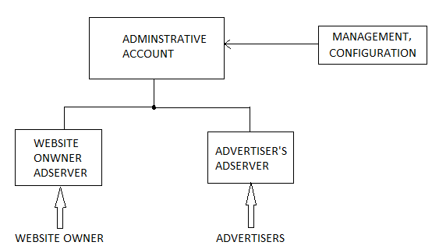

Fig.1 Architecture of Revive Ad server