Databricks API

https://docs.databricks.com/api/workspace/jobs/getpermissions
https://docs.databricks.com/api/workspace/jobs

Z-Ordering
What is Z-ordering?

Z-ordering is a technique to collocate related information in the same set of files.
Databricks data-skipping algorithms automatically use this co-locality.
This behaviour reduces the amount of data that needs to be read.
To Z-order data, specify the columns to order on in the ZORDER BY clause:

The ZORDER BY clause: In the above example, this ensures that your eventType data is co-located. If you expect a column to be commonly used in query predicates and if that column has high cardinality (that is, a large number of distinct values), then use ZORDER BY.

For Z-Ordering, the OPTIMIZE keyword is necessary. In Databricks (and Delta Lake), Z-Ordering is not a standalone command; it is an extension of the OPTIMIZE command. You cannot use ZORDER BY without OPTIMIZE.

- You can specify multiple columns for ZORDER BY as a comma-separated list.
  - However, the effectiveness of the locality drops with each extra column.
  - Z-ordering on columns that do not have statistics collected on them would be ineffective and a waste of resources. This is because data skipping requires column-local stats such as min, max, and count.
  - You can configure statistics collection on certain columns by reordering columns in the schema, or you can increase the number of columns to collect statistics on.

- Z-ordering is NOT idempotent but aims to be an incremental operation. However, if no new data was added to a partition that was just Z-ordered, another Z-ordering of that partition will NOT have any effect.

- Z-ordering aims to produce evenly balanced data files with respect to the number of tuples, but not necessarily data size on disk. The two measures are most often correlated, but there can be situations when that is not the case, leading to skew in optimize task times.

Liquid Clustering
- Liquid clustering is a data layout optimization technique that replaces table partitioning and ZORDER.
- It simplifies table management & optimizes query performance by automatically organizing data based on clustering keys.
- Unlike traditional partitioning, you can redefine clustering keys without rewriting existing data. This allows your data layout to evolve alongside changing analytic needs.
- Liquid clustering applies to both streaming tables and materialized views.
- Liquid clustering is generally available (GA) for Delta Lake tables and in Public Preview (PP) for managed Apache Iceberg tables.
- For Delta Lake tables, GA support is available with Databricks Runtime 15.2 and above.
- For Apache Iceberg tables, Databricks Runtime 16.4 LTS and above is required.
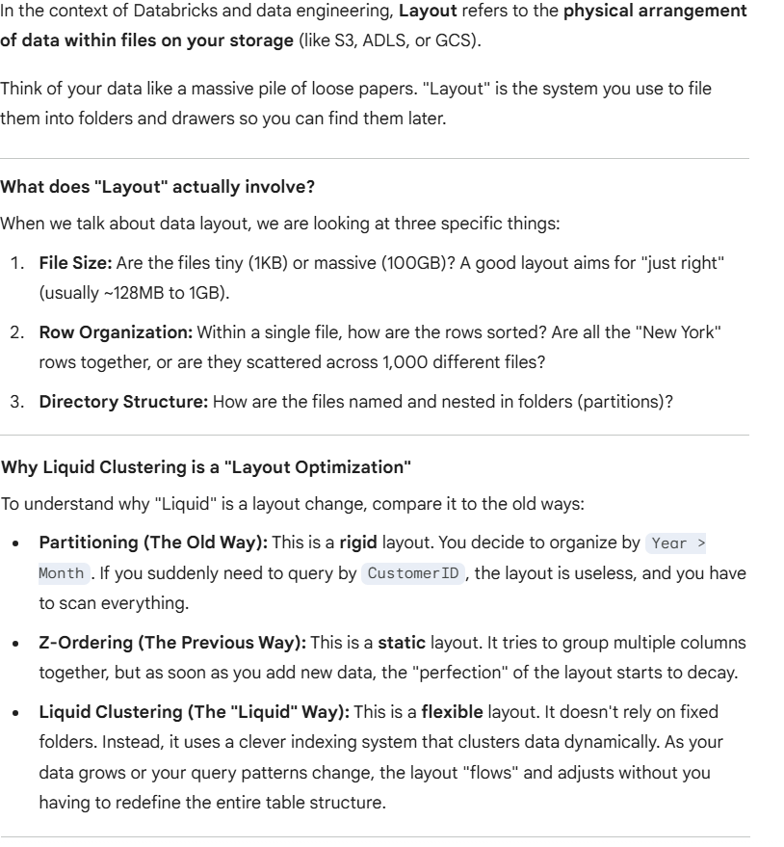

When to use liquid clustering
Databricks recommends liquid clustering for all new tables, including streaming tables and materialized views. The following scenarios particularly benefit from clustering:
- Tables that are often filtered by high cardinality columns.
- Tables that have skew in data distribution.
- Tables that grow quickly and require maintenance and tuning effort.
- Tables that have concurrent write requirements.
- Tables that have access patterns that change over time.
- Tables where a typical partition key could leave the table with too many or too few partitions.

Enable liquid clustering
- You can enable liquid clustering on an existing unpartitioned table or during table creation. Clustering is not compatible with partitioning or ZORDER.
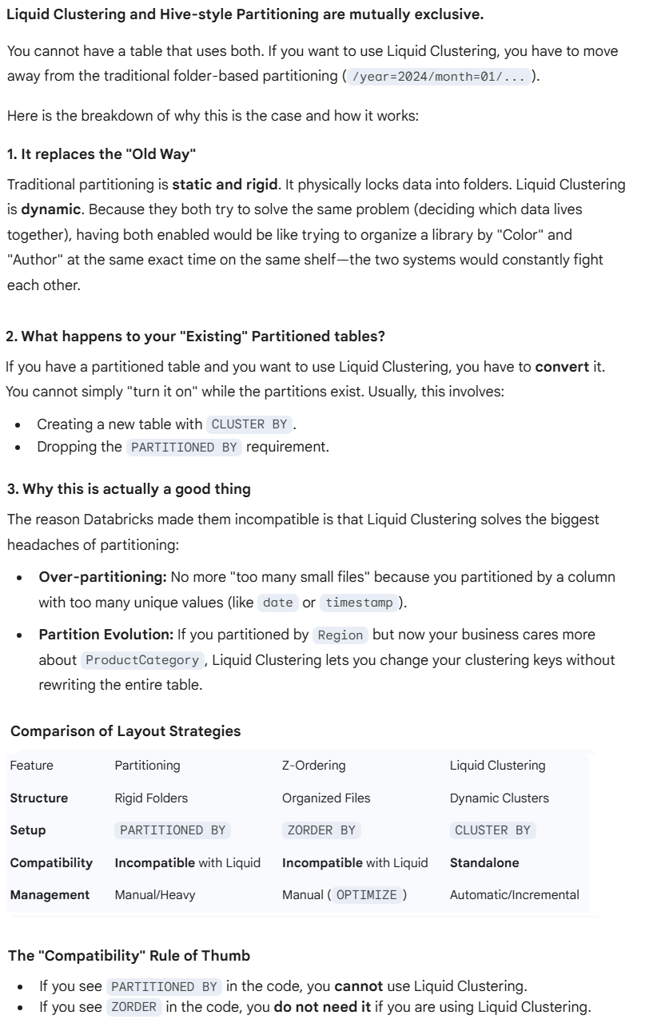

- Enabling Liquid Clustering is straightforward because it replaces the older PARTITIONED BY and ZORDER syntax with a single clause: CLUSTER BY. After enabling liquid clustering, run OPTIMIZE jobs to incrementally cluster data.
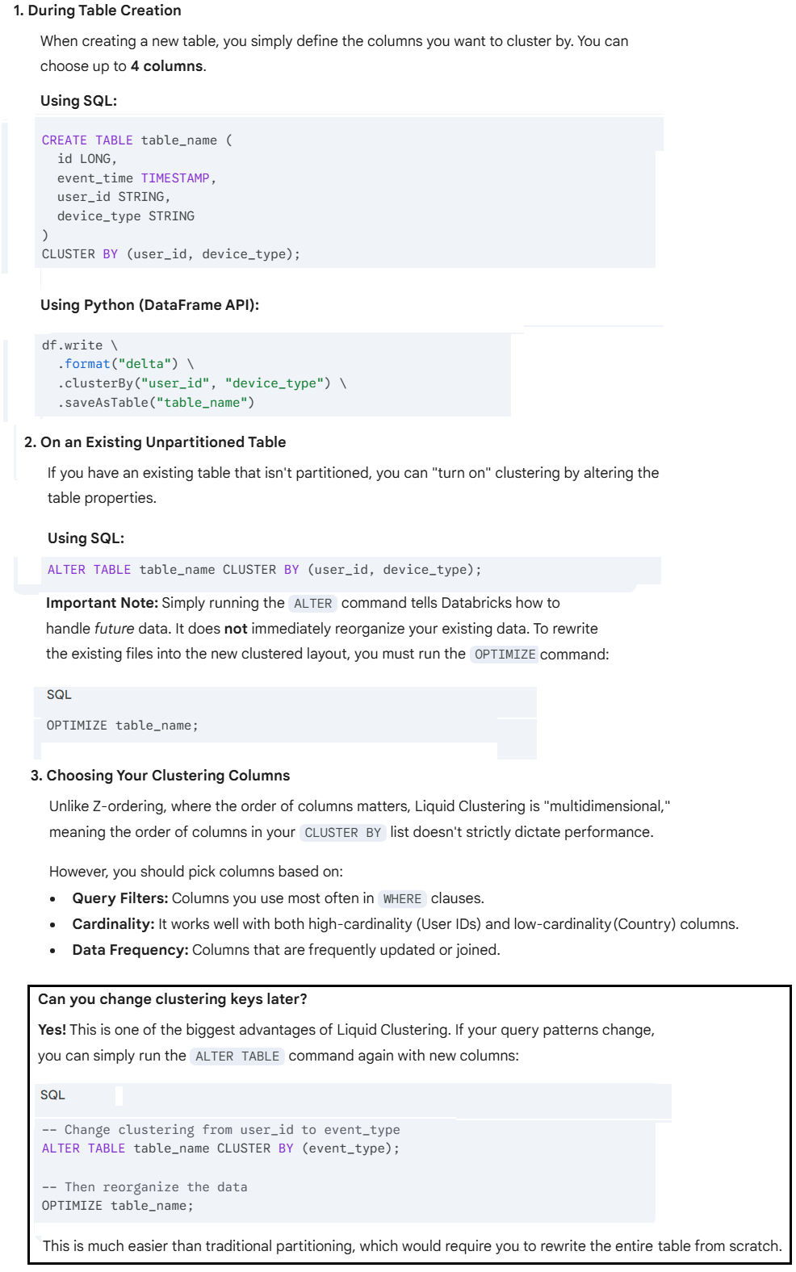

Below is as per Databricks Documentation

Create tables with clustering
- To enable liquid clustering, add the CLUSTER BY phrase to a table creation statement, as in the examples below.
- In Databricks Runtime 14.2 and above, you can use DataFrame APIs and Delta Table API in Python to enable liquid clustering for Delta Lake tables.
  - When using DataFrame APIs to set clustering keys, you can only specify clustering columns during table creation or when using OVERWRITE mode (such as with CREATE OR REPLACE TABLE operations). You cannot change clustering keys when using APPEND mode.

  - To change clustering keys on an existing table while appending data, use SQL ALTER TABLE commands to modify the clustering configuration separately from your data write operations.
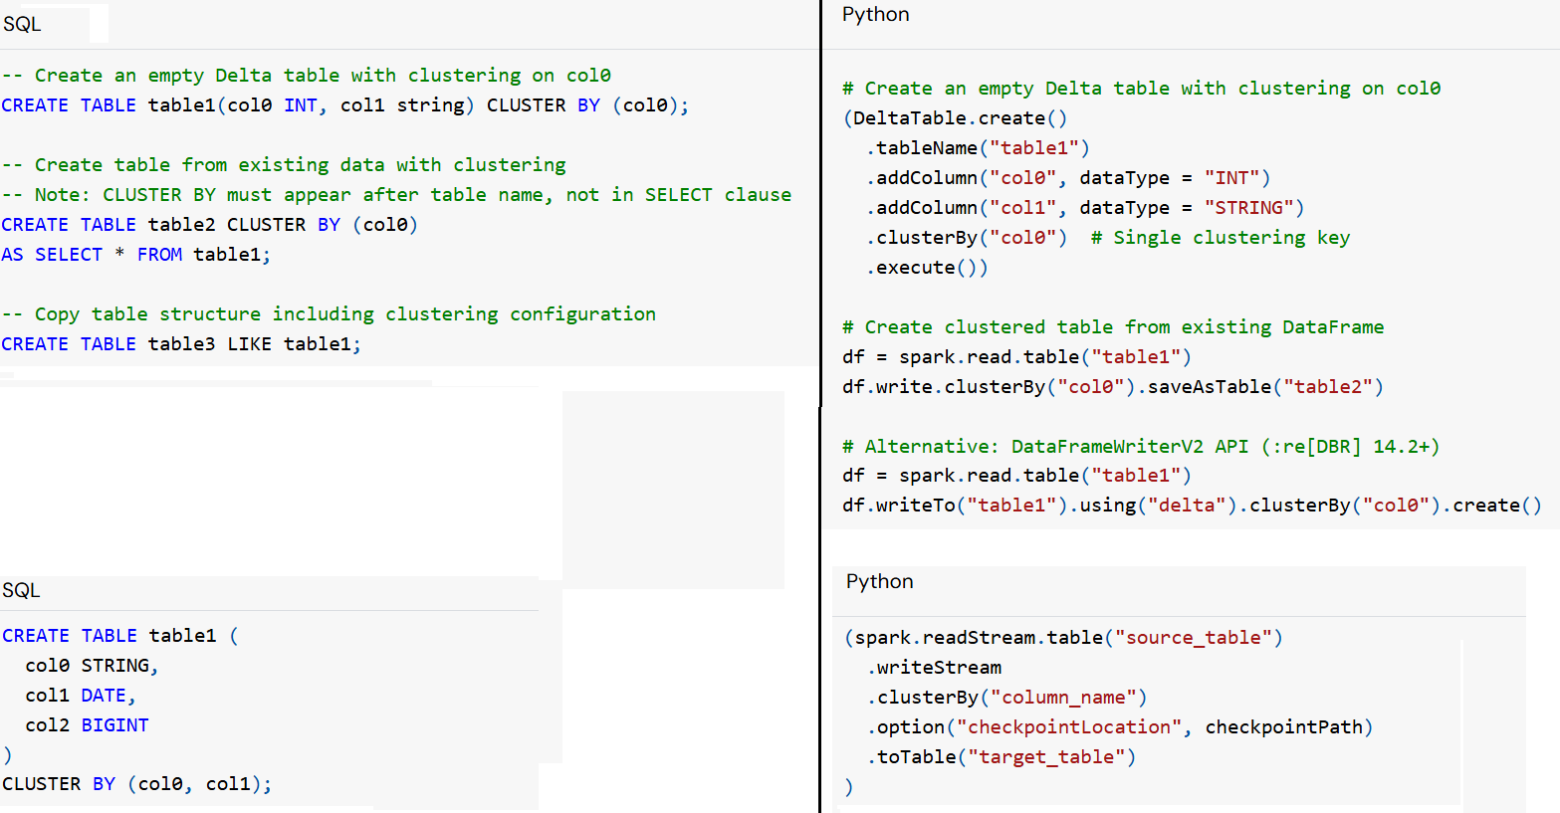

  - In Databricks Runtime 16.0 and above, you can create tables with liquid clustering enabled using Structured Streaming writes.
  - Databricks recommends using Databricks Runtime 16.4 and above for the best performance.
  - Delta tables with liquid clustering enabled use Delta writer version 7 and reader version 3.

Enable on existing tables
- Enable liquid clustering on an existing unpartitioned Delta table using the following syntax:
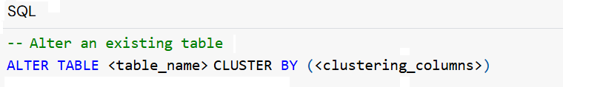
- The default behaviour does not apply clustering to previously written data. To force re-clustering for all records, you must use OPTIMIZE FULL.
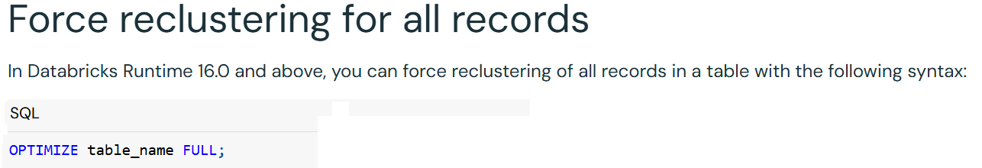
- For Apache Iceberg, you must explicitly disable deletion vectors and Row IDs when enabling liquid clustering on an existing managed Iceberg table.

Remove clustering keys
- To remove clustering keys, use the following syntax:
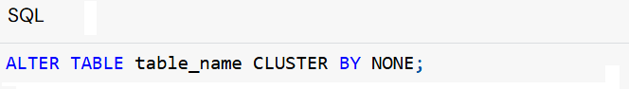

Choose clustering keys
- When you manually specify clustering keys, choose columns based on the columns most frequently used in query filters.
- You can define clustering keys in any order. If two columns are highly correlated, you only need to include one of them as a clustering key.
- You can specify up to 4 clustering keys.
- Clustering keys must be columns that have statistics collected. By default, the first 32 columns in a Delta table have statistics collected.

See how a table is clustered
- To check if a table is utilizing Liquid Clustering, you can use the DESCRIBE command. This will show you the clustering keys and whether the feature is active.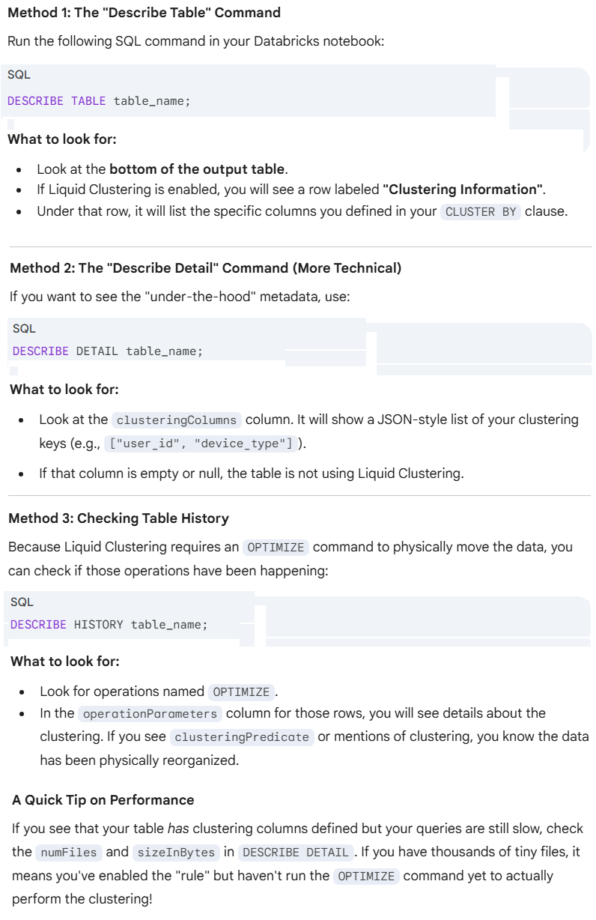

Data-Skipping
- Data skipping information is collected automatically when you write data into a table.
- Databricks takes advantage of this information (minimum and maximum values, null counts, and total records per file) at query time to provide faster queries.
- For Unity Catalog external tables, statistics are collected on the first 32 columns defined in your table schema by default.
- For Unity Catalog managed tables, file-skipping statistics are chosen intelligently using predictive optimization, and don't have a 32 column-limit.
- Predictive optimization automatically runs ANALYZE, a command for collecting statistics.
- Databricks recommends enabling predictive optimization for all Unity Catalog managed tables to simplify data maintenance and reduce storage costs.
- If you are NOT using predictive optimization, you can modify the behaviour that limits statistics collections to 32 columns by setting one of the following table properties.
Table property | Databricks  Runtime supported | Description
dataSkippingNumIndexedCols | All supported Databricks Runtime versions | Increase or decrease the number of columns on which statistics are collected. Depends on column order.
dataSkippingStatsColumns | Databricks Runtime 13.3 LTS and above | Specify a list of column names for which statistics are collected. Supersedes dataSkippingNumIndexedCols.

- Table properties can be set at table creation or with ALTER TABLE statements. The following example overrides default stats collection behaviour to set stats collection on named columns:

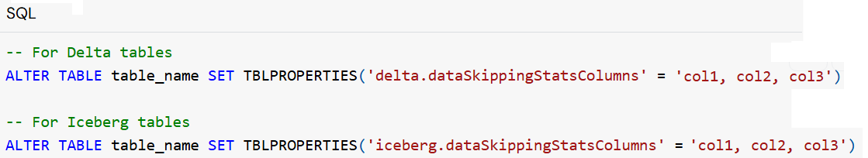

- In Databricks Runtime 14.3 LTS and above, if you have altered the table properties or changed the specified columns for statistics, you can manually trigger the re-computation of statistics for a table using the following command:

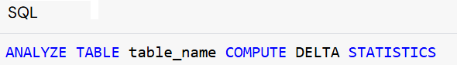

Predictive Optimization
- Predictive Optimization is a managed service in Databricks that removes the "manual labor" from data engineering.
- Predictive optimization removes the need to manually manage maintenance operations for Unity Catalog managed tables on Databricks.
- Instead of you having to remember to run OPTIMIZE or VACUUM commands on a schedule, Databricks uses AI/Machine Learning to watch your tables and determine exactly when they need maintenance to keep them fast and cost-effective.
- Predictive optimization is enabled by default if your account was created on or after November 11, 2024.
- With predictive optimization enabled, Databricks automatically does the following:
  - Identifies tables that would benefit from maintenance operations and queues these operations to run.
  - Collects statistics when data is written to a managed table.
- Databricks recommends using predictive optimization for all Unity Catalog managed tables. For example, automatic liquid clustering has intelligent optimization of data layout based on your data usage patterns.
- IMP: Predictive optimization only runs on Unity Catalog managed tables. Predictive optimization is not available in all regions.

Predictive Optimization Key Features
- Automatic Compaction: It automatically identifies "small file problems" and merges them into larger, more efficient files.
- Intelligent Vacuuming: It cleans up old, deleted files to save you money on storage costs without you having to risk deleting data that is still in use.
- No Manual Triggers: You no longer need to write Airflow jobs or Databricks Workflows just to keep your tables "healthy."
- Serverless Execution: The optimization happens on Databricks-managed compute, so it doesn't interfere with your main cluster's performance or speed.

How Predictive Optimization Works
- Observation: It tracks how your data is growing and how your queries are performing.
- Prediction: It identifies which tables will slow down if they aren't reorganized soon.
- Action: It automatically runs the necessary commands (like OPTIMIZE or VACUUM) in the background using "serverless" compute.

Why use it over Manual Optimization, is it compatible with Liquid Clustering?
- Over-optimizing: Running it every hour when no data has changed (wasting money).
- Under-optimizing: Forgetting to run it for a week while the table becomes sluggish.
- Liquid Clustering is compatible with Predictive Optimization. Liquid Clustering defines the Layout (how data is grouped), and Predictive Optimization manages the Timing (when to trigger the layout updates).
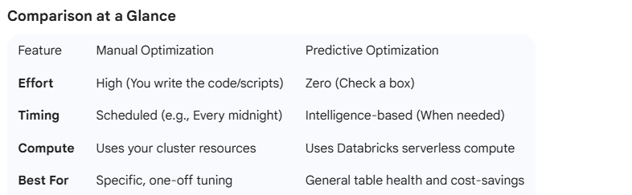

What operations does predictive optimization run?
Predictive optimization runs the following operations automatically for enabled tables:
Operation | Description
OPTIMIZE | Triggers incremental clustering for enabled tables.  Improves query performance by optimizing file sizes.  OPTIMIZE does not run ZORDER when executed with predictive optimization. On tables that use Z-order, predictive optimization will ignore the Z-ordered files.
VACUUM | Reduces storage costs by deleting data files no longer referenced by the table.
ANALYZE | Triggers incremental update of statistics to improve query performance.

Note #1:
- The retention window for the VACUUM command is determined by the delta.deletedFileRetentionDuration table property, which defaults to 7 days. This means VACUUM removes data files that are no longer referenced by a Delta table version in the last 7 days.
- If you'd like to retain data for longer (such as to support time travel for longer durations), you must set this table property appropriately before you enable predictive optimization, as in the following example:

Where does predictive optimization run?
- Predictive optimization identifies tables that would benefit from ANALYZE, OPTIMIZE, and VACUUM operations and queues them to run using serverless compute for jobs.
- Your account is billed for compute associated with these workloads using a serverless jobs SKU.

Prerequisites for predictive optimization
You must fulfil the following requirements to enable predictive optimization:
- Your Databricks workspace must be on the Premium plan or above in a region that supports predictive optimization.
- You must use SQL warehouses or Databricks Runtime 12.2 LTS or above when you enable predictive optimization.
- Only Unity Catalog managed tables are supported.

Enable predictive optimization
- We can enable predictive optimization for an Account, a Catalog, or a Schema.
- All Unity Catalog managed tables inherit the account value by default.
- Enabling Predictive Optimization is designed to be a "set it and forget it" experience. It uses an inheritance model, meaning you can turn it on at the top level (Account) and have it flow down to every table.
- We can override the account default for a Catalog or Schema to enable or disable predictive optimization at that level.
- We must have the following privileges to enable or disable predictive optimization at the specified level:
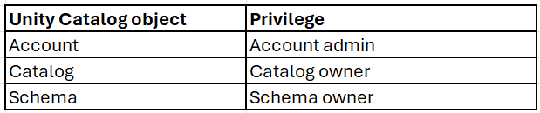

Enabling Predictive Optimization at the Account Level (Global)
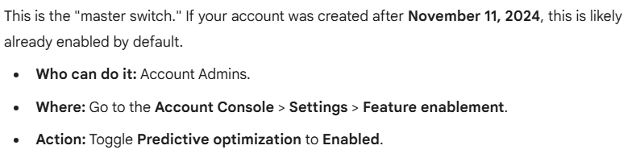

Enabling/Disabling Predictive Optimization for a Catalog or Schema
You can override the account setting for specific Catalogs or Schemas. This is useful if you have "Sandbox" data you don't want to spend money optimizing, or "Production" data that absolutely needs it. 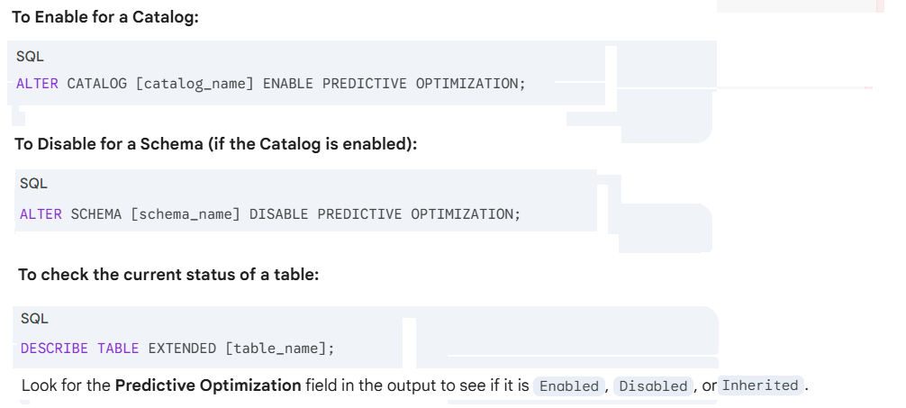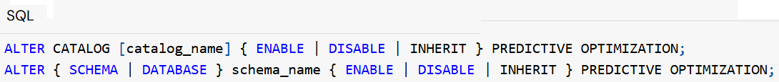

Monitoring the "AI's Work"
Since you aren't running the commands yourself, you'll want to see what the AI is doing. Databricks provides a system table that acts as a log for every automated OPTIMIZE or VACUUM task.
You can query this table to see the cost and the results:
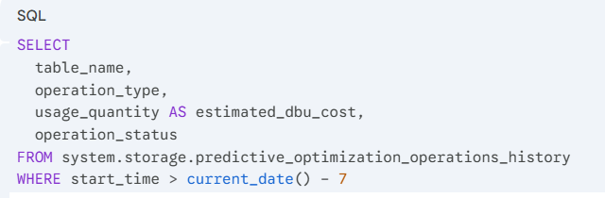
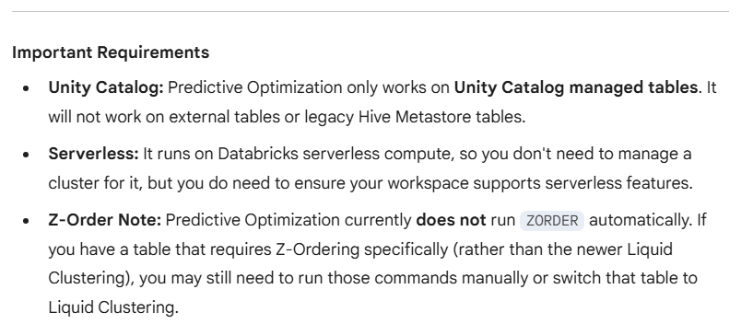

Check whether predictive optimization is enabled
- The Predictive Optimization field is a Unity Catalog property that details if predictive optimization is enabled.
- If predictive optimization is inherited from a parent object, this is indicated in the field value.
- Use the following syntax to see if predictive optimization is enabled:
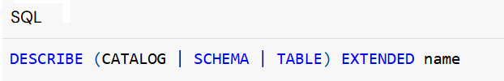
- Use system tables to track predictive optimization.
Databricks provides the system table system.storage.predictive_optimization_operations_history for observability into predictive optimization operations, costs, and impact.

Limitations
- Predictive optimization is not available in all regions.
- For tables with deleted file retention duration (delta.deletedFileRetentionDuration) configured below the default of 7 days, predictive optimization runs VACUUM with retention duration as 7 days.
- Predictive optimization does not perform maintenance operations on the following tables:
  - Tables loaded to a workspace as Delta Sharing recipients.
  - External tables.

Vaccum
- Remove data files no longer referenced by a table that are older than the retention threshold by running the VACUUM command on the table.
- Running VACUUM regularly is important for cost and compliance because of the following considerations:
  - Deleting unused data files reduces cloud storage costs.
  - Data files removed by VACUUM might contain records that have been modified or deleted. Permanently removing these files from cloud storage ensures these records are no longer accessible.
- The default retention threshold for data files after running VACUUM is 7 days.
- VACUUM might leave behind empty directories after removing all files from within them. Subsequent VACUUM operations delete these empty directories.
- Databricks recommends using predictive optimization to automatically run VACUUM for tables.
- Some table features use metadata files to mark data as deleted rather than rewriting data files. Use REORG TABLE ... APPLY (PURGE) to commit these deletions and rewrite data files.
- VACUUM removes all files from directories not managed by Databricks, ignoring directories beginning with _ or .. If you're storing additional metadata like Structured Streaming checkpoints within a table directory, use a directory name such as _checkpoints.
  - Data for change data feed is managed in the _change_data directory and removed with VACUUM.
  - Bloom filter indexes use the _delta_index directory. VACUUM cleans up files in this directory.
- The ability to query table versions older than the retention period is lost after running VACUUM.
- Log files are deleted automatically and asynchronously after checkpoint operations and are not governed by VACUUM. While the default retention period of log files is 30 days, running VACUUM on a table removes the data files necessary for time travel.
- Example syntax for VACCUM
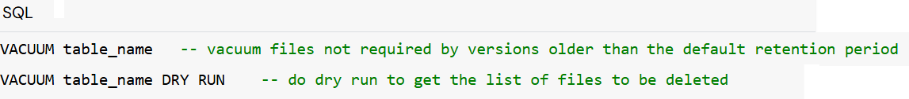

- In Databricks Runtime 18.0 and above, use the deletedFileRetentionDuration table property to control retention.
- For Unity Catalog managed tables, this applies to Databricks Runtime 12.2 and above.

Automatic Liquid Clustering
- Databricks recommends using automatic liquid clustering for supported tables, which intelligently selects clustering keys based on your query patterns.
- In Databricks Runtime 15.4 LTS and above, you can enable automatic liquid clustering for Unity Catalog managed Delta tables.
- Automatic liquid clustering allows Databricks to intelligently choose clustering keys to optimize query performance, using the CLUSTER BY AUTO clause.

How automatic liquid clustering works
Automatic liquid clustering provides intelligent optimization based on your usage patterns:
- Requires predictive optimization: Automatic key selection and clustering operations run asynchronously as a maintenance operation.
- Analyses query workload: Databricks analyses the table's historical query workload and identifies the best candidate columns for clustering.
- Adapts to changes: If your query patterns or data distributions change over time, automatic liquid clustering selects new keys to optimize performance.
- Cost-aware selection: Databricks changes clustering keys only when the predicted cost savings from data skipping improvements outweigh the data clustering cost.
Automatic liquid clustering might NOT select keys for the following reasons:
- The table is too small to benefit from liquid clustering.
- The table already has an effective clustering scheme, either from previous manual keys or natural insertion order that matches query patterns.
- The table does not have frequent queries.
- You are not using Databricks Runtime 15.4 LTS or above.
You can apply automatic liquid clustering for all Unity Catalog managed tables, regardless of data and query characteristics.

Enable or disable automatic liquid clustering
- To enable or disable automatic liquid clustering on a new or existing table, use the following syntax:
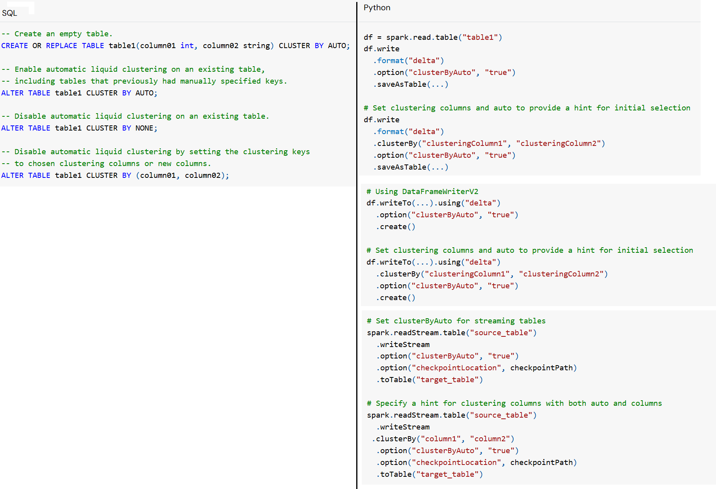
- The Python API is available in Databricks Runtime 16.4 and above.

- When you use “.clusterBy” together with .option('clusterByAuto', 'true), the behaviour is as follows:
  - If this sets automatic liquid clustering for the first time, the manual input is always respected and the clustering columns in “.clusterBy” are set.
  - If this is already a table with automatic liquid clustering, a hint using “.clusterBy” can be accepted once. For example, the columns specified by “.clusterBy” are only set if the table has no clustering columns set already.

- You can use Python only when creating or replacing a table. Use SQL to change the clusterByAuto status of an existing table. Because, Python DataFrame APIs are great for "creating" things, but Databricks uses SQL ALTER commands for managing "metadata" (the settings) of existing tables.
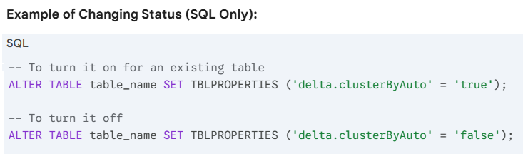

- When using DataFrame APIs, the clusterByAuto option can only be set when using OVERWRITE mode. You cannot set clusterByAuto when using APPEND mode.
  - overwrite mode: This deletes the old data and settings and starts over. Because you are effectively "re-creating" the table, Databricks allows you to set the clustering rules here.
  - append mode: This just adds new rows to an existing pile. You aren't allowed to change the "DNA" (the clustering settings) of the table while just adding rows.

Check if automatic clustering is enabled
- To check if a table has automatic liquid clustering enabled, use DESCRIBE TABLE or SHOW TBLPROPERTIES.
- If automatic liquid clustering is enabled, the clusterByAuto property is set to true. The clusteringColumns property shows the current clustering columns that were automatically or manually selected.

Limitations
- Automatic liquid clustering is not available for Apache Iceberg.

Optimize
Resources
https://docs.databricks.com/delta/tune-file-size.html#when-to-run-optimize

When to run OPTIMIZE
- Auto compaction and optimized writes each reduce small file problems, but are not a full replacement for OPTIMIZE.
- Especially for tables larger than 1 TB, Databricks recommends running OPTIMIZE on a schedule to further consolidate files.
- Databricks does not automatically run ZORDER on tables, so you must run OPTIMIZE with ZORDER to enable enhanced data skipping.

Auto compaction
- Auto compaction combines small files within table partitions to automatically reduce small file problems.
- Auto compaction occurs after a write to a table has succeeded and runs synchronously on the cluster that has performed the write.
- Auto compaction only compacts files that haven't been compacted previously.
- Control the output file size by setting the Spark Configuration parameters
  - spark.databricks.delta.autoCompact.maxFileSize for Delta
  - spark.databricks.iceberg.autoCompact.maxFileSize for Iceberg
- Enable auto compaction at the TABLE or SESSION level using the following settings:
  - Table property: autoOptimize.autoCompact
  - SparkSession setting:
    - spark.databricks.delta.autoCompact.enabled (Delta)
    - spark.databricks.iceberg.autoCompact.enabled (Iceberg)

Optimized writes
- Optimized writes improve file size as data is written and benefit subsequent reads on the table.
- Optimized writes are most effective for partitioned tables, as they reduce the number of small files written to each partition.
- Writing fewer large files is more efficient than writing many small files, but you might still see an increase in write latency because data is shuffled before being written.
- Optimized writes can be enabled at the TABLE or SESSION level using the following settings:
  - Table property: autoOptimize.optimizeWrite
  - SparkSession setting:
    - spark.databricks.delta.optimizeWrite.enabled (Delta) OR
    - spark.databricks.iceberg.optimizeWrite.enabled (Iceberg)
- These settings accept the following options:
Options | Behaviour
true | Use 128 MB as the target file size.
false | Turns off optimized writes. Can be set at the session level to override auto compaction for all tables modified in the workload.

A data engineer is using the following spark configurations in a pipeline to enable Optimized Writes and Auto Compaction:

spark.conf.set("spark.databricks.delta.optimizeWrite.enabled", True)
spark.conf.set("spark.databricks.delta.autoCompact.enabled", True)

They also want to enable Z-order indexing with Auto Compaction to leverage data skipping on all the pipeline’s tables.
Which of the following solutions allows the data engineer to complete this task?

- Use spark.conf.set("spark.databricks.delta.autoZorder.enabled", True)
- Z-order indexing with Auto Compaction can only be enabled on each table separately using:
ALTER TABLE table_name SET TBLPROPERTIES (delta.autoOptimize.zorder.enabled = true)
- Use spark.conf.set("spark.databricks.delta.autoCompact.zorder.enabled", True)
- There is no way to enable Z-order indexing with Auto Compaction since it does not support Z-Ordering

Overall explanation
Auto Compaction does not support Z-Ordering as Z-Ordering is significantly more expensive than just compaction.

