Databricks Asset Bundles (DAB)
A data engineer is configuring a job using Databricks Asset Bundles and wants to limit its access to authorized users.
The following job definition includes tasks and job clusters, but the engineer also needs to define which user groups can manage or view the job.
resources:
jobs:
my-job:
name: analytics-job
tasks: [...]
job_clusters: [...]
permissions:
- group_name: devops-team
level: CAN_MANAGE
- group_name: qa-team
level: CAN_VIEW

A data engineer has the following Databricks Asset Bundle (DAB) project:
resources:
apps:
bookstore_app:
name: "bookstore_demo"
source_code_path: ../src/bookstore

volumes:
bookstore_volume:
name: "bookstore"
catalog_name: demo_catalog
schema_name: demo_schema
grants:
- principal: ${resources.apps.bookstore_app.id}
privileges:
- READ_VOLUME
- WRITE_VOLUME

Which of the following correctly describes the result of deploying this DAB project?


- To execute a job called events_process_job which is deployed using Databricks Asset Bundles, which command can engineer run from their terminal?
databricks bundle run events_process_job

- To execute a job called events_process_job which is deployed using Databricks Asset Bundles, which command can engineer run from their terminal to specify TARGET environment for the job?
databricks bundle run events_process_job -t PROD

- A data engineer has an existing Databricks job and wants to manage it using Databricks Asset Bundles. They want to use the Databricks CLI to get the YAML definition of the job and download its referenced artifacts.
Which of the following commands allows the data engineer to achieve this?
- A data engineer has an existing Databricks job and wants to manage it using Databricks Asset Bundles. They have already generated the YAML definition of the job and downloaded its referenced artifacts.

However, they want to ensure that updates to the bundle's YAML will modify the existing job rather than creating a new job.

- Bundle Command Sequences
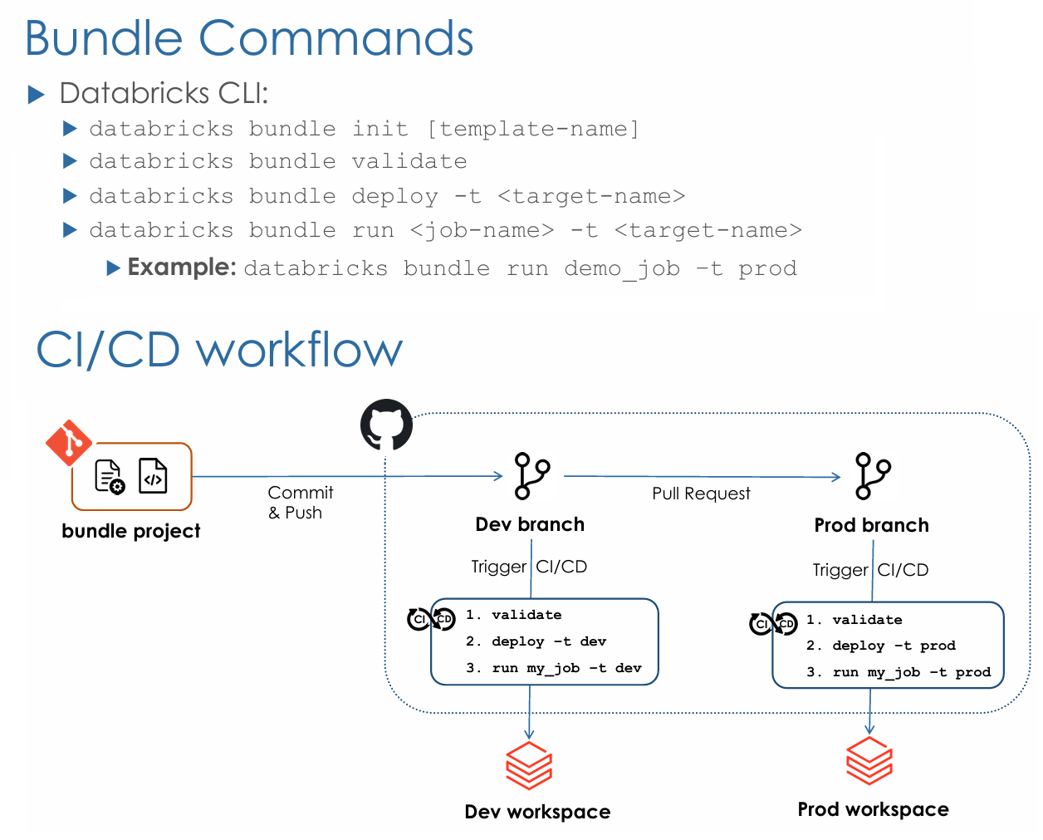

Databricks Asset Bundles (DABs) CLI commands

- databricks bundle validate:
This command validates the syntax and structure of your databricks.yml configuration file and other bundle-related files, ensuring they adhere to the expected format and schema. This helps catch errors before deployment.

- databricks bundle deploy:
This command deploys the resources defined in your bundle to your Databricks workspace. This includes creating or updating jobs, pipelines, notebooks, and other assets based on your bundle configuration.

- databricks bundle run:
This command executes the entry point or specific tasks defined within your bundle, such as running a job or a pipeline. It's useful for testing or manually triggering workflows.

- databricks bundle job:
This command is used to generate bundle configuration specifically for a Databricks job.

- databricks bundle pipeline:
This command is used to generate bundle configuration specifically for a Databricks pipeline (e.g., a Delta Live Tables pipeline).

- databricks bundle destroy:
This command permanently deletes the resources deployed by a bundle from your Databricks workspace. This action is irreversible and requires confirmation by default (unless the --auto-approve option is used).

- databricks bundle deployment bind:
This command links bundle-defined resources to existing resources in the Databricks workspace, allowing the bundle to manage them. If a resource is bound, the existing workspace resource is updated based on the bundle's configuration after the next deploy.

- databricks bundle deployment unbind:
This command detaches a bundle-defined resource from its remote resource in the Databricks workspace, effectively stopping the bundle from managing that resource.

- databricks bundle app:
This command is used to generate bundle configuration for a Databricks application.

- databricks bundle dashboard:
This command is used to generate configuration for a dashboard resource within a bundle.

Databricks CLI commands (CLI)
- Which of the following Databricks CLI commands allows a data engineer to list all runs of a job that completed successfully?
- Which of the following Databricks CLI commands allows a data engineer to list all runs of a job that started at or after a specific time?

- Databricks jobs cancel an individual run
databricks jobs cancel-run RUN_ID [flags]

databricks jobs cancel-run 45678 --json
databricks jobs cancel-run 45678 --timeout 5m

- Databricks jobs cancel ALL runs
databricks jobs cancel-all-runs [flags]

databricks jobs cancel-all-runs --job-id 555

--Targets run of that are sitting in the queue but haven't started consuming compute resources yet
databricks jobs cancel-all-runs --all-queued-runs

--Returns the result of your command as a JSON object rather than plain text
databricks jobs cancel-all-runs --json

--Combining all
databricks jobs cancel-all-runs --job-id 555 --all-queued-runs --json

- Databricks Jobs Create
databricks jobs create [flags]

--Refer a file for the entire job definition (tasks, compute, etc.)
databricks jobs create --json @my_job_config.json

--Refer JSON Inline string for the entire job definition (tasks, compute, etc.)
databricks jobs create --json '{"name": "My Daily Job", "tasks": [...]}'

- Databricks Delete a Job
databricks jobs delete JOB_ID [flags]

--Inline JSON
databricks jobs delete --json '{"job_id": 123456789}'

--Using a JSON file
databricks jobs delete --json @delete_params.json

- Databricks Delete a Non-Active run. Returns an error if the run is Active

What "Non-Active" means here
In Databricks terminology, a Run is considered "Active" if it is currently doing work. The documentation is warning you that you cannot delete the record of a task while it is still spinning.

- Active Run: Status is PENDING, RUNNING, or TERMINATING. (You cannot delete these).
- Non-Active Run: Status is TERMINATED, SKIPPED, or INTERNAL_ERROR. (You can delete these).

The Workflow for an Active Run:
- Cancel it: databricks jobs cancel-run --run-id 123
- Wait: Wait for the status to change to CANCELED (making it "Non-Active").
- Delete it: databricks jobs delete-run --run-id 123

databricks jobs delete-run RUN_ID [flags]

--Inline JSON String
databricks jobs delete-run --json '{"run_id": 987654321}'

--Using a JSON file
databricks jobs delete-run --json @path/to/run_params.json

- Databricks Retrieve the Details of a Single Job

databricks jobs get JOB_ID [flags]

- Databricks Retrieves the metadata of a job run

databricks jobs get-run RUN_ID [flags]

- Databricks Retrieve the output and metadata of a single task run.
databricks jobs get-run-output RUN_ID [flags]

- List Job runs in Descending Order by Start Time
databricks jobs list-runs [flags]

- Re-run one or more tasks
databricks jobs repair-run RUN_ID [flags]

- Run a Job and return the run_id of the Triggered Run
databricks jobs run-now JOB_ID [flags]

- Create and trigger a one-time run
databricks jobs submit [flags]

REST API
- A data engineer wants to use Databricks REST API to retrieve all runs of a job to check their statuses. Below REST API calls achieves this requirement.
Solution:
- Send GET request to the endpoint ‘/api/2.2/jobs/runs/list’
- Sending GET requests to the endpoint ‘/api/2.2/jobs/runs/list’ allows you to retrieve all runs of a job.
https://docs.databricks.com/api/workspace/jobs/listruns

- A data engineering team wants to automate job monitoring and improve observability by retrieving available jobs in the production Databricks workspace using REST API.
Solution
- Send GET request to the endpoint ‘/api/2.2/jobs/list’
- Sending GET requests to the endpoint ‘/api/2.2/jobs/list’ allows you to retrieve available jobs in a Databricks workspace.
https://docs.databricks.com/api/workspace/jobs/list

- A scheduled job failed due to an upstream data source issue. After resolving the issue, the data engineer wants to use the Jobs API to trigger the same job again without waiting for its next scheduled run.
Solution
- Send POST request to the endpoint ‘/api/2.2/jobs/run-now’
- Sending POST requests to the endpoint ‘/api/2.2/jobs/run-now’ allows you to trigger a job run using the job_id.
https://docs.databricks.com/api/workspace/jobs/runnow
- A data engineer wants to use Databricks REST API to retrieve the metadata of a job run using its run_id.
Solution
- Send GET request to the endpoint ‘api/2.2/jobs/runs/get’
- Sending GET requests to the endpoint ‘/api/2.2/jobs/runs/get’ allows us to retrieve the metadata of a job run using its run_id.
https://docs.databricks.com/dev-tools/api/latest/jobs.html#operation/JobsRunsGet
- When running an existing job via Databricks REST API, the “run_id” represents the globally unique identifier of the newly triggered run.
Solution
- run_id
- Running an existing job via the endpoint ‘/api/2.2/jobs/run-now’ returns the run_id of the triggered run. This represents the globally unique identifier of this newly triggered run.
https://docs.databricks.com/dev-tools/api/latest/jobs.html#operation/JobsRunNow
- When running an existing job via Databricks REST API, which of the following represents the globally unique identifier of the newly triggered run?
Solution
- Running an existing job via the endpoint ‘/api/2.2/jobs/run-now’ returns the run_id of the triggered run. This represents the globally unique identifier of this newly triggered run.
https://docs.databricks.com/dev-tools/api/latest/jobs.html#operation/JobsRunNow

Permission
Which of the following describes the minimal permissions a data engineer needs to edit the configurations of an existing cluster?
Solution:
“Can Manage” privilege on the cluster
Explanation
You can configure two types of cluster permissions:
1- The ‘Allow cluster creation’ entitlement controls your ability to create clusters
2- Cluster-level permissions control your ability to use and modify a specific cluster.
There are four permission levels for a cluster: No Permissions, Can Attach To, Can Restart, and Can Manage. The table lists the abilities for each permission:
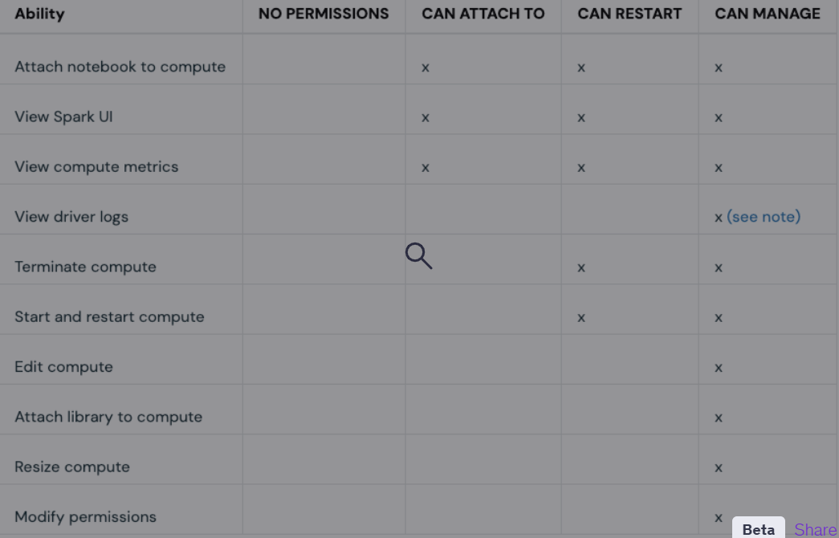
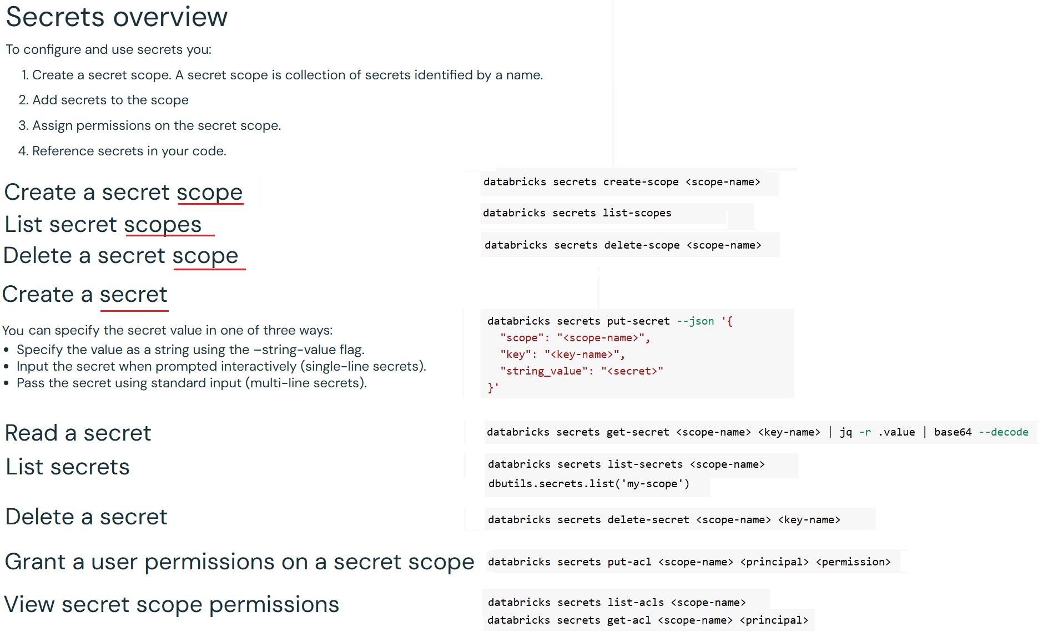

- Command for Apply ROW FILTER
ALTER TABLE <Table Name> SET ROW FILTER <Filter Function Name> ON (<Column Name>);

- Command for Apply MASKING
ALTER TABLE <Table Name> ALTER COLUMN <Column Name> SET MASK <Masking Function Name>;

Liquid Clustering
- Enable liquid clustering on an existing unpartitioned Delta table using the following syntax:
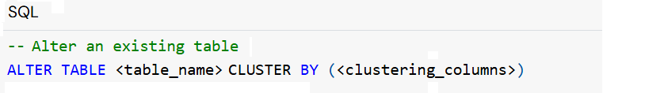

- The default behaviour does not apply clustering to previously written data. To force re-clustering for all records, you must use OPTIMIZE FULL.
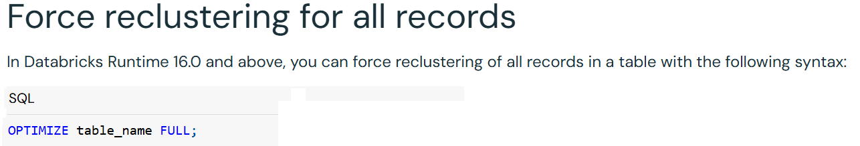

- For Apache Iceberg, you must explicitly disable deletion vectors and Row IDs when enabling liquid clustering on an existing managed Iceberg table.

- To remove clustering keys, use the following syntax:
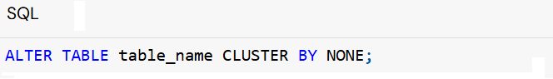

- Log files are deleted automatically and asynchronously after checkpoint operations and are not governed by VACUUM. While the default retention period of log files is 30 days, running VACUUM on a table removes the data files necessary for time travel.
- Example syntax for VACCUM
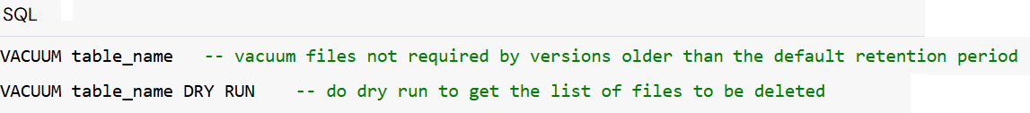

Vaccum
In Databricks Runtime 18.0 and above, use the deletedFileRetentionDuration table property to control retention.
- Log files are deleted automatically and asynchronously after checkpoint operations and are not governed by VACUUM. While the default retention period of log files is 30 days, running VACUUM on a table removes the data files necessary for time travel.
- Example syntax for VACCUM

- In Databricks Runtime 18.0 and above, use the deletedFileRetentionDuration table property to control retention.

Automatic Liquid Clustering
Enable or Disable Liquid Clustering
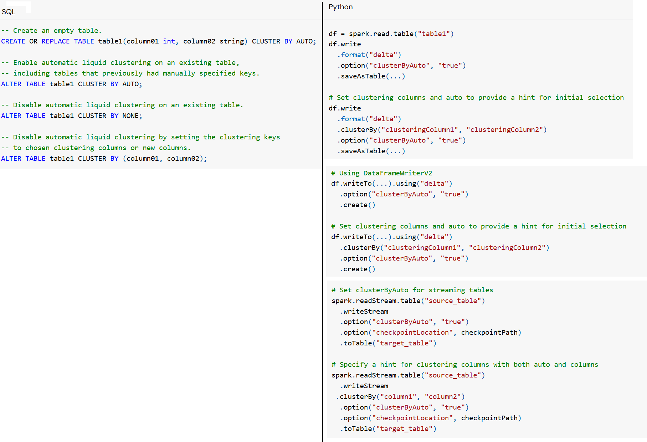

Optimize

When to run OPTIMIZE
- Auto compaction and optimized writes each reduce small file problems, but are not a full replacement for OPTIMIZE.
- Especially for tables larger than 1 TB, Databricks recommends running OPTIMIZE on a schedule to further consolidate files.
- Databricks does not automatically run ZORDER on tables, so you must run OPTIMIZE with ZORDER to enable enhanced data skipping.

Auto compaction
- Auto compaction combines small files within table partitions to automatically reduce small file problems.
- Auto compaction occurs after a write to a table has succeeded and runs synchronously on the cluster that has performed the write.
- Auto compaction only compacts files that haven't been compacted previously.
- Control the output file size by setting the Spark Configuration parameters
  - spark.databricks.delta.autoCompact.maxFileSize for Delta
  - spark.databricks.iceberg.autoCompact.maxFileSize for Iceberg
- Enable auto compaction at the TABLE or SESSION level using the following settings:
  - Table property: autoOptimize.autoCompact
  - SparkSession setting:
    - spark.databricks.delta.autoCompact.enabled (Delta)
    - spark.databricks.iceberg.autoCompact.enabled (Iceberg)

Optimized writes
- Optimized writes improve file size as data is written and benefit subsequent reads on the table.
- Optimized writes are most effective for partitioned tables, as they reduce the number of small files written to each partition.
- Writing fewer large files is more efficient than writing many small files, but you might still see an increase in write latency because data is shuffled before being written.
- Optimized writes can be enabled at the TABLE or SESSION level using the following settings:
  - Table property: autoOptimize.optimizeWrite
  - SparkSession setting:
    - spark.databricks.delta.optimizeWrite.enabled (Delta) OR
    - spark.databricks.iceberg.optimizeWrite.enabled (Iceberg)
- These settings accept the following options:
Options | Behaviour
true | Use 128 MB as the target file size.
false | Turns off optimized writes. Can be set at the session level to override auto compaction for all tables modified in the workload.

A data engineer is using the following spark configurations in a pipeline to enable Optimized Writes and Auto Compaction:

spark.conf.set("spark.databricks.delta.optimizeWrite.enabled", True)
spark.conf.set("spark.databricks.delta.autoCompact.enabled", True)

They also want to enable Z-order indexing with Auto Compaction to leverage data skipping on all the pipeline’s tables.
Which of the following solutions allows the data engineer to complete this task?

- Use spark.conf.set("spark.databricks.delta.autoZorder.enabled", True)
- Z-order indexing with Auto Compaction can only be enabled on each table separately using:
ALTER TABLE table_name SET TBLPROPERTIES (delta.autoOptimize.zorder.enabled = true)
- Use spark.conf.set("spark.databricks.delta.autoCompact.zorder.enabled", True)
- There is no way to enable Z-order indexing with Auto Compaction since it does not support Z-Ordering

Overall explanation
Auto Compaction does not support Z-Ordering as Z-Ordering is significantly more expensive than just compaction.

