# **Snowflake Database Replication & Fail-Over/Failback**

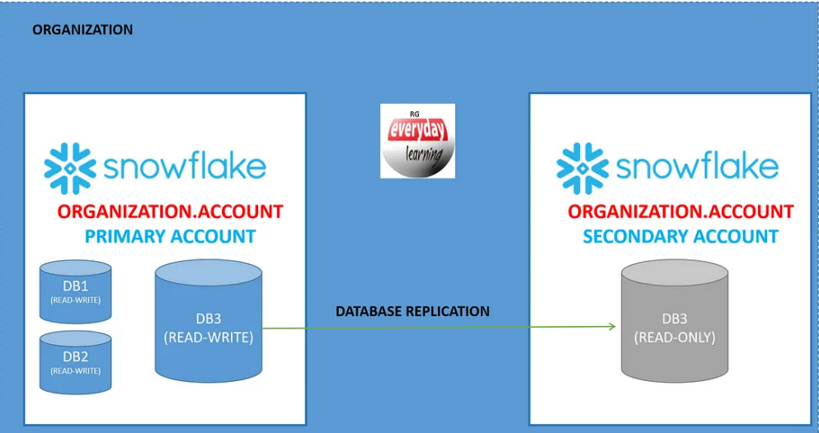

* In Snowflake, we set up one primary **snowflake account**, and then we replicate the data to one or many secondary accounts.
* In event of DR (Disaster Account) we switch between primary & secondary to support continuity of business for our organization.

## **What is Primary and Secondary Database?**

Primary Database

* When you enable the database replication for any existing database in a snowflake account that database is known as **Primary database**.
* **Primary database is a read-write database** where we perform all our operation and then get that replicated to secondary database.
* We can have many numbers of primary database, and we can replicate the same database to as many secondary accounts.

Secondary Database

* When you create the replica of primary database into any no of target account across or same region for same or different cloud provider snowflake account than it is termed as **secondary database**.
* **Secondary database is a read-only copy of the database** unless you fail over to secondary account.

**Note:** We can enable replication for any existing permanent or transient database.

## **What is Database Replication?**

* When any organization wants to replicate or sync any database from one account to another account within the same organization automatically across region and even across cloud provider.
* Replicated copy of database in secondary or target account is always read-only copy, and we will not be able to perform any DML or DDL operation on them.
* Database replication is a standard feature and available to all account.

## **What is Database Failover?**

* Database failover is very similar to Database replication, but Database replication only replicates or sync the database from one account to another account within the same organization but in the event of disaster in primary database it will not switch to secondary database for business continuity. To do that you need to set up the database failover.
* Database failover allows you to replicate the database to the target account as well as failover to a secondary database in event of disaster.
* It also supports to make secondary database as primary and start the database replication in reverse order once required.

## **What is Database Fail back?**

* Database fail back is the situation when your original primary database is now recovered and ready to be set for usage.
* Once you are sure that both primary and secondary database are in sync and there is no difference between them than you can switch back to original primary account using database failover feature.

## **What is Replication Groups and Failover Group?**

* A ***replication group*** is a defined collection of objects in a source account that are replicated as a unit to one or more target accounts. Replication groups provide read-only access for the replicated objects.
* A ***failover group*** is a replication group that can also fail over.
  + A **secondary failover group** in a target account provides read-only access for the replicated objects.
  + When a secondary failover group is promoted to become the **primary failover group**, read-write access is available.
  + Any target account specified in the list of allowed accounts in a failover group can be promoted to serve as the primary failover group.
* Replication and failover groups provide point-in-time consistency for the objects on the target account.

### **Replicated Database Objects**

* When a **primary database** is replicated, a snapshot of its database objects and data is transferred to the **secondary database**. However, some database objects are not replicated.
* The following table indicates which database objects are replicated to a secondary database.