
BRAILLE PATTERN BASED MOBILE OPERATING SYSTEM FOR BLIND AND VISUALLY
IMPAIRED PEOPLE

A PROJECT REPORT

Submitted by

J.ANANDHAMOORTHY (421111104003)

in partial fulfillment for the award of the degree

of

BACHELOR OF ENGINEERING

in

COMPUTER SCIENCE AND ENGINEERING

IFET COLLEGE OF ENGINEERING, CHENNAI

ANNA UNIVERSITY:: CHENNAI 600 025

MAY 2013

ANNA UNIVERSITY::CHENNAI 600 025

BONAFIDE CERTIFICATE

Certified that this project report “BRAILLE PATTERN BASED MOBILE OPERATING SYSTEM FOR BLIND AND VISUALLLY IMPAIRED PEOPLE” is the bonafide work of “J.ANANDHAMOORTHY” who carried out the project work under my supervision.

SIGNATURE SIGNATURE
Mrs.P. Kanimozhie M.Tech. Mrs.P. Kanimozhie M.Tech
HEAD OF THE DEPARTMENT, ASSISTANT PROFESSOR,
Computer Science and Engineering, Computer Science and Engineering,
IFET College of Engineering IFET Collge of Engineering ,
Villupuram-605108, Villupuram-605108

Submitted for the ANNA UNIVERSITY examination held on _________________

INTERNAL EXAMINER EXTERNAL EXAMINER

ACKNOWLEDGEMENT

Our sincere thanks to our honorable founder and chairman Mr.K.V.RAJA, our respected principle Dr.G.MAHENDRAN, M.TECH, Ph.D and our respected Head of the Department of Computer Science and Engineering Mrs.P.Kanimozhie, M.Tech. for giving us the opportunity to display our professional skills through this project.

We are greatly thankful to our project coordinator and guide Mrs.P.Kanimozhie, M.Tech Assistant Professor, Department of Computer Science and Engineering, for her valuable guidance and motivation, which helped us to complete this project on time.

We thank all our teaching and non-teaching staff members of the Computer Science department for their passionate support, for helping us to identify our mistakes and also for the appreciation they gave us in achieving our goal. We heartily thank our library staff and management for their extensive support by providing the information and resources that helped us to complete the project successfully. Also, we would like to record our deepest gratitude to our parents for their constant encouragement and support which motivated us to complete our project on time.

TABLE OF CONTENTS

CHAPTER NO. TITLE PAGE NO.

ABSTRACT 6
LIST OF TABLE 8

LIST OF FIGURES 8
LIST OF SYMBOLS 9

- INTRODUCTION 10
  - Brief history of MODEL PREDICTIVE
CONTROL 12
- THE RECEDING HORIZON
- OPTIMIZATION PROBLEM 16
  - Objective Function 19
  - Models 20
  - Finite step response 20
  - Finite impulse response 20
- DYNAMIC MATRIX CONTROL 22
- INTERNAL MODEL CONTROL 26
- MODEL PREDICTIVE CONTROL Vs.
DYNAMIC MATRIX CONTROL 28
- Implementation of MODEL PREDECTIVE
CONTROL in MATLAB 30
  - Van DE Vusse Reactor (continous stirred 30
Tank reactor)
  - INFERENCE 36
  - Introduction of noise to MODEL 39 PREDITIVE CONTROL
- Implementation of NEURAL NETWORK
PRECTIVE CONTROL in MATLAB 47
  - System Identification 47
  - Neural Network Predictive Control 48
  - Neural Network Architecture 50
  - Using the NN Predictive Control Block 51
  - Steps to Execute NN predictive Control 53
in MATLAB
- CONCLUSION 61
- REFERENCE 63

Braille Pattern Based Mobile Operating System for Blind and Visually Impaired People
ABSTRACT

Braille Pattern is a way the blind and visually impaired people to use the smartphone technology. Braille pattern increases the ability of visually impaired people to read and write the alphabets and numbers. In this project Braille pattern based mobile operating system as helpful for blind and visually impaired people to access and use the FirefoxOs powered smartphone. Nine dot braille input is used here to get the blind and visually impaired user input by touching the smartphone display. Then, the pattern will be searched in the database and perform the action corresponding to the pattern like opening the music application and play the music by one touch and change the song, here speech recognition is used to call any numbers in the contact list. This application will clearly interact with the blind and visually impaired people, and speak out ongoing process by providing a convenience to the visually impaired people. By all this way blind and visually impaired people can easy use the smartphone technology independently. FirefoxOS is the free and opensource operating system, can modify and redistribute it under the GPL licence. Here FIrefoxOS is the base operating system for BrailleOs.

ABSTRACT

This project thesis provides a brief overview of Model Predictive Control (MPC).A brief history of industrial model predictive control technology has been presented first followed by a some concepts like the receding horizon, moves etc. which form the basis of the MPC. It follows the Optimization problem which ultimately leads to the description of the Dynamic Matrix Control (DMC).The MPC presented in this report is based on DMC. After this the application summary and the limitations of the existing technology has been discussed and the next generation MPC, with an emphasis on potential business and research opportunities has been reviewed. Finally in the last part we generate Matlab code to implement basic model predictive controller and introduce noise into the model. Originally developed to meet the specialized control needs of power plants and petroleum refineries, MPC technology can now be found in a wide variety of application areas including chemicals, food processing, automotive, and aerospace applications Its reason for success is many, like it handles multivariable control problems naturally. But the most important reason for its success is its ability to handle constraints. Model predictive control (MPC) refers to a class of computer control algorithms that utilize an explicit process model to predict the future response of a plant. At each control interval an MPC algorithm attempts to optimize future plant behavior by computing a sequence of future manipulated variable adjustments. The first input in the optimal sequence is then sent into the plant, and the entire calculation is repeated at subsequent control intervals. The basic MPC controller can be designed with proper restrictions on the prediction horizon and model length. The prediction horizon has to be kept sufficiently larger than control horizon. But after applying to many other applications we find as the complexity increases then we need techniques other than DMC like generalized predictive control (GPC) which are better.
this paper also presents a predictive control strategy based on neural network model of the plant is applied to Continuous Stirred Tank Reactor (CSTR). This system is a highly nonlinear process; therefore, a nonlinear predictive method, e.g., neural network predictive control, can be a better match to govern the system dynamics. In the paper, the NN model and the way in which it can be used to predict the behavior of the CSTR process over a certain prediction horizon are described, and some comments about the optimization procedure are made. Predictive control algorithm is applied to control the concentration in a continuous stirred tank reactor (CSTR), whose parameters are optimally determined by solving quadratic performance index using the optimization algorithm. An efficient control of the product concentration in cstr can be achieved only through accurate model. Here an attempt is made to alleviate the modeling difficulties using Artificial Intelligent technique such as Neural Network. Simulation results demonstrate the feasibility and effectiveness of the NNMPC technique.

LIST OF TABLES

Table 1: ANN Parameters for CSTR modeling.

LIST OF FIGURES

Fig2.1. The receding horizon concept showing Optimization Problem.
Fig4.1. Block diagram of Dynamic Matrix Control (DMC)
Fig5. Block diagram of Internal Model Control (IMC)
Fig6. Block Diagram of Model Predictive Control (MPC)
Fig7.1. Output after applying MPC to the Van De Vusse Reactor
Fig7.2 Output after applying MPC to the Van De Vusse Reactor with P=15.
Fig7.2.1. Output after applying MPC to the Van De Vusse Reactor with N=70 we find that N=50 gives better results than N=70.the performance degrades sharply as N increases.
Fig7.3. Input and output disturbances with measurement Noise
Fig7.3.1. Output after adding Input and output disturbances with measurement Noise

Fig8.1. Shows prediction error between the plant output and the neural network output is used as the neural network training signal

Fig8.1.2. Shows structure of the neural network plant model
Fig8.2. NNMPC principle applied to CSTR chemical process
Fig8.3: ANN model of the CSTR
Fig8.4. Sample Block diagram of cstr
Fig8.5. Show predcstr(simulink nn model predictive control of cstr)
Fig8.5.1. Show a neural network predictive control block in simulink

Fig8.5.2. Show a plant identification block in simulink
Fig8.5.3. Show a plant input and output data in simulink
Fig8.5.4. Training data for NN predictive control block in simulink
Fig8.5.5. Show output of predcstr in simulink

LIST OF SYMBOLS

- φ predicted horizon
- ρ control penalty factor

- INTRODUCTION

Model predictive control systems rely on the idea of obtaining control values for process inputs by solving an on-line optimization problem. That problem is usually formulated with the help of a process model and measurements. At each control interval, an optimization algorithm attempts to determine the plant dynamics by computing a sequence of control input values satisfying the control specifications. The first control input in the sequence is applied to the plant, and the entire calculation is repeated at subsequent control intervals. When a realistic model of the plant is considered, the nonlinearities inherent to the process cannot be avoided and the quality of linear MPC diminishes because of the incapability of the linear model to approximate the real process. In some cases, the influence of nonlinear dynamics effects is so important that the use of nonlinear model predictive control (NMPC) is unavoidable. These observations have lead to the creation of NMPC, in which a more realistic model of the system is implemented for prediction and optimization. When introducing a dynamic nonlinear model within the NMPC algorithm, the complexity of the optimal control problem increases significantly. One of the most important part in a Model Predictive Control (MPC) algorithm is the optimization [2]. With the increase in calculation speed of hardware, it is now possible or, if not, it will soon be possible to use powerful optimization tools in an on line setup such as MPC.
Another important characteristic, which contributes to the success of the MPC technique, is that the MPC algorithms consider plant behavior over a future horizon in time. Thus, the effects of both feedforward and feedback disturbances can be anticipated and eliminated, fact which permits the controller to drive the process output more closely to the reference trajectory. The classical MBPC algorithms use linear models of the process to predict the output of the process over a certain horizon, and to evaluate a future sequence of control signals in order to minimize a certain cost function that takes account of the future output prediction errors over a reference trajectory, as well as control efforts. Although industrial processes especially continuous and batch processes in chemical and petrochemical plants usually contain complex nonlinearities, most of the MPC algorithms are based on a linear model of the process and such predictive control algorithms may not give rise to satisfactory control performance [3, 4]. Linear models such as step response and impulse response models are preferred, because they can be identified in a straightforward manner from process test data. In addition, the goal for most of the applications is to maintain the system at a desired steady state, rather than moving rapidly between different operating points, so a precisely identified linear model is sufficiently accurate in the neighborhood of a single operating point. As linear models are reliable from this point of view, they will provide most of the benefits with MPC technology. Even so, if the process is highly nonlinear and subject to large frequent disturbances; a nonlinear model will be necessary to describe the behavior of the process. Also in servo control problems where the operating point is frequently changing, a nonlinear model of the plant is indispensable. In situations like the ones mentioned above, the task of obtaining a high-fidelity model is more difficult to build for nonlinear processes.
In recent years, the use of neural networks for nonlinear system identification has proved to be extremely successful [5-9]. The aim of this paper is to develop a nonlinear control technique to provide high-quality control in the presence of nonlinearities, as well as a better understanding of the design process when using these emerging technologies, i.e., neural network control algorithm. The combination of neural networks and model-based predictive control seems to be a good choice to achieve good performance in the control. In this paper, we will use an optimization algorithm to minimize the cost function and obtain the control input. The paper analyses a neural network based nonlinear predictive controller for a Continuous Stirred Tank Reactor (CSTR), which is a highly nonlinear process. The procedure is based on construction of a neural model for the process and the proper use of that in the optimization process.
This paper begins with an introduction about the predictive control and then the description of the nonlinear predictive control and the way in which it is implemented. The neural model and the way in which it can be used to predict the behavior of the CSTR process over a certain prediction horizon are described, and some comments about the optimization procedure are made. Afterwards, the control aims, the steps in the design of the control system, and some simulation results are discussed.

  - Brief history of model predictive control

This section presents an abbreviated history of industrial MPC technology. Control algorithms are emphasized here because relatively little published information is available on the identification technology.
The development of modern control concepts can be traced to the work of Kalman in the early 1960's, who sought to determine when a linear control system can be said to be optimal [, ]. Kalman studied a Linear Quadratic Regulator (LQR) designed to minimize an quadratic objective function. The process to be controlled can be described by a discrete-time, deterministic linear state-space model:

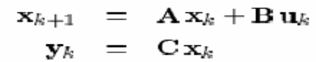

The vector represents process inputs, or manipulated variables; vector describes process output measurements. The vector represents process states. Figure 1 provides a schematic representation of a state space model. The state vector is defined such that knowing its value at time k and future inputs allows one to predict how the plant will evolve for all future time. Much of the power of Kalman's work relies on the fact that this general process model was used. The objective function to be minimized penalizes squared input and state deviations from the origin and includes separate state and input weight matrices and to allow for tuning trade-offs:

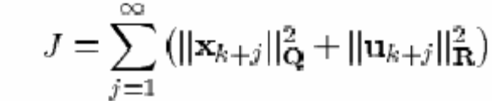

where the norm terms in the objective function are defined as follows:

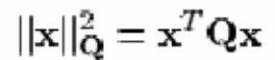

Implicit in the representation is the assumption that all variables are written in terms of deviations from a desired steady-state. The solution to the LQR problem was shown to be a proportional controller, with a gain matrix computed from the solution of a matrix Ricatti equation:
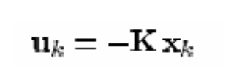
The infinite prediction horizon of the LQR algorithm endowed the algorithm with powerful stabilizing properties; it was shown to be stabilizing for any reasonable linear plant (stablizable and detectable) as long as the objective function weight matrices Q and R are positive definite. A dual theory was developed to estimate plant states from noisy input and output measurements, using what is now known as a Kalman Filter. The combined LQR controller and Kalman filter is called a Linear Quadratic Gaussian (LQG) controller. Constraints on the process inputs, states and outputs were not considered in the development of LQG theory. Although LQG theory provides an elegant and powerful solution to the problem of controlling an unconstrained linear plant, it had little impact on control technology development in the process industries. The most significant of the reasons cited for this failure include [, ] :
• constraints
• process nonlinearities
• model uncertainty (robustness)
• unique performance criteria
• Cultural reasons (people, education, etc.)
It is well known that the economic operating point of a typical process unit often lies at the intersection of constraints []. A successful industrial controller must therefore maintain the system as close as possible to constraints without violating them. In addition, process units are typically complex, nonlinear, constrained multivariable systems whose dynamic behavior changes with time due to such effects as changes in operating conditions and catalyst aging. Process units are also quite individual so that development of process models from fundamental physics and chemistry is difficult to justify economically. Indeed the application areas where LQG theory had a more immediate impact, such as the aerospace industry, are characterized by physical systems for which it is technically and economically feasible to develop accurate fundamental models. Process units may also have unique performance criteria that are difficult to express in the LQG framework, requiring time dependent output weights or additional logic to delineate different operating modes. However the most significant reasons that LQG theory failed to have a strong impact may have been related to the culture of the industrial process control community at the time, in which instrument technicians and control engineers either had no exposure to LQG concepts or regarded them as impractical. This environment led to the development, in industry, of a more general model based control methodology in which the dynamic optimization problem is solved on-line at each control execution. Process inputs are computed so as to optimize future plant behavior over a time interval known as the prediction horizon. In the general case any desired objective function can be used. Plant dynamics are described by an explicit process model which can take, in principle, any required mathematical form. Process input and output constraints are included directly in the problem formulation so that future constraint violations are anticipated and prevented. The first input of the optimal input sequence is injected into the plant and the problem is solved again at the next time interval using updated process measurements. In addition to developing more flexible control technology, new process identification technology was developed to allow quick estimation of empirical dynamic models from test data, substantially reducing the cost of model development. This new methodology for industrial process modeling and control is what we now refer to as Model Predictive Control (MPC) technology.
In modern processing plants the MPC controller is part of a multi-level hierarchy of control functions. It is often difficult to translate the control requirements at this level into an appropriate conventional control structure. In the MPC methodology this combination of blocks is replaced by a single MPC controller.
Although the development and application of MPC technology was driven by industry, it should be noted that the idea of controlling a system by solving a sequence of open-loop dynamic optimization problems was not new. Propoi, for example, described a moving horizon controller in 1963 []. Lee and Markus [] anticipated current MPC practice in their 1967 optimal control text:
One technique for obtaining a feedback controller synthesis from knowledge of openloop controllers is to measure the current control process state and then compute very rapidly for the open-loop control function. The first portion of this function is then used during a short time interval, after which a new measurement of the function is computed for this new measurement. The procedure is then repeated.
There is, however, a wide gap between theory and practice. The essential contribution of industry was to put these ideas into practice on operating units. Out of this experience came a fresh set of problems that has kept theoreticians busy ever since.

- THE RECEDING HORIZON

The ‘receding horizon’ idea:
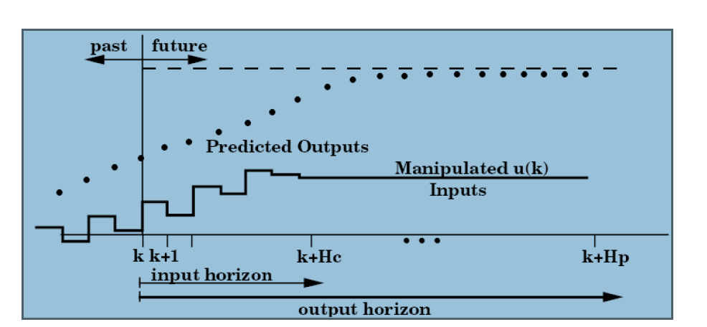

Fig2.1 The receding horizon concept showing Optimization Problem

The figure shows the basic idea of predictive control. In this presentation of the basics, we confine ourselves to discussing the control of a single-input, single-output (SISO) plant. We assume a discrete-time setting, and that the current time is labeled as time step k at the current time the plant output is y(k), and that the figure shows the previous history of the output trajectory. Also shown is a set point trajectory, which is the trajectory that the output should follow, ideally. The value of the set-point trajectory at any time t is denoted by s(t). Distinct from the set-point trajectory is the reference trajectory. This starts at the current output y(k), and defines an ideal trajectory along which the plant should return to the set-point trajectory, for instance after a disturbance occurs. The reference trajectory therefore defines an important aspect of the closed-loop behavior of the controlled plant. It is not necessary to insist that the plant should be driven back to the set-point trajectory as fast as possible, although that choice remains open. It is frequently assumed that the reference trajectory as fast as possible, although that choice remains open. It is frequently assumed that the reference trajectory approaches the set point exponentially, which we shall denote Tref, defining the speed of response. That is the current error is
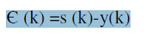
Then the reference trajectory is chosen such that the error i steps later , if the output followed it exactly, would be
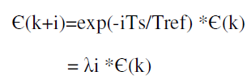
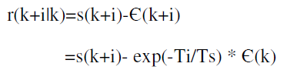
The notation r(k+i|k) indicates that the reference trajectory depends on the conditions at time k,in general. Alternative definitions of the reference trajectory are possible— For e.g. , a straight line from the current output which meets the set point trajectory after a specified time .
A predictive controller has an internal model which is used to predict the behaviour depends on the assumed input trajectory (i=0,1,…,Hp-1) that is to applied over the prediction horizon, and the idea is to select that input which promises best predicted behaviour. We shall assume that internal model is linear ; this makes the calculation of the best input relatively straightforward. The notation u rather than u here indicates that at time step k we only have a prediction of what the input at time k+i may be; the actual input at that time, u(k+i),will probably be different from .Note that we assume that we have the output measurement y(k) available when deciding, the value of the input u(k).This implies that our internal model must be strictly proper , namely that according to the model y(k) depends on the past inputs u(k-1),u(k-2), …, but not on the input u(k).
In the simplest case we can try to choose the input trajectory such as to bring output at the end of the prediction horizon, namely at time k_Hp , to the required value r(k + Hp). In this case we say, using the terminology of richalet,that we have a single coincidence point at time k+Hp. There are several input trajectories 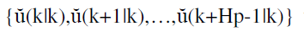 which achieve this , and we could choose one of them , for example the one which requires smallest input energy. But is usually adequate , and in a fact preferable, to impose some simple structure o the input
trajectory, parameterized by a smaller number of variables. The figure shows the input assumed to vary over the first three steps of the prediction horizon, but to remain constant thereafter: .In this case there is only one equation to be satisfied ---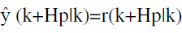--- there is a unique solution.
Once a future input trajectory has been chossen, only the first element of that trajectory is applied as the input signal to the plant. That is , we set , where u(k) denotes the actual input signal applied. Then the whole cycle of output measurement is repeated, prediction, and input trajectory determination is repeated., one sampling interval later: a new output measurement y(k+1) is obtained ;a new reference trajectory r(k+i|k+1)(i=2,3,…,) is defined ; predictions are made over the horizon k+1+I,with i=1,2,…Hp; a new trajectory ,with i=0,1,…,Hp-1) is chosen; and finally the next input is applied to the plant : .Since the horizon prediction remains of the same length as before, but slides along by one sampling interval at each step this way of controlling a plant is often called a receding horizon strategy

- OPTIMIZATION PROBLEM

The term optimization implies a best value for some type of performance criterion. This performance criterion is Known as an objective function. Here, we first discuss possible objective functions, then possible process models that can be used for MPC.
3.1. Objective Function
Here, there are several different choices for objectives functions. The first one that comes to mind is a standard least-squares or “quadratic “objective function. The objective function is a “sum of squares “ of the predicted errors (differences between the set points and model-predicted outputs) and the control moves (changes in control action from step to step).
A quadratic objective function for a prediction horizon of 3 and a control horizon of 2 can be written
Where represents the model predicted output ,r is the set point, _U is the change in manipulated input from one sample to the next ,w is a weight for the changes in the manipulated input, and the subscripts indicate the sample time (k is the current sample time ). For a prediction horizon of P and a control horizon of M,the least Squares objective function is written
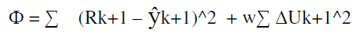
Another possible objective function is to simply take a sum of the absolute values of the predicted errors and control moves.
For a prediction horizon of 3 and a control horizon of 2, the absolute value objective function is
Which has the following general form for a prediction horizon of P and a control horizon of M;

The optimization problem solved stated as a minimization of the objective function, obtained by adjusting the M control moves, subject to modeling equations (equality constraints), and constraints on the inputs and outputs.

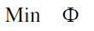
Least-squares formulations are by far the most common objective functions in MPC.Least squares yields analytical solutions for unconstrained problems and penalizes larger errors(relatively) more then smaller errors. The absolute value objective function has been used in a few algorithms because linear programming (LP) problem results.LPs are routinely solved in large-scale scheduling and allocation problems. For example, an oil company often uses an LP to decide how to distribute oil to various refineries and to decide how much and what product to produce at each plant .The LP approach is not useful for model predictive control, because the manipulated variable moves often “ hop” from one extreme constraint to another.
3.2. MODELS
Many different types of models are possible for calculating the predicted values of the process outputs, which are used in evaluating at discrete steps , it makes sense to use discrete models for the output prediction . Here, we review step and impulse response models both of which are used in common MPC algorithms.
3.3. FINITE STEP RESPONSE
FSR models are obtained by making a unit step input change to a process operating at steady state. The model coefficients are simply the output values at each time step.
Here, si represents the step response coefficients for the ith sample time after the unit step input change. If a non-unit step change is made, the output is scaled accordingly. The step response model is the vector of step response coefficients,
S=[ s1 s2 s3 s4 s5 . . . sN]’
Where the model length N is long enough so that the coefficients values are relatively constant (i.e. the process is close to a new steady state).
3.4. FINITE IMPULSE RESPONSE
Another common form of model is a finite impulse (FIR). Here , a unit pulse is applied to the manipulated input, and the model coefficients are simply the values of the outputs the ith impulse response coefficients. There is a direct relationship between step and impulse response models:
Hi=Si-Si-1
Si=Σhj
The impulse response coefficients are simply the changes in the step response coefficient at each time step. Similarly , step response coefficient is the sum of the impulse response coefficients to that point. It should be noted that there are two major limitations to step and impulse response models. They can only be used to represent open-loop stable processes, and they require a large number of parameters (model coefficients) compared to state space and transfer function models.

- DYNAMIC MATRIX CONTROL

DMC
Engineers at Shell Oil developed their own independent MPC technology in the early 1970's, with an initial application in 1973. Cutler and Ramaker presented details of an unconstrained multivariable control algorithm which they named Dynamic Matrix Control (DMC) at the 1979 National AIChE meeting [] and at the 1980 Joint Automatic Control Conference []. In a companion paper at the 1980 meeting Prett and Gillette [] described an application of DMC technology to an FCCU reactor/regenerator in which the algorithm was modified to handle nonlinearities and constraints. Neither paper discussed their process identification technology. Key features of the DMC control algorithm include:
• linear step response model for the plant
• quadratic performance objective over a finite prediction horizon
• future plant output behavior specified by trying to follow the set point as closely as possible
• optimal inputs computed as the solution to a least-squares problem

The linear step response model used by the DMC algorithm relates changes in a process output to a weighted sum of past input changes, referred to as input moves.
For the SISO case the step response model looks like:
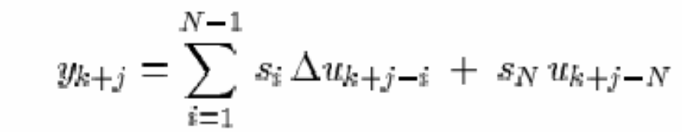
The move weights are the step response coefficients. Mathematically the step response can be defined as the integral of the impulse response; given one model form the other can be easily obtained. Multiple outputs were handled by superposition. By using the step response model one can write predicted future output changes as a linear combination of future input moves. The matrix that ties the two together is the so-called Dynamic Matrix. Using this representation allows the optimal move vector to be computed analytically as the solution to a least-squares problem. Feed forward control is readily included in this formulation by modifying the predicted future outputs. In practice the required matrix inverse can be computed off-line to save computation. Only the first row of the final controller gain matrix needs to be stored because only the first move needs to be computed.
The objective of a DMC controller is to drive the output as close to the set point as possible in a least-squares sense with a penalty term on the MV moves. This is equivalent to increasing the size of the diagonal terms in the square solution matrix prior to inversion. This results in smaller computed input moves and a less aggressive output response. As with the IDCOM reference trajectory, this technique provides a degree of robustness to model error. Prett and Gillette formalized this concept mathematically by defining move suppression factors designed to penalize excessive input movement. Move suppression factors also provide an important numerical benefit in that they can be used to directly improve the conditioning of the numerical
solution.
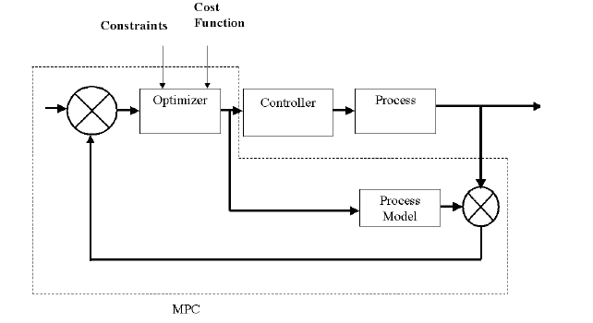
Figure 4.1.Block diagram of DMC
Cutler and Ramaker showed results from a furnace temperature control application to demonstrate improved control quality using the DMC algorithm. Feedforward response of the DMC algorithm to inlet temperature changes was superior to that of a conventional PID lead/lag compensator.
In their paper Prett and Gillette [] described an application of DMC technology to FCCU reactor/regenerator control. Four such applications were already completed and two additional applications were underway at the time the paper was written. The overall FCCU control system was implemented in a multi-level hierarchy, with a nonlinear steady-state FCCU model at the top. At the start of each optimization cycle, parameters in the nonlinear model were estimated so as to match model predictions with measured steady-state operating data. The calibrated nonlinear model was then perturbed numerically to generate partial derivatives of each process output with respect to each process input (the matrix of partial derivatives is known as the Jacobian matrix in numerical analysis). The partial derivatives were then used in a
Linear Program (LP) to compute a new economic optimal operating point for the FCCU, subject to steady-state process constraints. The optimal process input and output targets were then passed to a DMC algorithm for implementation. As soon as the DMC controller moved the unit to the new steady state the optimization cycle was repeated. This separation of the control system into constrained steady-state optimization and dynamic control is quite similar to the structure described by Richalet et al. and has since become standard in industrial control system design.
The DMC algorithm had the job of moving from the system from one optimal steadystate to another. Although the LP solution provided optimal targets for process inputs and outputs, dynamic disturbances could potentially cause the DMC algorithm to move inputs away from their optimal steady-state targets in order to keep outputs at their steady-state targets. Since moving one input away from its optimal target may be much more expensive than moving another, the control system should determine this trade-off in a rational way. The DMC algorithm was modified to account for such trade-offs by including an additional equation for each input in the process model. The new equation required that the sum of all moves for a particular input should equal the total adjustment required to bring that input to its optimal steady-state target. This allowed the inputs some freedom to move dynamically but required that the steadystate input solution be satisfied in a least-squares sense, with trade-offs determined by
the appropriate objective function weights.
Prett and Gillette described additional modifications to the DMC algorithm to prevent violation of absolute input constraints. When a predicted future input came sufficiently close to an absolute constraint, an extra equation was added to the process model that would drive the input back into the feasible region. These were referred to as time variant constraints. Because the decision to add the equation had to be made on-line, the matrix inverse solution had to be recomputed at each control execution. Prett and Gillette developed a matrix tearing solution in which the original matrix inverse could be computed off-line, requiring only the matrix inverse corresponding to active time variant constraints to be computed on-line.
The initial IDCOM and DMC algorithms represent the first generation of MPC technology; they had an enormous impact on industrial process control and served to
define the industrial MPC paradigm.
Summarizing the main steps involved in implementing DMC on a process are as follows:
1. Develop a discrete step response model with length N based on sample time _t.
2. Specify the prediction(P) and control (M) horizons.N≥P≥M
3. Specify the weighting on the control action(w=0 if no weighting on the control
action(w=0 if no weighting).
4. All calculations assume deviation variable form, so remember to convert to/from
physical units.
The effect of all these tuning parameters is now discussed for SISO systems.
Model-length and sample-time selection are independent. The model length should be approximately the ‘settling time’ of the process, that is, the time required to reach a new steady state after a step input change. For most systems, the model length isroughly 50 coefficients. The sample time is usually on the order of one tenth the dominant time constant, so the model length is roughly the settling time of the process.
Prediction and control horizons differ in length. Usually, the prediction horizon is selected to be much longer than the control horizon. This is particularly true if the control weighting factor is selected to be zero. Usually, if the prediction horizon is much longer than the control horizon, the control system is less sensitive to model error. Often P=20 or so , while M=1-3. Control weighting is often step to zero if the prediction horizon is much longer the control horizon. As the control horizon is increased, the control moves tend to become more aggressive so larger weight is needed to penalize the control moves.

- INTERNAL MODEL CONTROL

IMC
The IMC design procedure is a two step approach that although sub-optimal in a general norm sense, provides a reasonable tradeoff between performance and robustness. The main benefit of the IMC approach is the ability to directly specify the complementary sensitivity and sensitivity functions η and ∈, directly specify the nature of the closed loop response. The IMC design procedure consists of two main steps. The first step will ensure that q is stable and casual ; the second step will require q to be proper. An IMC model provides a practical tool to influence dynamic performance and robustness to modeling errors transparently in the design. IMC philosophy realizes on that control can be achieved only if the control system encapsulates either implicitly or explicitly some representation of the process to be controlled. If the controlled scheme has been developed based on an exact model of the process, then perfect control is possible.
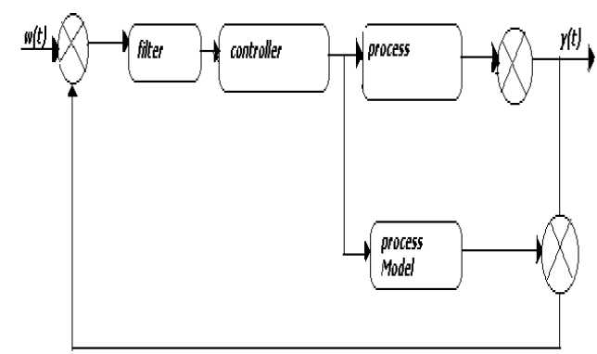
Fig5. Block diagram of Internal Model Control (IMC)
In IMC control law is easy to implement and requires little computation, its derivation is more complex. We consider a problem of tracking a set point sequence {r(k)},possibly in the presence of deterministic disturbances which might occur randomly, and whose effect must be cancelled(regulation).The desired dynamical behavior of the control system is chosen to be given by a stable reference model. In this paper the reference model is selected for process with a delay d and order n; a suitable linear reference model is given by
Where r denotes the set point and yr the output of the reference model, and where:
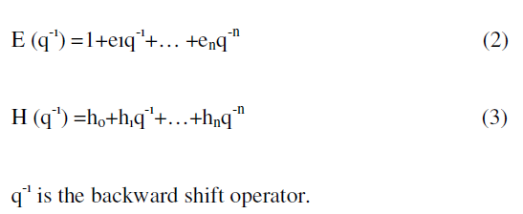

- MODEL PREDICTIVE CONTROL Vs.
DYNAMIC MATRIX CONTROL

Model predictive control is a strategy, which is based on the explicit use of some kind of processes model to predict the controlled variables over a certain time horizon, the prediction horizon. Dynamic matrix control (DMC) used here to predict future plant output, based on past and current values and on the proposed optimal future control action. These actions are calculated by the optimizer taking into account the cost function (where future tracking error is considered) as well as the constraints.
The control strategy consists of four parts:
1. At each sampling time, the value of the controlled variable y (t+k) is predicted over the prediction horizon k=1…NP.
This prediction depends on the future values of the controlled variable u(t+k) within a control horizon k=1…NU ,where NU<=NP .If NU<NP then u(t+k)=u (t+NU), k=NU+1….NP
2. A reference trajectory r (t+k), k=1…NP is defined which describes the desired process
trajectory over the prediction horizon.
3. The vector of future controls u (t+k) is computed such that a cost of function depending
on the predicted control error is minimized. The first element of the controlled variable is applied to the process.
4. The prediction error between the measured process output and the predicted output is
used for disturbance estimation.
Step 1 to 4 is repeated at each sampling instant; this is called a receding horizon strategy. We used the extended DMC algorithm to explicit use of nonlinear model in the DMC scheme. In linear DMC, the prediction of the vector of future values of the controlled variables y is performed using the dynamic matrix A, which consists of step response coefficients. At the core of MPC algorithm is a dynamic model until recently most industrial applications have relied on linear dynamic models. This dynamic models have been developed using empirical data obtained from plant testing. Linear, rather than nonlinear models have been used because of the difficulty in developing a generic nonlinear model from empirical data and also because of the computational expense involved in using nonlinear models in MPC formulations. The Model Predictive Controller is shown in the figure1 in

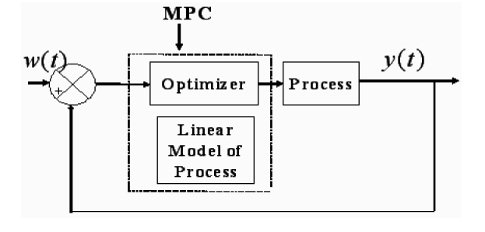

Fig6. Block Diagram of MPC
which optimizer that uses to solve the control trajectory over a future time horizon based on dynamic model of the process. The Dynamic Matrix Controller is shown in the fig 2.

- Implementation of MODEL PREDICTIVE CONTROL in MATLAB

7.1. Van DE Vusse Reactor (continous stirred Tank reactor)
Consider the Van de Vusse reactor problem. The continuous state space model is
given by
A= [ -2..4048 0; 0.8333 -2.2381];
B= [7;-1.117]
C= [0 1]
D= [ 0 ]
Where the measured state (output) is the concentration of the second component and
the manipulated input is the dilution rate.
MATLAB code:
%initialization of parameters
P=10;%prediction horizon
M=1;%control horizon
N=50;%model length
w=0.0;%weight
ysp=1;%output set point from 0
timesp=1;%time of set point change
delt=0.1;%sampling time interval
tfinal=6;%final simulation time
noise=0;
%define time
tvec=0:delt:tfinal;
ksp=fix(timesp/delt);
kfinal=length(tvec);
%define set point vector
r=[zeros(1,ksp),ones(1,(kfinal-ksp))*ysp];
%////////////////define plant as 'SISO' LTI object////////////////////////
c=input('enter plant in 1.statespace 2.transferfunction 3.polezero
4.frquencyresponse');
if c==1 a=input('enter A matrix');b=input('enter B matrix');
c=input('enter C matrix');d=input('enter D matrix');plant=ss(a,b,c,d);
elseif c==2 nump=input('enter numerator coefficients');denp=input('enter
denomenator coefficients');plant=tf(nump,denp);
elseif c==3 zero=input('enter zeroes');pole=input('enter poles');K=input('enter gain');
plant=zpk(zero,pole,K);
elseif c==4 resp=input('enter response');freq=input('enter
frequencies');plant=frd(resp,freq,'Units','Hz');
end
plant=tf(plant);
%plant=s/(s*s - 1.4*s +0.45),it is continous
%define plant parameters here
% nump=[1];
% denp=[1,-1.4,0.45];
% plant=tf(nump,denp);
%discretize the plant
plant=c2d(plant,delt);
%//////////////////define model here////////////////////////////////////
%assumption plant = model
model=plant;
% [numm,denm,tm]=tfdata(plant);
numm = get(model,'num'); numm = numm{:}; % Get numerator polynomial
denm = get(model,'den'); denm = denm{:}; % Get denominator polynomial
numm
%define step response coefficient matrix
s=step(model,0:delt:N*delt);
%define free response i.e. Sp matrix for past control moves
for i=1:P
for j=1:N-2
if(i+j<=N-1)
Sp(i,j)=s(i+j);
else
Sp(1,j)=0;
end
end
end
%define forced response i.e. Sf matrix for future and control moves
for i=1:P
for j=1:M
if i+1-j>0
Sf(i,j)=s(i+1-j);
else
Sf(i,j)=0;
end
end
end
Sf
% obtain W matrix
W=w*eye(M,M);
%obtain Kmat where Kmat=(Sf'*Sf + W)^-1*Sf'
Kmat=inv(Sf'*Sf + W)*Sf';
%piant initial conditions
ndenm=length(denm)-1;
nnumm=length(numm)-1;
umpast=zeros(1,nnumm);
ympast=zeros(1,ndenm);
% uu=zeros(1,kfinal);
% yy=zeros(1,kfinal);
% xinit=zeros(1,size(
% nump=[zeros(1,ndenp-nnump-1),nump]; % Pad numerator with leading zeros
% numm=[zeros(1,ndenm-nnumm-1),numm];
uinit=0;
yinit=0;
%initialize input vector
u=ones(1,min(P,kfinal))*uinit;
u
dist(1)=0;
y(1)=yinit;
% x(:,1)=xinit;
dup=zeros(1,N-2);
for k=1:kfinal
[m,p]=size(Kmat);
for i=1:p
if k-N+i>0
uold(i)=u(k-N+i);
else
uold(i)=0;
end
end
dvec=dist(k)*ones(1,p);
rvec=r(k)*ones(p,1);
y_free=Sp*dup' + s(N)*uold'+dvec';
E=rvec-y_free;
delup(k)=Kmat(1,:)*E;
if k>1
u(k)=u(k-1)+delup(k);
else
u(k)=delup(k)+uinit;
end
%plant equations
umpast=[u(k),umpast(1,1:length(umpast)-1)];
y(k+1)=-denm(2:ndenm+1)*ympast'+numm(2:nnumm+1)*umpast';
ympast=[y(k+1),ympast(1:length(ympast)-1)];
%model prediction
if k-N+1>0
ymod(k+1)=Sf(1,1)*delup(k)+Sp(1,:)*dup'+s(N)*u(k-N+1);
else
ymod(k+1)=Sf(1,1)*delup(k)+Sp(1,:)*dup';
end
%disturbance compensation
dist(k+1)=y(k+1)-ymod(k+1);
%additive disturbance compensation
%put input change into vector of past control moves
dup=[delup(k),dup(1,1:N-3)];
end
%stairs plotting for input(zero order hold) and setpoint
[tt,uu]=stairs(tvec,u);
[ttr,rr]=stairs(tvec,r);
figure(1)
subplot(2,1,1)
plot(ttr,rr,'--',tvec,y(1:length(tvec)))
ylabel('y');
xlabel('time');
title('plant output');
subplot(2,1,2)
plot(tt,uu)
ylabel('u');
xlabel('time');
OUTPUT IN MATLAB WINDOW
enter plant in 1.statespace 2.transferfunction 3.polezero 4.frquencyresponse1
enter A matrix[-2.4048 0;0.8333 -2.2381]
enter B matrix[7;-1.117]
enter C matrix[0 1]
enter D matrix[0]
numm =
0 -0.0751 0.1001
Sf =
0
-0.0751
-0.0940
-0.0768
-0.0376
0.0137
0.0704
0.1281
0.1840
0.2362
u = 0 0 0 0 0 0 0 0 0 0
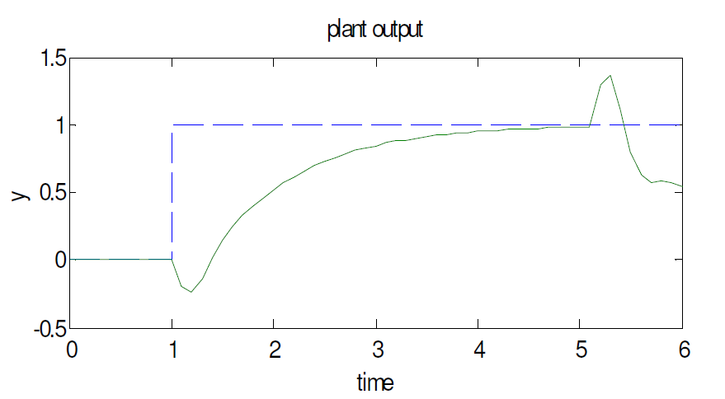
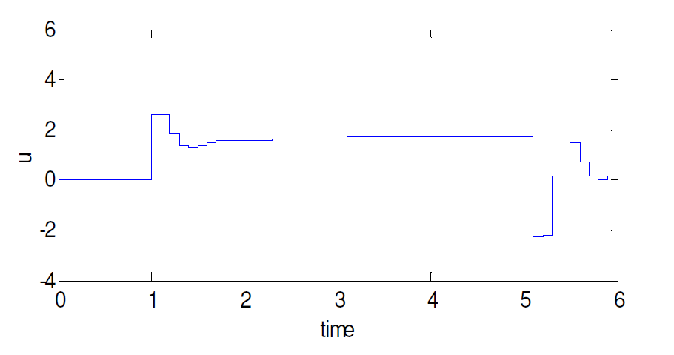
Fig7.1. Output after applying MPC to the Van De Vusse Reactor
7.2. INFERENCE
Effect of prediction horizon: If we have a fixed control horizon, then it is seen that choosing a smaller prediction horizon results set point being achieved in smaller time .However the shorter prediction horizon is more sensitive to model uncertainty.
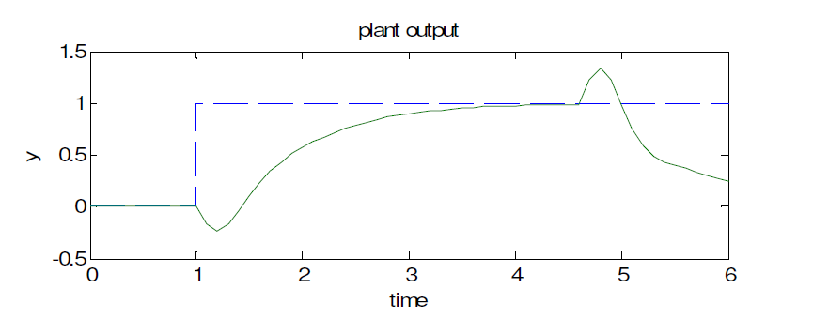
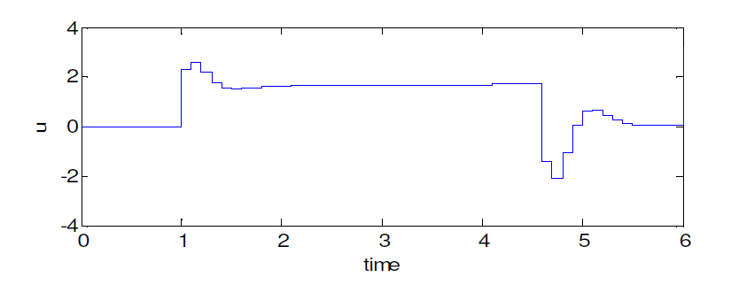
Fig7.2 Output after applying MPC to the Van De Vusse Reactor with P=15.
As seen in figure when P=15 requires much more control action compared to P=10. But still we find that prediction horizon does not have appreciable effect for this case .The performance for this case is roughly the same for P=10 and P=15.However there is a lower limit to the length of the prediction horizon below which it results in an unstable system. Here it is P=3. This is not due to any model error, since we have assumed a perfect model in these simulations. If the prediction horizon is too short, the initial step response coefficients dominate. Since these are negative while the later coefficients are positive (corresponding to a positive process gain), the predictive is really in error. The effect is the same as using a PID controller with a controller gain that is the wrong sign.
Effect of model length: Choosing a smaller model length does not capture the complete dynamics of the process. This results in a model error and poor performance.
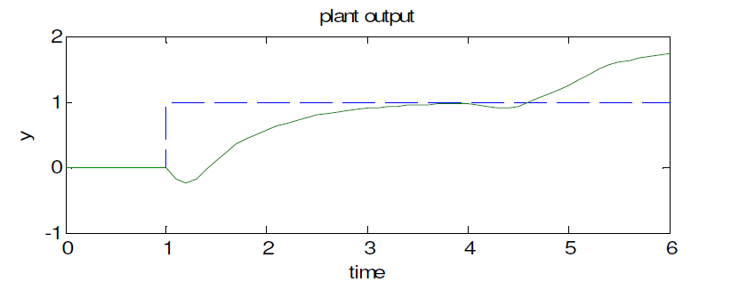

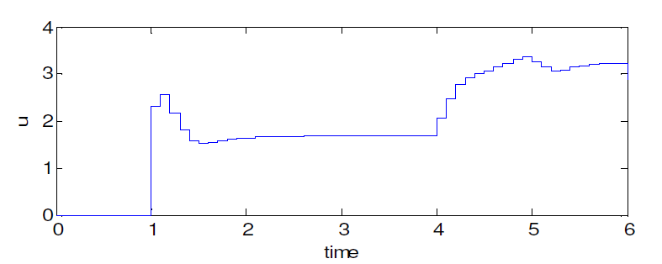
Fig7.2.1. Output after applying MPC to the Van De Vusse Reactor with N=70 we find that N=50 gives better results than N=70.the performance degrades sharply as N increases.

  - Introduction of noise to MODEL PREDITIVE CONTROL

This program provides offset tracking, but in addition simulates the effects of measurement noise, and of input and output disturbances as shown in figure

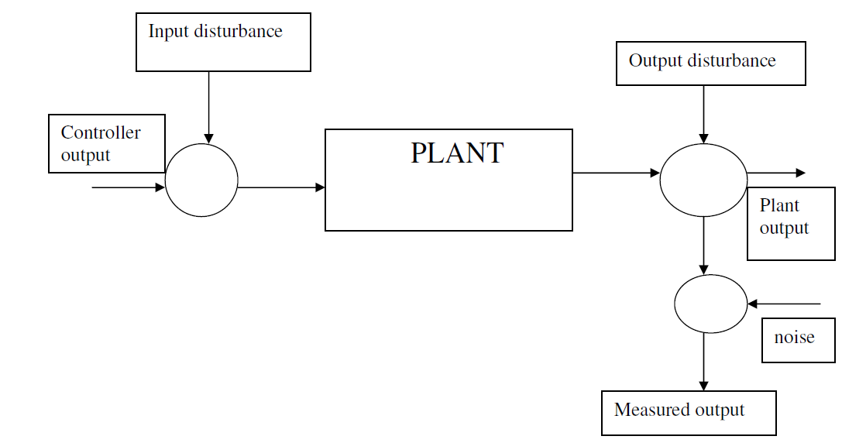

Fig7.3. Input and output disturbances with measurement Noise

MATLAB code:
%initialization of parameters
P=10;%prediction horizon
M=1;%control horizon
N=50;%model length
w=0.0;%weight
ysp=1;%output set point from 0
timesp=1;%time of set point change
delt=0.1;%sampling time interval
tfinal=4;%final simulation time
noise=0;
%define time
tvec=0:delt:tfinal;
ksp=fix(timesp/delt);
kfinal=length(tvec);
%define set point vector
r=[zeros(1,ksp),ones(1,(kfinal-ksp))*ysp];
%////////////////define plant as 'SISO' LTI object////////////////////////
c=input('enter plant in 1.statespace 2.transferfunction 3.polezero
4.frquencyresponse');
if c==1 a=input('enter A matrix');b=input('enter B matrix');
c=input('enter C matrix');d=input('enter D matrix');plant=ss(a,b,c,d);
elseif c==2 nump=input('enter numerator coefficients');denp=input('enter
denomenator coefficients');plant=tf(nump,denp);
elseif c==3 zero=input('enter zeroes');pole=input('enter poles');K=input('enter gain');
plant=zpk(zero,pole,K);
elseif c==4 resp=input('enter response');freq=input('enter
frequencies');plant=frd(resp,freq,'Units','Hz');
end
plant=tf(plant);
%plant=s/(s*s - 1.4*s +0.45),it is continous
%define plant parameters here
% nump=[1];
% denp=[1,-1.4,0.45];
% plant=tf(nump,denp);
%discritize the plant
plant=c2d(plant,delt);
%//////////////////define model here////////////////////////////////////
%assumption plant = model
model=plant;
% [numm,denm,tm]=tfdata(plant);
numm = get(model,'num'); numm = numm{:}; % Get numerator polynomial
denm = get(model,'den'); denm = denm{:}; % Get denominator polynomial
numm
%define step response coefficient matrix
s=step(model,0:delt:N*delt);
%define free response i.e. Sp matrix for past control moves
for i=1:P
for j=1:N-2
if(i+j<=N-1)
Sp(i,j)=s(i+j);
else
Sp(1,j)=0;
end
end
end
%define forced response i.e. Sf matrix for future and control moves
for i=1:P
for j=1:M
if i+1-j>0
Sf(i,j)=s(i+1-j);
else
Sf(i,j)=0;
end
end
end
Sf
% obtain W matrix
W=w*eye(M,M);
%obtain Kmat where Kmat=(Sf'*Sf + W)^-1*Sf'
Kmat=inv(Sf'*Sf + W)*Sf';
% Noise and disturbances:
sd = 0.1; % Standard deviation of measurement noise
randn('state',0); % Resets state of random number generator. Change to
% get different random sequences generated.
noise = sd*randn(kfinal,1); % Measurement noise, normal distribution,
% mean=0, standard deviation = sd.
udist = 0.1*ones(kfinal,1); % Input disturbance (default constant 0.1)
ydist = 0.1*[ones(floor(kfinal/2),1);-ones(ceil(kfinal/2),1)];
% Output disturbance (default constant +/-0.1, changing sign halfway)
%piant initial conditions
ndenm=length(denm)-1;
nnumm=length(numm)-1;
umpast=zeros(1,nnumm);
ympast=zeros(1,ndenm);
% uu=zeros(1,kfinal);
% yy=zeros(1,kfinal);
% xinit=zeros(1,size(
% nump=[zeros(1,ndenp-nnump-1),nump]; % Pad numerator with leading zeros
% numm=[zeros(1,ndenm-nnumm-1),numm];
uinit=0;
yinit=0;
%initialize input vector
u=ones(1,min(P,kfinal))*uinit;
u
dist(1)=0;
y(1)=yinit;
% x(:,1)=xinit;
dup=zeros(1,N-2);
for k=1:kfinal
[m,p]=size(Kmat);
for i=1:p
if k-N+i>0
uold(i)=u(k-N+i)+udist(k);
else
uold(i)=0+udist(k);
end
end
dvec=ydist(k)*ones(1,p);
rvec=r(k)*ones(p,1);
dnoise=noise(k)*ones(1,p);
y_freed=Sp*dup' + s(N)*uold'+dvec';
y_free=y_freed+dnoise';
E=rvec-y_free;
delup(k)=Kmat(1,:)*E;
if k>1
u(k)=u(k-1)+delup(k);
else
u(k)=delup(k)+uinit;
end
%plant equations
umpast=[u(k)+udist(k),umpast(1,1:length(umpast)-1)];
y(k+1)=-denm(2:ndenm+1)*ympast'+numm(2:nnumm+1)*umpast';
ympast=[y(k+1),ympast(1:length(ympast)-1)];
%model prediction
if k-N+1>0
ymod(k+1)=Sf(1,1)*delup(k)+Sp(1,:)*dup'+s(N)*u(k-N+1);
else
ymod(k+1)=Sf(1,1)*delup(k)+Sp(1,:)*dup';
end
%disturbance compensation
dist(k+1)=y(k+1)-ymod(k+1);
%additive disturbance compensation
%put input change into vector of past control moves
dup=[delup(k),dup(1,1:N-3)];
end
%stairs plotting for input(zero order hold) and setpoint
[tt,uu]=stairs(tvec,u);
[ttr,rr]=stairs(tvec,r);
figure(1)
subplot(2,1,1)
% Plot output, solid line and set-point, dottedd line:
plot(tvec,y(1:length(tvec)),'-',tvec,y(1:length(tvec))+noise',':',... ttr,rr,'--');
grid;
title(...
'Plant output (solid), Measured output (dotted) and set-point (dashed)')
xlabel('Time')
subplot(212)
% plot input signal as staircase graph:
plot(tt,uu,'-');
hold on;
plot(tvec,u+udist',':')
grid;
title('Controller output (solid), Plant input (dotted)')
xlabel('Time')
output in Matlab window
enter plant in 1.statespace 2.transferfunction 3.polezero 4.frquencyresponse1
enter A matrix[-2.4048 0;0.8333 -2.2381]
enter B matrix[7;-1.117]
enter C matrix[0 1]
enter D matrix[0]
numm =
0 -0.0751 0.1001
Sf =
0
-0.0751
-0.0940
-0.0768
-0.0376
0.0137
0.0704
0.1281
0.1840
0.2362
u =
0 0 0 0 0 0 0 0 0 0
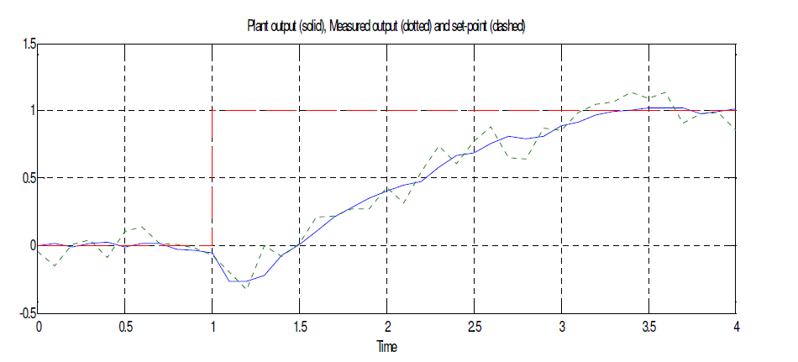

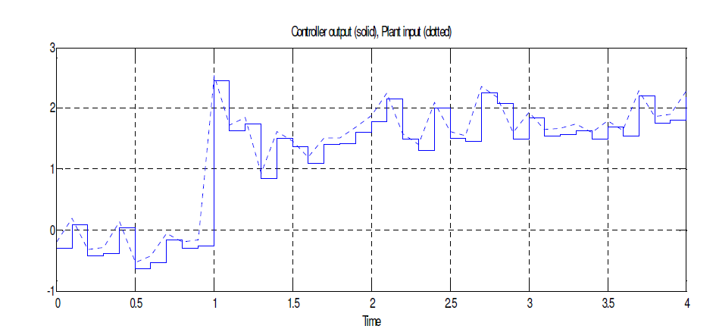

Fig7.3.1. Output after adding Input and output disturbances with measurement Noise

8. Implementation of NEURAL NETWORK PREDICTIVE CONTROL in MATLAB

  - System Identification
The first stage of model predictive control is to train a neural network to represent the forward dynamics of the plant. The prediction error between the plant output and the neural network output is used as the neural network training signal. The process is represented by the following figure
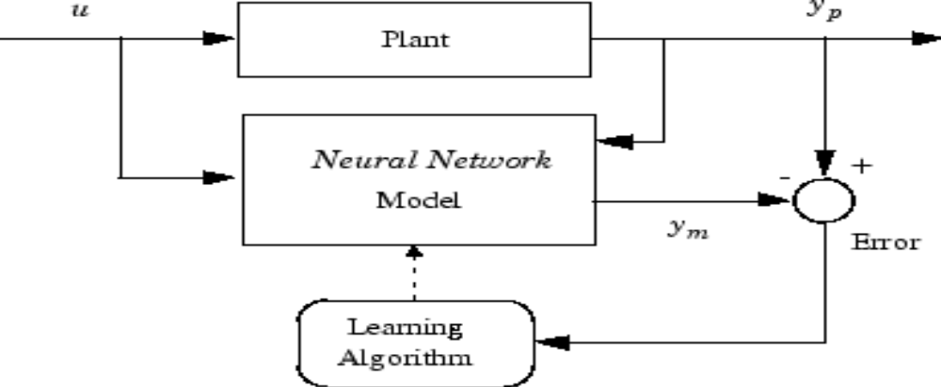
Fig8.1. Shows prediction error between the plant output and the neural network output is used as the neural network training signal
The neural network plant model uses previous inputs and previous plant outputs to predict future values of the plant output. The structure of the neural network plant model is given in the following figure.
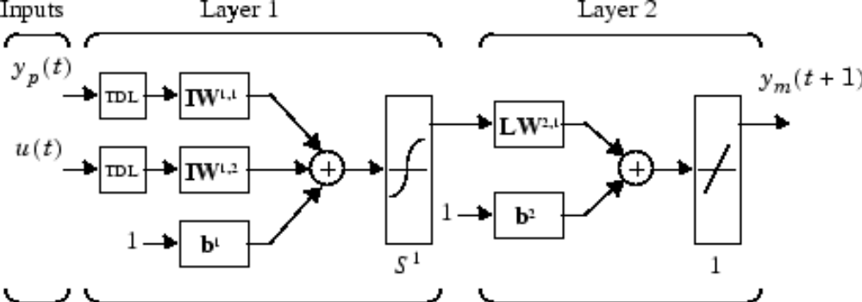
Fig8.1.2. Shows structure of the neural network plant model

This network can be trained offline in batch mode, using data collected from the operation of the plant. You can use any of the training algorithms used in matlab library. This process is discussed in more detail later in this chapter.
  - Neural Network Predictive Control
By the knowledge of the identified neural model of the nonlinear plant which is capable of doing multi step ahead predictions, Predictive control algorithm is applied to control nonlinear process. The idea of predictive control is to minimize cost function, J at each sampling point:
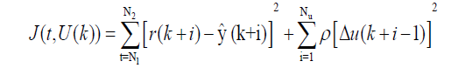

With respect to the Nu future controls,
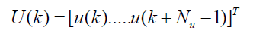
and subject to constraints:
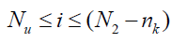
Using the predictive control strategy with identified NARX model (NNMPC) it is possible to calculate the optimal control sequence for nonlinear plant. Here, term r(k+i) is the required reference plant output, is predicted NN model output, is the control increment, N1 and N2 are the minimum and maximum prediction (or cost) horizons, Nu is the control horizon, and ρ is the control penalty factor.
The predictive control approach is also termed as a receding horizon strategy, as it solves the above-defined optimization problem for a finite future, at a current time and implements the first optimal control input as the current control input. The vector is calculated by minimizing cost function, J at each sample k for selected values of the control parameters {N1, N2, Nu, r}.
These control parameters defines the predictive control performance. N1 is usually set to a value 1 that is equal to the time delay, and N2 is set to define the prediction horizon i.e. the number of time-steps in the future for which the plant response is recursively predicted.

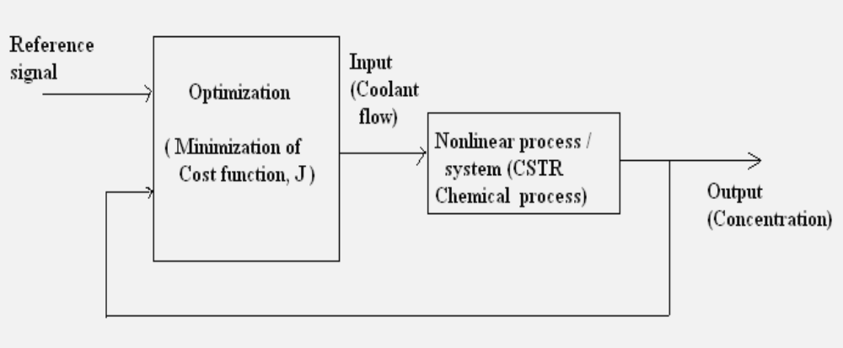

Fig8.2. NNMPC principle applied to CSTR chemical process
The minimization of criterion, J in NNMPC is an optimization problem minimized iteratively. Similar to NN training strategies, iterative search methods are applied to determine the minimum.
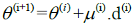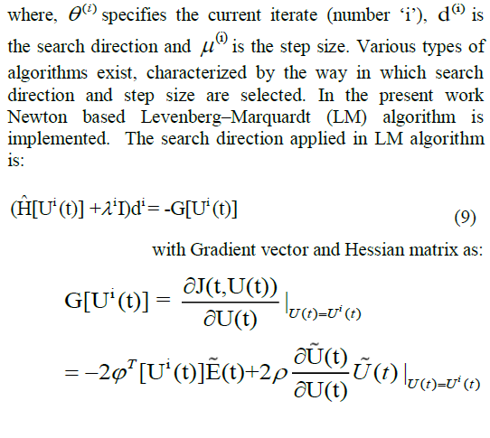

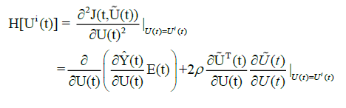
where B(i) specifies the approximation of the inverse Hessian and G[U(i)(t)] is the gradient of the J with respect to the control inputs. The most popular formula known as Broyden- Fletcher-Goldfarb-Shanno (BFGS) algorithm to approximate the inverse Hessian is used here.
8.3. Neural Network Architecture
The feed forward network with sigmoidal activation function was chosen based on the trials with different structures of multilayer perceptron.
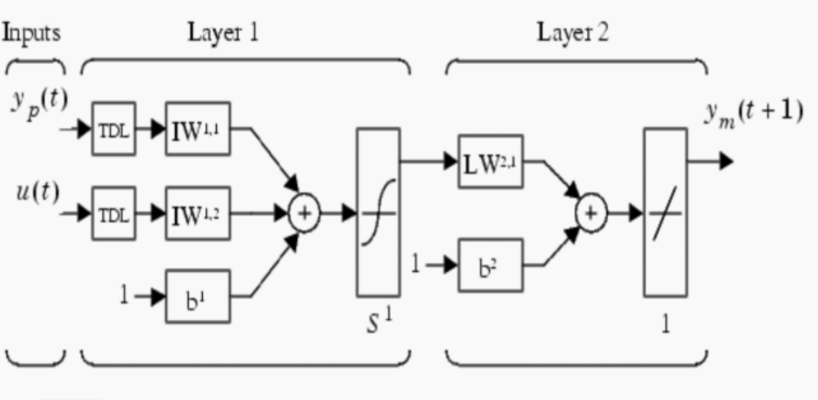
Fig8.3: ANN model of the CSTR
The lowest error corresponds to 7 neurons in the hidden layer. Hence it is selected as optimal architecture of ANN. The ANN selected here consists of 4 neurons in the input layer, 7 neurons in the hidden layer and one neuron in the output layer. The ANN architecture used in the present work is shown in Figure 3. The training algorithm used in the CSTR modeling is back propagation algorithm. Before training the process weights are initialized to small random numbers. The weights are adjusted till error gets minimized for all training sets. When the error for the entire set is acceptably low, the training is stopped.

Table 2 shows the parameters used in developing the ANN model for the CSTR
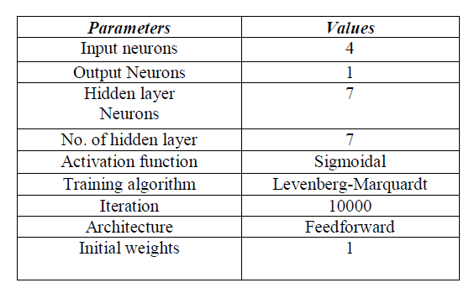
Table 1: ANN Parameters for CSTR modeling

8.4. Using the NN Predictive Control Block
This section shows how the NN Predictive Controller block is used. The firststep is to copy the NN Predictive Controller block from the Neural Network Toolbox block library to the Simulink Editor. See the Simulink documentation if you are not sure how to do this. This step is skipped in the following example.
An example model is provided with the Neural Network Toolbox software to show the use of the predictive controller. This example uses a catalytic Continuous Stirred Tank Reactor (CSTR). A diagram of the process is shown in the following figure.

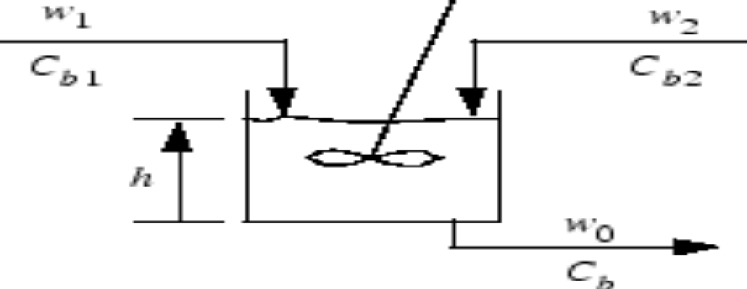
Fig8.4. sample Block digram of cstr
The dynamic model of the system is
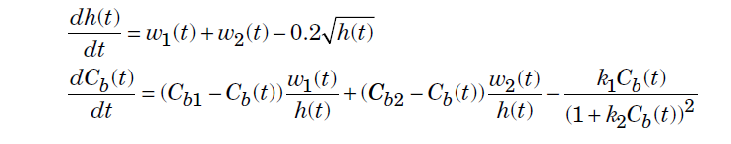
where h(t) is the liquid level, Cb(t) is the product concentration at the output of the process, w1(t) is the flow rate of the concentrated feed Cb1, and w2(t) is the flow rate of the diluted feed Cb2. The input concentrations are set to Cb1 = 24.9 and Cb2 = 0.1. The constants associated with the rate of consumption are k1 = 1 and k2 = 1.
The objective of the controller is to maintain the product concentration by adjusting the flow w1(t). To simplify the example, set w2(t) = 0.1. The level of the tank h(t) is not controlled for this experiment
  - Steps to Execute NN predictive Control in MATLAB

To run this,
Step 1: Start MATLAB.
Step 2: Type predcstr in the MATLAB Command Window. This command opens
the Simulink Editor with the following model.
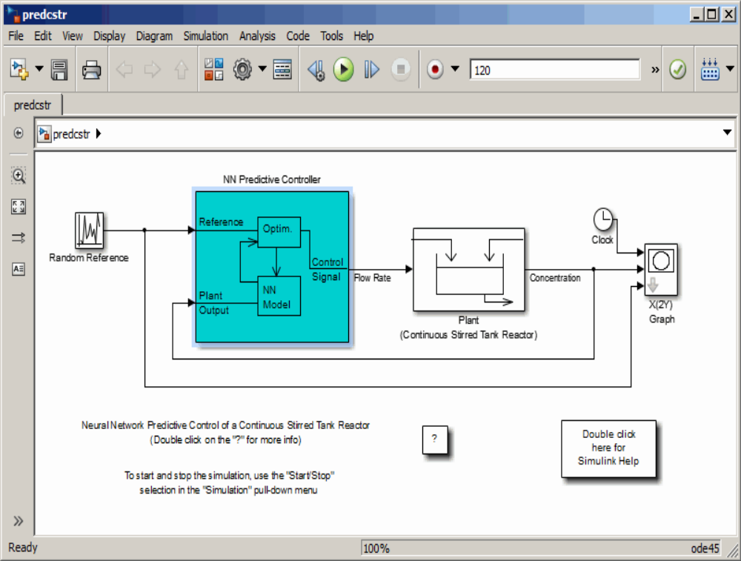

Fig8.5. Show predcstr(simulink nn model predictive control of cstr)

The Plant block contains the Simulink CSTR plant model. The NN
Predictive Controller block signals are connected as follows:
• Control Signal is connected to the input of the Plant model.
• The Plant Output signal is connected to the Plant block output.
• The Reference is connected to the Random Reference signal
Step 3: Double-click the NN Predictive Controller block. This opens the following
window for designing the model predictive controller. This window enables
you to change the controller horizons N2 and Nu. (N1 is fixed at 1.) The
weighting parameter ρ, described earlier, is also defined in this window.
The parameter α is used to control the optimization. It determines how
much reduction in performance is required for a successful optimization
step. You can select which linear minimization routine is used by the
optimization algorithm, and you can decide how many iterations of the
optimization algorithm are performed at each sample time.

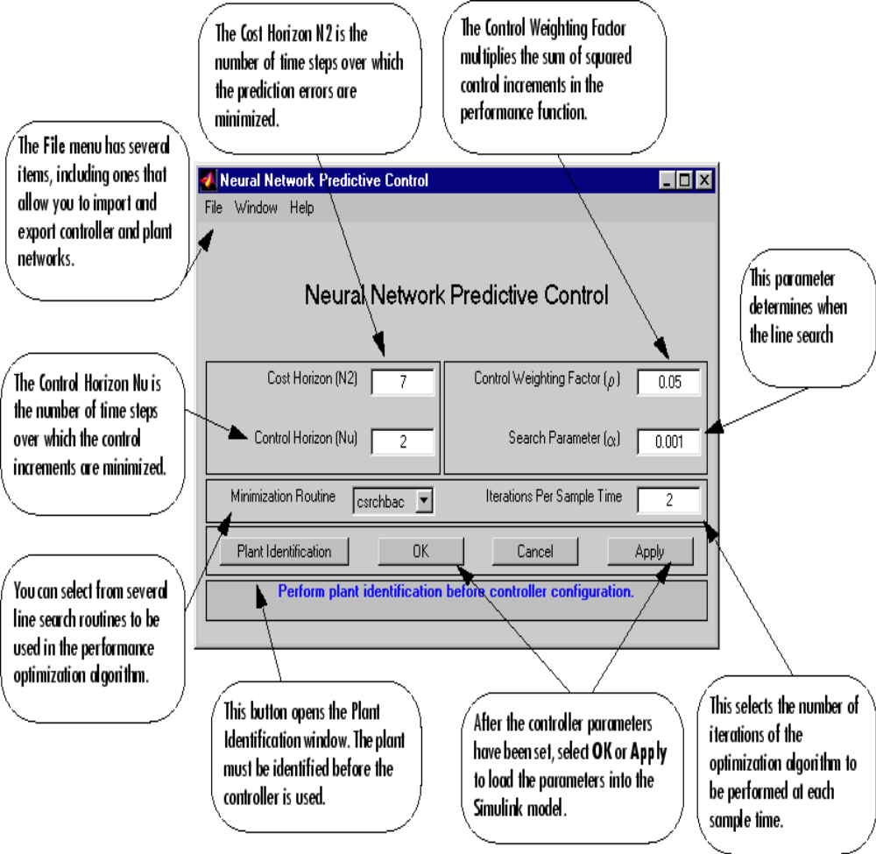
Fig8.5.1. Shows a neural network predictive control block in simulink

Step 4: Select Plant Identification. This opens the following window. You must
develop the neural network plant model before you can use the controller.
The plant model predicts future plant outputs. The optimization algorithm
uses these predictions to determine the control inputs that optimize future
performance. The plant model neural network has one hidden layer, as
shown earlier. You select the size of that layer, the number of delayed
inputs and delayed outputs, and the training function in this window. You
can select any of the training functions to train the neural network
plant model.
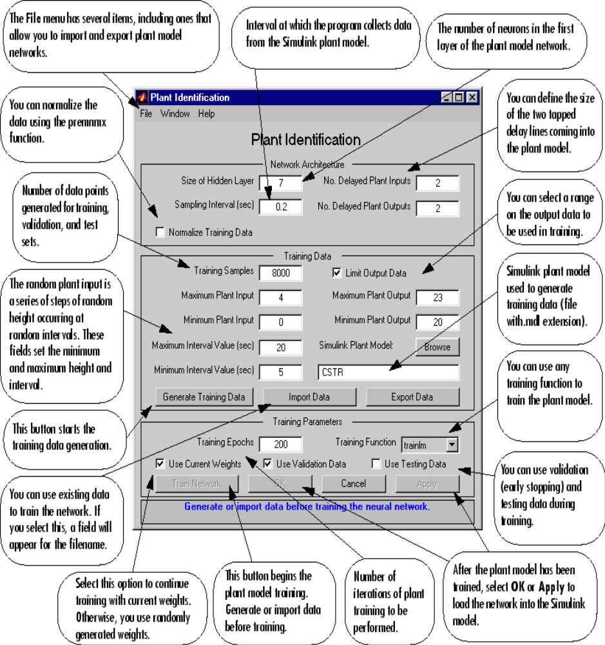
Fig8.5.2. Show a plant identification block in simulink
Step 5: Select the Generate Training Data button. The program generates
training data by applying a series of random step inputs to the Simulink
plant model. The potential training data is then displayed in a figure
similar to the following.
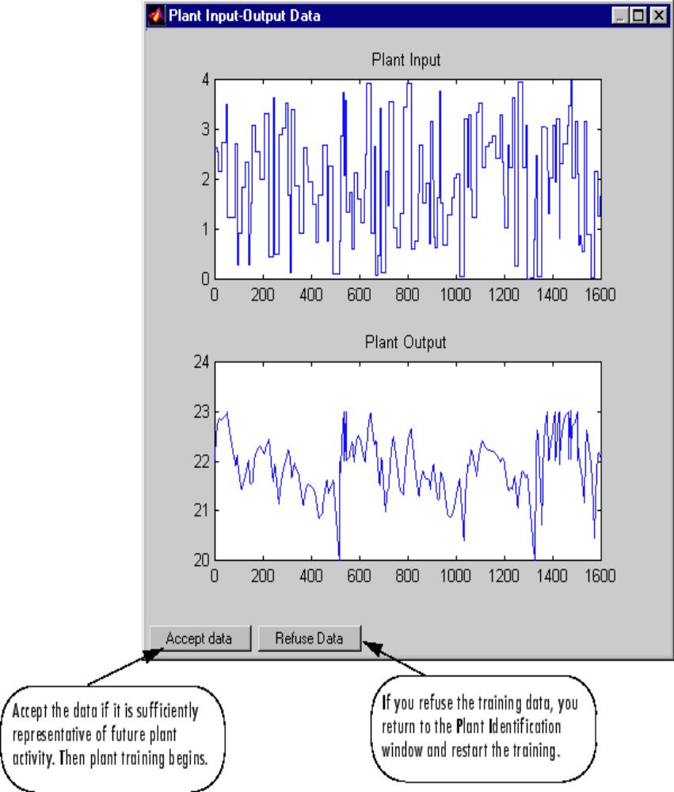
Fig8.5.3. Show a plant input and output data in simulink

Step 6: Select Accept Data, and then select Train Network from the Plant
Identification window. Plant model training begins. The training proceeds
according to the training algorithm (trainlm in this case) you selected.
This is a straightforward application of batch training, as described in
“Multilayer Networks and Backpropagation Training” on page 2-2. After
the training is complete, the response of the resulting plant model is
displayed, as in the following figure. (There are also separate plots for
validation and testing data, if they exist.)

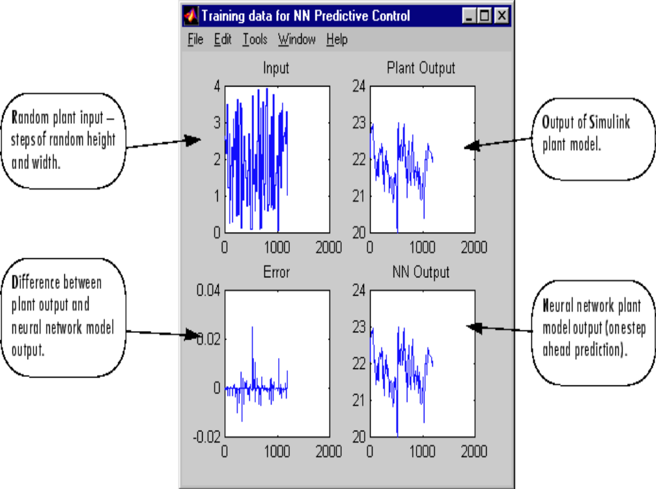

Fig8.5.4. Training data for NN predictive control block in simulink

You can then continue training with the same data set by selecting Train Network again, you can Erase Generated Data and generate a new data set, or you can accept the current plant model and begin simulating the closed loop system. For this example, begin the simulation, as shown in the following steps
Step 7: Select OK in the Plant Identification window. This loads the trained neural
network plant model into the NN Predictive Controller block.
Step 8: Select OK in the Neural Network Predictive Control window. This loads
the controller parameters into the NN Predictive Controller block
Step 9: Return to the Simulink Editor and start the simulation by choosing the
menu option Simulation > Run. As the simulation runs, the plant output
and the reference signal are displayed, as in the following figure.

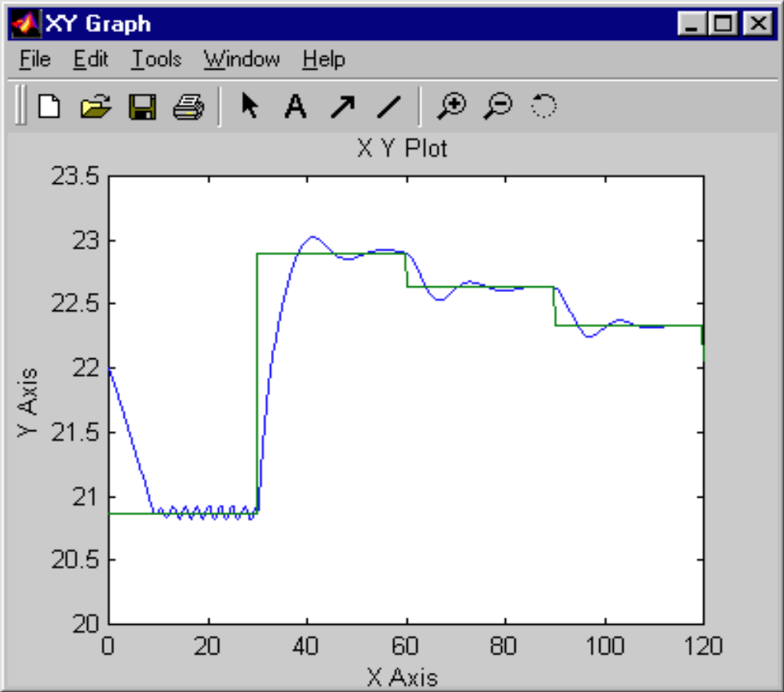
Fig8.5.5. shows output of predcstr in simulink

9.CONCLUSION

MPC technology has progressed steadily in the twenty two years since the first IDCOM and DMC applications. Survey data reveal approximately 2200 applications to date, with a solid foundation in refining and petrochemicals, and significant penetration into a wide range of application areas from chemicals to food processing. Current generation MPC technology offers significant new capabilities but the controllers still retain, for the most part, an IDCOM-like or a DMC-like personality. The SMC-Idcom and HIECON algorithms are IDCOM-like controllers which have evolved to use multiple objective functions and ranked constraints. The DMC, RMPCT and OPC algorithms are DMC-like controllers that use a single dynamic objective function to evaluate control and economic trade-offs using weighting factors. The PFC controller inherits some of the IDCOM personality but is significantly different in that it can accommodate nonlinear and unstable processes and uses basis functions to parameterize the input function.
An important observation is that industrial MPC controllers almost always use empirical dynamic models identified from test data. The impact of identification theory on process modeling is perhaps comparable to the impact of optimal control theory on model predictive control. It is probably safe to say that MPC practice is one of the largest application areas of system identification. The current success of MPC technology may be due to carefully designed plant tests.
Another observation is that process identification and control design are clearly separated in current MPC technology. Efforts towards integrating identification and control design may bring significant benefits to industrial practice. For example, uncertainty estimates from process identification could be used more directly in robust control design. Ill-conditioned process structures could be reflected in the identified models and also used in control design.
Choosing an MPC technology for a given application is a complex question involving issues not addressed in this paper. It is the opinion of the authors that for most applications, a knowledgeable control engineer could probably achieve acceptable control performance using any of the packages discussed here, although the time and effort required may differ. If the process is nonlinear or unstable, or needs to track a complex set point trajectory with no offset, the PFC algorithm may offer significant advantages. If a vendor is to be selected to design and implement the control system, it would be wise to weigh heavily their experience with the particular process in question.
Research needs as perceived by industry are mostly control engineering issues, not algorithm issues. Industrial practitioners do not perceive closed loop stability, for example, to be a serious problem. Their problems are more like: Which variables should be used for control? When is a model good enough to stop the identification plant test? How do you determine the source of a problem when a controller is performing poorly? When can the added expense of an MPC controller be justified? How do you design a control system for an entire plant? How do you estimate the benefits of a control system? Answering these questions could provide control practitioners and theoreticians with plenty of work in the foreseeable future. Several technical advances have not yet been incorporated into industrial MPC technology. These include using an infinite prediction horizon to guarantee nominal closed loop stability, and using linear estimation theory to improve output feedback. In addition, robust stability conditions have been developed for a modified QDMC algorithm. It would seem that the company which first implements these advances will have a significant marketing and technical advantage.
The future of MPC technology is bright, with all of the vendors surveyed here reporting significant applications in progress. Next-generation MPC technology is likely to include multiple objective functions, an infinite prediction horizon, nonlinear process models, better use of model uncertainty estimates, and better handling of ill conditioning.
The overall result showed the capability of employing these control strategies to control a non-linear system such as exothermic reactor (CSTR) use in this case study. Set point tracking behavior of the DMC and IMC is compared. At every change of operating condition linearization of nonlinear system is to be carried out. For nonlinear process i.e. Continues stirred tank reactor (CSTR), DMC has stable response around ingratiation point. As operating condition changes DMC became unstable. While for all set point changes, the IMC controller yields a fast response but it introduced offset. The IMC requires slightly larger but acceptable control moves. If larger control moves are acceptable, faster set point tracking can be obtained by decreasing the pole of the set point filter. Proposed IMC strategy is potentially applicable to wide class of process control problem. Some oscillatory behavior of the control at the step changes can be seen in both cases which can be reduced by using Neural Network.

10.REFERENCE

BOOK
1. Bequette B.W. “Process Control Modelling
Design and Simulation” prentice hall edition
2. MaciejowskiJ.M. “Predictive Control with
Constraints”, prentice hall edition.
3. C.Culter and B. Ramaker, “ Dynamic matrix controls: A computer control
algorithm,”Proc.1980
Joint automatic conference
4. T.Peterson, E.Hernadez, Y.Arkun and F.J.Schor, “Nonlinear predictive control of a semi
batchpolymerization reactor by an extended DMC,” Proc. 1989 American control
conference,pp
1534- 1539,1989.
5. E.Hernadez and Y. Arkun, “Neural network modeling and an extended DMC algorithm to
control
nonlinear system”, Proc.1990 American control conference, pp2454-2459, 1990.
6. S.J.Qin and T.A.Badgwel, “An overview of industrial model predictive controls technology.
In
chemical process control: Assesment and new direction for research.”
INTERNET
S. Joe Qin and Thomas A. Badgwell “An Overview of Industrial
Model Predictive Control Technology”
http://www.che.utexas.edu/~qin/cpcv/node2.html#
http://www.che.utexas.edu/~qin/cpcv/node4.html#
MIKAEL JOHANSON “Control theory and practice”
Mikael Johansson mikaelj@ee.kth.se
PDF file: William B. Dunbar “Notes on model predictive control”
dunbar@cds.caltech.edu.
PDF file: “MODEL PREDICTIVE CONTROL” by Mr. DEBADATTA PATRA,B.Tech,M.Tech

