**Smart street light system**

**INTRODUCTION:**

* 1. This project aims for designing and executing the advanced development in embedded systems for energy saving of street lights. Currently we have a manual system where the street lights will be switched ON in the evening before the sunsets and they are switched OFF in the next day morning after there is sufficient light on the outside[1]. But the actual timing for these lights to be switched ON is when there is absolute darkness. With this, the power will be wasted up to some extent. This project gives solution for electrical power wastage [2]. Also the manual operation of the lighting system is completely eliminated. The proposed system provide a solution for energy saving. This is achieved by sensing and approaching a vehicle using an IR transmitter and IR Receiver couple. Upon sensing the movement the sensor transmit the data to the microcontroller which furthermore the Light to switch ON [4]. Similarly as soon as the vehicle or an obstacle goes away the Light gets switched OFF as the sensor sense any object at the same time the status(ON/OFF) of the street light can be accessed from anywhere and anytime through internet. This project is implemented with smart embedded system which controls the street lights based on detection of vehicles or any other obstacles on the street .Whenever the obstacle is detected on the street within the specified time the light will get automatically ON/OFF according to the obstacle detection and the same information can be accessed through internet. The real time information of the street light(ON/OFF Status) can be accessed from anytime, anywhere through internet. **Reduction & Preventive measures of waste generation-** The main cause of waste formation know so far is the extensive use of unnecessary products and constant buying of new products. The rapid growth in population has also added excessive generation of waste. To control the growth of waste judiciously a conscious decision has to be taken to use all the existing products efficiently at personal and professional level.
  2. The street lighting is one of the largest energy expenses for a city. An intelligent street lighting system can cut municipal street lighting costs as much as 50% - 70%. An intelligent street lighting system is a system that adjusts light output based on usage and occupancy, i.e., automating classification of pedestrian versus cyclist, versus automotive. An intelligent street light management proposes the installation of the wireless based system to remotely track and control the actual energy consumption of the street lights and take appropriate energy consumption reduction measures through power conditioning and control [3]. The street light controller should be installed on the pole lights which consist of microcontroller along with various sensor and wireless module. The street light controller installed on the street light pole will control LED street lighting depending on traffic flow, communicate data between each street light. The data from the street light controller can be transferred to base station using wireless technology to monitor the system [5]. The mode of operation of the system can be conducted using auto mode and manual mode. The control system will switch on-off the lights at required timings and can also vary the intensity of the street light according to requirement.

## LITERATURE SURVEY

[1]System the GSM technology has been used in which the manual switching OFF/ON of the street light using GSM. Here the system controls the intensity of the street light by dimming

and brightness the intensity on the detection of any object using PIR sensor. [2] This paper is focused on the necessity of the automated street light system and the peculiar way of implementation with embedded system tools. In this system the piezo electric sensor is used to detect the movement of the object on the street instead of using IR sensor. A microcontroller msp430 as a brain to control the process involved. This paper gives a solution to the controlling the intensity of the light considering the movement on the road.

1. This project is designed to detect the vehicle movement on the highways to switch ON only a block of the street light ahead of it and switch OFF the trailing light to save energy. During the night all the lights on the highways remain ON for the vehicle, but lot of energy is wasted when there is no vehicle movement on the highways. In this paper two kind of sensors has been used which are light sensor, photo electric sensor. system is appropriate for street lighting in remote urban and rural areas where the traffic is low at times.

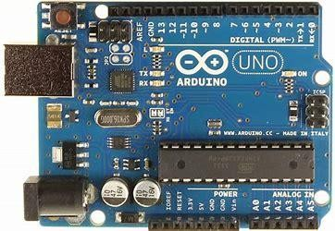

Fig.1 Arduino

1. Arduino is an open-source hardware and software company, project and user community that designs and manufactures single-board microcontrollers and microcontroller kits for building digital devices. Its hardware products are licensed under a CC-BY-SA license, while software is licensed under the GNU Lesser General Public License or the GNU General Public License, permitting the manufacture of Arduino boards and software distribution by anyone. Arduino boards are available

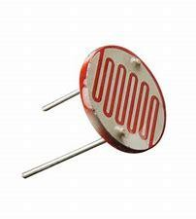

Fig.2 LDR

[5]A Light Dependent Resistor (LDR) or a photo resistor is a device whose resistivity is a function of the incident electromagnetic radiation. Hence, they are light sensitive devices. They are also called as photo conductors, photo conductive cells or simply photocells. They are made up of semiconductor materials having high resistance. A light dependent resistor works on the principle of photo conductivity. Photo conductivity is an optical phenomenon in

which the materials conductivity (Hence resistivity) reduces when light is absorbed by the material..

## PROPOSED SYSTEM

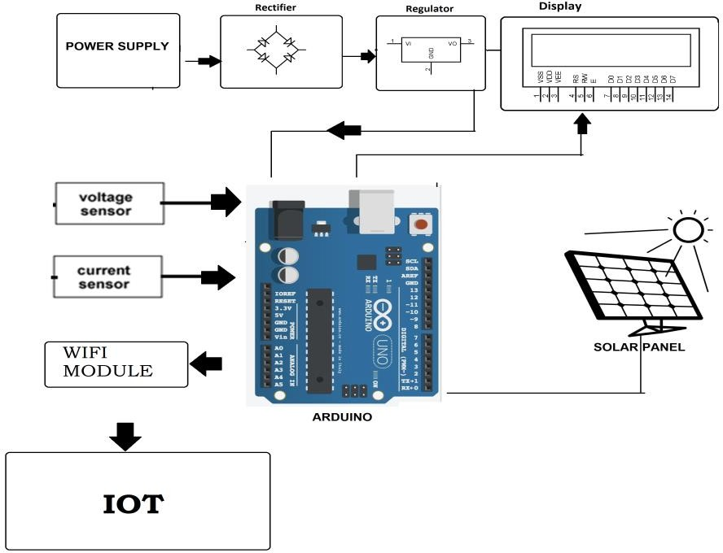

Fig.4 Working of system

[6]The system architecture of the intelligent street light system consists of IR sensors, LDR,PIC16F877A microcontroller, Relay, UART and Wifi Module. LDR‟s are light dependent devices whose resistance decreases when light falls on them and increases in the dark.

When a light dependent resistor is kept in dark, its resistance is very high. The vehicle which passes by the street light is detected by IR sensor. Relay are used as a switch to switch on/off the street light bulb. A UART (Universal Asynchronous Receiver/Transmitter) is the microchip with programming that controls a computer's interface to its attached street light system

## IMPLEMENTATION

With the advances in technology and good resource planning the cost of the project can be cut down and also with the use of good equipment the maintenance can also be reduced in terms of periodic checks. The LEDs have long life, emit cool light, donor have any toxic material and can be used for fast switching. For these reasons our project presents far more advantages which can over shadow the present limitations

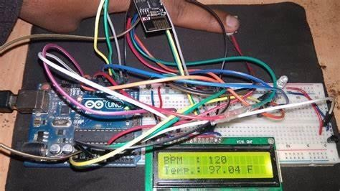

## RESULTS AND EVALUATION

The project aims were to reduce the side effects of the current street lighting system, and find a solution to save power. In this project the first thing to do, is to prepare the inputs and outputs of the system to control the lights of the street. The prototype as shown in Fig has been implemented and works as expected and will prove to be very useful and will fulfil all the present constraints if implemented on a large scale.

This IoT Based smart intelligent lighting system for smart city which includes LDR, IR Sensor, Current Sensor, PIC microcontroller, Intel Galileo Gen2 Board, Wifi Module, Relays.

## CONCLUSION

This project “IoT Based Smart Intelligent Lighting System for Smart City “ is a cost effective, practical, ecofriendly and the safest way to save energy and this system the light status information can be accessed from anytime and anywhere. It clearly tackles the two problems that world is facing today, saving of energy and also disposal of incandescent lamps, very efficiently. Initial cost and maintenance can be the draw backs of this project.

With the advances in technology and good resource planning the cost of the project can be cut down and also with the use of good equipment the maintenance can also be reduced in terms of periodic checks. The LEDs have long life, emit cool light, donor have any toxic material and can be used for fast switching. For these reasons our project presents far more advantages which can over shadow the present limitations. Keeping in view the long term benefits and the initial cost would never be a problem as the investment return time is very less. The project has scope in various other applications like for providing lighting in industries, campuses and parking lots of huge shopping malls. This can also be used for surveillance in corporate campuses and industries.

## REFERENCES

1. Archana. G, Aishwarya N, Anitha J “Intelligent Street Light System” International Journal of Recent Advances in Engineering & Technology, Vol-3, Issue-4, 2015.
2. AkshayBalachandran, Murali Siva, V. Parthasarathi, Surya and Shriram K. Vasudevan “An Innovation in the Field of Street Lighting System with Cost and Energy Efficiency”Indian Journal of Science and Technology,Vol-8, August 2015
3. DeepanshuKhandelwal, Bijo M Thomas, KritikaMehndiratta, Nitin Kumar “Sensor Based Automatic Street Lighting system” International Journal of Education and Science Research Review Volume-2, Issue-2 April- 2015
4. IsahAbdulazeez Watson, OshomahAbdulaiBraimah, Alexander Omoregie “ Design and Implementation of an Automatic Street Light Control System” International Journal of Emerging Technology and Advanced Engineering, Volume 5, Issue 3, March 2015
5. KapseSagar Sudhakar1, AbhaleAmol Anil2, Kudakechetan Ashok3, ShirsathShravan Bhaskar4 “Automatic Street Light Control System” International Journal of Emerging Technology and Advanced Engineering”Volume 3, Issue 5, May 2013
6. Mustafsaad, AbdalhalimFarij, Ahamed Salah “Automatic Street Light Control System Using Microcontroller” Mathematical method and Optimization Technique in Engineering ISBN: 978-960- 474-339-1.
7. SaksheeSrivastava, “Electronics And Communication Engineering, Institute Of Technology And Management AL-1, Sector-7, GIDA, Gorakhpur, U.P., INDIA” Advance in Electronic and Electric Engineering. ISSN 2231-1297, Volume 3, Number 5, 2013.
8. Prof. K.Y.Rajput, GargeyeeKhatav, Monica Pujari, PriyankaYadav, “International Journal of Engineering Science Invention” [www.ijesi.org](http://www.ijesi.org/) Volume 2 Issue 3 ǁ March. 2013 ǁ PP.60-69”. Volume 2, Issue 3,March. 2013.
9. L. Jasio, T. Wilmshurst, D. Ibrahim, J. Morton,M. Bates, J. Smith D. Smith and C. Hellebuyck,PIC Microcontrollers: know it all, Publishing Elsevier Science, 2008
10. K. S. Sudhakar, A. A. Anil, K. C. Ashok and S. S. Bhaskar, Automatic Street Light Control System, International Journal of Emerging Technology and Advanced Engineering, Vol. 3,May 2013.
11. Soledad Escolar, JesúsCarretero, Maria-Cristina Marinescu and Stefano Chessa “Estimating Energy Savings in Smart Street Lighting byUsing an Adaptive Control System” International Journal of Distributed Sensor NetworksVolume 2014, Article ID 971587
12. Samir A. ElsagheerMohamed “Smart Street Lighting Control and Monitoring System for Electrical Power Saving by Using VANET”,Int. J. Communications, Network and System Sciences, 2013, 6, 351-360.
13. Andrea Zanella, Senior Member, IEEE, Nicola Bui, Angelo Castellani “Internet of Things for Smart Cities” IEEE Internet Of Things Journal, vol. 1, no. 1, Feb. 2014. J.Sherly1,D.Somasundareswari