## Introduction

An Amazon **S3(Simple Storage Service) bucket** is a public cloud storage resource available in Amazon Web Services' (**AWS**) it is an object storage offering. Amazon **S3 buckets**, which are similar to file folders, store objects, which consist of data and its descriptive metadata.

## S3 bucket features

* AWS offers several features for Amazon S3 buckets. An IT professional can enable versioning for S3 buckets to preserve every version of an object when an operation is performed on it, such as a copy or delete operation.
* This helps an IT team prevent accidental deletion of an object. Likewise, upon bucket creation, a user can set up server access logs, object-level API logs, tags and [encryption](https://searchsecurity.techtarget.com/definition/encryption).
* Also, S3 Transfer Acceleration helps execute fast, secure transfers from a client to an S3 bucket via AWS [edge locations](https://searchdatacenter.techtarget.com/definition/edge-computing).
* User can specify access **privileges** for the objects stored in a bucket, through mechanisms such as the [AWS Identity and Access Management](https://searchaws.techtarget.com/definition/Amazon-Web-Services-AWS-Identity-and-Access-Management-IAM) service, bucket policies and access control lists.

## S3 bucket pricing

* Pay only for what you use. There is no minimum fee. There are **four cost components** to consider when deciding on which S3 storage class best fits your data profile – storage pricing, request and data retrieval pricing, data transfer and transfer acceleration pricing, and data management features pricing.
* For pricing details visit: <https://aws.amazon.com/s3/pricing/>

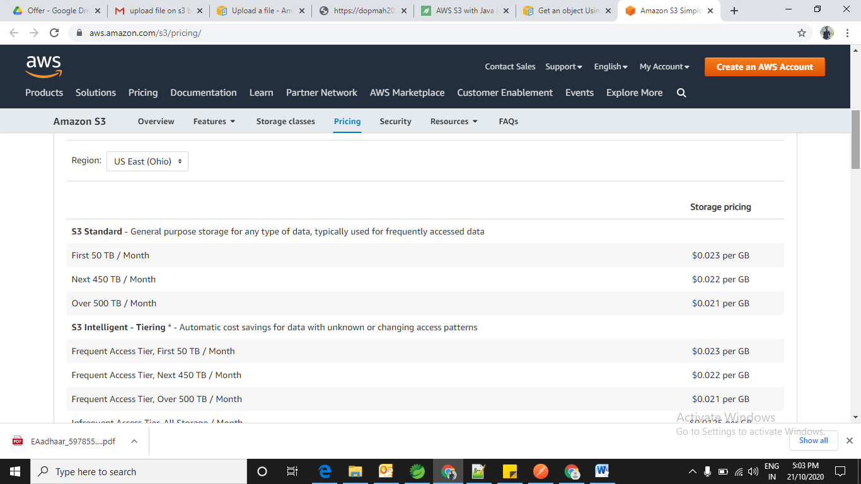

## Create an S3 Bucket

* Before you can upload data to Amazon S3, you must create a bucket in one of the AWS **Regions** to store your data. After you create a bucket, you can upload an unlimited number of data objects to the bucket.
* The AWS account that creates the bucket by default it owns it.
* You can create up to **100** buckets in each of your **AWS accounts**. If you need additional buckets, you can increase your account bucket quota to a **maximum of 1,000 buckets** by submitting a service quota increase.
* For information about how to increase your bucket quota, see [AWS Service Quotas](https://docs.aws.amazon.com/general/latest/gr/aws_service_limits.html)
* To create the buckets visit this URL: <https://docs.aws.amazon.com/AmazonS3/latest/user-guide/create-bucket.html> *.*

**Upload File (Object) S3 using java**

* Multipart upload allows you to upload a single object as a **set of parts**.
* Each part is a contiguous portion of the object's data. You can upload these object parts independently and in any order.
* If transmission of any part fails, you can retransmit that part without affecting other parts.
* After all parts of your object are uploaded, Amazon S3 assembles these parts and creates the object. In general, when your object size **reaches 100 MB**, you should consider using **multipart uploads** instead of uploading the object in a single operation.
* You need to Saves **the upload ID** that the AmazonS3Client.initiateMultipartUpload() method returns. You provide this upload ID for each subsequent multipart upload operation.
* To upload the file (**object**) in the form of **multipart**  if object size **100 MB** visit url: <https://docs.aws.amazon.com/AmazonS3/latest/dev/llJavaUploadFile.html>
* To upload the file (**object**) in single request which is **less** than 100 MB visit url:

<https://docs.aws.amazon.com/sdk-for-java/v1/developer-guide/examples-s3-objects.html#upload-object>

## Download the object

* When you download an object through the AWS SDK for Java, Amazon S3 returns all of the object's **metadata** and an input stream from which to read the object's contents.
* To get the uploaded file (object) visit the url: <https://docs.aws.amazon.com/AmazonS3/latest/dev/RetrievingObjectUsingJava.html>

## Maven Dependency

<dependency>

<groupId>com.amazonaws</groupId>

<artifactId>aws-java-sdk</artifactId>

<version>1.11.163</version>

</dependency>

**References:**

1. <https://www.baeldung.com/aws-s3-java>
2. <https://searchaws.techtarget.com/definition/AWS-bucket#:~:text=An%20Amazon%20S3%20bucket%20is,data%20and%20its%20descriptive%20metadata>.
3. <https://aws.amazon.com/s3/pricing/>
4. <https://calculator.aws/#/createCalculator>
5. <https://docs.aws.amazon.com/AmazonS3/latest/user-guide/create-bucket.html>
6. <https://docs.aws.amazon.com/AmazonS3/latest/dev/uploadobjusingmpu.html>
7. <https://docs.aws.amazon.com/AmazonS3/latest/dev/llJavaUploadFile.html>
8. <https://docs.aws.amazon.com/AmazonS3/latest/dev/uploadobjusingmpu.html>
9. <https://docs.aws.amazon.com/AmazonS3/latest/dev/RetrievingObjectUsingJava.html>

**Designed by: Anand Nandeshwar (21-10-2020)**