|  |  |  |  |  |  |  |  |
| --- | --- | --- | --- | --- | --- | --- | --- |
|  | | | | | |  | |
|  | | | | | |  | |
| Programme | : | **B. Tech.,** | Semester | : | **Summer 2023-2024** | |
| Course Title | : | **Operating Systems** | Code | : | **BCSE303L** | |
| Faculty | : | **Dr. M. Braveen** | Slot(s) | : |  | |

**DIGITAL ASSIGNMENT – 3**

1. Five batch jobs A through E, arrive at a computer center at almost the same time. They have estimated running times of 10, 6, 2, 4, and 8 minutes. Their priorities are 3, 5, 2, 1, and 4, respectively, with 5 being the highest priority. For each of the following scheduling algorithms, determine the average process turnaround time. Ignore process switching overhead.

(a Round Robin (time slot: 2 minutes)

(b) Priority Scheduling

(c) First-Come, First-Served

    (run in order 10,6,2,4 and 8)

(d) Shortest Job First

 Draw Gantt Chart and calculate completion time, average turnaround time and waiting time individually. Which scheduling algorithm is best for the above scenario? Justify your answer.

1. Cinderella is working as a system administrator for a lab having one server installed with the multiuser operating system (UNIX) along with 30 dumb terminals. According to the necessity of the resources, she purchased and connected 6 Tape Drives [TD], 3 Plotters [Plo], 4 Printers [Prin] and 2 CD Drives to the server. At a particular time, five people (A to E) entered the lab and started working. Considering the given information below:

**Resources Assigned Resources still needed**

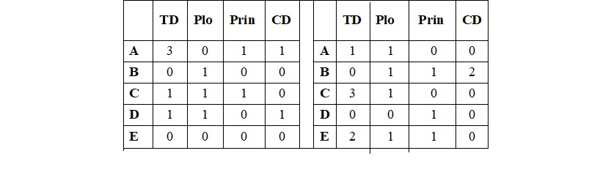

Find out whether all five persons will be able to complete their work. If so, in what order they will complete?

1. Consider a disk queue with requests for I / O to blocks on cylinders 52, 41, 126, 174, 77, 5, 97, 9. The cylinders are numbered from 0 to 199 and the head is initially at 57. Now, calculate the seek time for the above using the following disk scheduling algorithms.
   1. First Come First Served (FCFS)
   2. Shortest Seek Time First (SSTF)
   3. SCAN
   4. C-SCAN
   5. Look
   6. C-Look
2. Assume that, the system has three-page frames in main memory. It receives a series of page references in the following order: 2, 7, 3, 2, 1, 7, 6, 0, 1, 0, 3, 5, 4, 1, 5, 2, 4, 6, 7, 5. Initially, the frames are empty. Show the successive pages residing in the three frames using
   1. FIFO
   2. LRU
   3. Optimal
3. Consider five memory partitions of 200 KB, 100 KB, 300 KB, 150KB, and 400 KB (in order), how would each of the first-fit, best-fit, and worst-fit algorithms place processes of 226KB,   75 KB, 125 KB, and 380 KB (in order)? Identify the algorithm that makes the most efficient use of memory.