Conceptual

Q.1. What is Databricks
What is Databricks and how does it differ from traditional Spark?
Answer:
Databricks is a unified analytics platform built on Apache Spark that adds:
- Managed clusters
- Delta Lake for reliable data lakes
- Collaborative notebooks
- Built-in governance (Unity Catalog)
- Optimized runtime (Photon)

Traditional Spark requires manual cluster management and lacks built-in ACID, governance, and performance optimizations.

Q.2. What is Delta Lake
What is Delta Lake and why it is critical in Databricks
Answer:
Delta Lake is a storage layer that adds:
- ACID transactions
- Schema enforcement & evolution
- Time travel
- Upserts (MERGE)
- Data versioning
It solves problems like:
- Partial writes
- Corrupt data
- Concurrent reads/writes
- Reprocessing errors

Q.3. Delta Lake ACID handling
How does Delta Lake handle ACID transactions?
Answer:
Delta Lake uses:
- Transaction logs (_delta_log) stored as JSON/Parquet
- Optimistic concurrency control
- Snapshot isolation
Each write:
- Reads latest snapshot
- Writes new files
- Commits metadata atomically

Q.4. Unity Catalog
What is Unity Catalog and why is it important?
Answer:
Unity Catalog provides:
- Centralized data governance
- Fine-grained access control (row/column)
- Data lineage
- Secure cross-workspace data sharing
It replaces legacy Hive metastore and enforces governance at:
- Catalog → Schema → Table → Column level

Q.5. Managed vs External Table
Difference between Managed Tables and External Tables
Answer:
Feature | Managed Table | External Table
Data location | Databricks-managed | User-managed
Drop table | Deletes data | Data remains
Use case | Analytics, curated layers | Shared/raw data

Q.6. Optimizing Delta Table
How do you optimize Delta tables?
Answer:
Key techniques:
- OPTIMIZE → file compaction
- ZORDER BY → data skipping
- Proper partitioning
- Avoid small files
- Use Photon runtime
- Cache hot tables

Q.7. How Auto Loader Work
How does Auto Loader work?
Answer:
Auto Loader is Databricks’ incremental file ingestion mechanism.
Key features:
- Detects new files using file notification or directory listing
- Handles schema inference & evolution
- Scales to millions of files
- Supports exactly-once semantics with checkpoints
Used mainly with Structured Streaming.

Q.9. Z-Ordering
What is Z-Ordering?
Answer:
Z-Ordering co-locates related data in the same files by interleaving column values.
Benefits:
- Faster queries
- Better data skipping
- Works well for high-cardinality columns

Q.10. Structured Streaming
Explain Structured Streaming in Databricks
Answer:
Structured Streaming treats streams as unbounded tables.
Features:
- Exactly-once processing
- Event-time handling
- Stateful operations
- Checkpointing
- Supports Kafka, Auto Loader, Delta

Q.11. Checkpointing
How does checkpointing work?
Answer:
Checkpoints store:
- Offsets
- State data
- Metadata
They ensure:
- Fault tolerance
- Exactly-once processing
- Stream recovery after failures
Stored in durable storage (ADLS/S3).

Q.12. Batch vs Streaming
Difference between Batch and Streaming in Databricks
Answer:
Batch | Streaming
Finite data | Infinite data
Triggered manually | Continuous
Simpler | Stateful
Lower cost | Near-real time

Q.13. Delta Schema Evolution
How do you handle schema evolution in Delta?
Answer:
Using:
ALTER TABLE SET TBLPROPERTIES ('delta.schema.autoMerge.enabled' = true)
OR
.write.option("mergeSchema", "true")
Supports:
- Adding columns
- Nested schema changes

Q.14. Optimize vs Vacuum
Difference: OPTIMIZE vs VACUUM
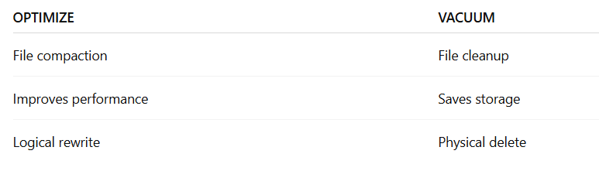

Q.15. Delta SCD-2
How do you implement SCD Type-2 in Delta?
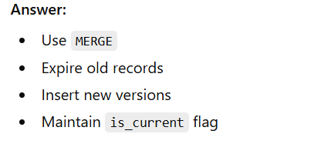

Q.16. Watermark
What is Watermark, why it is needed?
Solution:
Watermark is used in Spark Structured Streaming to define how long the engine should wait for late-arriving event-time data, allowing Spark to clean up old state and prevent unbounded memory usage
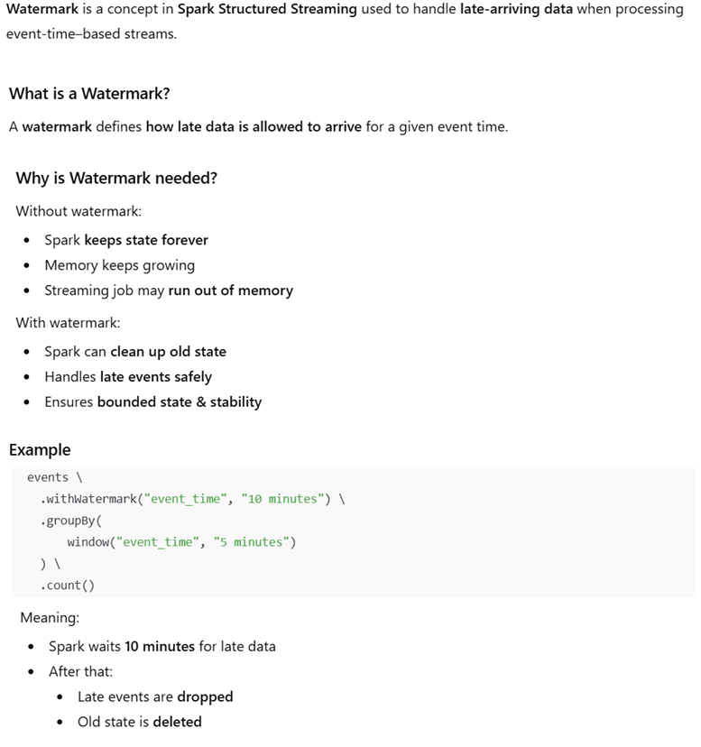

Q.17 Deletion Vector
Deletion Vector, why it is needed?
Deletion Vectors (DVs) are a Delta Lake optimization feature used to efficiently handle row-level deletes and updates without rewriting entire Parquet files.
What is a Deletion Vector?
A Deletion Vector is a bitmap that marks which rows inside a Parquet file are logically deleted.
Instead of physically removing rows, Delta records row positions to ignore during reads.
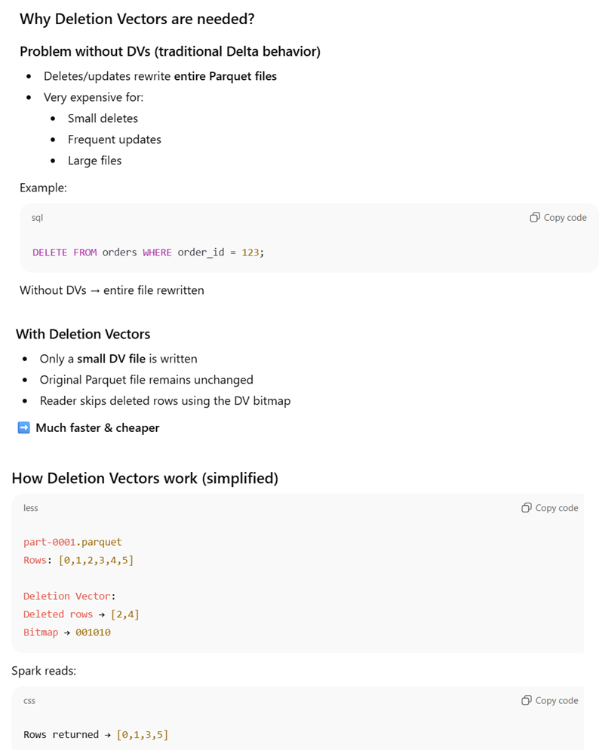

Q.18. Time Travel vs Table_Changes
Time Travel vs table_changes()
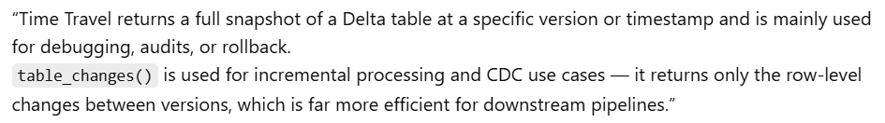
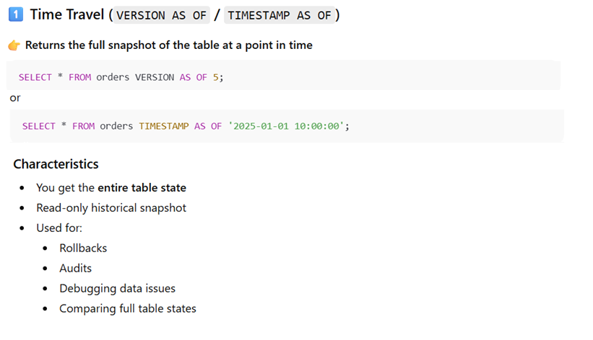
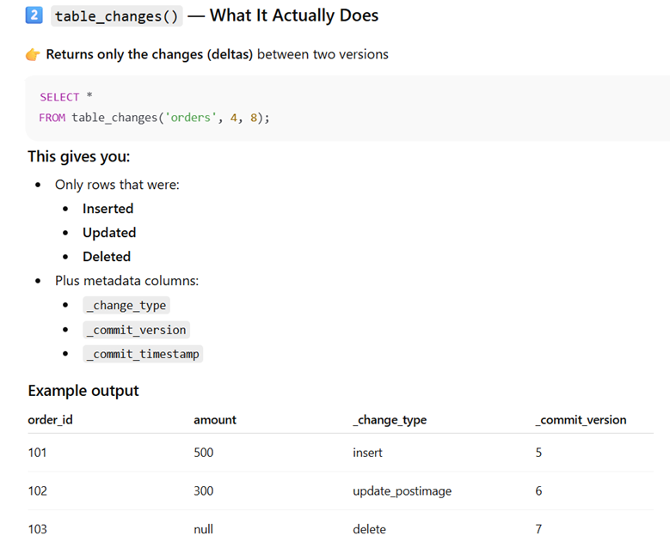
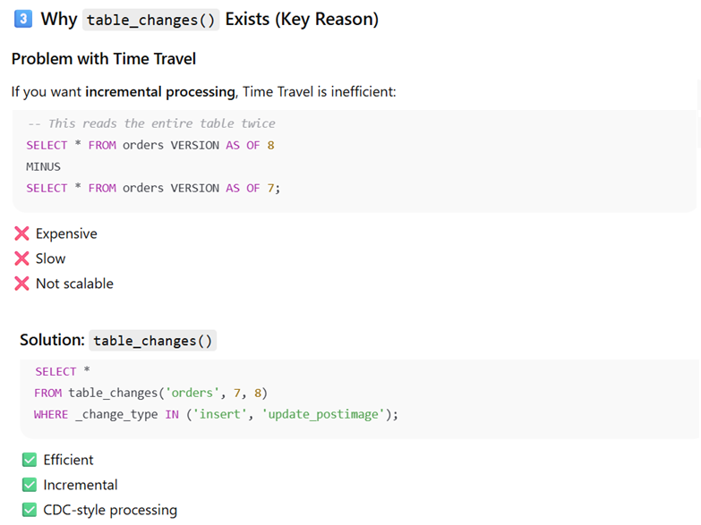

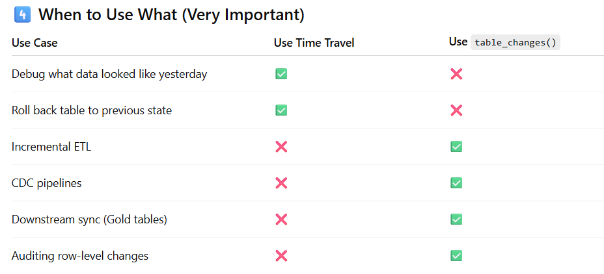

Q.19: Update PostImage vs Update PreImage
What is update_postimage & update_preimage and where they are useful?
Solution:
These appear when you use Delta Lake Change Data Feed (CDF) or table_changes().
They represent the before and after state of a row that was updated.
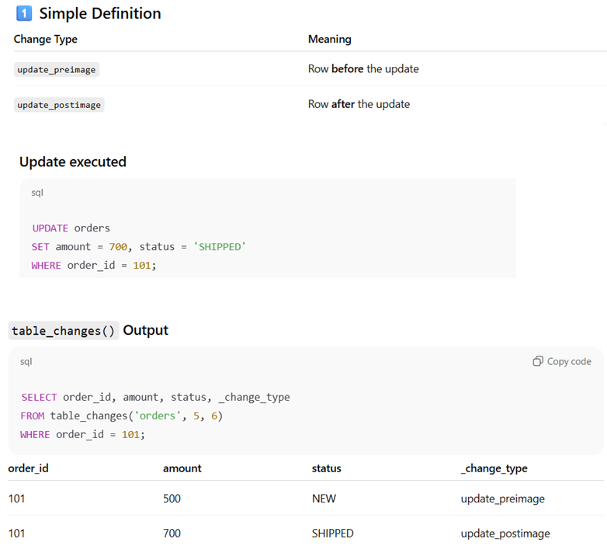

Q.20:Delta CDF
What is Delta Change Data Feed (CDF) ? How can you enable this.
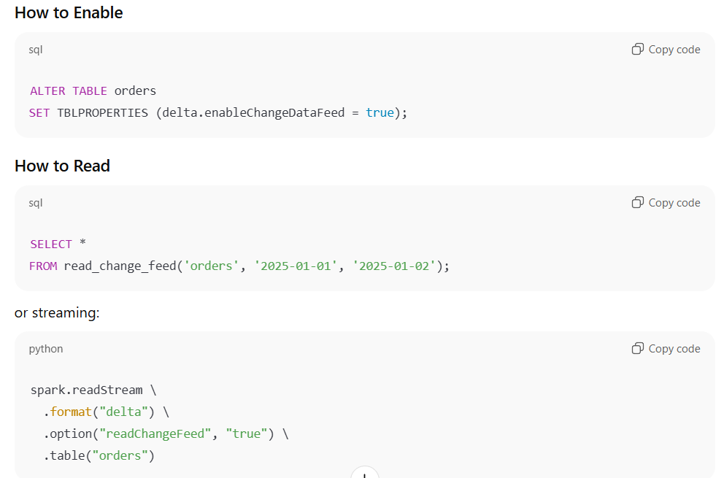
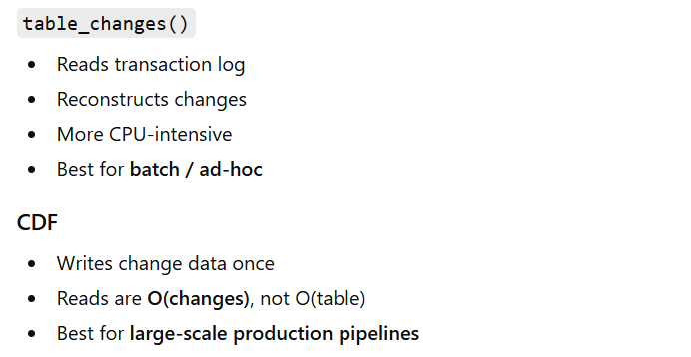
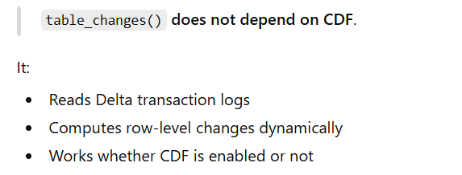
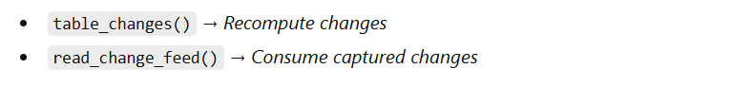

Q.22:Changed data in CDV vs Trans Log
How changed data is stored in CDC as opposed to Transaction Log?
Solution:
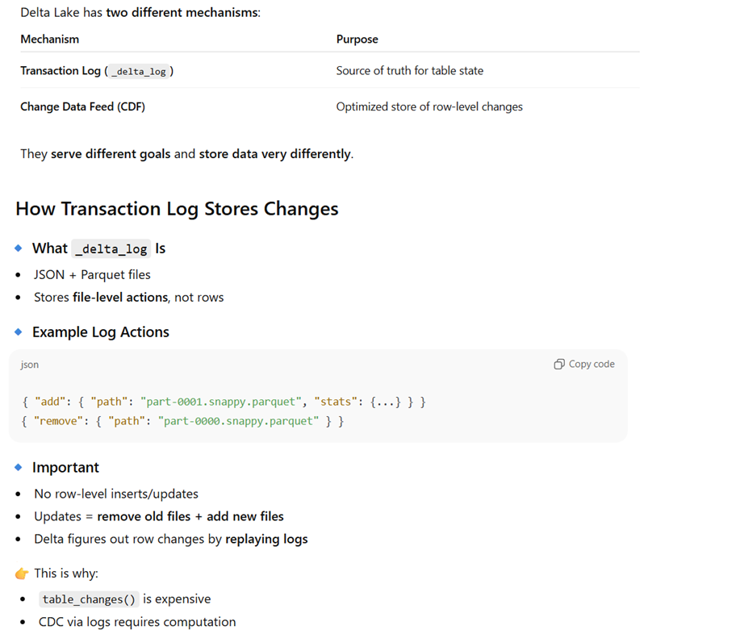
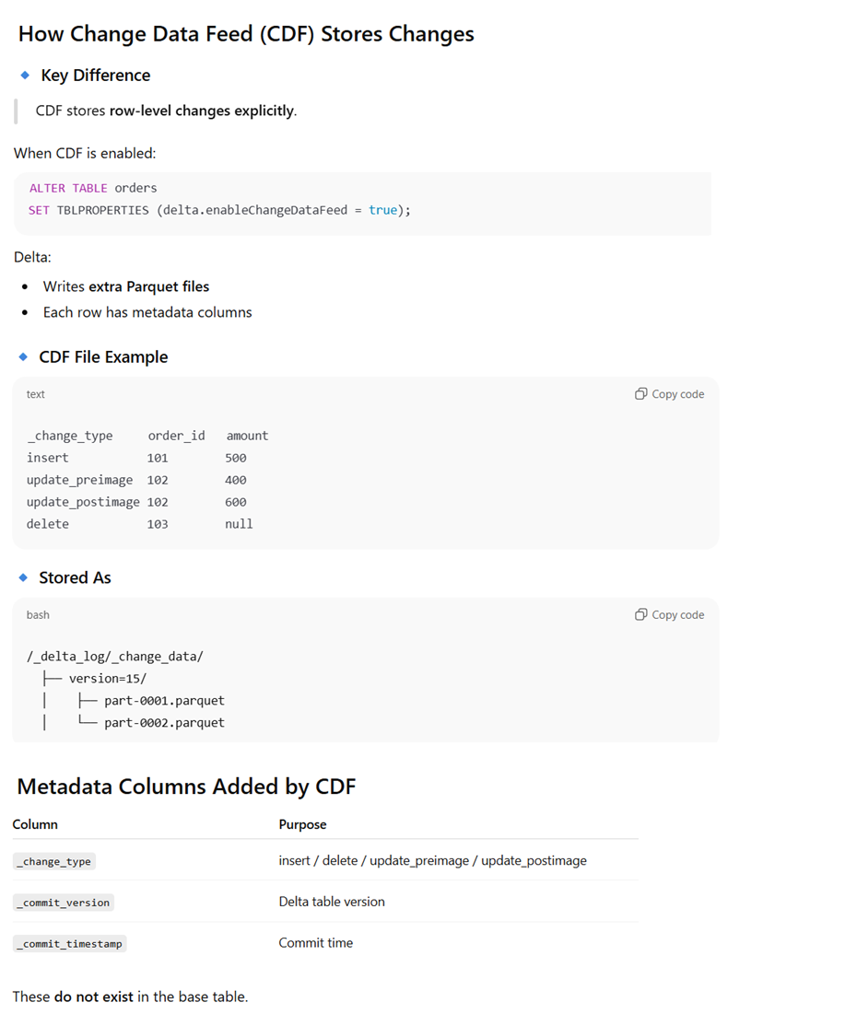
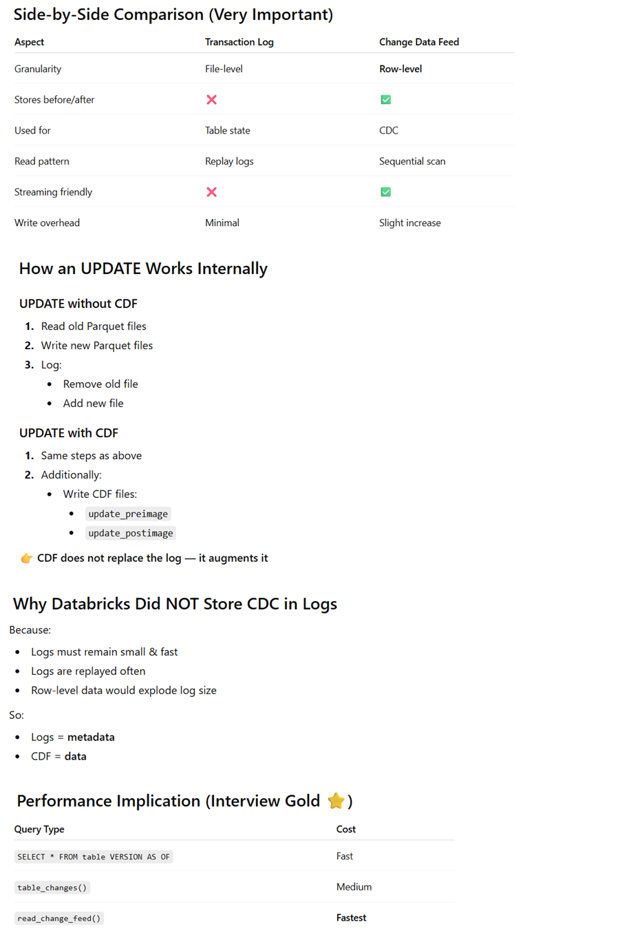

Q.23: Table_Chagnes vs Read_Chagne_Feed
Both table_changes() and read_change_feed() reads from CDF ? If yes then why read_change_feed is fastest?
Solution:
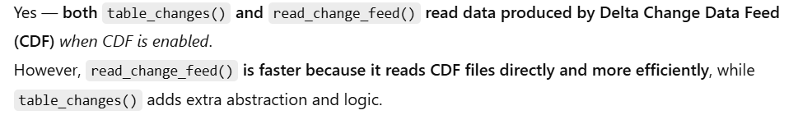
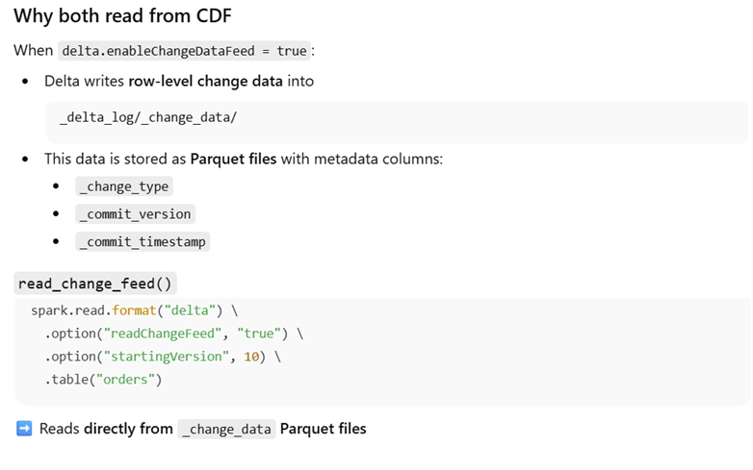
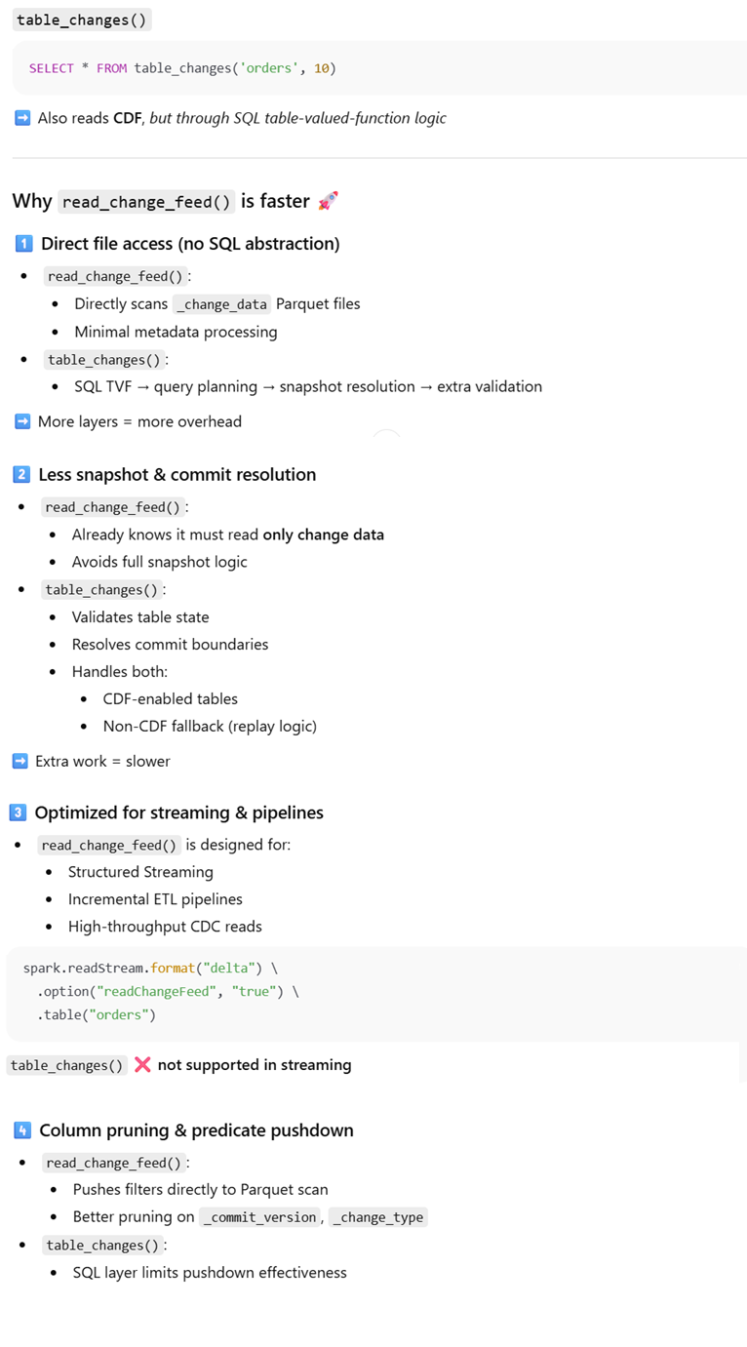
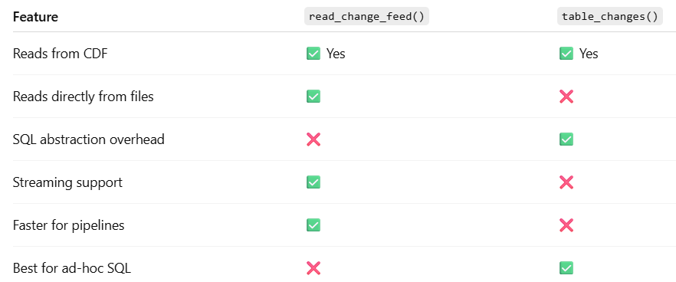

Coding Based

Q.1. Auto Loader – Incremental Read
Read JSON incrementally using Auto Loader
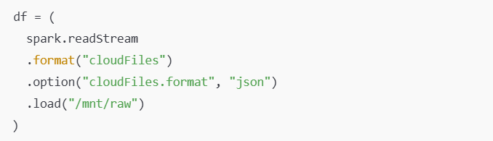

Q.2. Delta Streaming Write
Write streaming data to Delta
