Introduction

To start with, could you briefly walk me through the project you are currently working on as a Data Engineer?
Specifically, I would like you to cover:
- The overall objective of the project
- Your day-to-day responsibilities and the role you play in the team
- The data sources you ingest data from
- The downstream systems or consumers that use this data.

(OR)
Let us start with your current project.
Can you give me a brief overview of what you’re working on as a Data Engineer, including your daily responsibilities, the data sources you work with, and where the data eventually flows?
(OR)
Can you describe your current data engineering project end to end—starting from data ingestion, your role, and daily tasks, to the downstream systems or analytics platforms that consume the data?

Sample Response:
Sure. I will give you a brief overview of my current project.
I am currently working on a data platform project for a retail analytics use case. The main objective of the project is to ingest, process, and serve data from multiple source systems to support reporting, analytics, and downstream machine learning use cases.

In terms of my role and day-to-day responsibilities, I work as a Data Engineer responsible for designing and building end-to-end data pipelines. My daily tasks include:
- Ingesting data from various sources
- Building and optimizing ETL/ELT pipelines using Spark and SQL
- Performing data transformations, validations, and quality checks
- Monitoring jobs and handling failures
- Working closely with analytics and business teams to support new data requirements
Regarding data sources, we ingest data from:
- Relational databases like PostgreSQL and Oracle
- Event-based data from Kafka
- Files in S3/ADLS such as CSV and Parquet
- APIs from third-party systems
For downstream systems, the processed data is:
- Loaded into a data warehouse (Snowflake) for reporting and BI
- Exposed to analytics tools like Tableau and Power BI
- Used by data science teams for machine learning models

Overall, my role involves ensuring the data is reliable, scalable, and available for business and analytics users.

Pre-requisites

Before we proceed, could you please turn on your video?
(OR)
If possible, could you please turn on your video so we can continue the interview?

As part of our interview verification process, could you please show a valid government-issued ID to the camera?
(OR)
As part of our standard interview verification process, we require a quick ID check. Could you please show a government-issued ID to the camera?

Theory

Q.1:
What is Spark, how it is faster than traditional Hadoop System?
Solution:
Spark is an in-memory, fault-tolerant, distributed computing framework used for batch processing, streaming, machine learning, graph processing, and SQL analytics.
Key Idea:
Process data in memory instead of repeatedly reading/writing to disk.

Why Spark is better than Hadoop MapReduce:
- In-memory processing → much faster (10–100×) than Hadoop’s disk-based MapReduce
- Less disk I/O → intermediate data stays in memory
- Supports multiple workloads → batch, streaming, SQL, ML, graph (Hadoop MR supports only batch)
- Easy to use → high-level APIs (Python, Scala, SQL) vs complex Java MapReduce
- Better for iterative & interactive jobs → Hadoop is slow for these
In short:
Hadoop MapReduce is disk-based and slow; Spark is memory-based and fast.

Q.2:
Can you walk me through Spark’s internal execution flow when a Spark job is submitted, including DAG creation, stages, and task execution?
(OR)
What happens behind the scenes when a Spark job is submitted, from the driver to execution on the cluster?
Solution:
Spark Internal Execution Flow (Brief)
- Spark application is submitted using spark-submit.
- The Driver starts and creates SparkSession / SparkContext.
- Spark connects to the Cluster Manager and requests resources.
- Executors are launched on worker nodes.
- Transformations are recorded lazily as a DAG.
- An action triggers DAG execution.
- DAG is split into stages at shuffle boundaries.
- Each stage is divided into tasks (one per partition).
- Tasks are scheduled and executed on executors.
- Results are returned to the driver or written to storage.

One-Line Summary
Submit → Driver → DAG → Stages → Tasks → Executors → Output

Q.3:
What is the difference between SparkContext and SparkSession?
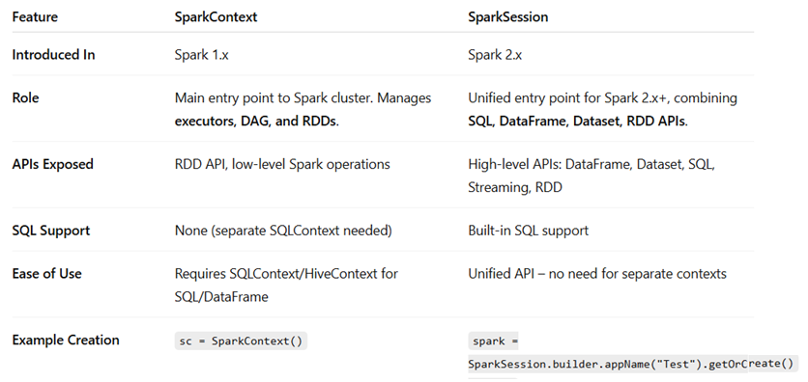

Why SparkSession Was Introduced?
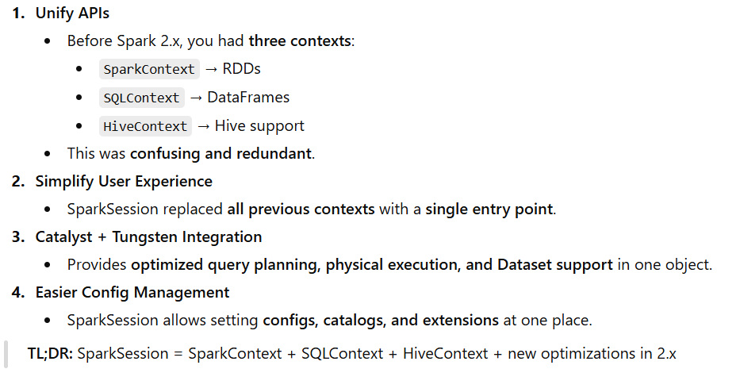

Do We Still Need SparkContext After SparkSession?
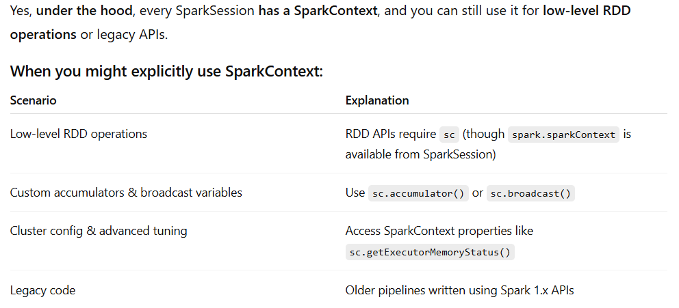
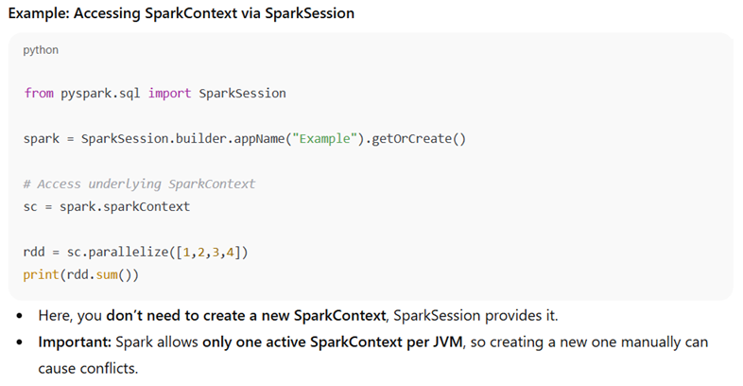

Practical

Q.1:
You are given a dataset containing email IDs as a single column. Write a PySpark program to extract the email domain (the part after @) and compute the count of each domain.
Input Data:
Email_ID
==============
Test1@gmail.com
Test2@yahoo.com
Test3@rediff.com
Test4@gmail.com
Test5@yahoo.com

Expected Output:
|Email Domain |Count |
+---------------------+-------+
| gmail.com | 2 |
| yahoo.com | 2 |
| rediff.com | 1 |
+---------------------+-------+

Solution #1 - With DOT in Email Domain
from pyspark.sql import SparkSession
from pyspark.sql.functions import split, col, lit

# Create a Spark Session
spark = SparkSession.builder.appName("EmailDomainCount").getOrCreate()

# Load the input data into a DataFrame
input_data = ["123@gmail.com", "456@yahoo.com", "123@rediff.com", "567@gmail.com", "888@yahoo.com"]
df = spark.createDataFrame(input_data, "string").toDF("Email")

# Extract email domains
df = df.withColumn("Domain", split(col("Email"), "@").getItem(1))

#Group and count email domains
result = df.groupBy("Domain").count()

#Rename columns for the desired output
result = result.withColumnRenamed("Domain", "Email Domain").withColumnRenamed("count", "Count")

#Show the expected output
result.show()

Solution #2 - Read Email IDs with DOT from CSV
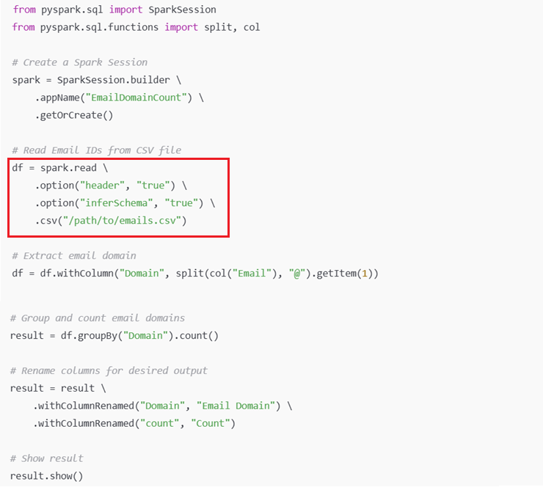
Solution #3 - Without DOT in Email Domain
from pyspark.sql import SparkSession
from pyspark.sql.functions import split, col, lit

# Create a Spark Session
spark = SparkSession.builder.appName("EmailDomainCount").getOrCreate()

# Load the input data into a DataFrame
input_data = ["123@gmail.com", "456@yahoo.com", "123@rediff.com", "567@gmail.com", "888@yahoo.com"]
df = spark.createDataFrame(input_data, "string").toDF("Email")

# Extract email domains
df = df.withColumn("Domain", split(col("Email"), "@").getItem(1))

# Remove dots from the email domains
df = df.withColumn("Domain", split(col("Domain"), "\.").getItem(0))

#Group and count email domains
result = df.groupBy("Domain").count()

#Rename columns for the desired output
result = result.withColumnRenamed("Domain", "Email Domain").withColumnRenamed("count", "Count")

#Show the expected output
result.show()

Q.2:
You are given a Source table and a Target table with the same schema (ID, Name).
How would you validate the data between these two tables and classify each record as:
- matching
- non-matching
- source not present
- target not present

Based on the ID and Name values?

Input Data:
Source Table
ID | Name
1 | Aman
2 | Bob
3 | Chetna
4 | Dany
5 | Rohit

Target Table
ID | Name
1 | Aman
2 | Bob
3 | Rakesh
4 | Fredy
6 | Ram

Expected Data:
ID | RESULT
1 | matching
2 | matching
3 | non-matching
4 | non-matching
5 | target not present
6 | source not present

Solution:
Input Data Creation
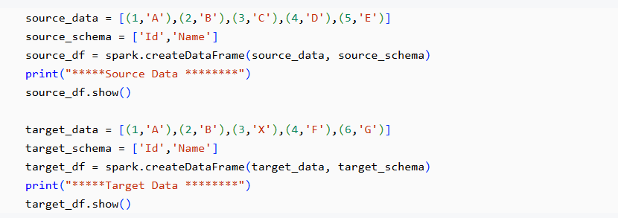
Intermediate Program
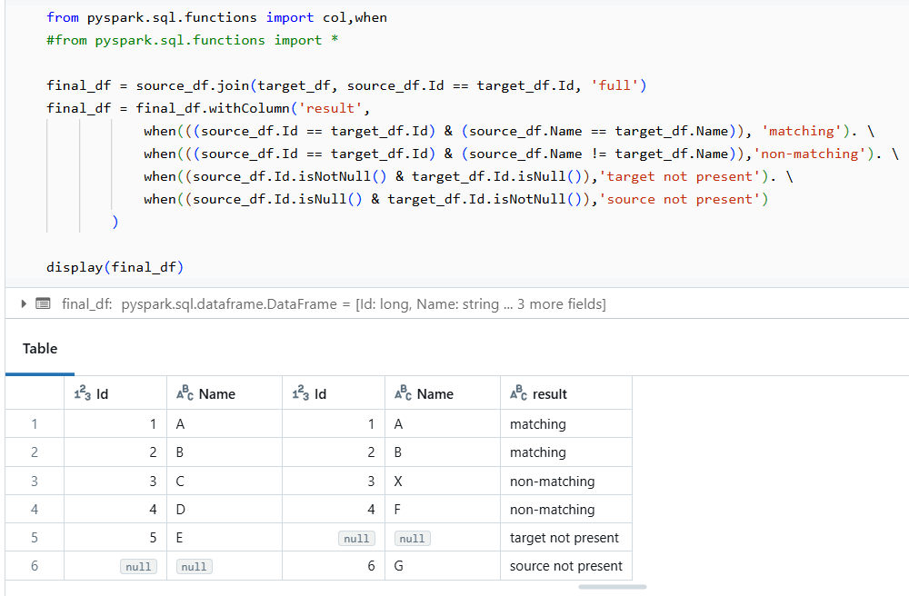
Final Program
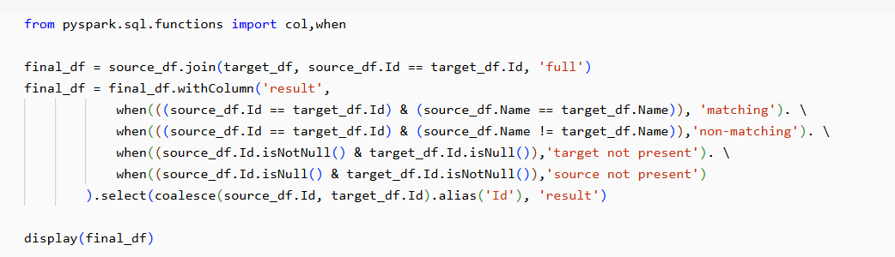

Q.3:
You are given an employee table containing ID, NAME, AGE, DEPARTMENT, and SALARY.
Write a query to find the department with the highest total salary.
i.e. Find out total salary per department and take the highest one.

Input Data:
Employee
ID | NAME | AGE | DEPARTMENT | SALARY
1 | John | 30 | Sales | 50000
2 | Alice | 28 | Marketing | 60000
3 | Bob | 32 | Finance | 55000
4 | Sarah | 29 | Sales | 52000
5 | Mike | 31 | Finance | 58000

Expected Output:
DEPARTMENT | TOTAL_SALARY
Finance | 113000

Hint:
- Groups employees by department
- Calculates the total salary for each department
- Returns only the department with the maximum total salary

Solution:
Input Data Creation
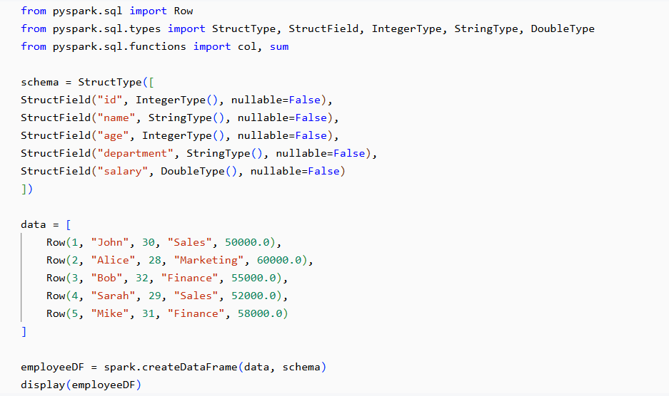
Method #1
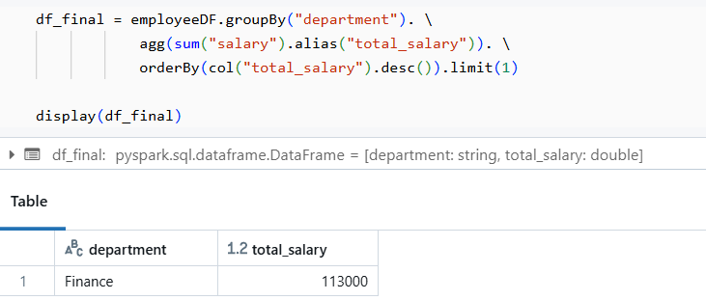

Method #2
How would you handle a tie if multiple departments have the same highest total salary?
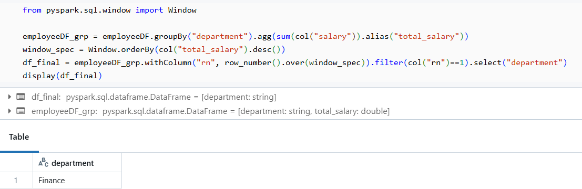

Q.4:
Multiple Parts – Calculate Customer Balance Calculation Using PySpark

Part 1: Transaction Aggregation Using PySpark
You are given a CSV file named “Transaction.csv” that contains customer transaction details.
Input File: Transaction.csv
CUSTOMER_ID | TRANSACTION_TYPE | TRANSACTION_AMOUNT
1 | credit | 30
1 | debit | 90
2 | credit | 50
3 | debit | 57
2 | debit | 90

Business Rules
- Transaction_Type can be Credit or Debit
- Credit → increases balance
- Debit → decreases balance

Write a PySpark program to:
- Read the Transaction.csv file
- For each CUSTOMER_ID, calculate:
  - Total Credit amount
  - Total Debit amount
  - Total Remaining Amount = Total Credit - Total Debit

- Produce the output in the format shown below
Expected Output:
CUSTOMER_ID | TOTAL_CREDIT | TOTAL_DEBIT | TOTAL_REMAINING_AMOUNT
1 | 30 | 90 | -60
2 | 50 | 90 | -40
3 | 0 | 57 | -57

Solution:
Part #1
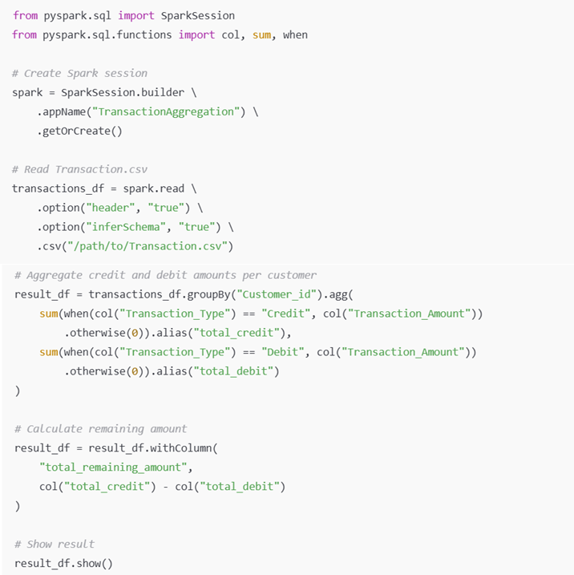

Part 2: Final Balance Calculation Using PySpark
You are given another CSV file named Amount.csv that contains the current balance for each customer
CUSTOMER_ID | CURRENT_AMOUNT
1 | 1000
2 | 2000
3 | 3000
4 | 4000

Using the aggregated transaction output from Part 1, write a PySpark program to calculate the final balance for each customer by applying the transactions to the current amount.
Business Rules
- Credit → Add transaction amount to the current balance
- Debit → Subtract transaction amount from the current balance
- If a customer has no transactions, their final balance should remain the same as the current amount
- All customers present in Amount.csv must appear in the output

Expected Output:
CUSTOMER_ID | FINAL_AMOUNT
1 | 940
2 | 1960
3 | 2943
4 | 4000

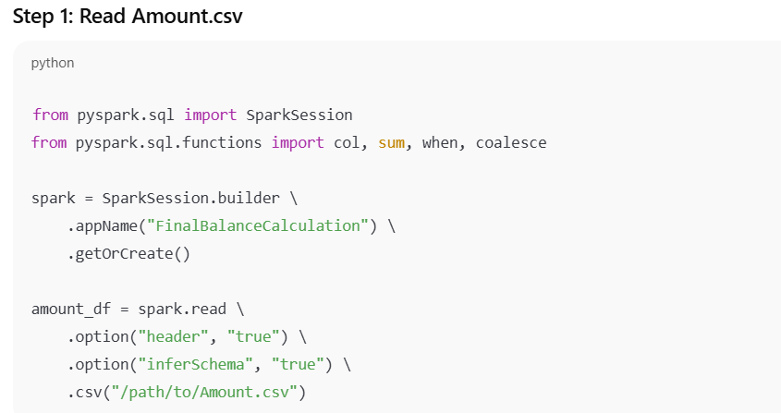
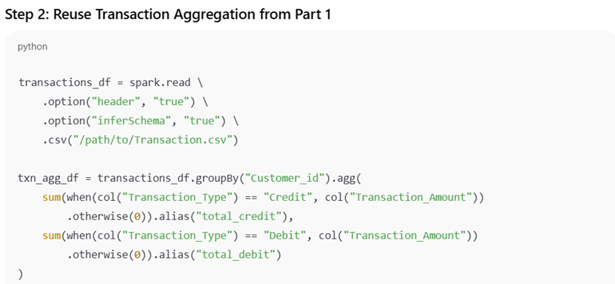
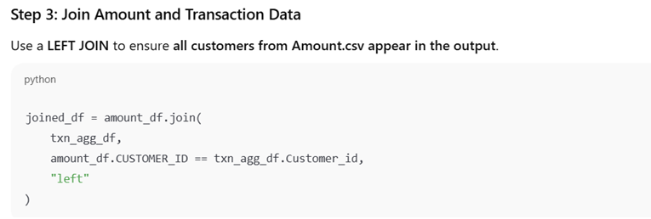
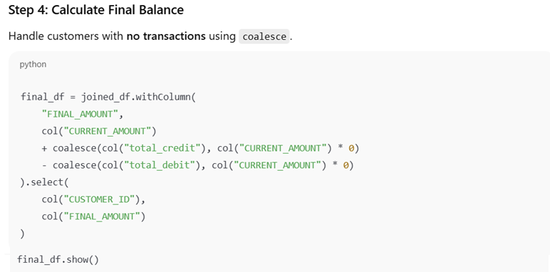

Q.5:
You are given a dataset where each record is a comma-separated string, but the last name and salary are inconsistently formatted.
- Some records contain LastName-Salary
- Some records contain LastName,Salary
- The data is not uniformly structured

Write a PySpark program to parse the input and produce a structured DataFrame with the following columns:
- EmpId
- FirstName
- LastName
- Salary

Input Data
1,Rahul,Sharma-100k
2,Mohan,Lal-200k
3,Rakesh,Gupta-270k
4,Suresh,Roy,80k

Expected Output
EMP_ID | FIRST_NAME | LAST_NAME | SALARY
1 | Rahul | Sharma | 100k
2 | Mohan | Lal | 200k
3 | Rakesh | Gupta | 270k
4 | Suresh | Roy | 80k

Solution #1 - Using SPARK API
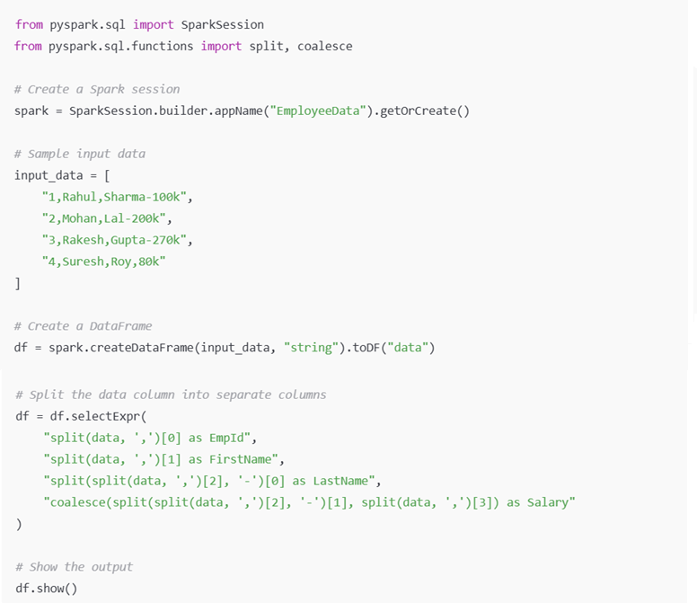

Solution #2 - Using SPARK SQL
