Concept & Predict Output

Q.1: Namespace
What is a namespace in Python? What are the benefits of namespace?
Solution:
A namespace in Python is a container that maps names (identifiers) to objects. Think of it like a dictionary:
{'x': 10, 'name': 'Alice', 'func': <function>}
Every variable, function, class, or object exists in a namespace.
Namespaces help Python keep track of all identifiers and prevent name conflicts by isolating identifiers in different contexts.

Q.2: Types of Namespaces
What are the different types of namespaces we have in Python? In which order Python looks up or searches a variable? What is LEGB rule?
Solution:
Types of Namespaces
Python has four main namespaces, summarized by the LEGB rule:
Namespace Type | Where it Exists | Example / Notes
Local (L) | Inside a function or method | Variables defined inside a function
Enclosing / Nonlocal (E) | Any enclosing function (nested functions) | Variables in enclosing (outer) functions for nested functions, accessed using nonlocal
Global (G) | Module-level (file-level) | Variables defined at the top of a Python file
Built-in (B) | Built-in Python namespace | Python built-in functions and exceptions (len, print, TypeError)

LEGB Rule:
Python follows the LEGB Rule to resolve variable names:
When Python looks up a variable name, it searches in this order:
Local → Enclosing → Global → Built-in
- Local (L) – Names assigned inside the current function.
- Enclosing (E) – Names in the enclosing functions (if nested).
- Global (G) – Names defined at the module level.
- Built-in (B) – Names in the built-in Python namespace.
The first match wins.
Example (All 4 Namespaces Together)
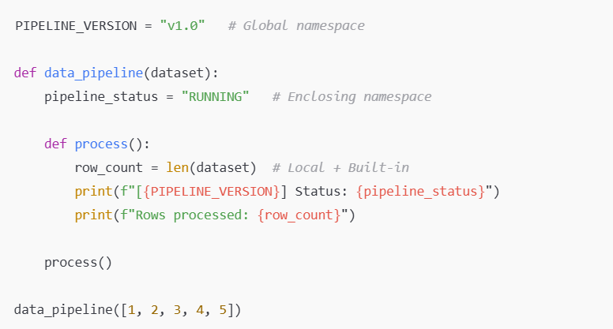

Q.3: Basic Namespace – Predict output
Basic Namespace - What will this code print?
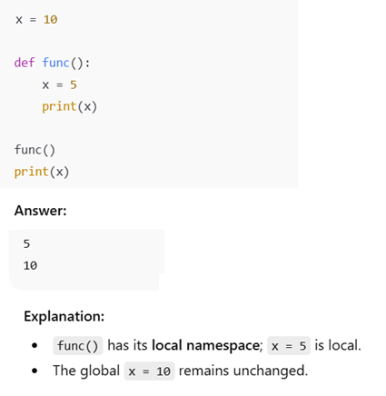

Q.4: Global Namespace – Predict Output
Global Modification - What will the output of this program?
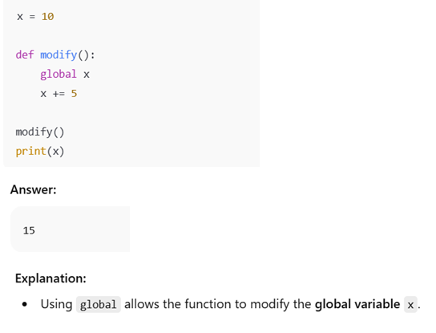

Q.5: Scope Resolution – Predict Output
Scope Resolution - What will the output of this program?
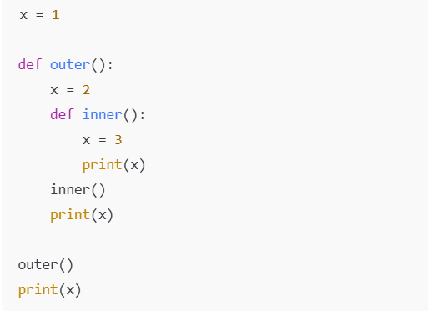
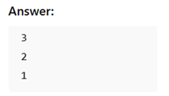

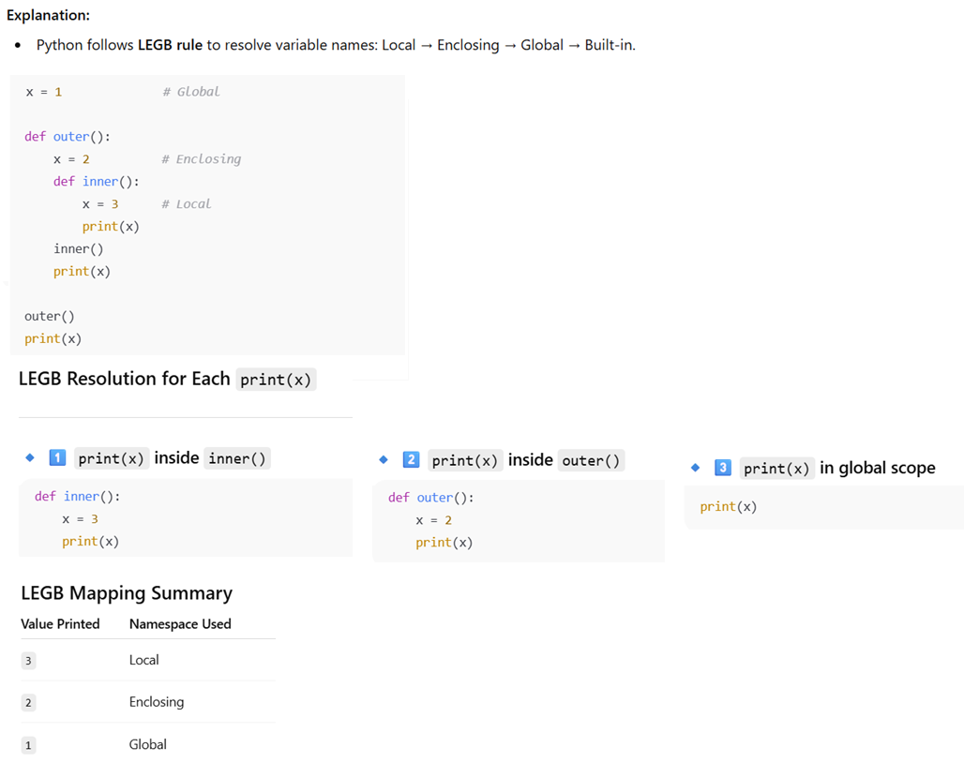

Q.6: Generator Example
Scenario: Imagine you have a 500GB server log file and you want to:
- Process each line.
- Extract lines containing the word "ERROR".
- Write the filtered lines to another file.
What would be your approach of writing the Python Program?

Solution
We CANNOT use a list here
- Reading the whole file into a list with lines = file.readlines() would require hundreds of GBs of RAM.

with open("server.log", "r") as f:
lines = f.readlines() # reads **all lines at once** into memory

- This is impractical or impossible on standard machines.

Use a Generator
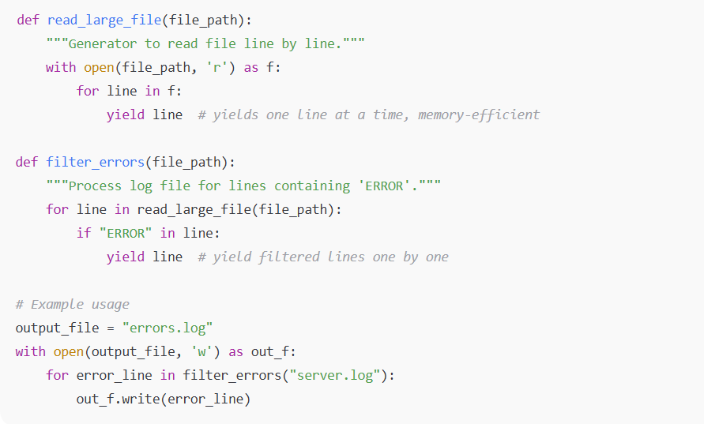
Why only a generator works here
- Memory efficiency: Only one line at a time is in memory.
- Scalability: Can handle files larger than RAM.
- Lazy evaluation: Processing starts immediately, no need to wait for full file load.

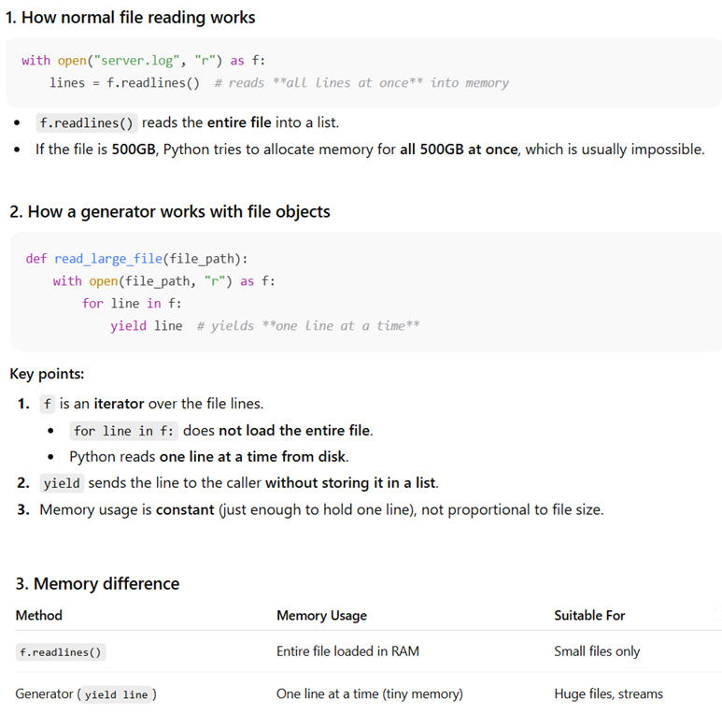

Q.7: Decorator
What is a decorator in Python?
Solution:
A decorator is a function that takes another function as input and extends or modifies its behaviour without explicitly changing its code.
A decorator works by returning a new function that wraps the original function

Q.8: How Decorator Internally Works
How do decorators work internally?
Solution:
- Python passes the function to the decorator, which returns a wrapper function.
- The wrapper replaces the original function in the current scope.

Logging Decorator
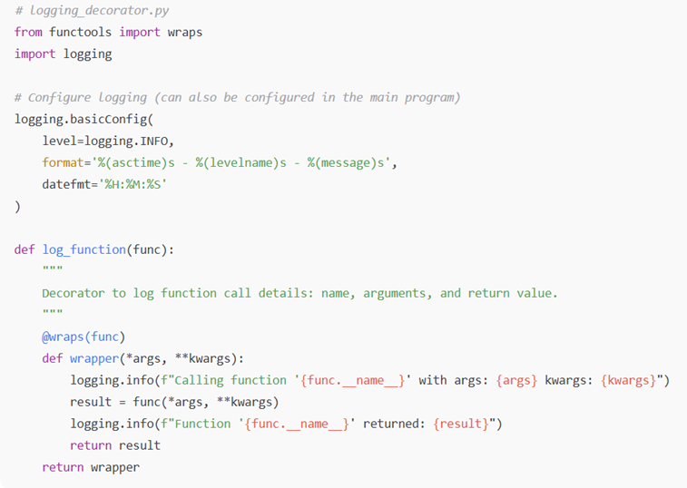
Example Program Using Logging Decorator
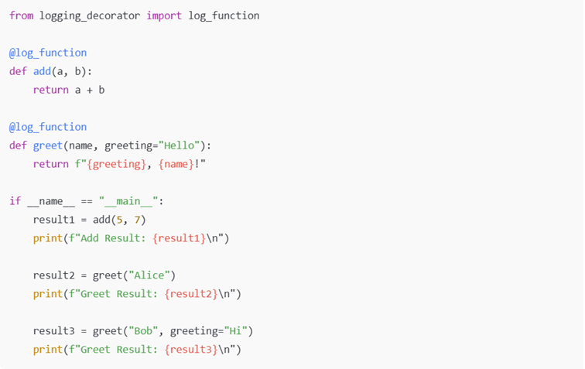
Sample Output
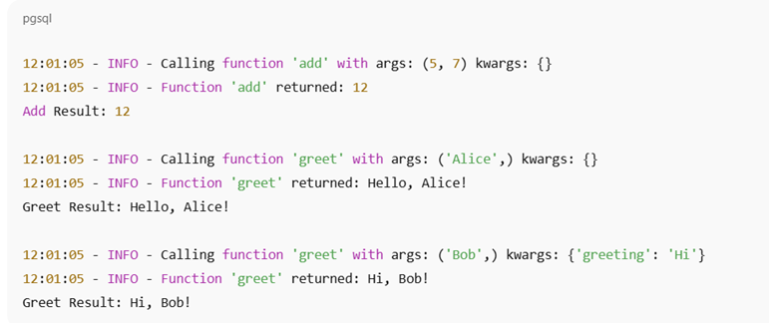

Q.9: List vs Tuple
What is the difference between LIST & TUPLE? In which scenario you prefer LIST over TUPLE & vice-versa?

Solution:
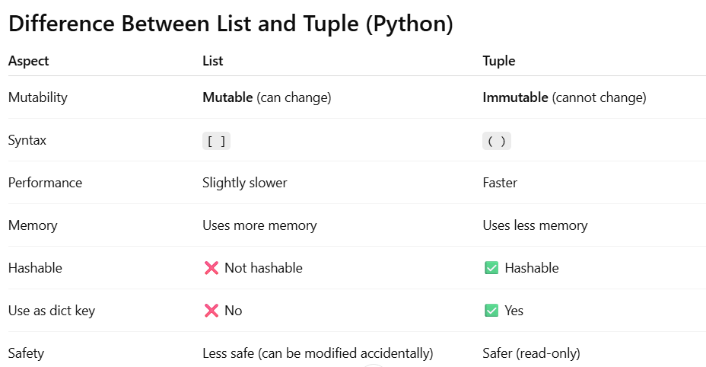
✅ When to Prefer LIST
1. ETL Data Transformation
Scenario:
You are cleaning and transforming data in an ETL pipeline.
columns = ["name", "age", "income"]
columns.append("city") # allowed
✔ Columns change during transformations
✔ Rows are filtered, appended, removed
Why LIST?
Because the data is dynamic and mutable.

✅ When to Prefer TUPLE
1. Fixed Schema / Metadata
Scenario:
Column schema of a table.
schema = ("user_id", "name", "email", "created_at")
✔ Schema should never change
✔ Prevents accidental modification
Why TUPLE?
Immutability ensures data integrity.

Performance & Memory
import sys
sys.getsizeof([1, 2, 3]) # more memory
sys.getsizeof((1, 2, 3)) # less memory

✔ Tuples are faster
✔ Better for read-heavy workloads
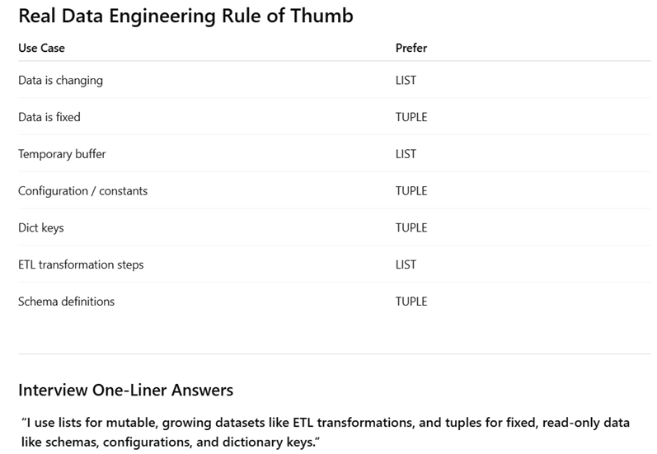

Q.10: Modules & Packages
What are Modules in Python? And what is Package?
How Python identifies a Package?

Solution:
Modules in Python
- A module is simply a Python file (.py) that contains Python code — functions, classes, variables, or runnable code.
- Modules help organize code and reuse it across multiple programs.
Example of a module (math_utils.py):
# math_utils.py
def add(a, b):
return a + b

def subtract(a, b):
return a – b

You can import and use this module in another script:
import math_utils

result = math_utils.add(5, 3)
print(result) # Output: 8

2. Packages in Python
- A package is a collection of modules organized in a directory.
- It allows you to structure your code in a hierarchical manner, making it easier to manage large projects.
- A package must contain a special file called __init__.py (Python <3.3) or it can be optional in Python ≥3.3 (but still recommended).

Example package structure:
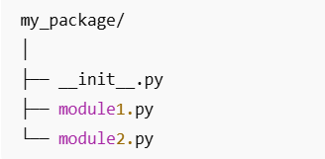
Here:
- my_package is the package.
- module1.py and module2.py are modules inside the package.

You can import modules like:
from my_package import module1
from my_package.module2 import some_function

3. __init__.py file
The __init__.py file has two main purposes:
a) Marks a directory as a Python package
- Without __init__.py, older Python versions (<3.3) do not recognize a folder as a package.
- Example: my_package only becomes a package if it contains __init__.py.

b) Initializes the package
- Code inside __init__.py runs when the package is imported.
- You can define:
  - Package-level variables
  - Functions
  - Imports to simplify module access
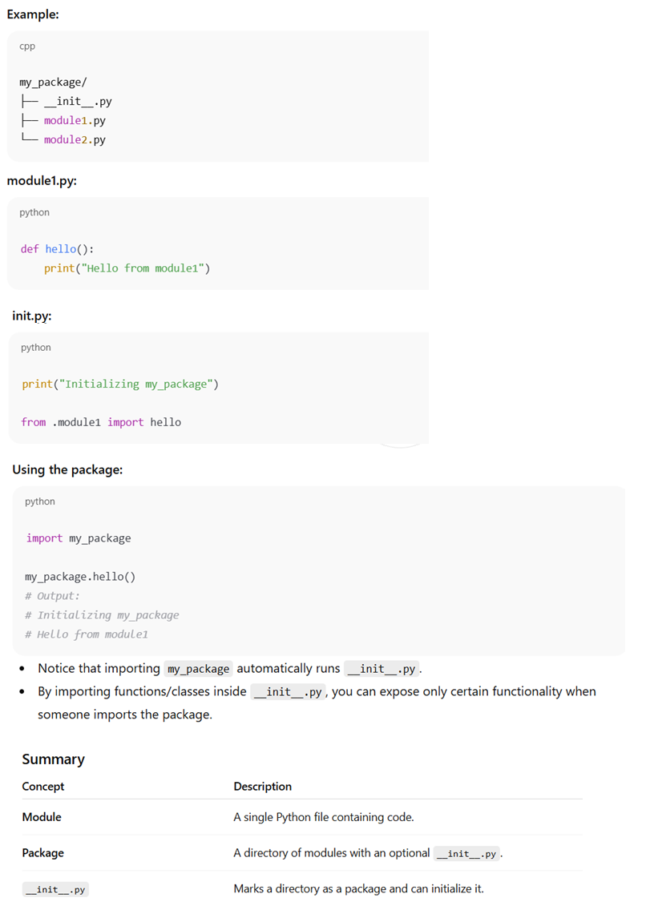

Q.11: List Mutability & References
Question: Write the output and explain why.
a = [1, 2, 3]
b = a
b.append(4)
print(a)
Expected Output
[1, 2, 3, 4]

What It Tests
- Understanding of reference assignment
- Lists are mutable
- b does not create a copy

Q.12: List Copy vs Reference
a = [1, 2, 3]
b = a[:]
b.append(4)
print(a, b)

Expected Output
[1, 2, 3] [1, 2, 3, 4]
What It Tests
- Shallow copy using slicing
- Difference between = and copying

Q.13: Iteration While Modifying a List
a = [1, 2, 3, 4, 5]
for i in a:
if i % 2 == 0:
a.remove(i)
print(a)

Expected Output
[1, 3, 5]
What It Tests
- Side effects of modifying lists during iteration
- Hidden logical bugs

Q.14. Difference between append() vs extend()?
a = [1, 2]
a.append([3, 4])
print(a)
Expected Output
[1, 2, [3, 4]]

Follow-up
a = [1, 2]
a.extend([3, 4])
print(a)
Expected Output
[1, 2, 3, 4]

What It Tests
- Difference between adding a list vs its elements

Q.15. List as Function Argument
Question
def modify(lst):
lst.append(100)

a = [1, 2, 3]
modify(a)
print(a)
Expected Output
[1, 2, 3, 100]

What It Tests
- Lists passed by object reference
- Function side effects

Q.16: What is a Shallow Copy & Deep Copy?

Solution:
A shallow copy creates a new container object, but does not copy the inner objects.
- Outer object → new
- Inner objects → shared references

A deep copy creates a new container and new copies of all nested objects.
- Outer object → new
- Inner objects → also new

Q.17: Shallow Copy – Predict output
What is the output?
a = [[1, 2], [3, 4]]
b = a.copy()
b[0].append(99)
print(a)
print(b)
Solution:
[[1, 2, 99], [3, 4]]
[[1, 2, 99], [3, 4]]

Why?
- a.copy() is a shallow copy
- Inner lists are shared

Coding Exercise

Q.1: Code - Pandas with Chunking
Suppose you have a CSV file which has large datasets that do not fit in memory with Pandas, how you handle this?
Solution:
- Use chunksize parameter in read_csv() to process data in chunks.

- Example:
chunks = pd.read_csv('large_file.csv', chunksize=100000)
for chunk in chunks:
process(chunk)

Complete Example:
You have a 50GB CSV, and you want total sales per customer without loading entire CSV into memory.

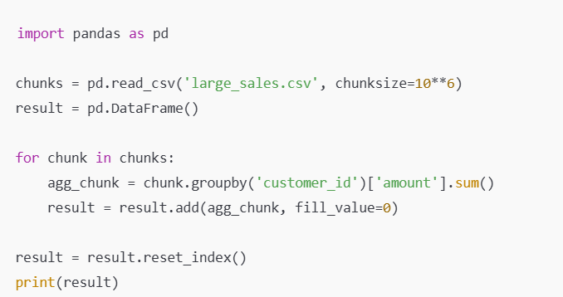

Q.2: Code - Removing Duplicates from Pandas DataFrame
You have duplicate rows in a DataFrame. How will you remove duplicate records while keeping the most recent one based on “LOAD_DATE” column?
Solution:
df.drop_duplicates(subset=['id', 'load_date'], keep='last', inplace=True)
- subset: columns to consider for duplicates
- keep: 'first', 'last', or False to drop all duplicates

Q.3: Code - Handle Exception while reading File
Write a Python function to read a CSV file and handle:
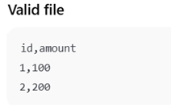
- File not found and
- Empty file Exceptions condition
- At last, print the message ‘File Read Completed’, irrespective of successful/failed read.

Solution:
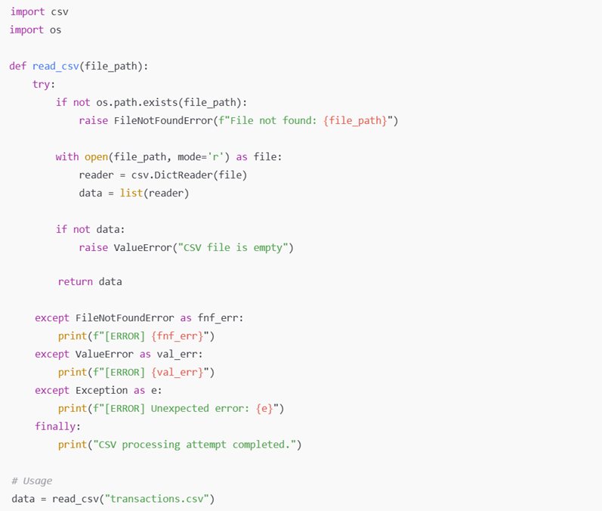
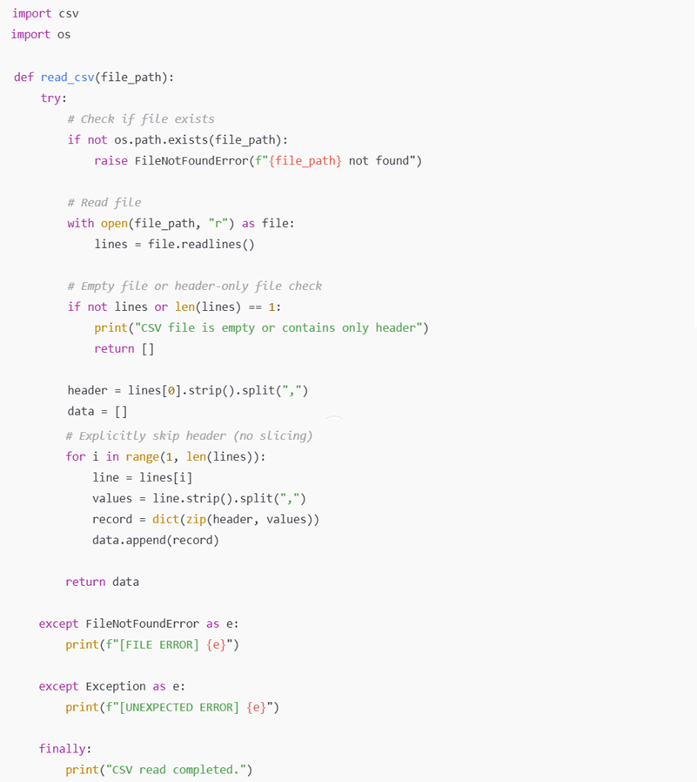

Q.4: Code - Remove Duplicate from List
Assume you have following list which has duplicate records.
Input = [1,2,2,3,1,4]
Can you write a function to Remove Duplicates, you need to PRESERVE ORDER as well. So, expected output here would be
Output = [1,2,3,4]

What It Tests
- List traversal
- Order preservation logic

Solution:
def remove_duplicates(lst):
result = []
for i in lst:
if i not in result:
result.append(i)
return result

a = [1, 2, 2, 3, 1, 4]
output = remove_duplicates(a)
print(output)

Q.5: Code – Calculate Sum of Digits from List
You are given a list of integers.
For each number, can you write a function to calculate the sum of its digits and return a list of results in the same order.
Input list - [123,456]
Expected output list - [6,15]

Solution:
lst = [123, 456]

def getSum(n):
total = 0
while (n != 0):
total = total + int(n % 10)
n = int(n/10)
return total

result = []
for num in lst:
result.append(getSum(num))

print(result) # Expected output: [6, 15]

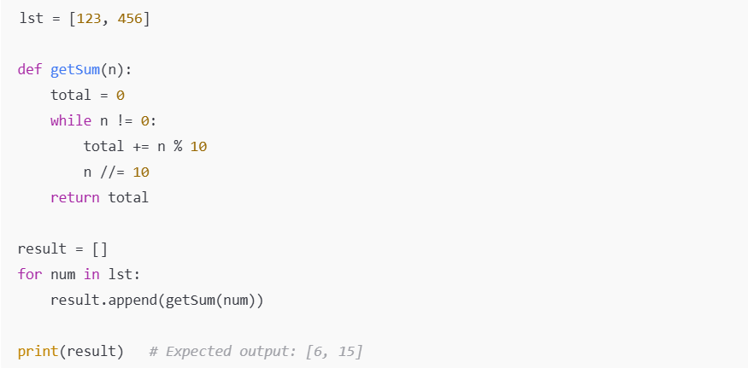

Q.6: Code – Sort a List of 10 elements
How to sort a list of 10 elements without using any built-in function in ascending order using a for loop (Bubble Sort approach).

List = [34, 7, 23, 32, 5, 62, 32, 12, 4, 15]
Solution:
# Define a list of 10 elements
numbers = [34, 7, 23, 32, 5, 62, 32, 12, 4, 15]

# Get the length of the list
n = len(numbers)

# Implement Bubble Sort using a for loop
print("Initial List:", numbers)
for i in range(n - 1):
print("Index i = ", i)
print("Value at index[i] = ", numbers[i])
for j in range(n - i - 1):
print("Index j = ", j)
if numbers[j] > numbers[j + 1]:
# Swap elements if they are in the wrong order
numbers[j], numbers[j + 1] = numbers[j + 1], numbers[j]
#print("Sorted List (Interim):", numbers)
print("Sorted list(Interim):", numbers)
print()
print("*******************************")

# Print the sorted list
print("Sorted list(Final):", numbers)

