Q.1:
Given the following two tables, containing duplicate and NULL values, could you predict the output of an INNER JOIN and a LEFT JOIN?
TABLE1
Column1
1
1
0
NULL

TABLE2
Column2
1
1
NULL
NULL
Solution:
Inner Join
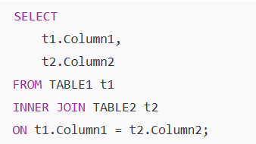
Output
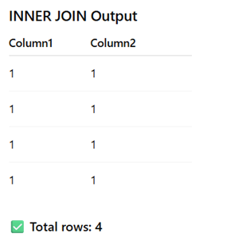
LEFT JOIN
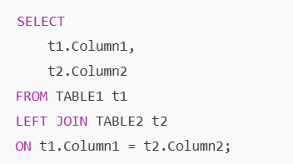
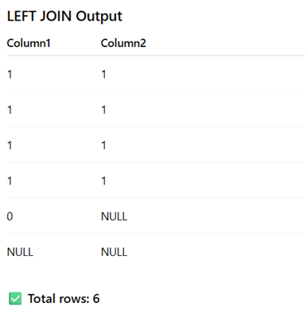

Q.2:
I have following LOGS table, write an SQL query to find all Numbers that appears at least three times consecutively?
Return the result in any order.
Input Data:
ID | NAME
1 | 1
2 | 1
3 | 1
4 | 2
5 | 1
6 | 2
7 | 2

Expected Output:
ConsecutiveNums
1

Solution:
Method #1
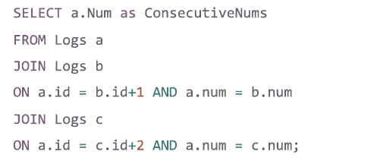

Method #2
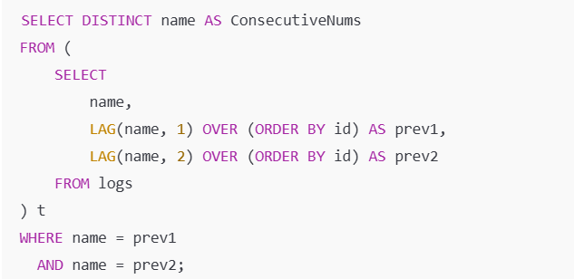
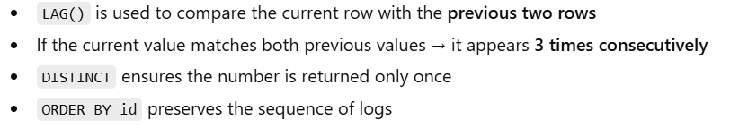
Method #3
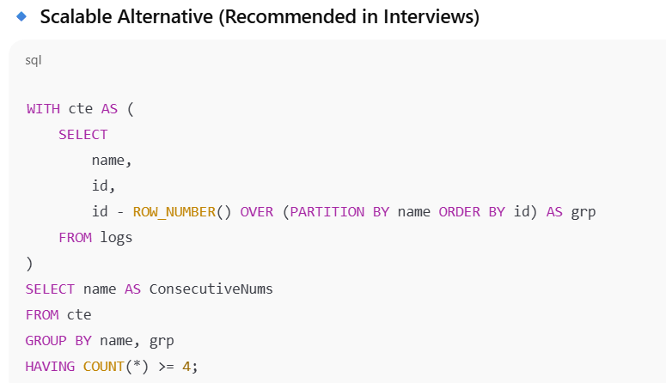
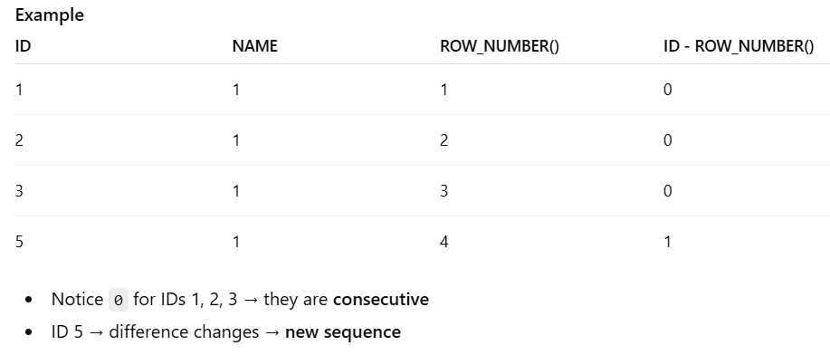

Q.3:
Problem Statement
Given a dataset of table FOOTBALL containing match results between two teams per game, along with the scores scored by each team, calculate the total score accumulated by each team across all matches.
Each record represents a single match:
- Team1 scored Score1
- Team2 scored Score2

A team may appear multiple times across different matches and may appear either as Team1 or Team2. The objective is to aggregate all scores scored by each team, regardless of their position in the match, and produce a consolidated result showing the total score per team.
Input Data: Football
Team1 | Team2 | Score1 | Score2
A | B | 4 | 5
C | D | 2 | 1
C | A | 3 | 2
A | C | 1 | 4

Expected Output
Team | Score
A | 7
B | 5
C | 9
D | 1

Solution:
SELECT Team, SUM(Score) AS Score
FROM
(
SELECT Team1 AS Team, Score1 AS Score FROM football
UNION ALL
SELECT Team2 AS Team, Score2 AS Score FROM football
)
GROUP BY Team;

Q.4:
I have following EMPLOYEE table which has ID column and there is another column for MANAGER_ID.
Write a SQL query that finds out employees who earn more than their Managers?
Input Data: Employee
ID | NAME | SALARY | MANAGER_ID
1 | JOE | 70000 | 3
2 | HENRY | 80000 | 4
3 | SAM | 60000 | NULL
4 | MAX | 90000 | NULL

Expected Output:
EMPLOYEE
JOE

Solution:
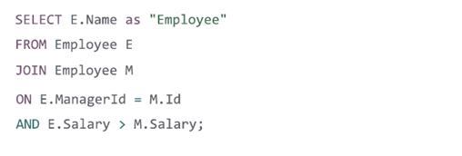

Q.5:
I have following EMPLOYEE table which has ID column, SALARY and there is also a column for DEPARTMENT ID.
Input Data: Employee
ID | NAME | SALARY | DEPARTMENT_ID
1 | JOE | 70000 | 1
2 | JIM | 90000 | 1
3 | HENRY | 80000 | 2
4 | SAM | 60000 | 2
5 | MAX | 90000 | 1

I have another table DEPARTMENT that holds all departments of the Company.
Input Data: Department
ID | NAME
1 | IT
2 | SALES

Write a SQL query to find employees who have the highest Salary in each of the departments.
Expected Output:
DEPARTMENT | EMP_NAME | SALARY
IT | MAX | 90000
IT | JIM | 90000
SALES | HENRY | 80000

Solution:
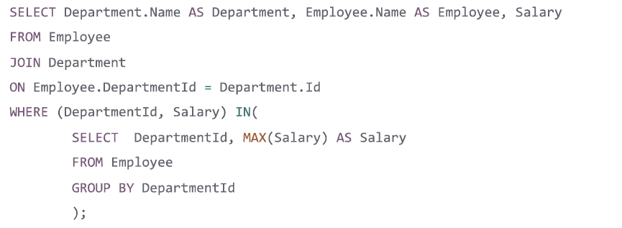

Q.6:
I have following EMPLOYEE table which has ID column, SALARY and there is also a column for DEPARTMENT ID.
Input Data: Employee
ID | NAME | SALARY | DEPARTMENT_ID
1 | JOE | 85000 | 1
2 | HENRY | 80000 | 2
3 | SAM | 60000 | 2
4 | MAX | 90000 | 1
5 | JENNY | 69000 | 1
6 | RANDY | 85000 | 1
7 | WILL | 70000 | 1

The department table holds all departments of the Company
Input Data: Department
ID | NAME
1 | IT
2 | SALES

Write a SQL query to find employees who earn the TOP 3 salaries in each of the department.
Expected Output:
DEPARTMENT | EMP_NAME | SALARY
IT | MAX | 90000
IT | RANDY | 85000
IT | JOE | 85000
IT | WILL | 70000
SALES | HENRY | 80000
SALES | SAM | 60000

Solution:
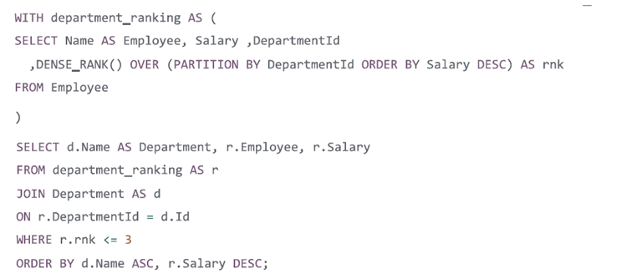

--------------------------------------------- Additional ----------------------------------------
Q.1: Find all those employees who have a salary increment for more than 3 consecutive years?
with tmp as
(
select *,
coalesce(lag(salary,1) over(partition by employee_id order by employee_id,year ),0) as lag_data,
row_number() over(partition by employee_id) rn
from public.emp_dtl
),
tmp1 as
(
select
*,(salary-coalesce(lag_data,0)) diff ,
case when (salary-coalesce(lag_data,0)) >0 then 1 else 0 end as flag
from tmp
)
select employee_id, sum(flag) from tmp1
group by employee_id
having sum(flag)>2;

Your query:
- Uses LAG to compare current salary vs previous year salary
- Flags a row as 1 if salary increased
- Groups by employee_id
- Returns employees where sum(flag) > 2

CREATE TABLE emp_dtl (
employee_id INT,
year INT,
salary INT
);

INSERT INTO emp_dtl VALUES
(101,2020,50000),(101,2021,52000),(101,2022,54000),(101,2023,56000),
(102,2020,40000),(102,2021,42000),(102,2022,41000),(102,2023,43000),
(103,2020,60000),(103,2021,62000),(103,2022,61000),(103,2023,63000),(103,2024,65000);

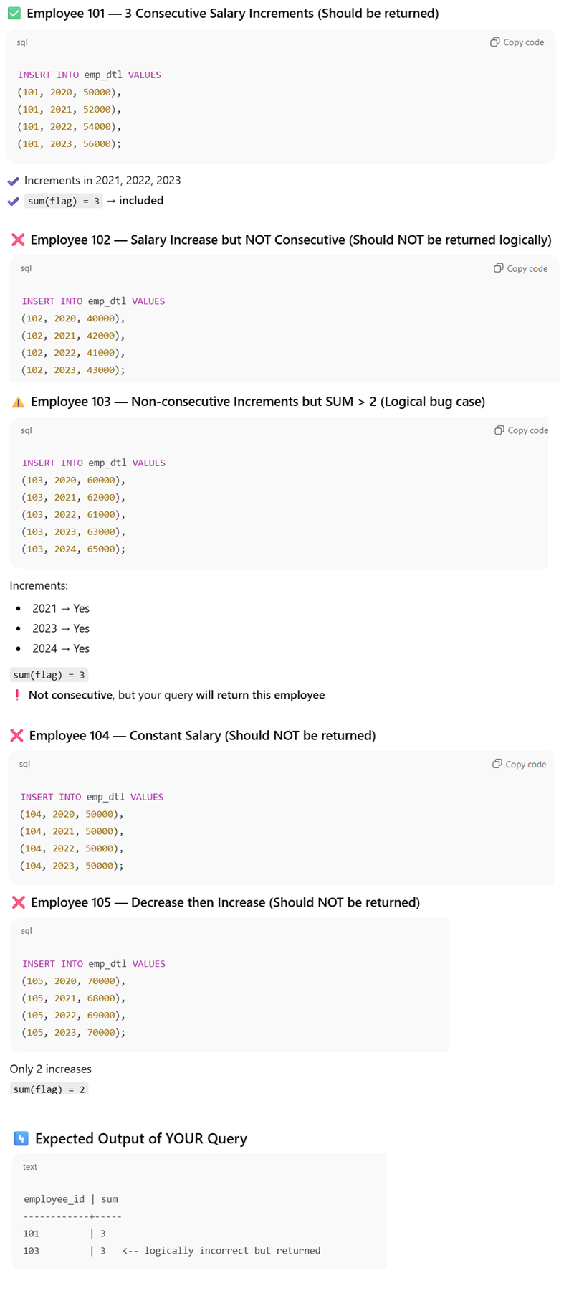

Correct Query

