Que1- What is the dev tool and the purpose of the dev tool?

* Dev tools are the set of web developers tools.
* These tools do a range of things, from inspecting currently-loaded HTML, CSS and JavaScript to showing which assets the page has requested and how long they took to load.

Que3- What is a web server in detail?

* The term web server can refer to hardware or software, or both of them working together.
* They are used to store the information and process that information and return somewhat that the client is looking for.
* Whenever client request some information, server will give that information.

Que4-What is the HTTP response status code? List popular status code and their meaning in one table

* HTTP response status codes indicate whether a specific [HTTP](https://developer.mozilla.org/en-US/docs/Web/HTTP) request has been successfully completed. Responses are grouped in five classes:

1. [Informational responses](https://developer.mozilla.org/en-US/docs/Web/HTTP/Status#information_responses) (100–199)
2. [Successful responses](https://developer.mozilla.org/en-US/docs/Web/HTTP/Status#successful_responses) (200–299)
3. [Redirects](https://developer.mozilla.org/en-US/docs/Web/HTTP/Status#redirection_messages) (300–399)
4. [Client errors](https://developer.mozilla.org/en-US/docs/Web/HTTP/Status#client_error_responses) (400–499)
5. [Server errors](https://developer.mozilla.org/en-US/docs/Web/HTTP/Status#server_error_responses) (500–599)

https://developer.mozilla.org/en-US/docs/Web/HTTP/Status#information_responses

Que-5 Difference between static and dynamic client-server architecture.

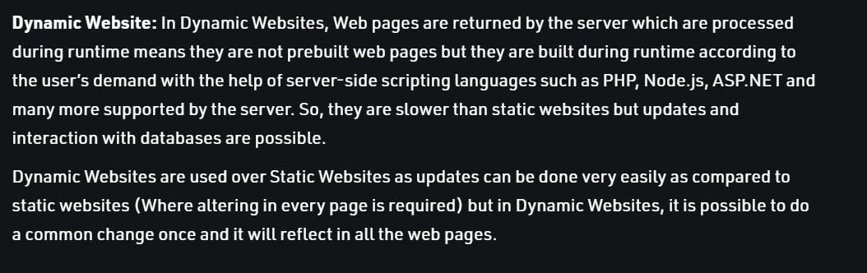

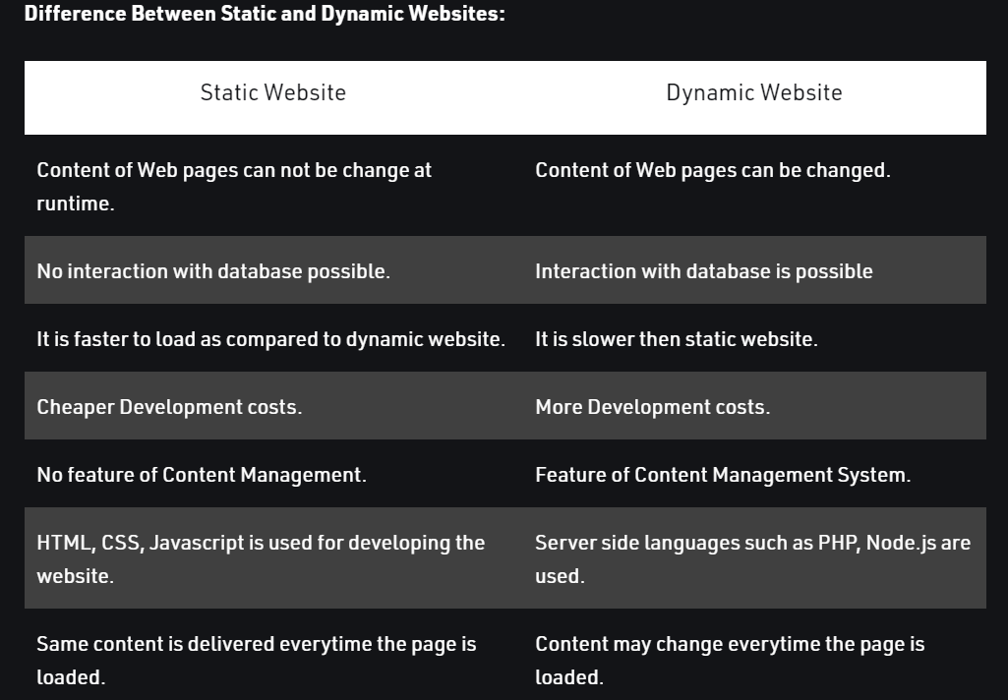

Que7- What is a cookie and it's usage?

**What Are Cookies?**

**Cookies** are text files with small pieces of data — like a username and password — that are used to identify your computer as you use a computer network. Specific cookies known as HTTP cookies are used to identify specific users and improve your web browsing experience.

Data stored in a cookie is created by the server upon your connection. This data is labeled with an ID unique to you and your computer.

When the cookie is exchanged between your computer and the network server, the server reads the ID and knows what information to specifically serve to you.

## Different types of cookies - Magic Cookies and HTTP Cookies

* Magic Cookies
* HTTP Cookies

**"Magic cookies"** are an old computing term that refers to packets of information that are sent and received without changes. Commonly, this would be used for a login to computer database systems, such as a business internal network.

**HTTP cookies,** or internet cookies, are built specifically for Internet web browsers to track, personalize, and save information about each user’s session. A “session” just refers to the time you spend on a site.

## What Are Cookies Used For?

1. **Session management.** For example, cookies let websites recognize users and recall their individual login information and preferences, such as sports news versus politics.
2. **Personalization.** Customized advertising is the main way cookies are used to personalize your sessions. You may view certain items or parts of a site, and cookies use this data to help build targeted ads that you might enjoy.
3. **Tracking.** Shopping sites use cookies to track items users previously viewed, allowing the sites to suggest other goods they might like and keep items in shopping carts while they continue shopping.

Que8- What is a database and its usage, popular database technologies?

A database is a systematic collection of data.

Databases make data management easy.

### MOST POPULAR DATABASES

[Oracle](https://www.improgrammer.net/top-10-databases-should-learn-2015/#Oracle)

Its really famous among all developers, easy to use, well-written documents, amazing new features like JSON from SQL and so on.

[MySQL](https://www.improgrammer.net/top-10-databases-should-learn-2015/#MySQL)

Enterprises can commence out utilizing the free community server and later upgrade to the commercial version.

[Microsoft SQL Server](https://www.improgrammer.net/top-10-databases-should-learn-2015/#Microsoft-SQL-Server)

MS SQL Server is a relational database management system built for the basic function of storing retrieving data as required by other applications.

[PostgreSQL](https://www.improgrammer.net/top-10-databases-should-learn-2015/#PostgreSQL)

It (pronounced as post-gress-Q-L) is an open source relational database management system developed by a worldwide team of volunteers.

[MongoDB](https://www.improgrammer.net/top-10-databases-should-learn-2015/#MongoDB)

MongoDB is a cross-platform, document-oriented database that provides, high performance, high availability, and easy scalability.

[DB2](https://www.improgrammer.net/top-10-databases-should-learn-2015/#DB2)

DB2 is a database product from IBM. DB2 is designed to store, analyze and retrieve the data efficiently.

[Redis](https://www.improgrammer.net/top-10-databases-should-learn-2015/#Redis)

It is an open source, advanced key-value store and an apt solution for building high-performance, scalable web applications.

[Elasticsearch](https://www.improgrammer.net/top-10-databases-should-learn-2015/#Elasticsearch)

It is a real-time distributed and open source full-text search and analytics engine.

[SQLite](https://www.improgrammer.net/top-10-databases-should-learn-2015/#SQLite)

SQLite is a relational database management system contained in a C library. In contrast to many other database management systems, SQLite is not a client–server database engine. Rather, it is embedded into the end program. Best for mobile application.

[Microsoft Access](https://www.improgrammer.net/top-10-databases-should-learn-2015/#Microsoft-Access)

It is a Database Management System from Microsoft that combines the relational Microsoft Jet Database Engine with a graphical user interface and software-development tools.