Trader Performance vs. Bitcoin Market Sentiment
Data Science Assignment — Primetrade.ai

1. Objective
This analysis explores the relationship between Bitcoin market sentiment (Fear/Greed Index) and trader performance using historical trading data from Hyperliquid. The goal is to uncover patterns that could inform smarter trading strategies.

2. Data Overview
- Trader Dataset: 211,224 individual trade executions across multiple accounts and coins (Account, Coin, Execution Price, Size, Side, Closed PnL, Leverage-related fields, Timestamp, etc.)
- Sentiment Dataset: Daily Fear & Greed Index classification (Extreme Fear, Fear, Neutral, Greed, Extreme Greed) from 2018–2025.
- Datasets were merged on trade date. Only 6 of 211,224 trades (<0.01%) had no matching sentiment value and were excluded.

3. Key Findings

3.1 Profitability by Sentiment
Average Closed PnL per trade is highest during Extreme Greed and lowest during Extreme Fear and Neutral periods:
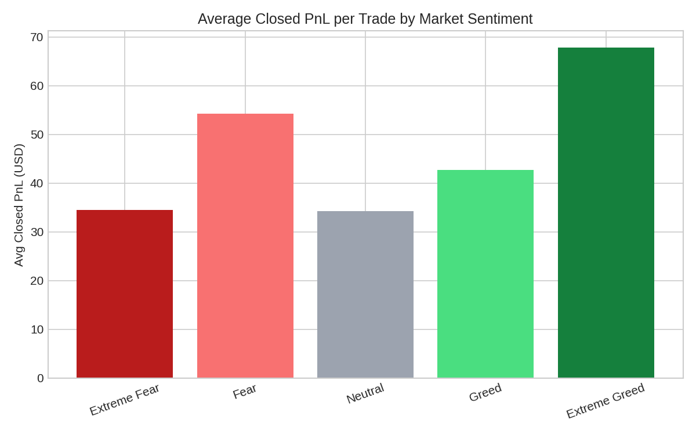
Sentiment | Avg PnL/Trade ($) | Total PnL ($) | Trade Count
Extreme Fear | 34.54 | 739,110 | 21,400
Fear | 54.29 | 3,357,155 | 61,837
Neutral | 34.31 | 1,292,921 | 37,686
Greed | 42.74 | 2,150,129 | 50,303
Extreme Greed | 67.89 | 2,715,171 | 39,992

Insight: Extreme Greed periods produced the highest average profit per trade (~$68), nearly double the Neutral/Extreme Fear average (~$34). Fear periods also showed strong average PnL, suggesting traders on this platform capture value both when sentiment is fearful (buying dips) and when it's extremely greedy (riding momentum) — the worst zone is 'Neutral', where conviction and directional moves are weaker.

3.2 Win Rate by Sentiment
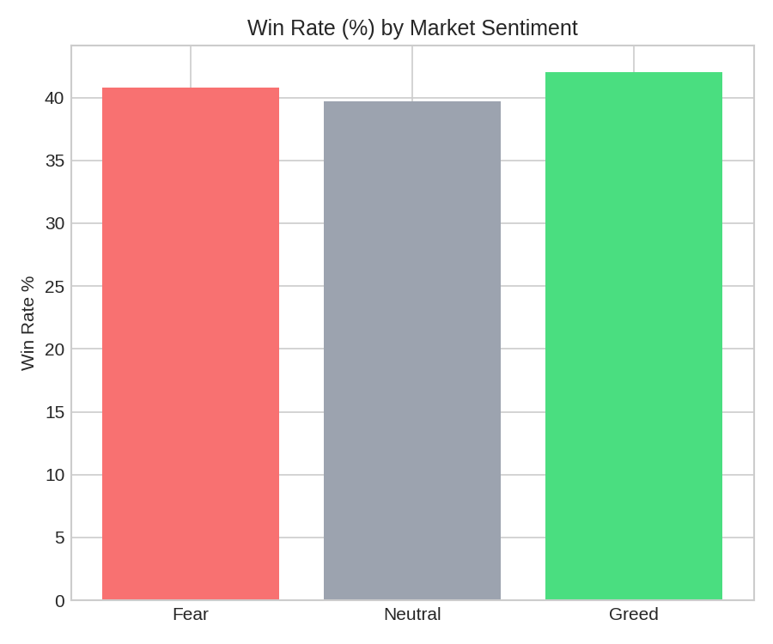
Win rate (share of trades closed with positive PnL) is fairly stable across regimes (~40-42%), slightly higher during Greed (42.0%) and lowest during Neutral (39.7%). This suggests sentiment affects the SIZE of wins/losses more than the FREQUENCY of winning trades.

3.3 Trade Size by Sentiment
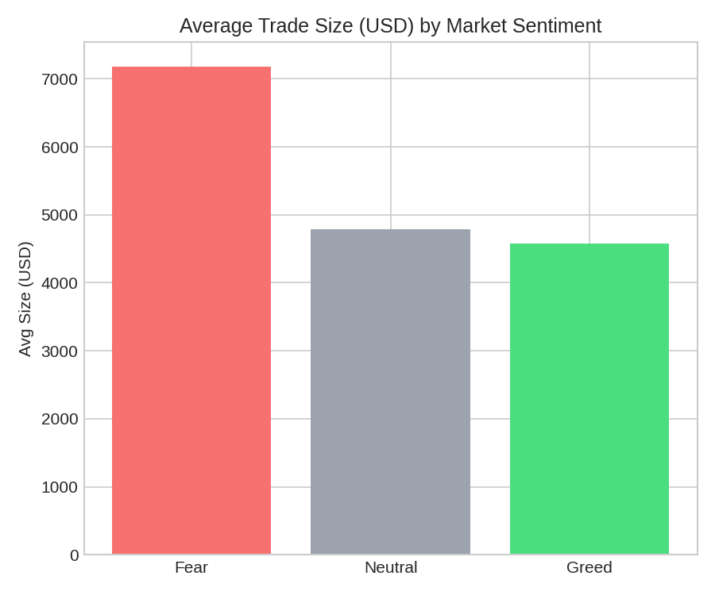
Traders place noticeably larger trades during Fear (~$7,182 avg) compared to Neutral (~$4,783) and Greed (~$4,574). This indicates traders take bigger positions when sentiment is fearful — potentially a contrarian/dip-buying behavior or larger risk-taking during volatile downturns.

3.4 Trading Activity Volume
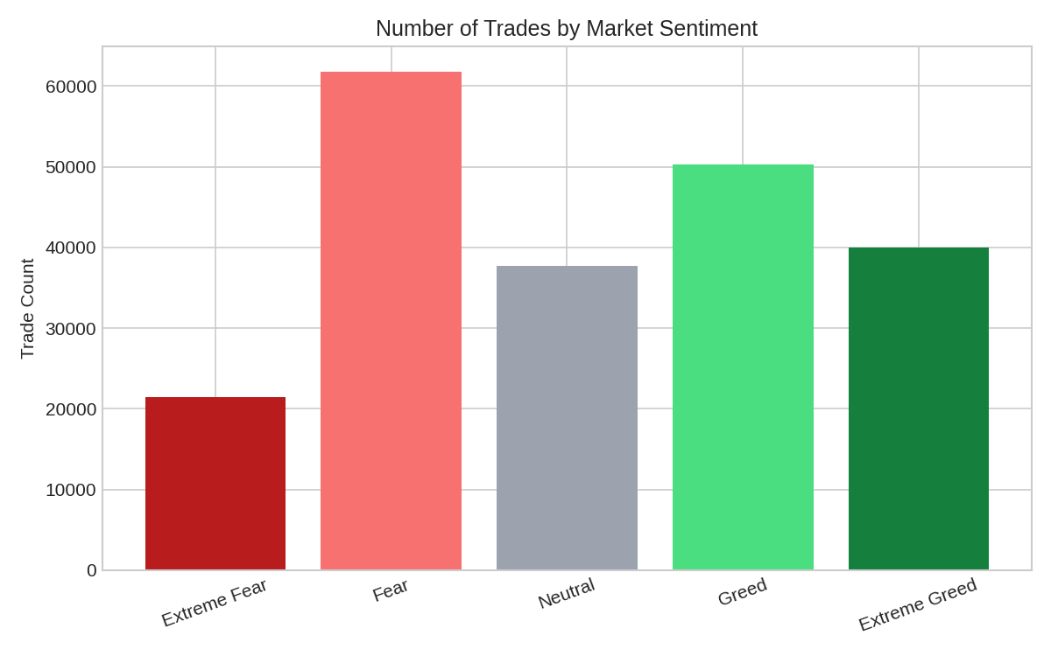
The highest trading activity occurs during 'Fear' (61,837 trades) followed by 'Greed' (50,303) — far more than 'Extreme Fear' or 'Extreme Greed'. This suggests most trading activity happens in moderately emotional markets rather than at sentiment extremes, where liquidity/participation may thin out.

3.5 Buy/Sell Bias by Sentiment
Sentiment | % Buy | % Sell
Fear | 49.5% | 50.5%
Neutral | 50.3% | 49.7%
Greed | 47.1% | 52.9%

During Greed, traders sell slightly more than they buy (52.9% vs 47.1%) — consistent with profit-taking behavior as prices rise. During Fear/Neutral, buy/sell is close to balanced.

3.6 Individual Trader Behavior
Looking at the most active accounts individually, sentiment sensitivity varies a lot by trader — some accounts perform dramatically better during Greed (one top account averaged $217 PnL/trade in Greed vs $27 in Fear), while others perform best during Fear. This means sentiment-based strategy adjustments should likely be personalized rather than applied uniformly to all traders.

4. Strategic Takeaways
- Extreme Greed periods are the most profitable per trade on average — momentum/trend-following strategies may work best here, with attention to timely exits given the propensity to sell during Greed.
- Fear periods attract larger position sizes — position-sizing risk controls (e.g., stricter leverage caps) may be warranted during Fear to avoid amplified losses on bigger bets.
- Neutral sentiment is the weakest regime for profitability — may be a signal to reduce trading frequency or tighten strategy criteria when sentiment is flat.
- Win rate doesn't vary much by sentiment (~40%), so profitability differences come from trade sizing and magnitude of wins/losses, not from picking more 'correct' trades — risk/reward management matters more than sentiment-based trade selection alone.
- Trader-level heterogeneity is high — a single sentiment-based rule won't fit all accounts; segmenting traders by their historical sentiment sensitivity could improve strategy design.

5. Methodology Notes
- Tool: Python (pandas) for data cleaning, merging, and aggregation; matplotlib for visualization.
- Trade dates were parsed from 'Timestamp IST' and matched to the Fear & Greed Index by calendar date.
- 5-class sentiment (Extreme Fear → Extreme Greed) used for granular analysis; a simplified 3-class (Fear/Neutral/Greed) grouping used for win-rate, trade size, and buy/sell comparisons.

