**LEXICAL,SYNTAX AND SEMANTIC ANALYSIS OF A C PROGRAM**

BY:-

Anand R(2017103003)

Shravan G A(2017103592)

**PROBLEM STATEMENT:**

The Process of Compiler design consists of the folllowing stages Lexical analysis, Syntax analysis, Semantic analysis, Code generation. In this project we attempt to do a complete Lexical, Syntax analysis and Semantic analysis of a C program that would take place in a Simple C compiler.

Lexicalanalysis is the first phase of a compiler. It takes the modified source code from language preprocessors that are written in the form of sentences. The lexicalanalyzer breaks these syntaxes into a series of tokens, by removing any whitespace or comments in the source code.

Syntaxanalysisis a second phaseof the compilerdesignprocess that comes after lexicalanalysis. It checks if the given input is in the correct syntaxof the programming language in which the input which has been written

SemanticAnalysisis the third phaseof Compiler. SemanticAnalysismakes sure that declarations and statements of program are semanticallycorrect. Functions of

semantic analysis include Type checking, Label checking and Flow control checking.

**TOOLS USED:**

Lex and Yacc

**IMPLEMENTATION DETAILS:**

Lexical analysis is achieved by Lex. It reads an input stream (ie) source code, processes the character sequences to produce symbol sequences called tokens which is used as inputto the parser.

Parser is the yacc program. It is used to achieve Syntax and Semantic analysis. Yacc is used to parse through the token stream obtained from Lex and it identifies all the syntax errors that are present in the program thereby achieving Syntax analysis. Yacc is also used to do type checking, label checking and flow control checking thereby achieving Semantic analysis.

**OUTPUT:**

For the input C program

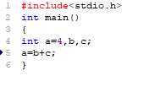

The output is

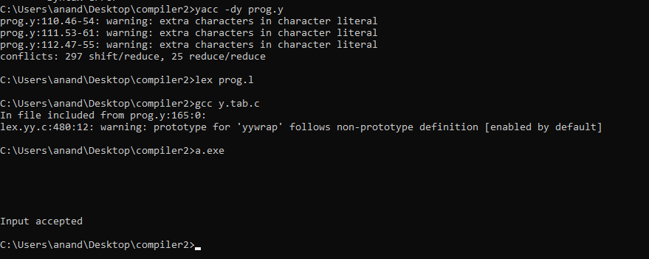

For a C program with error

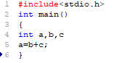

The output is

