Stock Portfolio Optimization — Example Run

Date range: 2024-03-28 to 2025-03-28

Tickers: AAPL, AMZN, GOOGL, MSFT, TSLA

Mean Annual Return:

AAPL 0.274488

AMZN 0.111354

GOOGL 0.077958

MSFT -0.067533

TSLA 0.445967

dtype: float64

Annualized Covariance Matrix:

AAPL AMZN GOOGL MSFT TSLA

AAPL 0.059938 0.024994 0.024725 0.024996 0.064648

AMZN 0.024994 0.081023 0.049315 0.040468 0.084794

GOOGL 0.024725 0.049315 0.084598 0.033170 0.081370

MSFT 0.024996 0.040468 0.033170 0.046625 0.057539

TSLA 0.064648 0.084794 0.081370 0.057539 0.466227

Optimization result (Sharpe-maximizing long-only portfolio):

Optimal portfolio weights: [0.917 0. 0. 0. 0.083]

(Expected return, volatility, Sharpe ratio): [0.289, 0.252, 1.146]

Notes and interpretation:

- The optimizer (long-only, weights sum to 1) concentrated most weight in AAPL (~91.7%) and placed ~8.3% in TSLA. Other assets have zero weight in this solution.

- The annualized expected return for this portfolio is ~28.9% with an annual volatility of ~25.2%, yielding a Sharpe ratio ≈ 1.146.

- MSFT shows a negative sample mean for the selected date range; that contributed to its exclusion from the optimal portfolio.

- The solution is heavily concentrated — in practice you may want to enforce diversification constraints (e.g., max weight per asset) or include transaction costs and turnover limits before using in live strategies.

- Results are based on historical data only. Past returns are not a guarantee of future performance.

Files produced in this example run:

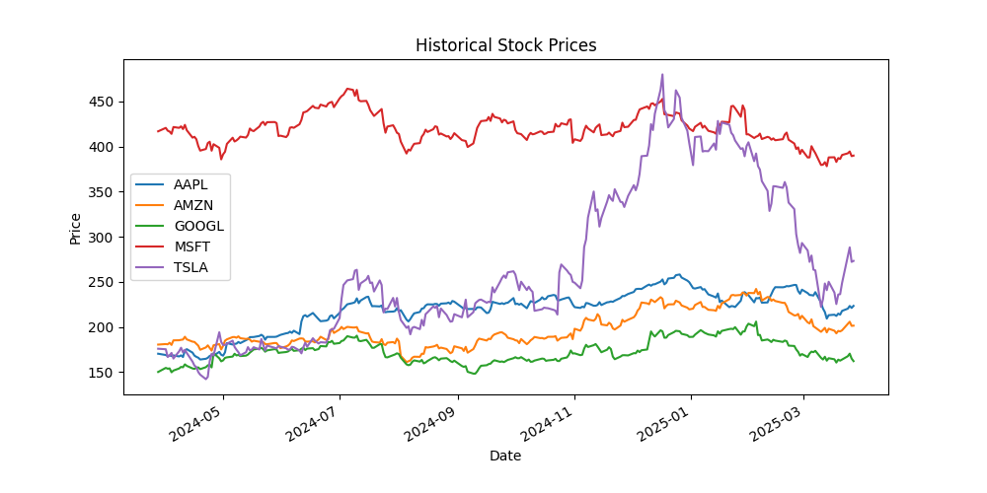

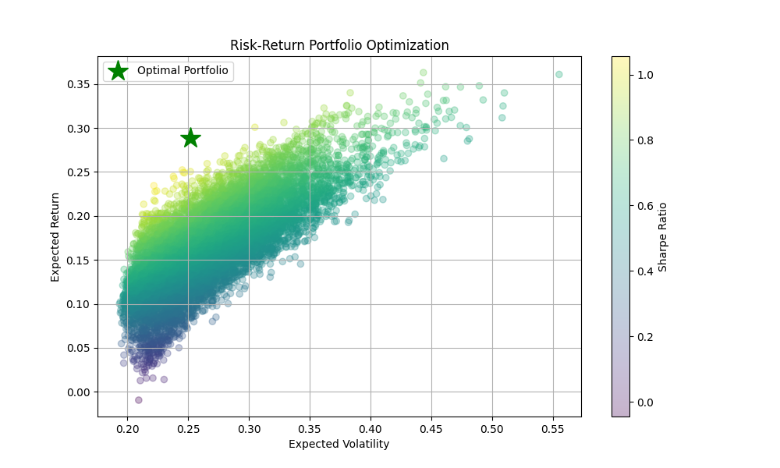— Monte-Carlo risk-return scatter with the Sharpe-optimal portfolio highlighted