# SHOP UP -E COMMERCE SHOPPING WEBSITE

**A PROJECT REPORT**

***Submitted by***

## Anand Kumar Singh

***in partial fulfillment for the award of the degree***

***of***

## BACHELOR OF TECHNOLOGY

**IN**

**Computer Science and Engineering**



## Lovely Professional University, Punjab

**12417612**

**NOVEMBER 2024**

TABLE OF CONTENTS

|  |  |  |
| --- | --- | --- |
| **SR.NO** | **DETAILS** | **PAGE NO** |
| **01** | **INTRODUCTION** | **2** |
| **02** | **TECHNOLOGY USED** | **3** |
| **03** | **WORKFLOW OF PROJECT** | **4** |
| **04** | **PROJECT FUNCTIONALITY** | **6** |
| **05** | **HTML SNIPPET** | **7-13** |
| **06** | **CSS SNIPPET** | **14-19** |
| **07** | **CODE SCREENSHOTS** | **20-23** |
| **08** | **CONCLUSION** | **24** |
| **09** | **REFRENCES** | **24** |

# 01:INRODUCTION

E-commerce websites are digital platforms that facilitate buying and selling of goods and services over the internet. These websites have revolutionized the retail industry, providing businesses with a global marketplace and offering consumers the convenience of shopping from anywhere at any time. E-commerce sites can range from small niche stores to massive online marketplaces, offering a variety of products and services. The main focus of an e-commerce website is to provide a seamless and secure online shopping experience, combining attractive design, user-friendly functionality, and efficient back-end operations.

**Types of E-Commerce Website**

1. **Business to Consumer (B2C)**:
   * **Examples**: Amazon, Flipkart, Walmart, BestBuy.
2. **Business to Business (B2B)**:

**Examples**: Alibaba, Amazon Business, Grainger.

1. **Consumer to Consumer (C2C)**:

**Examples**: eBay, Craigslist, OLX.

1. **Consumer to Business (C2B)**:

**Examples**: Stock photo websites (e.g., Shutterstock), freelance platforms (e.g., Upwork).

1. **Mobile Commerce (M-Commerce)**:

**Examples**: Apps like Amazon, Flipkart, eBay, etc.

## 02:TECHNOLOGY USED

## Website Design and Development

This section describes the design and development process behind the website, focusing on how HTML and CSS are used to create an appealing and

functional user interface.

### HTML Structure

The HTML structure is set up to display different sections of the webpage, including Home, About Us, Key Features and Contact. Each section has its own content, such as text, headings, and lists, to showcase information about India's sustainable development initiatives.

### CSS Style

External CSS ensures separation of structure (HTML) and presentation (CSS), making it easier to maintain and update the design without altering the HTML structure. CSS includes visual design aspects like font styles, colours, layout, and responsive design adjust

**03:WORKFLOW OF THE PROJECT**

Landing on the Site:

* The user is presented with a clean and organized homepage featuring the ShopUp logo, search bar, and navigation menu.

Browsing Categories:

* The user can navigate through various product categories such as "Grocery", "Mobiles", "Appliances", etc., by clicking on the category images.

Searching for Products:

* The search bar allows users to type keywords to find products.

Viewing Products:

* Once the user selects a category or searches for a product, they can view a list of available products with images, pricing, discounts, and ratings.
* Users can see detailed information on products like discount percentages and add the item to their cart.

Adding Products to Cart:

* When the user clicks the Add to Cart button on a product, it gets added to the shopping cart.
* Users can continue shopping or navigate to the cart.

Checking Out:

* After reviewing the cart, the user will proceed to checkout (though the checkout process itself is not implemented in this HTML code).

Log In or Sign Up:

* Users have the option to log in if they have an account or sign up as new customers.

Finalizing the Purchase:

* Once logged in, users can enter shipping and payment details to complete the order. This part, however, requires further integration with backend systems like a payment gateway and user authentication.

**04:PROJECT FUNCTIONALITY**

* **Header Section**:
  + Contains the logo, search bar, and user profile selection.
  + The search bar allows users to search for products.
  + Cart button and user login options are placed for easy navigation.
* **Navigation**:
  + Links to various sections of the website such as "Home", "Products", "Cart", and "Profile" are available.
* **Product Section**:
  + Displays products in a grid format with an image, title, rating, price, and discount information.
  + Each product has an "Add to Cart" button (though no JavaScript functionality is implemented yet).
* **Footer Section**:

Displays a simple footer with the text "© 2024 Flipkart Clone".

**05:HTML SNIPPET**

HTML <!DOCTYPE html>

<html lang="en">

<head>

    <meta charset="UTF-8">

    <meta name="viewport" content="width=device-width, initial-scale=1.0">

    <title>Flipkart Clone</title>

    <link rel="stylesheet" href="anand.css">

</head>

<body>

    <header id="ba">

         <img id="az" src="https://encrypted-tbn0.gstatic.com/images?q=tbn:ANd9GcTIki3Oznb_z7mKNmqIFq6jSgAfUfxPOzJ4aQ&s"width="150x">

         <input type="search" id="af" placeholder="&#128269;Search for Products, Brands and More">

         <button id="bf">&#128722; Cart</button>

         <select name="profession" id="profession">

            <option>&#128100Login</option>

            <option>New Customer? <b>Sign up</b></option><hr>

            <option>&#128100 My Profile</option>

            <option>Orders</option>

            <option></option>

            <option></option>

         </select>

        <nav>

            <ul>`

                <li><a href="#">Home</a></li>

                <li><a href="#">Products</a></li>

                <li><a href="#">Cart</a></li>

                <li><a href="#">Profile</a></li>

            </ul>

        </nav>

    </header>

    <header id="bb">

        <nav>

            <ul>

                <li id="bd"><img src="https://rukminim2.flixcart.com/flap/80/80/image/29327f40e9c4d26b.png?q=100"height=120px><br>&nbsp;&nbsp;Grocery</li>

                <li id="bd"><img src="https://rukminim2.flixcart.com/flap/80/80/image/22fddf3c7da4c4f4.png?q=100"height=120px><br>&nbsp;&nbsp;&nbsp;&nbsp;&nbsp;&nbsp;Mobiles</li>

                <li id="bd"><img src="https://rukminim2.flixcart.com/fk-p-flap/80/80/image/0139228b2f7eb413.jpg?q=100"height=120px><br>&nbsp;&nbsp;&nbsp;&nbsp;&nbsp;Appliances</li>

                <li id="bd"><img src="https://rukminim2.flixcart.com/flap/80/80/image/71050627a56b4693.png?q=100"height=120px><br>&nbsp;&nbsp;Flight Booking</li>

                <li id="bd"><img src="https://th.bing.com/th/id/OIP.oL3QFZi4qfiu2qygLKIm0gHaH1?w=176&h=188&c=7&r=0&o=5&dpr=1.3&pid=1.7"height=120px><br>&nbsp;&nbsp;&nbsp;&nbsp;Fashion</li>

                <li id="bd"><img src="https://th.bing.com/th?id=OIP.WuH8X0GFesWzQX4RDtEq-gHaFj&w=288&h=216&c=8&rs=1&qlt=90&o=6&dpr=1.3&pid=3.1&rm=2"height=120px><br>&nbsp;&nbsp;&nbsp;&nbsp;Two Wheelers</li>

                <li id="bd"><img src="https://encrypted-tbn0.gstatic.com/images?q=tbn:ANd9GcTOf5eng_vqnPB1El7N2GikfsEZfLVzU6PNVw&s"width=225px>&nbsp;&nbsp;&nbsp;&nbsp;&nbsp;Electronics</li>

            </ul>

        </nav>

    </header>

    <main>

        <h1>Shop Your Favourites</h1>

        <header id="bg">

            <nav>

                <ul>

                </ul>

            </nav>

        </header>

        <div class="product-container">

            <div class="product">

                <img src="https://encrypted-tbn1.gstatic.com/shopping?q=tbn:ANd9GcS5AklSOVIXVEVx7GvPozF8JTaDLFSRun_wEfp43ut1jukTZLaVdcVTAOim4Bsyqp3sFwuQCgrAhBnxLvRFcg9nb2Ten-10tKL33QzDkSyia2YcnRUC8GFQj-4" alt="Product 1"width="1000px">

                <h4>Boult Z40 with Zen ENC Mic</h4>

                <button id="ac">4.1 &#9055</button>

                (16,206)<br><br>

                <b>₹1,599</b> <strike>₹2299</strike>

                <b style="color: green;">64% off<br>bank offer</b><br>

                <button>Add to Cart</button>

            </div>

            <div class="product">

                <img src="https://rukminim2.flixcart.com/image/312/312/xif0q/mobile/6/q/r/-original-imah4jz64htqmsxg.jpeg?q=70"width="160">

                <h4>Apple iPhone 16 Pro Max (White Titanium, 1 TB)</h4>

                <button id="ac">4.6 &#9055</button>

                (30,234)<br><br>

                <b>₹1,84,900</b>

                <br>

                <button>Add to Cart</button>

            </div>

            <div class="product">

                <img src="https://rukminim2.flixcart.com/image/612/612/xif0q/shoe/f/f/s/9-fc-phantom-wh-gry-field-care-white-grey-original-imah5z9uhmf6qcxk.jpeg?q=70"width="600px">

                <h4>NIKE

                    Air Jordan 2 Retro Sneakers For Men</h4>

                <button id="ac">3.9 &#9055</button>

                (6,506)<br><br>

                <b>₹11,599</b> <strike>₹14,900</strike>

                <b style="color: green;">33% off<br>bank offer</b><br>

                <button>Add to Cart</button>

            </div>

            <div class="product">

                <img src="https://encrypted-tbn2.gstatic.com/shopping?q=tbn:ANd9GcQ5Spj9o1-uSu56fSI5hsObQa3hBXq3ZmCVyuURf9caG_0nYVzNk_Whfdz3udBzjKUfTzhSDqqDkCH1O6cntI6H7x8bsbRo2NjRQyV1rD40fzfiMnSlv8OyjuhNXoEnjnzgHDvweQ&usqp=CAc" alt="Product 2">

                <h4>Flexnest 17in1 Adjustable Iron Dumbbells Set</h4>

                <button id="ac">4.0 &#9055</button>

                (6,808)<br><br>

                <b>₹33,999</b> <strike>₹299</strike>

                <b style="color: green;">64% off<br>bank offer</b>

                <button>Add to Cart</button>

            </div>

            <div class="product">

                    <img src="https://rukminim2.flixcart.com/image/612/612/ksru0sw0/watch/e/0/c/1-ar11362-emporio-armani-men-original-imag69rdjzav8xyz.jpeg?q=70"width="140">

                    <h4>EMPORIO ARMANI

                        Diver Analog Watch</h4>

                    <button id="ac">4.5 &#9055</button>

                    (16,206)<br><br>

                    <b>₹1,599</b> <strike>₹2299</strike>

                    <b style="color: green;">64% off<br>bank offer</b>

                    <button>Add to Cart</button>

                </div>

                <div class="product">

                    <img src="https://rukminim2.flixcart.com/image/312/312/xif0q/computer/m/2/a/-original-imah4znzxmp3gsmw.jpeg?q=70">

                    <h4>Product 1</h4>

                    <button id="ac">4.5 &#9055</button>

                    (16,206)<br><br>

                    <b>₹1,599</b> <strike>₹2299</strike>

                    <b style="color: green;">64% off<br>bank offer</b>

                    <button>Add to Cart</button>

                </div>

                <footer>

                    <p>&copy; 2024 Flipkart Clone</p>

                </footer>

        </div>

    </main>

</body>

</html>

**06:CSS SNIPPET**

**body {**

**font-family: Arial, sans-serif;**

**margin: 0;**

**padding: 0;**

**}**

**#ba{**

**background-color: #2874f0;**

**color: white;**

**padding: 15px;**

**display: flex;**

**justify-content: space-between;**

**align-items: center;**

**}**

**#bd{**

**margin: 30px;**

**}**

**#bb{**

**background-color: aliceblue;**

**color:black;**

**padding: 15px;**

**display: flex;**

**justify-content: space-between;**

**align-items: center;**

**height: 150px;**

**}**

**#bf{**

**position: absolute;**

**height: 40px;**

**border-radius: 5px;**

**left: 810px;**

**}**

**nav ul {**

**list-style-type: none;**

**display: flex;**

**}**

**nav ul li {**

**margin-left: 20px;**

**}**

**nav ul li a {**

**color: white;**

**text-decoration: none;**

**}**

**.product-container {**

**display: flex;**

**flex-wrap: wrap;**

**padding: 20px;**

**}**

**.product {**

**border: 1px solid #ddd;**

**border-radius: 5px;**

**margin: 5px;**

**padding: 15px;**

**text-align: center;**

**width: 200px;**

**}**

**#ac{**

**background-color: green;**

**color: white;**

**font-size:small;**

**}**

**.product:hover{**

**box-shadow: 5px 5px 5px 3px gray;**

**}**

**.product img {**

**max-width: 100%;**

**}**

**product button{**

**background-color: #2874f0;**

**}**

**footer {**

**text-align: center;**

**padding: 10px;**

**background-color: #f1f1f1;**

**position: fixed;**

**bottom: 0;**

**width: 100%;**

**}**

**#af{**

**position: absolute;**

**height: 40px;**

**width: 500px;**

**left: 190px;**

**border-radius: 7px;**

**}**

**#profession{**

**position: absolute;**

**height: 40px;**

**width: 100px;**

**left: 700px;**

**border-radius:7px;**

**}**

**#profession:hover{**

**background:aliceblue;**

**}**

**#bg{**

**background-color: gray;**

**height: 80px;**

**}**

**#az{**

**border-radius: 6px;**

**}**

07: **HTML CODE**

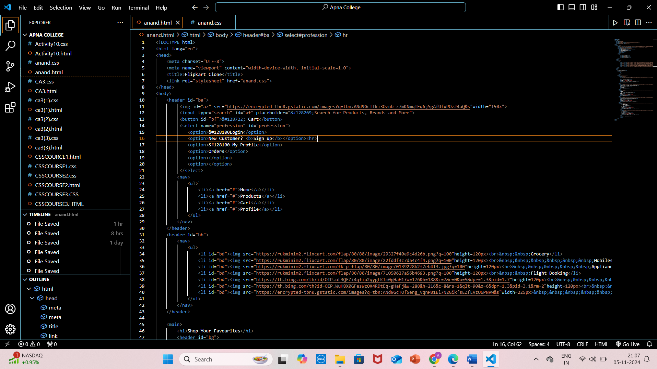

## 

## 

## 07:CSS CODE

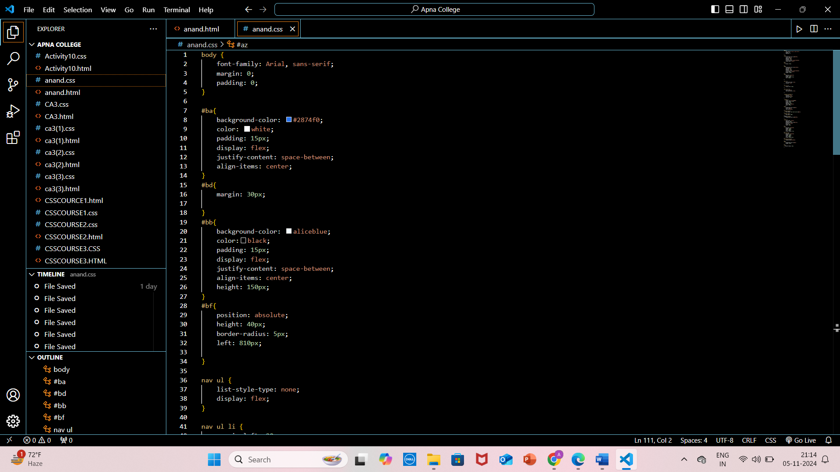

## 

## 08:Conclusion

The ShopUp project demonstrates how basic HTML and CSS can be used to create a simple, functional e-commerce webpage. This project serves as a stepping stone for building more dynamic and interactive websites by adding JavaScript functionality for features like cart management, user authentication, and product filtering.

**09:References**

Flipkart product images

Google images

19