Blog 2

Face to Face with the Bengal Tiger: A Safari Experience Your Clients Will Never Forget
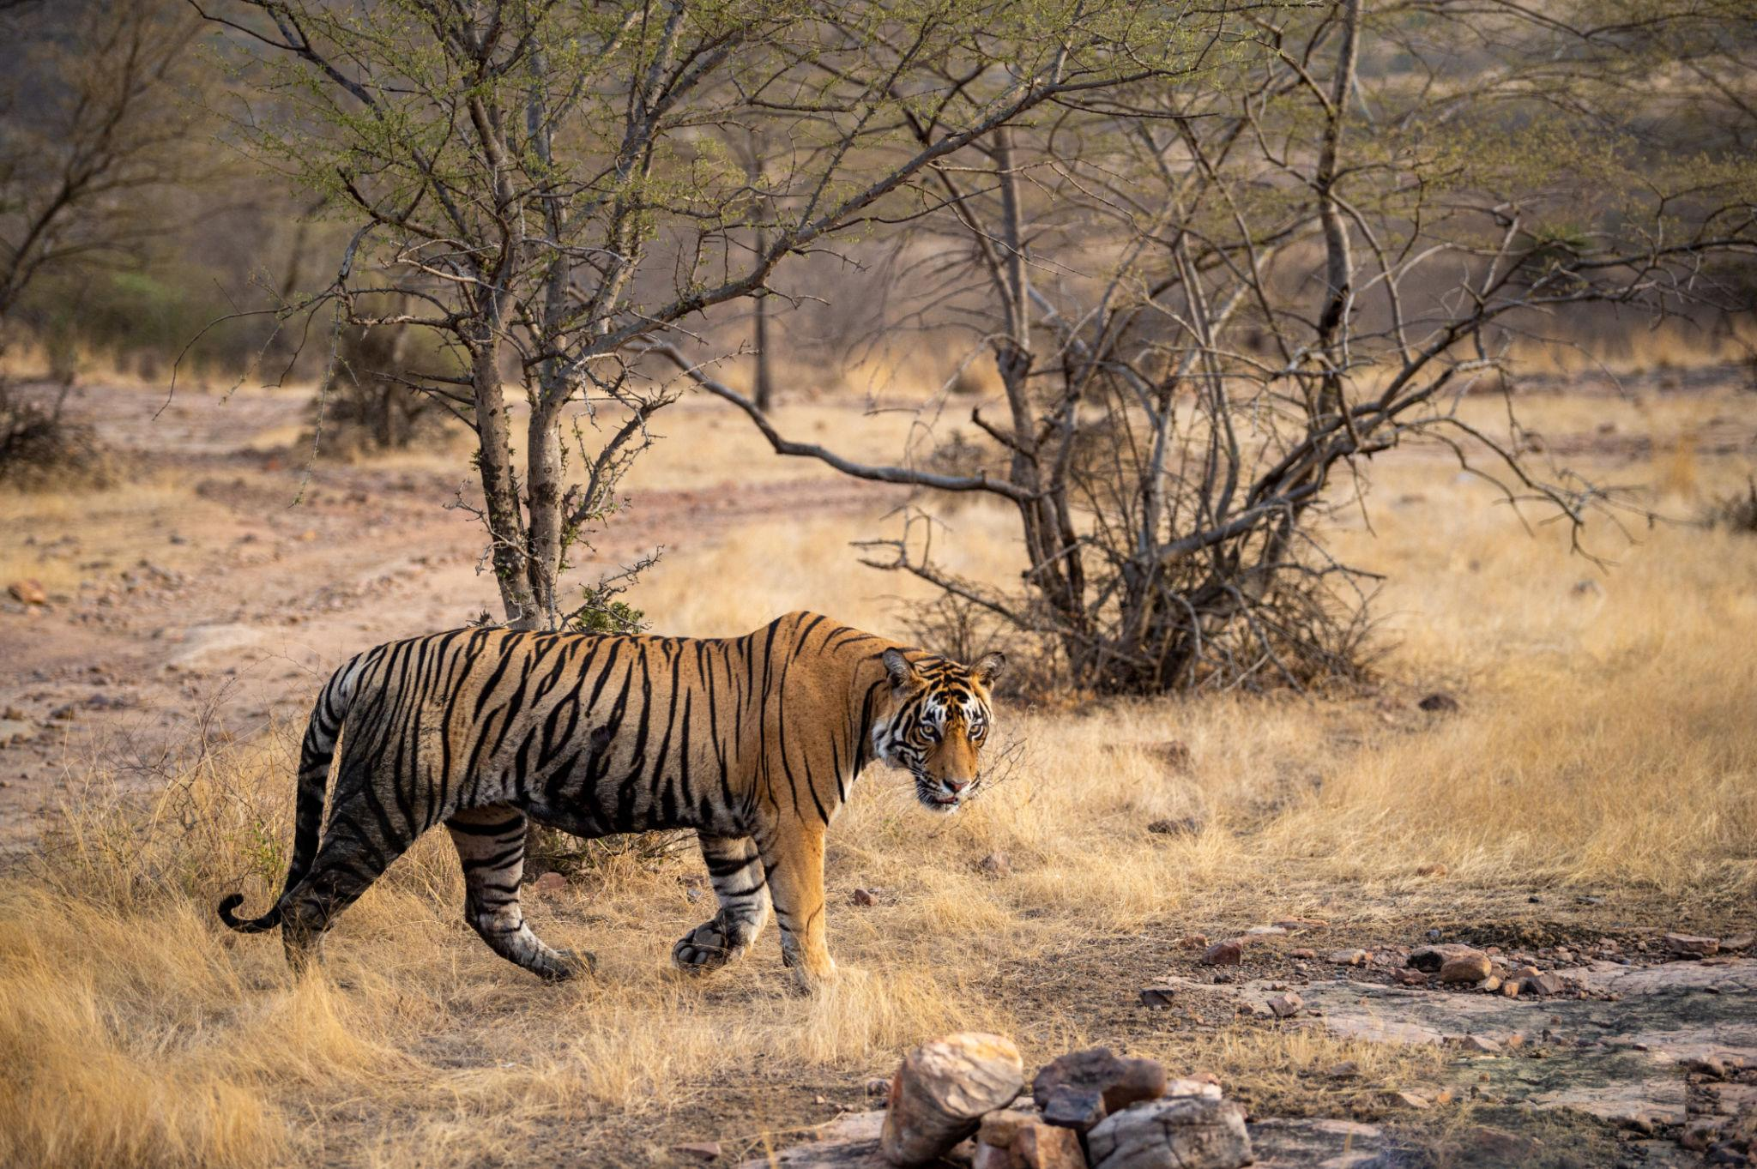
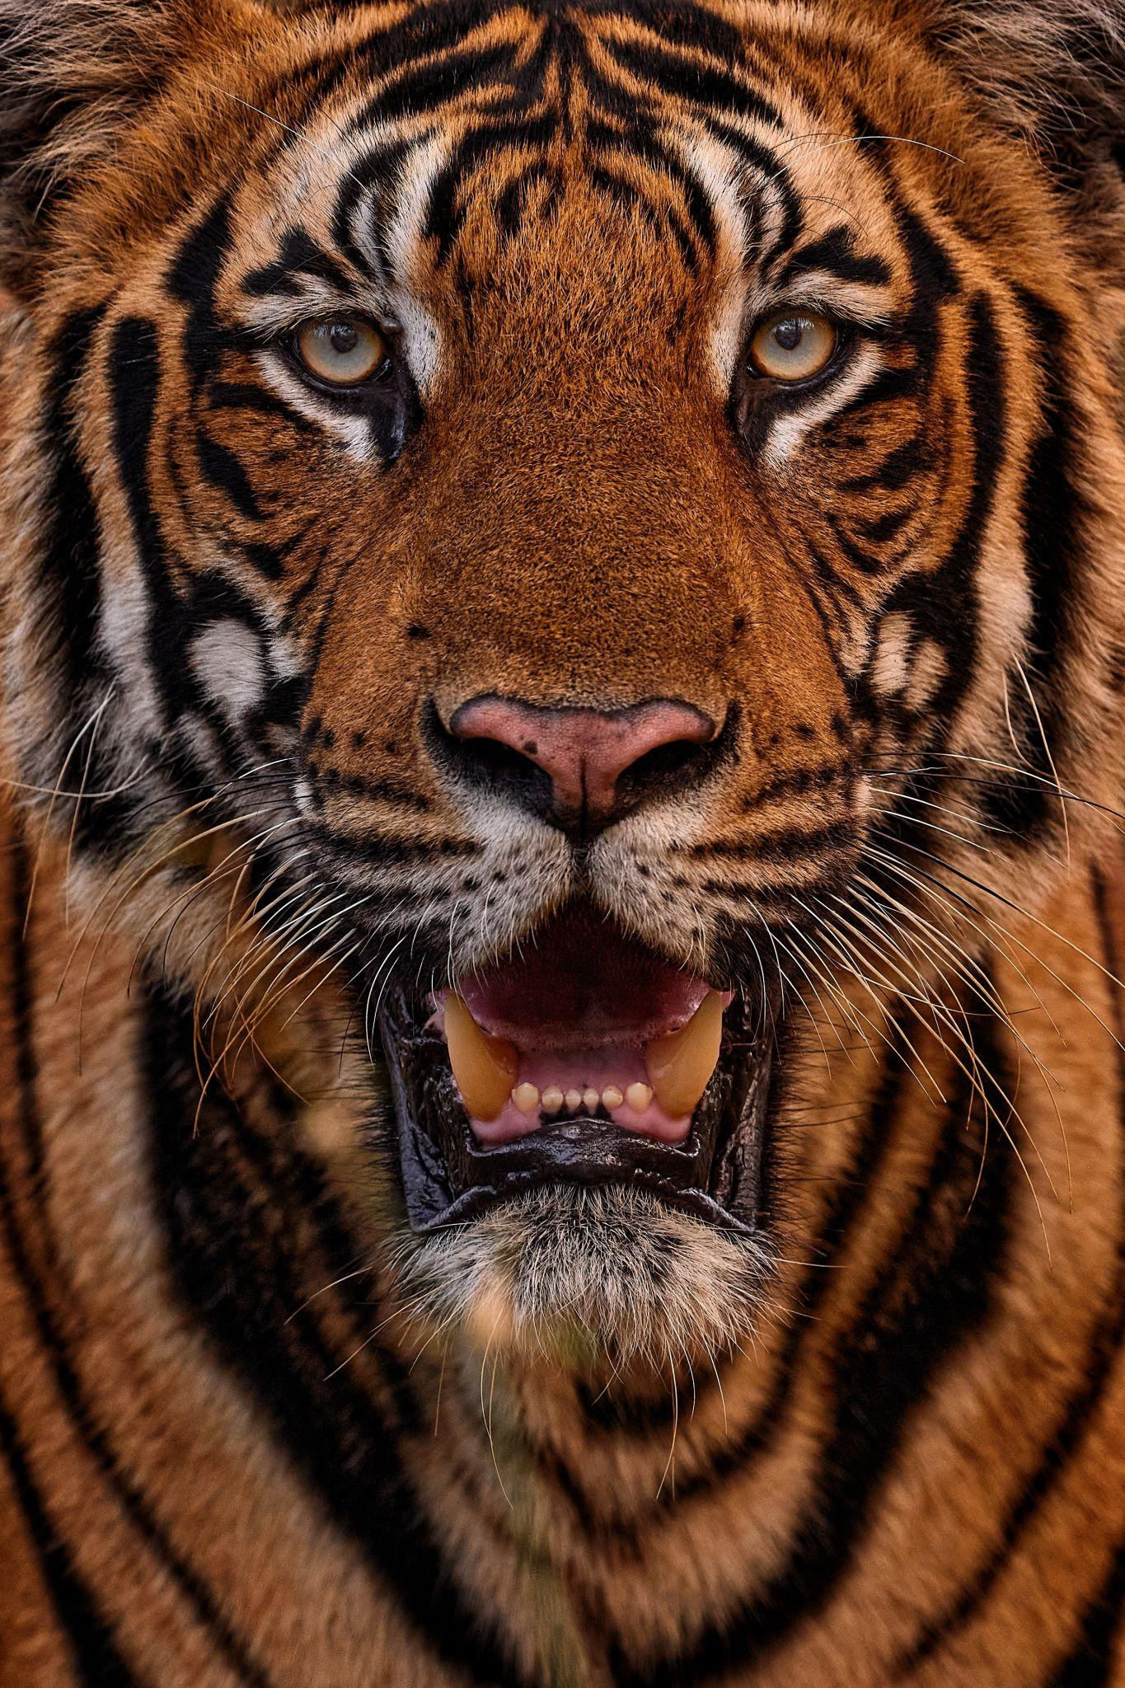
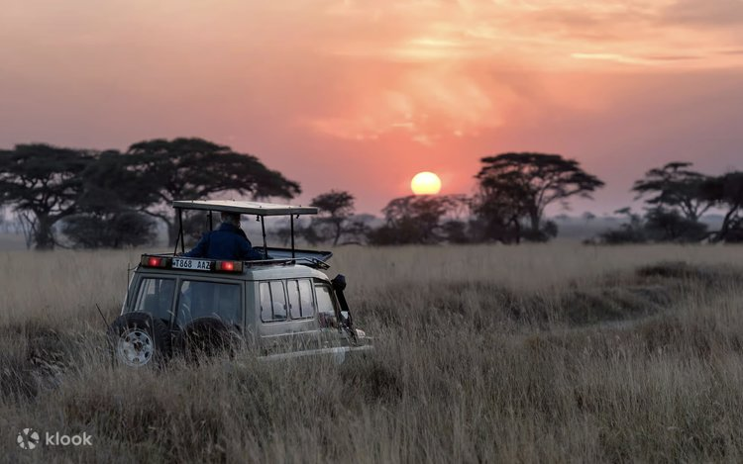
4
SEO Keywords: Bengal tiger safari India, Ranthambore wildlife tour, luxury safari India, tiger sighting India
Meta Description: Discover why a Bengal tiger safari in India is one of the world’s most unforgettable wildlife experiences for North American travelers.

The jeep engine turns off.
There’s a stillness that settles across the jungle — broken only by the alarm call of a spotted deer.
And then, through tall golden grass, stripes appear.
A Bengal tiger. Not in a documentary. Not behind glass. Just meters away.
For many international travelers, this moment becomes the defining memory of their India journey.

Why India Is the Ultimate Tiger Destination
India is home to nearly 75% of the world’s wild Bengal tiger population. Conservation efforts over the past decade have transformed its national parks into some of the best-managed wildlife reserves globally.
Top safari regions include:
- Ranthambore (Rajasthan)
- Bandhavgarh (Central India)
- Kanha (Central India)
- Tadoba (Maharashtra)
Each park offers distinct landscapes — from ancient forts rising above jungle canopies to misty sal forests.
For North American agencies, tiger safaris position India alongside Africa’s Big Five experiences — but with a cultural depth Africa cannot replicate.

What Makes an Indian Safari Different?
Unlike African plains, Indian forests are dense, dramatic, and intimate.
Safaris are conducted in small 4x4 vehicles with trained naturalists. Sightings feel earned — not staged.
Beyond tigers, clients encounter:
- Leopards
- Sloth bears
- Wild elephants
- Marsh crocodiles
- Hundreds of bird species
The experience blends wildlife with heritage. In Ranthambore, 10th-century fort walls overlook tiger territory — a rare combination of history and wilderness.

Best Time for Tiger Sightings
October to June is safari season.
For higher sighting probability:
- March to May offers drier landscapes
- Animals gather near water sources
- Visibility improves as foliage thins
Advance permit booking is critical — zones sell out quickly during peak months.

Elevating the Safari for Luxury & Incentive Groups
India’s safari lodges range from rustic charm to refined luxury.
Private dining under the stars.
Spa treatments after game drives.
Curated naturalist sessions for educational groups.
For incentive travel planners, a tiger sighting becomes more than an excursion — it becomes a story clients retell for years.

Planning Matters
Safari timing, buffer days, and intercity logistics require careful coordination. Weather, park closures, and zone allocation systems demand on-ground expertise.
This is where strong DMC partnership becomes essential.

India’s jungles are wild. Powerful. Unpredictable.
The difference between a good safari and an unforgettable one lies in who is managing the details.
At IndoMaple Tours, we combine deep regional knowledge with Canadian service standards — ensuring your clients experience India’s wildlife safely and seamlessly.
Let’s collaborate.

