.

Data Analysis Project – Sales Management

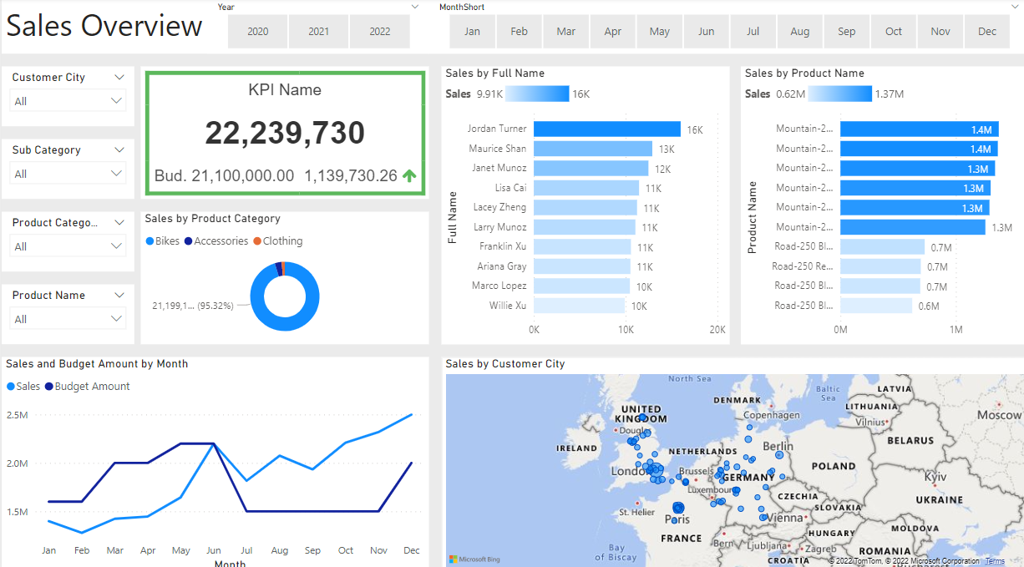

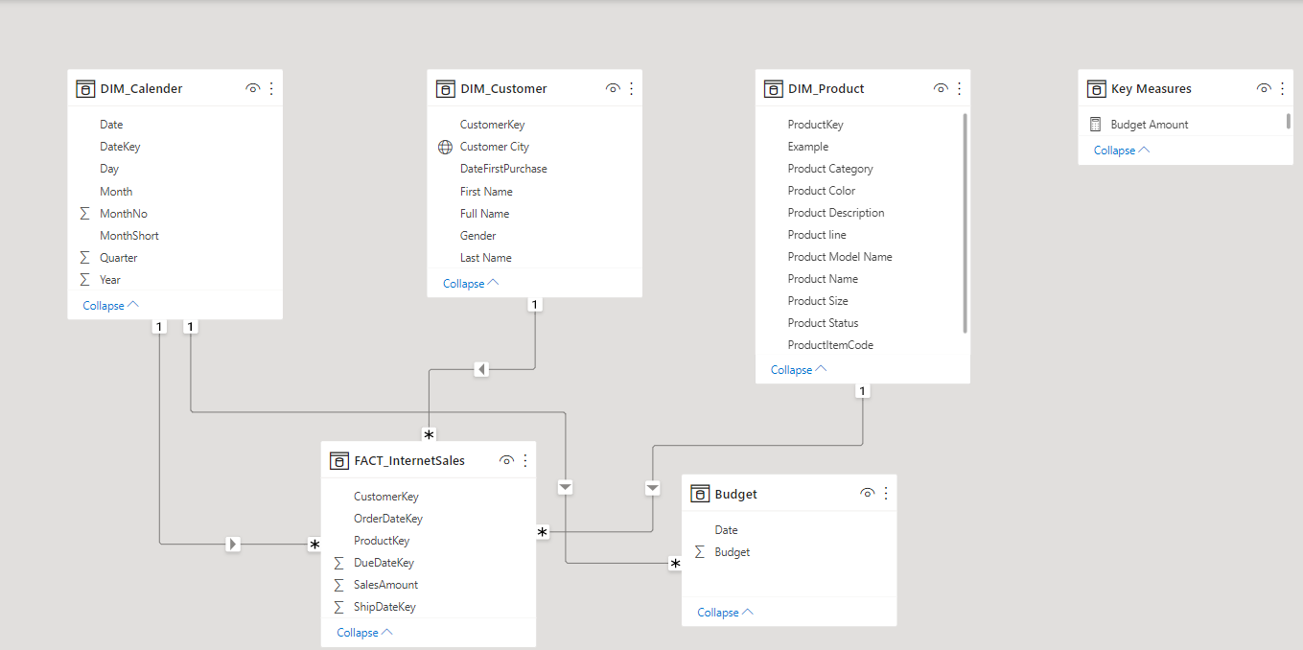

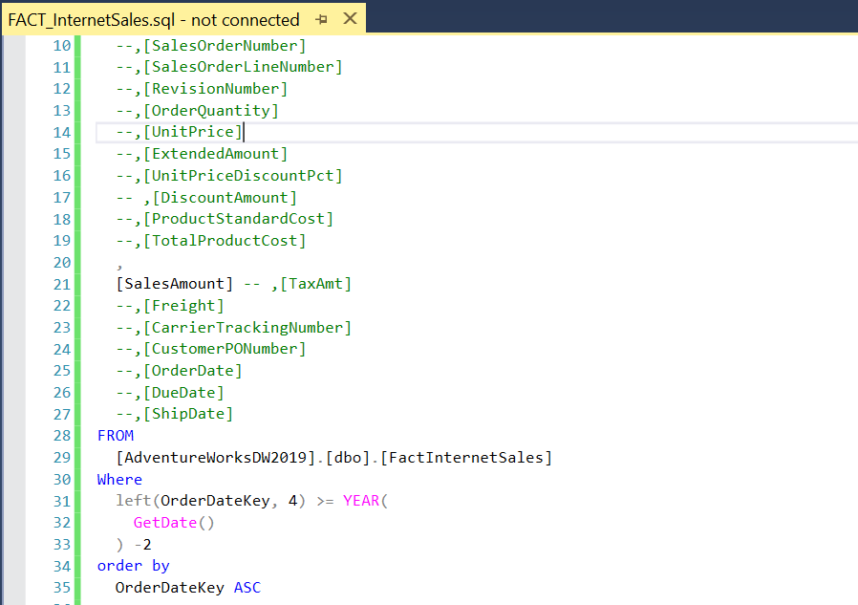

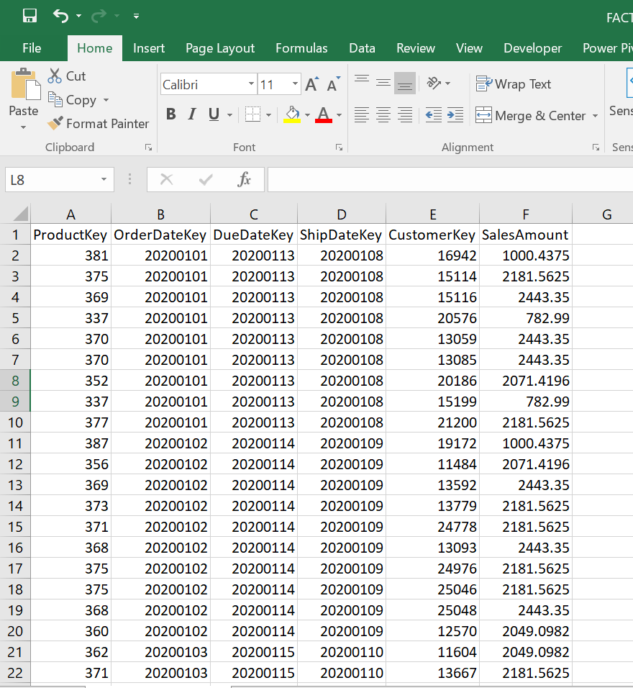

**Business Request & User Stories**

The Business request for this data analysis was an executive sales report for sales managers. Based on the request that was made from the business we following user stories were defined to fulfill delivery and ensure that acceptance criteria’s were maintained throughout the project.

|  |  |  |  |  |
| --- | --- | --- | --- | --- |
| No | As a (Role) | I want (request / demand) | So that I (user value) | Acceptance Criteria |
| 1 | Sales Manager | To get the Dashboard over view of the Internet sales | Can follow better which customer and products sells the best | A Power BI dashboard which updates data once a day |
| 2 | Sales Representative | A detailed overview of Internet Sales per customer | Can follow up my customer that buys the most and who we can sell are to | A Power BI Dashboard which allows me to filter data for each customer |
| 3 | Sales Representative | A detailed overview of Internet Sales per Products | Can follow up my products that sells the most | A Power BI Dashboard which allows me to filter data for each products |
| 4 | Sales Manager | A Dashboard overview of internet sales | Follow sales over time against budget | A power BI Dashboard with graphs and KPI’s comparing against budget. |

Data Cleansing & Transformation (SQL)

To create a necessary data model for doing analysis and fulfilling the business needs defined in the user stories the following tables were extracted using SQL.

One Data source (Sales Budget) were provided in the excel format and were connected in the data model in a later step of the process.

Below are the SQL statements for cleansing and transforming necessary data.

Dim Product

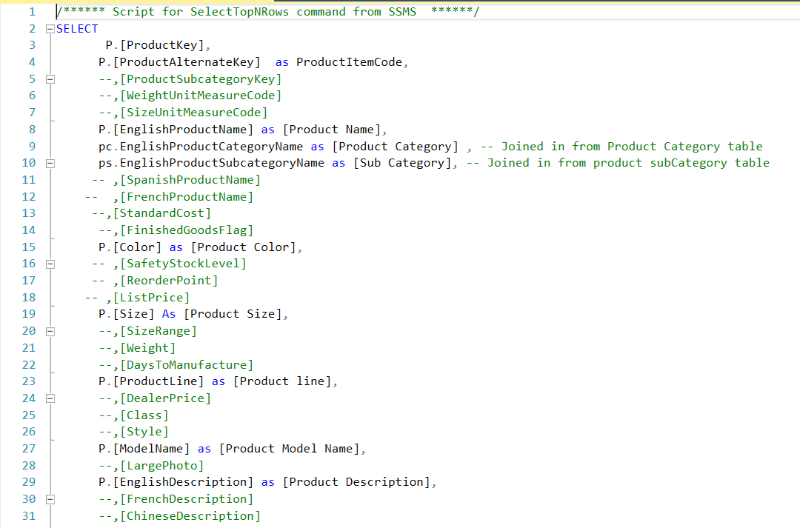

Dim Customer

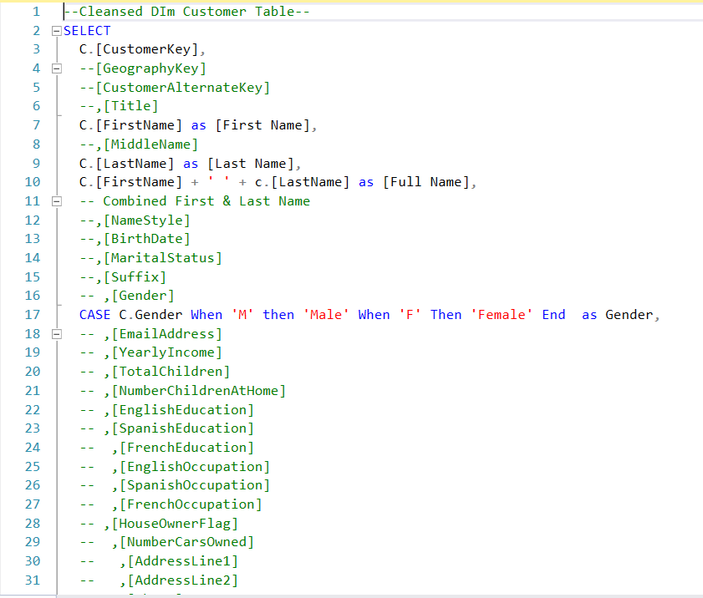

Dim Calendar

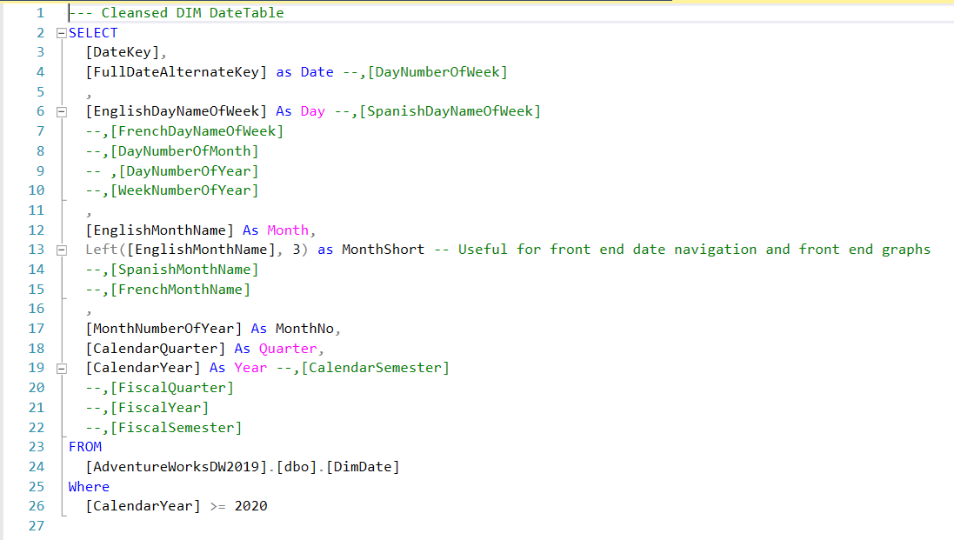

Dim Fact Internet Sale

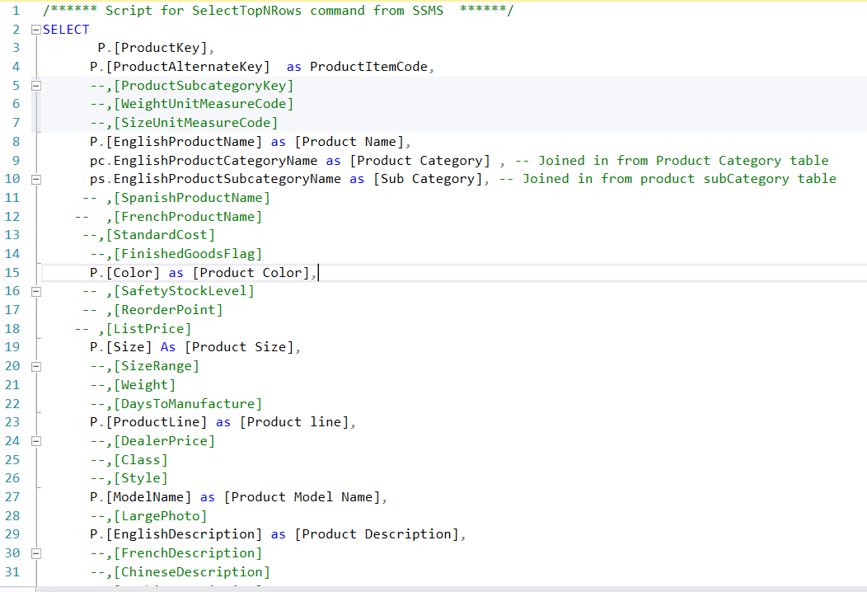

Data Model

Below is a screenshot of data model after cleansed and prepared tables were read into POWER BI.

This Data Model also shows how FACT_Budget has been connected to FATC_InternetSales to other necessary DIM Tables.



Sales Management Dashboard.

The Finished sales management dashboard with one page, which works as dashboard and overview. With two other pages focused on combining tables for necessary details and visualization to show sales over time, per customer and per product.

