IBM SkillsBuild Cybersecurity Bootcamp 2026
Conducted by BharatCares
Network Intrusion Detection
with Machine Learning
A Scikit-learn classifier trained on the NSL-KDD dataset
Project Report
Submitted by: Anand Vishwakarma
Project submission (Deliverable 2)
25 October 2026

1. Abstract
This project builds and evaluates machine-learning models that detect malicious network connections. Using the public NSL-KDD dataset, four classifiers (Logistic Regression, Decision Tree, Random Forest and Hist Gradient Boosting) were trained on 125,973 labelled connections and tested on the official test set of 22,544 connections, which includes 17 attack types that never appear in training.
The best model by F1 score was the Decision Tree, with 81.0% accuracy, 96.6% precision and 69.1% recall. Random Forest and Hist Gradient Boosting had the best ROC-AUC (0.962 and 0.959). A key finding is the generalisation gap: Random Forest reaches F1 0.999 in cross-validation on the training data but only 0.754 on the official test set. Denial-of-Service and Probe attacks were detected well (about 83% and 81%), while Remote-to-Local (R2L) and User-to-Root (U2R) attacks were mostly missed. The report also shows how the alert threshold trades missed attacks against false alarms.

2. Introduction and Objectives

2.1 Problem statement
Security teams receive far more network activity than people can inspect. An intrusion detection system (IDS) helps by flagging connections that look malicious. The bootcamp material describes how a SOC turns raw telemetry into alerts, investigations and responses, and stresses that detection should happen early in the attack life cycle, before damage is done. A machine-learning detector can support that triage step, but only if its strengths and blind spots are understood.

2.2 Objectives
- Build a classifier that separates normal connections from attacks.
- Compare several models fairly on a held-out, official test set.
- Measure how well each attack family (DoS, Probe, R2L, U2R) is detected.
- Explain which features drive the decisions and how the alert threshold changes the balance of false alarms and missed attacks.
- Report the limitations honestly, including the gap between training and test performance.

3. Dataset
The project uses NSL-KDD, an improved version of the KDD Cup 1999 intrusion data prepared by the Canadian Institute for Cybersecurity at the University of New Brunswick. It removes duplicate records so that models cannot score well simply by memorising frequent rows. Each record describes one network connection with 41 features (such as protocol, service, TCP flag, bytes sent and received, and traffic-rate statistics) and a label. No missing values or duplicate rows were found in either file.
Table 1. Dataset files
File | Role | Connections | Attack share
KDDTrain+.txt | Training | 125,973 | 46.5%
KDDTest+.txt | Testing | 22,544 | 56.9%
Source: https://www.unb.ca/cic/datasets/nsl.html (files fetched from the GitHub mirror https://github.com/defcom17/NSL_KDD).
Specific attack names were grouped into the four standard families, plus a binary normal/attack label. The test set contains 37 distinct attack names but the training set only 22, so 17 attack types are completely new to the models.
Table 2. Attack families and class balance
Family | Meaning | Train | Test
Normal | Legitimate traffic | 67,343 (53.5%) | 9,711 (43.1%)
DoS | Denial of Service: flood a service until it fails | 45,927 (36.5%) | 7,460 (33.1%)
Probe | Scanning and surveillance | 11,656 (9.3%) | 2,421 (10.7%)
R2L | Remote to Local: remote attacker gains local access | 995 (0.8%) | 2,885 (12.8%)
U2R | User to Root: privilege escalation | 52 (0.04%) | 67 (0.3%)
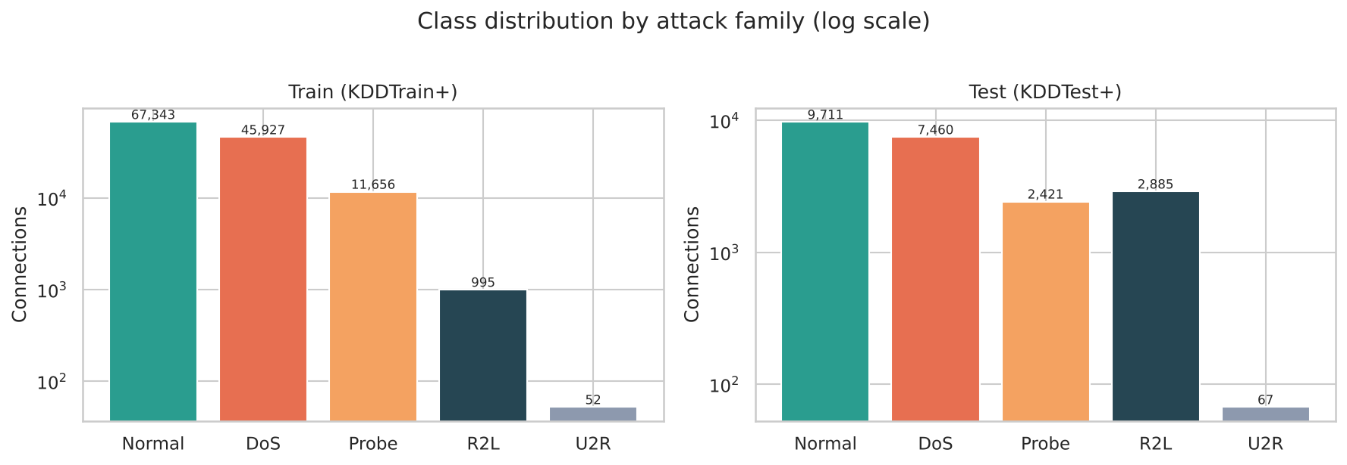
Figure 1. Class distribution by attack family (log scale). R2L and U2R are rare in training.
Two points stand out. First, R2L and U2R are very rare in training (995 and 52 records) yet R2L is 12.8% of the test set. Second, the attack mix shifts between training and test, which is what makes the test set a realistic challenge.

4. Tools and Technologies
Tool | Purpose
Python 3.13 | Programming language
pandas, NumPy | Loading, labelling and manipulating the data
scikit-learn | Preprocessing pipelines, classifiers, cross-validation and metrics
matplotlib, seaborn | Charts and heatmaps
Jupyter Notebook | Interactive, reproducible analysis
All random processes use random_state=42 so the results can be reproduced.

5. Methodology

5.1 Preprocessing
- Three categorical features (protocol_type, service, flag) were one-hot encoded. Unknown categories are ignored at prediction time because the test set contains services not seen in training.
- The 37 numeric features were standardised, which helps the linear model.
- The difficulty column (a dataset annotation) and num_outbound_cmds (always zero) were dropped.
- Encoding and scaling sit inside one scikit-learn Pipeline together with the model. The preprocessing is therefore learned from training data only, which prevents data leakage.

5.2 Models
Model | Why it was chosen
Logistic Regression | Simple, interpretable baseline
Decision Tree (max depth 20) | Fast, rule-like model that is easy to explain
Random Forest (200 trees) | Robust ensemble of trees, gives feature importance
Hist Gradient Boosting | Strong boosted-tree model for tabular data

5.3 Evaluation
All models were trained on KDDTrain+ and scored on the untouched KDDTest+. Because the two kinds of error have different costs in security, several metrics are reported:
- Recall: the share of real attacks caught. A missed attack (false negative) lets an intruder in, so this is the costly error.
- Precision: the share of alerts that are real attacks. Low precision means false alarms and alert fatigue for analysts.
- F1: the balance of precision and recall. ROC-AUC: how well the model ranks attacks above normal traffic across all thresholds.
Random Forest was also checked with 3-fold stratified cross-validation on the training set to measure how performance changes on unseen attack types. A separate 5-class Random Forest with balanced class weights was trained to name the attack family.

6. Results

6.1 Model comparison
Table 3. Binary detection results on the official test set (sorted by F1)
Model | Accuracy | Precision | Recall | F1 | ROC-AUC | Train (s)
Decision Tree | 0.810 | 0.966 | 0.691 | 0.806 | 0.830 | 1.7
Hist Gradient Boosting | 0.809 | 0.970 | 0.686 | 0.804 | 0.959 | 5.7
Random Forest | 0.770 | 0.968 | 0.617 | 0.753 | 0.962 | 8.0
Logistic Regression | 0.754 | 0.917 | 0.623 | 0.742 | 0.791 | 5.2
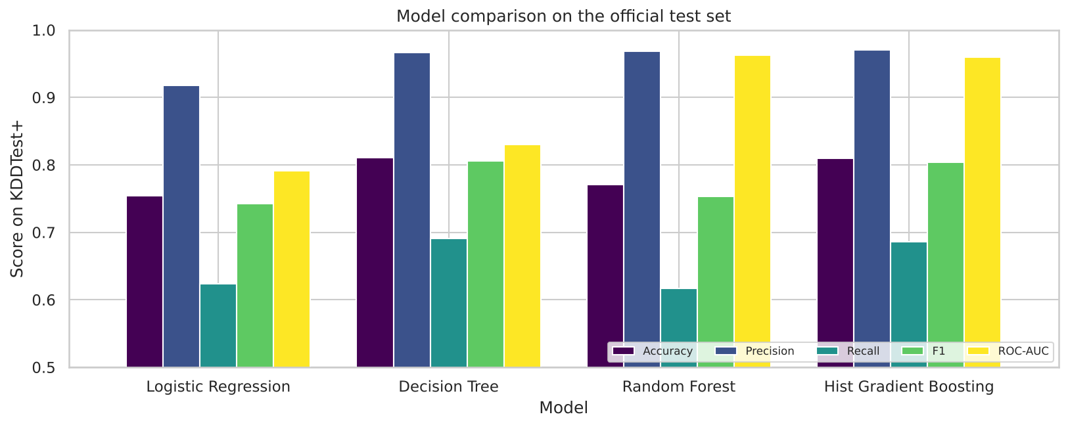
Figure 2. Model comparison on KDDTest+.
The Decision Tree has the best F1 (0.806), with Hist Gradient Boosting very close (0.804). All models have high precision (92% to 97%) but moderate recall (62% to 69%). The ROC-AUC tells a different story: Random Forest (0.962) and Hist Gradient Boosting (0.959) rank connections far better than the Decision Tree (0.830). Their default 0.5 threshold is simply not the best operating point, which is explored in Section 6.5.

6.2 Seen versus unseen attacks
Evaluation | Random Forest F1
3-fold cross-validation on KDDTrain+ | 0.999
Official test set (KDDTest+) | 0.754
Cross-validation mixes records from the same attack types, so the model looks almost perfect. On the official test set, which contains attack types it has never seen, the F1 score falls by about 0.25. This is the most important result of the project: a detector that is excellent on known attacks can still miss new ones.

6.3 Error analysis of the best model
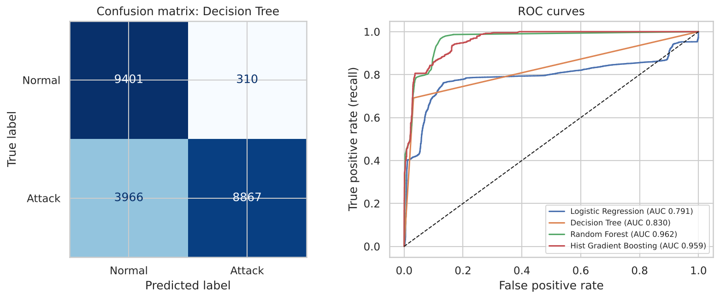
Figure 3. Confusion matrix of the Decision Tree and ROC curves for all models.
The Decision Tree correctly identified 8,867 attacks and 9,401 normal connections. It raised 310 false alarms (3.2% of normal traffic) but missed 3,966 of the 12,833 attacks in the test set (30.9%). Few false alarms with many misses is the typical profile of a model that is cautious about raising alerts.
Table 4. Detection rate by attack family (Decision Tree)
Family | Connections | Flagged as attack | Detection rate
Normal (false-alarm rate) | 9,711 | 310 | 3.2%
DoS | 7,460 | 6,171 | 82.7%
Probe | 2,421 | 1,952 | 80.6%
R2L | 2,885 | 725 | 25.1%
U2R | 67 | 19 | 28.4%
DoS and Probe attacks leave strong statistical signatures (floods of connections, scans across many ports) and are detected well. R2L and U2R attacks look much more like ordinary user activity and are rare in training, so most are missed.

6.4 Feature importance
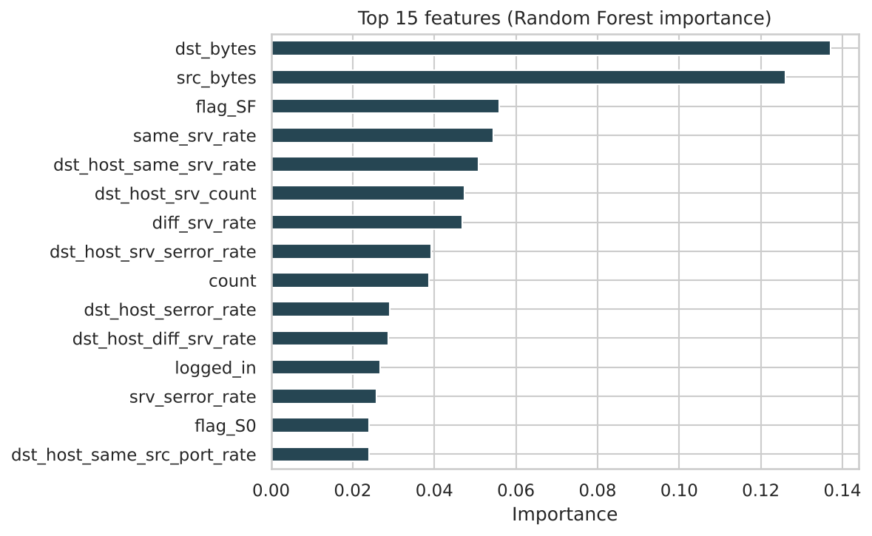
Figure 4. Top 15 features by Random Forest importance.
The most influential features are dst_bytes and src_bytes (data moved in each direction), the SF TCP flag (a normally completed connection), same_srv_rate and dst_host_same_srv_rate. These match what the bootcamp describes as typical attacker behaviour: floods and scans produce many short, similar connections that often never complete properly.

6.5 Choosing an alert threshold
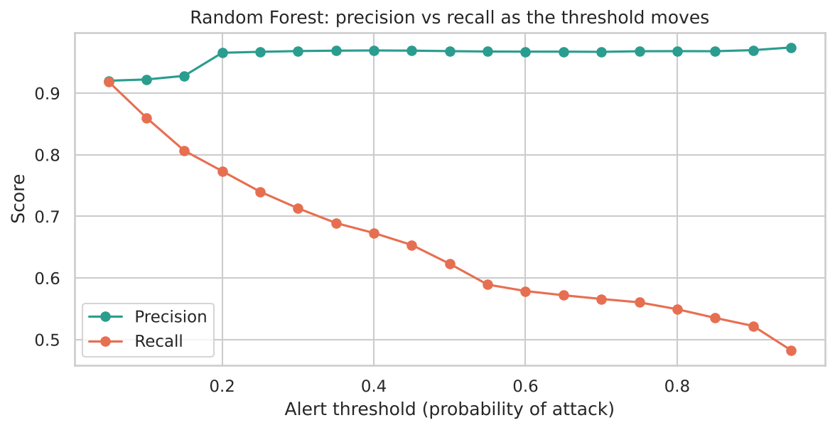
Figure 5. Precision and recall of the Random Forest as the alert threshold changes.
Threshold | Precision | Recall | False alarms
0.15 | 0.928 | 0.807 | 803
0.25 | 0.967 | 0.740 | 324
0.50 | 0.968 | 0.623 | 263
0.75 | 0.968 | 0.560 | 238
0.85 | 0.968 | 0.535 | 227
Lowering the threshold from 0.50 to 0.15 raises recall from 62.3% to 80.7%, at the cost of more false alarms (263 to 803) and a drop in precision from 96.8% to 92.8%. A SOC that cannot afford to miss attacks would accept more alerts, while a team with limited analysts would prefer a higher threshold. This sweep was run on the test set only to illustrate the trade-off. In a real deployment the threshold must be chosen on separate validation data.

6.6 Naming the attack family (5-class model)
Table 5. Five-class Random Forest, per-family results on the test set
Family | Precision | Recall | F1 | Connections
Normal | 0.633 | 0.974 | 0.767 | 9,711
DoS | 0.961 | 0.759 | 0.848 | 7,460
Probe | 0.847 | 0.591 | 0.697 | 2,421
R2L | 0.727 | 0.003 | 0.006 | 2,885
U2R | 0.600 | 0.045 | 0.083 | 67
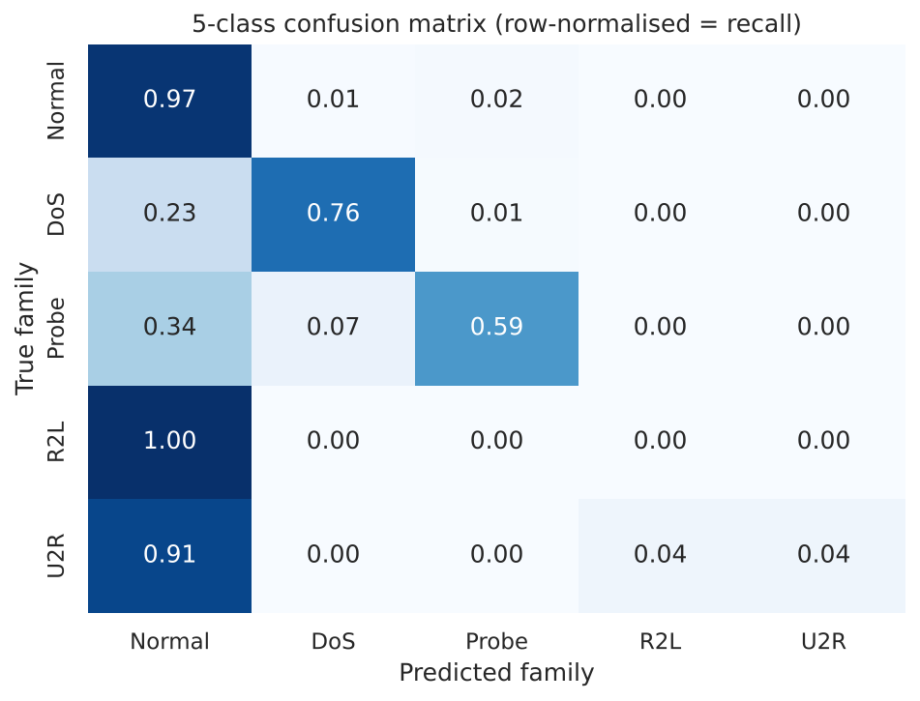
Figure 6. Five-class confusion matrix (each row sums to 1, so the diagonal is recall).
Normal traffic (97% recall) and DoS (76%) are identified well, but R2L recall is only 0.3% and U2R only 4.5%. Most R2L attacks in the test set are of types absent from training, so the model has nothing to match them against, and balanced class weights could not fix that.

7. Security Considerations and Discussion
- Missed attacks are the main risk. About 31% of attacks went undetected by the best model. A deployed IDS would need extra layers such as signature rules, anomaly detection and human threat hunting, in line with the defence-in-depth idea from the bootcamp.
- Alert fatigue is real. Threshold tuning is a business decision as much as a technical one, because every extra alert costs analyst time.
- New attacks need new detection. Supervised models learn what they have seen. The large gap between cross-validation and test scores shows why SOCs also rely on anomaly detection and threat intelligence.
- Humans stay in the loop. The masterclass guidance that analysts should never trust an automated verdict they cannot verify applies here too. Feature importance and per-family reporting make the model easier to check.
- Ethical use. Only a public, recorded dataset was used. No live network, system or account was scanned or attacked, following the golden rule of ethical hacking: never test a system without written authorisation.

8. Limitations and Future Work

8.1 Limitations
- NSL-KDD is a 1999-era simulated dataset with pre-computed connection features. It does not represent modern encrypted traffic, cloud services or current attack techniques.
- R2L and U2R examples are scarce in training, and many test attacks are new types.
- Evaluation is offline, with one random seed and only light hyper-parameter choices.

8.2 Future work
- Add anomaly-detection models such as Isolation Forest to catch unseen attacks.
- Rebalance rare classes (for example with resampling) and tune thresholds on a validation split.
- Evaluate on newer datasets such as CIC-IDS2017 or UNSW-NB15, and test deep-learning models.
- Wrap the model in a small service that scores live flow records and feeds a SIEM dashboard, in an authorised lab.

9. Conclusion
The project shows that standard machine-learning models can detect most denial-of-service and probing attacks with very few false alarms, reaching about 81% accuracy and 96.6% precision on the official NSL-KDD test set. It also shows the limits: performance drops sharply on attack types that were not in training, and rare families such as R2L and U2R are largely missed. For a security team the practical lesson is that model accuracy alone is not enough. Recall per attack family, the alert threshold and the gap between training and real-world performance all need to be examined before trusting an automated detector.

10. References
- Tavallaee, M., Bagheri, E., Lu, W., and Ghorbani, A. (2009). A Detailed Analysis of the KDD CUP 99 Data Set. IEEE Symposium on Computational Intelligence for Security and Defense Applications.
- Canadian Institute for Cybersecurity, University of New Brunswick. NSL-KDD dataset. https://www.unb.ca/cic/datasets/nsl.html
- NSL-KDD data files (GitHub mirror). https://github.com/defcom17/NSL_KDD
- Pedregosa, F. et al. (2011). Scikit-learn: Machine Learning in Python. Journal of Machine Learning Research, 12, 2825-2830.
- IBM SkillsBuild Cybersecurity Bootcamp 2026 (BharatCares): masterclass material on the attack life cycle, SOC metrics and ethical hacking.

Appendix: Submitted Files and How to Run
File | Description
Anand Vishwakarma_NetworkIntrusionDetector.ipynb | Complete, executed project code
requirements.txt | Python libraries needed to run the notebook
Anand Vishwakarma_ProjectReport.docx | This report
README.md | Overview, dataset link, technologies and setup steps
To reproduce the results: install the libraries with pip install -r requirements.txt, open the notebook in Jupyter and choose Run All Cells. The dataset downloads automatically on the first run, and the whole notebook takes roughly one minute.

