Some potential system malware threats may not be removed by anti-virus

you may get the below error message after your system boot up.

"A potential threat has been detected on your computer"

"Suspicious activity has been detected"

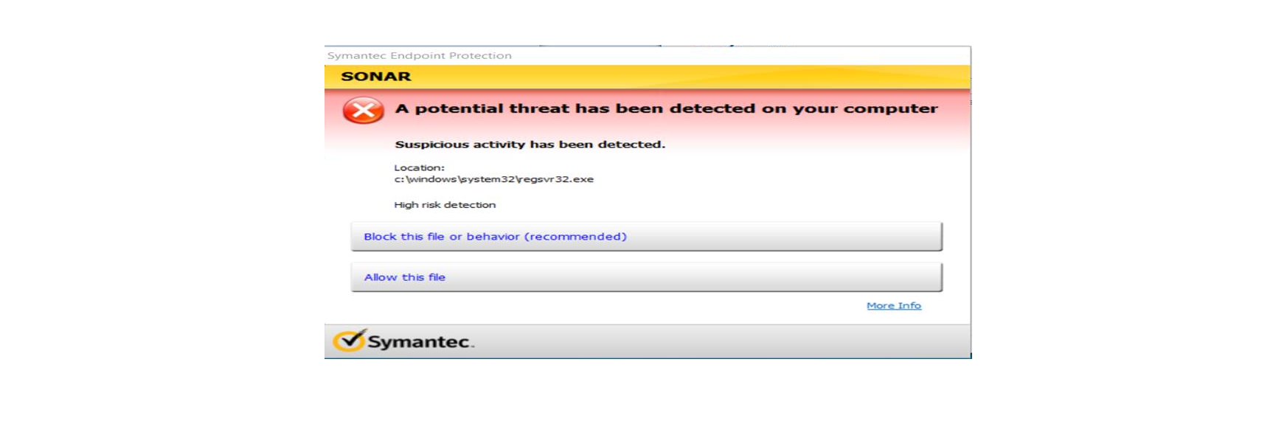

**Risks:** This malware which causes suspicious outbound connection and If not removed this threat may move from machine to machine which might

**Where to find:**

Could be in C:\ you can find some folder called google or mozilla but if its not found then it should be in your machine registry

**Solution:** Manually this threat must be removed from the following registry path.

HKEY_CURRENT_USER\Software\Microsoft\Windows\CurrentVersion\Run

