In React, an interceptor is a piece of code that runs automatically before an API request is sent or after an API response is received.

Interceptors are commonly used with Axios in React applications to handle authentication tokens, API errors, loading behavior, and expired sessions in one place instead of repeating the same logic in every API call.

Why do we need interceptors?
Suppose your React application has 10 API calls. Every API request requires an authentication token.
Without an interceptor, you might write this in every API call:

axios.get("/api/users", {
headers: {
Authorization: `Bearer ${token}`,
},
});

You would need to repeat this logic for every request.
With an interceptor, you can attach the token automatically to all requests.

There are two main types of Axios interceptors:

1. Request interceptor
Before API request
Used to attach authentication tokens, add headers, or log outgoing requests.

2. Response interceptor
After API response
Used to handle errors such as 401 Unauthorized, process responses, or manage expired sessions.

Step 1: Create an Axios instance
Create src/api/axiosInstance.js.

import axios from "axios";

const axiosInstance = axios.create({
baseURL: "https://jsonplaceholder.typicode.com",
timeout: 10000,
});

// Request interceptor
axiosInstance.interceptors.request.use(
(config) => {
const token = localStorage.getItem("token");

if (token) {
config.headers.Authorization = `Bearer ${token}`;
}

return config;
},
(error) => {
return Promise.reject(error);
}
);

// Response interceptor
axiosInstance.interceptors.response.use(
(response) => {
return response.data;
},
(error) => {
if (error.response?.status === 401) {
console.log("Unauthorized: Please log in again");
}

return Promise.reject(error);
}
);

export default axiosInstance;

What happens here?
- axios.create() creates a reusable Axios instance.
- interceptors.request.use() runs before each request.
- localStorage.getItem("token") retrieves the saved token.
- config.headers.Authorization attaches the token to the request.
- interceptors.response.use() runs when a response is received.
- error.response?.status === 401 checks whether the server rejected the request because authentication is missing or invalid.
- Promise.reject(error) passes the error to the API caller so it can handle it.

Notice that return response.data makes this interceptor return the response body directly instead of the full Axios response object.

Step 2: Use it inside a React component

import { useEffect, useState } from "react";
import axiosInstance from "./api/axiosInstance";

function Users() {
const [users, setUsers] = useState([]);
const [error, setError] = useState("");

useEffect(() => {
axiosInstance
.get("/users")
.then((data) => {
setUsers(data);
})
.catch((error) => {
setError(error.message || "Failed to load users");
});
}, []);

return (
<div>
<h2>Users</h2>

{error && <p>{error}</p>}

{users.map((user) => (
<p key={user.id}>{user.name}</p>
))}
</div>
);
}

export default Users;

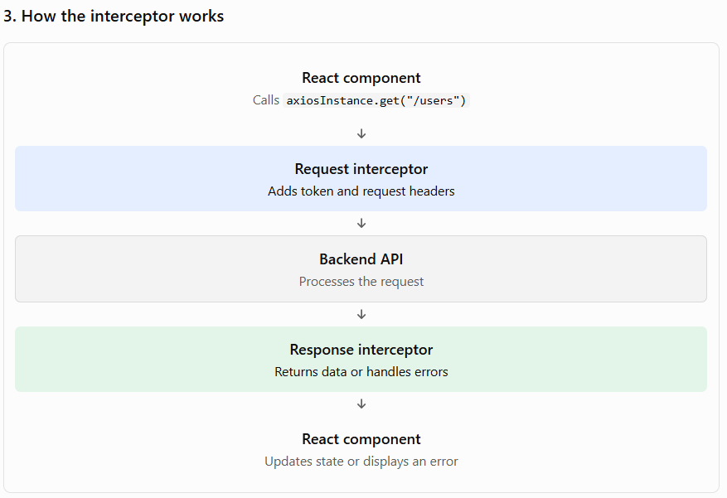

You can use interceptors alongside Redux Toolkit, React Query, or ordinary React state management.
Important: If you register interceptors inside a React component or a useEffect, repeated mounting can register duplicate interceptors. Prefer a shared Axios instance, and eject interceptors during cleanup when registering them dynamically.

