Jest in React

What is Jest?
Jest is a JavaScript testing framework used to automatically check whether your code behaves as expected.

Imagine you develop an e-commerce React application with these features:
- Login and logout
- Product listing and search
- Shopping cart
- API calls
- Form validation
- Payment calculations
You need to ensure that these features continue working whenever you modify your code.

You could test every feature manually, but that becomes time-consuming and error-prone. Jest lets you write tests that check these behaviours automatically.

Without Jest vs. with Jest
Manual testing
Open the application, enter data, click buttons, inspect results, and repeat after changes.
Automated testing
Run a command and let your saved tests check expected behaviour repeatedly.

For example, suppose you have a function that calculates a shopping cart total.

function calculateTotal(price, quantity) {
return price * quantity;
}

You expect:
Price ₹500 × quantity 2 = ₹1,000
Price ₹200 × quantity 3 = ₹600

Instead of calculating these manually every time you change the function, Jest can check both cases automatically.

test("calculates the cart total", () => {
expect(calculateTotal(500, 2)).toBe(1000);
expect(calculateTotal(200, 3)).toBe(600);
});

If the function starts returning the wrong value, Jest reports a failed test.
Important: Jest does not replace React. React builds your UI; Jest tests your JavaScript and React code.

What is the purpose of Jest?
Jest helps you verify that your application is working correctly and that changes have not broken existing functionality.

Purpose | Real-world example
Unit testing | Check whether a discount calculation returns the correct value
Component testing | Verify that a login form renders correctly
Interaction testing | Check that clicking Add to Cart updates the UI
API testing | Check that products appear after a successful API response
Regression testing | Ensure login still works after modifying authentication code
Error handling | Verify that an API failure displays an error message
Mocking dependencies | Test a component without calling the real backend

A key concept is regression testing. Suppose your cart calculation works today. A month later, you add discount functionality and accidentally break the original calculation. An existing Jest test can catch that problem before the change reaches production.
Jest tests can run locally and, in a CI, /CD pipeline before code is merged or deployed.

Jest vs. React Testing Library vs. Playwright
These tools are related, but they serve different purposes.
Jest
Testing framework
Runs tests, checks expectations, creates mocks, and reports results.
React Testing Library (RTL)
React component testing utilities
Renders components and lets you interact with buttons, inputs, text, and other UI elements.
Playwright
Browser end-to-end testing
Opens a real browser and tests complete user journeys across pages and application behavior.

How Jest works internally
When you run Jest, it discovers your test files, executes the tests, compares actual results with expected results, and reports failures.

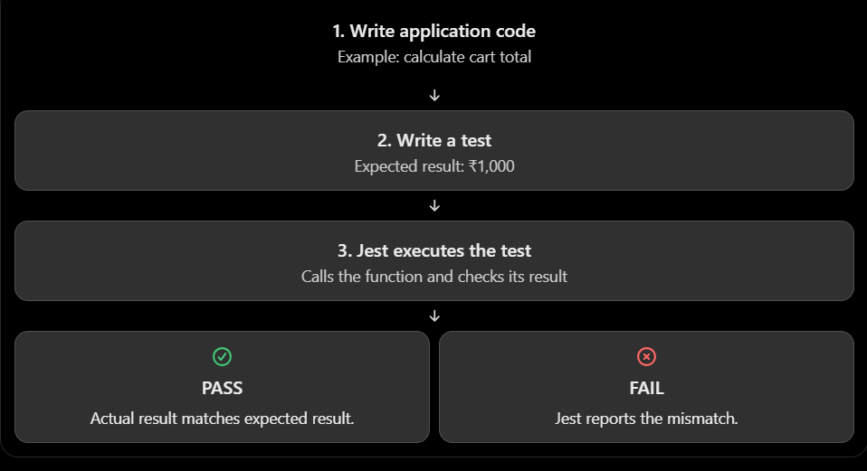
Installing and configuring Jest in React
The setup depends on how your React project was created

Step 1: Install Jest
For a JavaScript project configured to run Jest directly:

npm install --save-dev jest

A React component test also needs a DOM-like environment and React Testing Library:

npm install --save-dev jest-environment-jsdom
npm install --save-dev @testing-library/react
npm install --save-dev @testing-library/dom
npm install --save-dev @testing-library/jest-dom

These packages have different responsibilities:
Package | Responsibility
jest | Runs tests and evaluates assertions
jest-environment-jsdom | Provides a simulated browser DOM
@testing-library/react | Renders and interacts with React components
@testing-library/dom | Provides DOM querying utilities used by Testing Library
@testing-library/jest-dom | Adds matchers such as toBeInTheDocument()

Jest itself does not automatically configure every React or TypeScript project. JSX and TypeScript transformation may require additional configuration, such as Babel or a suitable framework integration.

For a Vite project, don't assume that installing Jest alone is enough to execute JSX tests. If your immediate goal is to add testing to Vite, Vitest is often easier to configure.

Step 2: Create a simple JavaScript function
Create src/utils/cart.js:
export function calculateTotal(price, quantity) {
return price * quantity;
}

Step 3: Create a test file
Create src/utils/cart.test.js:
import { calculateTotal } from "./cart";

test("calculates the total price", () => {
expect(calculateTotal(500, 2)).toBe(1000);
});

Step 4: Run Jest
For a Jest setup that uses the CLI directly, add a script to package.json:
{
"scripts": {
"test": "jest"
}
}

Then run:
npm test

Jest should report a passing test when the project configuration supports the files and syntax you are using.

Understand the five most important Jest concepts
These concepts appear in most Jest tests.

A. test() or it()
Defines one individual test case.

test("adds two numbers", () => {
expect(10 + 20).toBe(30);
});

it() does the same thing:

it("adds two numbers", () => {
expect(10 + 20).toBe(30);
});

Both are valid. Choose whichever naming style your team prefers.

B. expect()
Specifies the value or behavior you want to verify.
expect(10 + 20)
This expression means: "I am about to check the result of 10 + 20."

C. Matchers
A matcher specifies how the expected and actual results should be compared.
expect(10 + 20).toBe(30);
Here, .toBe(30) means the result must be exactly 30 for this numeric value.

D. describe()
Groups related tests together.

describe("Cart calculations", () => {
test("calculates a normal total", () => {
expect(500 * 2).toBe(1000);
});

test("calculates a zero quantity", () => {
expect(500 * 0).toBe(0);
});
});

You can think of describe() as a folder for logically related tests, except it groups tests in code.

E. Test output
When a test passes, Jest reports PASS. When a test fails, it reports FAIL and shows the assertion mismatch.

For example:
Expected: 1000
Received: 502

This helps you locate the problem without manually reproducing every case.

Common Jest matchers you should know
Matchers are particularly important for interviews and daily development.
Matcher | Purpose | Example
.toBe() | Compare primitive values or object identity | expect(2 + 3).toBe(5)
.toEqual() | Compare object or array contents recursively | expect(user).toEqual({ id: 1 })
.toStrictEqual() | Compare structures more strictly | expect(data).toStrictEqual({ id: 1 })
.toBeTruthy() | Check whether a value is truthy | expect("hello").toBeTruthy()
.toBeFalsy() | Check whether a value is falsy | expect(false).toBeFalsy()
.toBeNull() | Check for null | expect(result).toBeNull()
.toContain() | Check whether an array contains an item | expect(items).toContain("Laptop")
.toHaveLength() | Check array or string length | expect(items).toHaveLength(3)
.toHaveBeenCalled() | Check whether a mock function was called | expect(saveMock).toHaveBeenCalled()
.toHaveBeenCalledWith() | Check the arguments used in a call | expect(saveMock).toHaveBeenCalledWith("John")
.toThrow() | Check whether a function throws an error | expect(fn).toThrow()

.toBe()
In Jest, .toBe() is a matcher used to check whether the actual value is exactly the expected value. It is commonly used to test numbers, strings, booleans, null, undefined, and object references.

1. Basic syntax
expect(actualValue).toBe(expectedValue);

- expect() — provides the actual value you want to test.
- .toBe() — checks whether the value matches the expected value.
- expectedValue — the value you expect to receive.

Simple examples

Example 1: Comparing numbers

test('checks addition', () => {
const result = 2 + 3;

expect(result).toBe(5);
});

How it works:
- 2 + 3 produces 5.
- expect(result) passes 5 to Jest.
- .toBe(5) checks whether the actual result is 5.
- The test passes because both values match.

Example 2: Comparing strings
test('checks username', () => {
const username = 'Ananda';

expect(username).toBe('Ananda');
});

This test passes.
But the following test fails:
expect(username).toBe('ananda');
Why? Because string comparison is case-sensitive. 'Ananda' and 'ananda' are different strings.

Example 3: Comparing booleans
test('checks login status', () => {
const isLoggedIn = true;

expect(isLoggedIn).toBe(true);
});
This test passes because the actual value is true.

Important concept: .toBe() uses Object.is()

Quick comparison
Matcher | Purpose | Example
.toBe() | Exact value or same reference | expect(10).toBe(10)
.toEqual() | Deep comparison of object/array contents | expect({id: 1}).toEqual({id: 1})
.toStrictEqual() | Deep comparison with stricter rules, including certain structural differences | expect({id: 1}).toStrictEqual({id: 1})

Remember this simple rule:
- Use .toBe() when checking primitive values or whether two variables refer to the same object.
- Use .toEqual() when checking whether objects or arrays contain the expected data.

.toEqual()
In Jest, .toEqual() is a matcher used to compare the contents of arrays, objects, and other values. It checks whether the actual value has the same structure and data as the expected value, rather than checking whether both variables refer to the exact same object.

1. Basic example of .toEqual()

import { describe, test, expect } from '@jest/globals';

test('checks user details', () => {
const user = {
id: 1,
name: 'Ananda'
};

expect(user).toEqual({
id: 1,
name: 'Ananda'
});
});

Output: Test passes ✅

Why does it pass?
Jest compares the actual object (user) with the expected object and finds that their properties and values match.
- id is 1 in both objects.
- name is 'Ananda' in both objects.

Now, let's change the expected value:
expect(user).toEqual({
id: 2,
name: 'Ananda'
});
Output: Test fails ❌ because the actual id is 1, but the expected id is 2.

2. How .toEqual() works with arrays
You can use .toEqual() to compare array elements and their order.
test('checks product prices', () => {
const prices = [100, 200, 300];
expect(prices).toEqual([100, 200, 300]);
});
Test passes ✅ because all elements match in the same order.

But this fails:
expect(prices).toEqual([100, 300, 200]);
Test fails ❌ because the elements are in a different order.

Remember: Array order matters when using .toEqual().
Mock data
Prepare the expected API response.

Understand the important Jest methods
These are the methods you're using in the test file.
Method | Purpose
render(<Test />) | Renders your React component.
jest.spyOn(global, "fetch") | Allows you to mock the browser's fetch function.
.mockResolvedValue(...) | Makes the mocked asynchronous call return a successful result.
screen.getByText(...) | Finds text immediately; throws if it isn't found.
screen.findByText(...) | Waits for text to appear asynchronously.
screen.queryByText(...) | Returns null if the text isn't found, without throwing.
.toBeInTheDocument() | Checks whether an element exists in the rendered DOM.
.toEqual(...) | Compares actual data with expected data.
jest.restoreAllMocks() | Restores mocked functions after each test.

.toStrictEqual()

In Jest, .toStrictEqual() is a matcher used to check whether the actual value is exactly equal to the expected value, including differences in object properties, undefined values, array structure, and object types.

It is similar to .toEqual(), but .toStrictEqual() performs a stricter comparison.

1. Basic example of .toStrictEqual()
import { expect, test } from '@jest/globals';
test('compare two objects', () => {
const user = { id: 1, name: 'Anand' };
expect(user).toStrictEqual({
id: 1,
name: 'Anand'
});
});
Output: Test passes ✅

Why?
Both objects contain exactly the same properties and values.
id is 1 in both objects.
name is 'Anand' in both objects.
Both objects have the same structure.

.toStrictEqual() vs .toEqual()

Example 1: Comparing objects with an undefined property
const user = {
id: 1,
name: 'Anand',
age: undefined
};

test('toEqual example', () => {
expect(user).toEqual({
id: 1,
name: 'Anand'
});
});

.toEqual() — Passes

.toEqual() ignores certain structural differences, including an object property whose value is undefined when that property is missing from the expected object.

test('toStrictEqual example', () => {
expect(user).toStrictEqual({
id: 1,
name: 'Anand'
});
});
.toStrictEqual() — Fails
The actual object has an age property, but the expected object does not. Strict equality detects this difference.

Comparing arrays
Arrays must have the same elements in the same order.
test('compare arrays', () => {
expect([10, 20, 30]).toStrictEqual([10, 20, 30]);
});
Passes ✅
But this test fails:
test('compare arrays', () => {
expect([10, 20, 30]).toStrictEqual([10, 30, 20]);
});
Fails ❌ because the element order is different.

Comparing objects with different types
.toStrictEqual() checks object types more strictly than .toEqual().

.toBeTruthy()
Meaning: Checks whether a value is truthy in JavaScript.
A truthy value is any value that JavaScript treats as true when evaluated in a Boolean context.

test('check truthy value', () => {
expect(1).toBeTruthy();
expect("Hello").toBeTruthy();
expect(true).toBeTruthy();
expect([]).toBeTruthy();
expect({}).toBeTruthy();
});

Result: All tests pass because all these values are truthy.

Remember: In JavaScript, empty arrays [] and empty objects {} are truthy!

.toBeFalsy()
Meaning: Checks whether a value is falsy in JavaScript.
A falsy value is a value that JavaScript treats as false in a Boolean context.
Example 1: Basic Jest test
test('check falsy values', () => {
expect(false).toBeFalsy();
expect(0).toBeFalsy();
expect("").toBeFalsy();
expect(null).toBeFalsy();
expect(undefined).toBeFalsy();
});
Result: All tests pass because every value is falsy.

Important: .toBeFalsy() does not mean the value must literally be false. It can also be 0, "", null, or another falsy value.

.toBeNull()
Meaning: Checks whether a value is exactly null.
Unlike .toBeFalsy(), it does not accept other falsy values.

test('check null value', () => {
expect(null).toBeNull();
});

Key differences
Matcher | What it checks | Example that passes
.toBeTruthy() | Value evaluates to true | expect("Hi").toBeTruthy()
.toBeFalsy() | Value evaluates to false | expect(0).toBeFalsy()
.toBeNull() | Value is exactly null | expect(null).toBeNull()

.toContain()
In Jest, .toContain() is a matcher used to check whether an array contains a particular element or a string contains a particular substring.

It returns a passing test if the specified value is found. Otherwise, the test fails.

Basic syntax
expect(actualValue).toContain(expectedValue);

- expect() — the actual value you want to test.
- .toContain() — checks whether the expected value exists inside it.
- expectedValue — the value you are looking for.

Example 1: Check whether an array contains a value
Suppose you have an array of fruits.
test('check whether an array contains Apple', () => {
const fruits = ['Apple', 'Banana', 'Orange'];
expect(fruits).toContain('Apple');
});
Result: PASS

Example 2: Check whether a string contains text
You can also use .toContain() with strings.
test('check whether a message contains Hello', () => {
const message = 'Hello, welcome to Jest!';

expect(message).toContain('Hello');
});
Result: PASS

Checking user roles
Imagine a React application where a user has certain permissions.
test('user should have admin permission', () => {
const userRoles = ['user', 'admin', 'editor'];

expect(userRoles).toContain('admin');
});
Result: PASS

.not.toContain()
What if you want to verify that a value does not exist?
Use .not.toContain().
test('array should not contain Mango', () => {
const fruits = ['Apple', 'Banana', 'Orange'];

expect(fruits).not.toContain('Mango');
});

Important difference: .toContain() vs .toEqual()
These two matchers serve different purposes.
const fruits = ['Apple', 'Banana', 'Orange'];

expect(fruits).toContain('Apple');
// PASS

expect(fruits).toEqual(['Apple', 'Banana', 'Orange']);
// PASS

expect(fruits).toEqual(['Apple']);
// FAIL
- .toContain() checks whether a particular element exists inside a collection.
- .toEqual() checks whether the actual value matches the expected value, comparing arrays and objects recursively.

Quick recap
- .toContain() — checks whether an array contains an element or a string contains a substring.
- .not.toContain() — checks that the element or substring is absent.
- .toContainEqual() — checks whether an array contains an element deeply equal to the expected object or value.
- String comparisons are case-sensitive.
- For arrays of objects, use .toContainEqual() when you want to compare object contents rather than object references.

.toHaveLength()
In Jest, .toHaveLength() is a matcher used to check the length of an array, string, or another object that has a numeric length property.
It is useful when you want to verify how many elements an array contains or how many characters a string has.

Syntax:
expect(value).toHaveLength(expectedLength);

test('check array length', () => {
const numbers = [10, 20, 30];
expect(numbers).toHaveLength(3);
});

.toHaveBeenCalled()
In Jest, .toHaveBeenCalled() is a matcher used to check whether a mock function has been called at least once during a test.
It is especially useful when testing:
- Button clicks in React.
- Functions called after user interactions.
- API-related functions.
- Callback functions passed as props.
- Event handlers and utility functions.
1. Basic example
Suppose you have a function that displays a welcome message.

test('checks whether function was called', () => {
const greet = jest.fn();
greet();
expect(greet).toHaveBeenCalled();
});
Output: PASS

Code | Explanation
jest.fn() | Creates a mock function that Jest can track.
greet() | Calls the mock function.
expect(greet) | Specifies which function we want to check.
.toHaveBeenCalled() | Checks whether the function was called at least once.

Because greet() was called, the test passes

Step 1: Create the React component
Button.jsx
const Button = ({ onClick }) => {
return (
<button onClick={onClick}>
Submit
</button>
);
};

export default Button;

Here, onClick is a function passed from the parent component.

Step 2: Write the Jest test
Button.test.jsx
import { render, screen, fireEvent } from '@testing-library/react';
import { expect, test, jest } from '@jest/globals';
import Button from './Button';

test('calls the function when button is clicked', () => {
const mockFunction = jest.fn();

render(<Button onClick={mockFunction} />);

const button = screen.getByRole('button', {
name: 'Submit'
});

fireEvent.click(button);

expect(mockFunction).toHaveBeenCalled();
});

Output: PASS

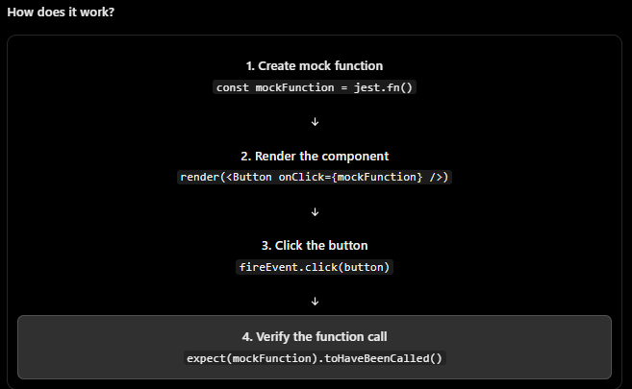

Important points to remember
.toHaveBeenCalled() is mainly used with mock functions created using jest.fn() or with suitable Jest spies.
- It verifies that a function was called at least once.
- It does not check the return value of the function.
- It does not check the arguments passed to the function.
- It does not prove that an API request succeeded or that a database operation completed.
In React tests, combine it with user interactions to verify that buttons, forms, and other UI elements invoke the expected callbacks.
Interview-ready answer: .toHaveBeenCalled() is a Jest mock-function matcher that verifies whether a mock or spy was invoked at least once. For exact call counts, we use .toHaveBeenCalledTimes(), and for specific arguments, we use .toHaveBeenCalledWith().

.toHaveBeenCalledWith()
In Jest, .toHaveBeenCalledWith() is a matcher used to check whether a mock function was called with specific arguments.
In simple words, it answers this question:
Did this function receive the exact arguments that I expected when it was called?
It is especially useful when testing API functions, button clicks, event handlers, and functions passed as props in React applications.

Basic example
Suppose you have a function that adds two numbers.
const mockFn = jest.fn();

mockFn(10, 20);

expect(mockFn).toHaveBeenCalledWith(10, 20);
Result: PASS

Why?
- jest.fn() creates a mock function.
- mockFn(10, 20) calls the function with two arguments.
- .toHaveBeenCalledWith(10, 20) verifies that the function was called with those arguments.

.toThrow()
In Jest, .toThrow() is used to test whether a function throws an error when it is executed.
For example, if your function throws an error when the input is invalid, you can use .toThrow() to verify that the error is actually thrown.

Basic example
Imagine you have a function that throws an error.
function checkAge() {
throw new Error("Age is required");
}

Now, let's write a Jest test for it.

test('should throw an error', () => {
expect(() => checkAge()).toThrow();
});

Output: Test passes.

Example for an asynchronous function:
test('should reject with an error', async () => {
await expect(
Promise.reject(new Error("Request failed"))
).rejects.toThrow("Request failed");
});

fireEvent, render, and screen in React Testing Library

When you write a React application, you create components such as buttons, forms, login pages, search boxes, modals, and tables. You need to verify that these components work correctly.
For example:
- Does a button increment a counter when clicked?
- Does a login form show an error when the password is empty?
- Does a search box filter the list?
- Does a modal open when the user clicks a button?
- Does a form submit the correct data?
React Testing Library helps you test these behaviors without manually opening your application in a browser.

import { fireEvent, render, screen } from '@testing-library/react';

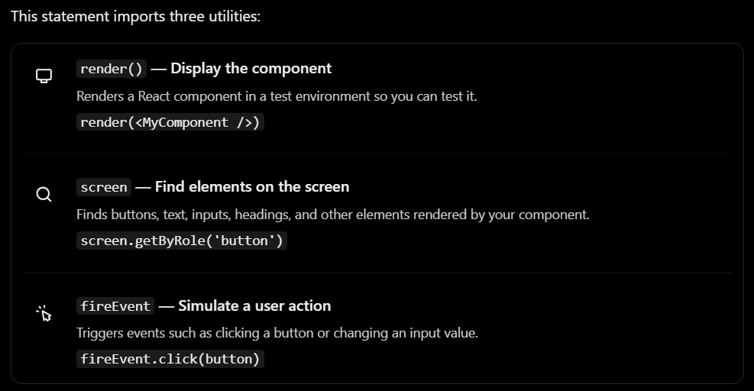

The easiest way to remember them is:
render → screen → fireEvent → screen again
- Render the component.
- Find an element.
- Perform an action.
- Check whether the UI changed as expected.

1. render() — When must you use it?
render() is used when you want to test a React component.
Suppose you have a component that displays a welcome message.

Welcome.jsx
function Welcome() {
return <h1>Welcome to our application</h1>;
}

export default Welcome;

You can test it like this:
Welcome.test.jsx
import { render, screen } from '@testing-library/react';
import { expect, test } from 'vitest';
import Welcome from './Welcome';

test('displays the welcome message', () => {
render(<Welcome />);

expect(
screen.getByText('Welcome to our application')
).toBeInTheDocument();
});

What happens here?
- render(<Welcome />) renders the component in the test environment.
- screen.getByText(...) searches for the welcome message.
- toBeInTheDocument() checks whether that message exists in the rendered UI.
- If the text is present, the test passes. If it is missing, the test fails.

When should you use render()?
Use it whenever your test needs a component to exist before you can inspect its UI or interact with it. For example, testing a login page, a reusable button, a dropdown, or a product list.
Note: The example uses Vitest for the test runner. React Testing Library works with Jest as well.

2. screen — How do you find elements?
After rendering a component, you need a way to locate its elements.
For example, consider this React component:
function Login() {
return (
<div>
<h1>Login</h1>
<input placeholder="Enter email" />
<button>Submit</button>
</div>
);
}
You can find these elements using screen.
render(<Login />);

screen.getByRole('heading', { name: 'Login' });

screen.getByPlaceholderText('Enter email');

screen.getByRole('button', { name: 'Submit' });
These statements find the heading, input, and button, respectively.

The most useful screen queries
Query | When to use it
getByRole() | Find buttons, headings, checkboxes, links, etc.
getByText() | Find text displayed in the UI.
getByLabelText() | Find an input associated with a label.
getByPlaceholderText() | Find an input using its placeholder.
getByTestId() | Find an element with a data-testid attribute.
queryByText() | Check whether text is absent without immediately throwing an error.
findByText() | Find text that appears asynchronously, such as after an API response.
For example:
// Find a button
screen.getByRole('button', { name: 'Save' });

// Find a message
screen.getByText('Profile saved successfully');

// Find an input
screen.getByPlaceholderText('Enter your name');

// Check that an error message is absent
expect(screen.queryByText('Invalid password'))
.not.toBeInTheDocument();

Important: getBy, queryBy, and findBy
These are three query families you will use frequently.

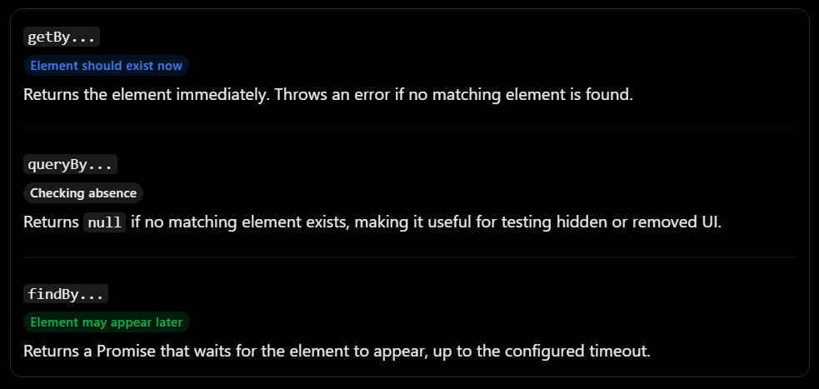

fireEvent — How do you simulate user actions?
fireEvent triggers DOM events in your test environment.

Imagine a counter application.
Counter.jsx
import { useState } from 'react';

function Counter() {
const [count, setCount] = useState(0);

return (
<div>
<p>Count: {count}</p>

<button onClick={() => setCount(count + 1)}>
Increment
</button>
</div>
);
}

export default Counter;
You want to check that clicking the button increments the counter.

Counter.test.jsx
import {
fireEvent,
render,
screen
} from '@testing-library/react';

import { expect, test } from 'vitest';
import Counter from './Counter';

test('increments the counter when clicked', () => {
render(<Counter />);

const button = screen.getByRole('button', {
name: 'Increment'
});

fireEvent.click(button);

expect(screen.getByText('Count: 1'))
.toBeInTheDocument();
});

