Dashboard.dart

import 'package:carousel_slider/carousel_slider.dart';

import 'package:flutter/material.dart';

class Dashboard extends StatelessWidget {

  const Dashboard({super.key});

  @override

  Widget build(BuildContext context) {

    return Scaffold(

      body: SafeArea(

          child: Column(children: [

        AppBar(

          toolbarHeight: 70,

          elevation: 0,

          leading: Container(

            // margin: EdgeInsets.all(20),

            padding: EdgeInsets.all(2),

            child: Image.asset(

              'assets/yubis-logo.png',

              scale: 0.1,

            ),

          ),

          backgroundColor: Colors.white,

          shadowColor: Colors.white,

          actions: [

            IconButton(

              icon: Icon(

                Icons.search,

                color: Colors.grey,

              ),

              onPressed: () {},

            ),

            IconButton(

              icon: Icon(

                Icons.shopping_bag_outlined,

                color: Colors.grey,

              ),

              onPressed: () {},

            )

          ],

        ),

        SizedBox(

          height: 20,

        ),

        CarouselSlider(

          items: [

            Container(

              margin: EdgeInsets.all(6.0),

              decoration: BoxDecoration(

                borderRadius: BorderRadius.circular(8.0),

                image: DecorationImage(

                  image: AssetImage('assets/banner1.jpeg'),

                  fit: BoxFit.cover,

                ),

              ),

            ),

            Container(

              margin: EdgeInsets.all(6.0),

              decoration: BoxDecoration(

                borderRadius: BorderRadius.circular(8.0),

                image: DecorationImage(

                  image: AssetImage('assets/banner2.jpeg'),

                  fit: BoxFit.cover,

                ),

              ),

            ),

            Container(

              margin: EdgeInsets.all(6.0),

              decoration: BoxDecoration(

                borderRadius: BorderRadius.circular(8.0),

                image: DecorationImage(

                  image: AssetImage('assets/banner3.jpeg'),

                  fit: BoxFit.cover,

                ),

              ),

            )

          ],

          options: CarouselOptions(

            height: 180.0,

            enlargeCenterPage: true,

            autoPlay: true,

            aspectRatio: 16 / 9,

            autoPlayCurve: Curves.fastOutSlowIn,

            enableInfiniteScroll: true,

            autoPlayAnimationDuration: Duration(milliseconds: 800),

            viewportFraction: 0.9,

          ),

        ),

        SizedBox(

          height: 10,

        ),

        Padding(

          padding: const EdgeInsets.all(16.0),

          child: Row(

            mainAxisAlignment: MainAxisAlignment.start,

            children: [

              Text(

                'Kategori Produk',

                style: TextStyle(fontSize: 16, color: Colors.black),

              )

            ],

          ),

        ),

        Padding(

            padding: const EdgeInsets.all(16.0),

            child: Column(

              children: [

                Row(

                  mainAxisAlignment: MainAxisAlignment.spaceAround,

                  children: [

                    Column(children: [

                      Image.asset(

                        'assets/006-vegetables.png',

                        width: 40,

                      ),

                      SizedBox(

                        height: 10,

                      ),

                      Text('Sayuran'),

                    ]),

                    Column(children: [

                      Image.asset(

                        'assets/033-broccoli.png',

                        width: 40,

                      ),

                      SizedBox(

                        height: 10,

                      ),

                      Text('Paket'),

                    ]),

                    Column(children: [

                      Image.asset(

                        'assets/035-apple.png',

                        width: 40,

                      ),

                      SizedBox(

                        height: 10,

                      ),

                      Text('Buahan'),

                    ]),

                    Column(children: [

                      Image.asset(

                        'assets/013-flour.png',

                        width: 40,

                      ),

                      SizedBox(

                        height: 10,

                      ),

                      Text('Karbohidrat'),

                    ]),

                  ],

                ),

                SizedBox(

                  height: 20,

                ),

                Row(

                  mainAxisAlignment: MainAxisAlignment.spaceAround,

                  children: [

                    Column(children: [

                      Image.asset(

                        'assets/017-fridge.png',

                        width: 40,

                      ),

                      SizedBox(

                        height: 10,

                      ),

                      Text('Bumbu Dapur'),

                    ]),

                    Column(children: [

                      Image.asset(

                        'assets/028-shopping-basket.png',

                        width: 40,

                      ),

                      SizedBox(

                        height: 10,

                      ),

                      Text('Sembako'),

                    ]),

                    Column(children: [

                      Image.asset(

                        'assets/011-fish.png',

                        width: 40,

                      ),

                      SizedBox(

                        height: 10,

                      ),

                      Text('Protein'),

                    ]),

                    Column(children: [

                      Image.asset(

                        'assets/028-shopping-basket.png',

                        width: 40,

                      ),

                      SizedBox(

                        height: 10,

                      ),

                      Text('Makanan Sehat'),

                    ]),

                  ],

                ),

                SizedBox(

                  height: 20,

                ),

                Row(

                  mainAxisAlignment: MainAxisAlignment.spaceAround,

                  children: [

                    Column(children: [

                      Image.asset(

                        'assets/chips-snack-svgrepo-com.png',

                        width: 40,

                      ),

                      SizedBox(

                        height: 10,

                      ),

                      Text('Makanan Ringan'),

                    ]),

                    Column(children: [

                      Image.asset(

                        'assets/017-fridge.png',

                        width: 40,

                      ),

                      SizedBox(

                        height: 10,

                      ),

                      Text('Makanan Frozen'),

                    ]),

                  ],

                ),

                SizedBox(

                  height: 90,

                )

              ],

            )),

        BottomNavigationBar(

          type: BottomNavigationBarType.fixed,

          selectedItemColor: Colors.green,

          selectedFontSize: 13,

          unselectedFontSize: 13,

          iconSize: 30,

          items: [

            BottomNavigationBarItem(

                label: "Beranda",

                icon: Icon(Icons.home_repair_service_outlined)),

            BottomNavigationBarItem(

              label: "Produk",

              icon: Icon(Icons.apple_outlined),

            ),

            BottomNavigationBarItem(

              label: "Promo",

              icon: Icon(Icons.bookmark_add_outlined),

            ),

            BottomNavigationBarItem(

              label: "Transaksi",

              icon: Icon(Icons.book_online_outlined),

            ),

            BottomNavigationBarItem(

              label: "Akun",

              icon: Icon(Icons.person_outline),

            ),

          ],

        ),

      ])),

    );

  }

}

Main.dart

import 'package:flutter/material.dart';

import 'splashscreen_view.dart';

void main() {

  runApp(const MyApp());

}

class MyApp extends StatelessWidget {

  const MyApp({Key? key}) : super(key: key);

  // This widget is the root of your application.

  @override

  Widget build(BuildContext context) {

    return MaterialApp(

      debugShowCheckedModeBanner: false,

      title: 'Yubis Sayur',

      theme: ThemeData(

        // This is the theme of your application.

        //

        // Try running your application with "flutter run". You'll see the

        // application has a blue toolbar. Then, without quitting the app, try

        // changing the primarySwatch below to Colors.green and then invoke

        // "hot reload" (press "r" in the console where you ran "flutter run",

        // or simply save your changes to "hot reload" in a Flutter IDE).

        // Notice that the counter didn't reset back to zero; the application

        // is not restarted.

        primarySwatch: Colors.blue,

      ),

      home: SplashScreenPage(),

    );

  }

}

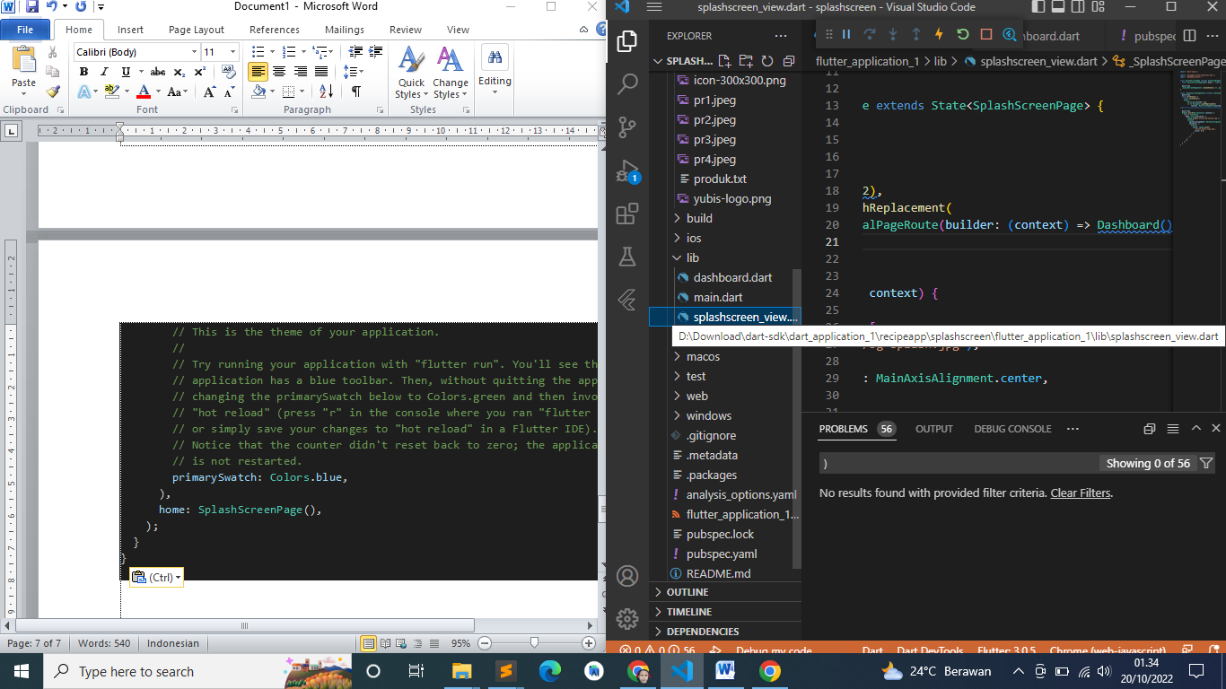

import 'dart:async';

import 'package:flutter/material.dart';

import 'dashboard.dart';

class SplashScreenPage extends StatefulWidget {

  const SplashScreenPage({Key? key}) : super(key: key);

  @override

  _SplashScreenPageState createState() => _SplashScreenPageState();

}

class _SplashScreenPageState extends State<SplashScreenPage> {

  @override

  void initState() {

    super.initState();

    Timer(

        Duration(seconds: 12),

        () => Navigator.pushReplacement(

            context, MaterialPageRoute(builder: (context) => Dashboard())));

  }

  @override

  Widget build(BuildContext context) {

    return Scaffold(

      body: Stack(children: [

        Image.asset('assets/bg-splash.jpg'),

        Column(

          mainAxisAlignment: MainAxisAlignment.center,

          children: [

            Center(

              child: Image.asset(

                'assets/yubis-logo.png',

                scale: 0.6,

              ),

            )

          ],

        )

      ]),

    );

  }

}

Pubspec

name: flutter_application_1

description: A new Flutter project.

# The following line prevents the package from being accidentally published to

# pub.dev using `flutter pub publish`. This is preferred for private packages.

publish_to: 'none' # Remove this line if you wish to publish to pub.dev

# The following defines the version and build number for your application.

# A version number is three numbers separated by dots, like 1.2.43

# followed by an optional build number separated by a +.

# Both the version and the builder number may be overridden in flutter

# build by specifying --build-name and --build-number, respectively.

# In Android, build-name is used as versionName while build-number used as versionCode.

# Read more about Android versioning at https://developer.android.com/studio/publish/versioning

# In iOS, build-name is used as CFBundleShortVersionString while build-number used as CFBundleVersion.

# Read more about iOS versioning at

# https://developer.apple.com/library/archive/documentation/General/Reference/InfoPlistKeyReference/Articles/CoreFoundationKeys.html

version: 1.0.0+1

environment:

  sdk: ">=2.17.6 <3.0.0"

# Dependencies specify other packages that your package needs in order to work.

# To automatically upgrade your package dependencies to the latest versions

# consider running `flutter pub upgrade --major-versions`. Alternatively,

# dependencies can be manually updated by changing the version numbers below to

# the latest version available on pub.dev. To see which dependencies have newer

# versions available, run `flutter pub outdated`.

dependencies:

  flutter:

    sdk: flutter

  # The following adds the Cupertino Icons font to your application.

  # Use with the CupertinoIcons class for iOS style icons.

  cupertino_icons: ^1.0.2

  carousel_slider: ^4.1.1

dev_dependencies:

  flutter_test:

    sdk: flutter

  # The "flutter_lints" package below contains a set of recommended lints to

  # encourage good coding practices. The lint set provided by the package is

  # activated in the `analysis_options.yaml` file located at the root of your

  # package. See that file for information about deactivating specific lint

  # rules and activating additional ones.

  flutter_lints: ^2.0.0

# For information on the generic Dart part of this file, see the

# following page: https://dart.dev/tools/pub/pubspec

# The following section is specific to Flutter packages.

flutter:

  # The following line ensures that the Material Icons font is

  # included with your application, so that you can use the icons in

  # the material Icons class.

  uses-material-design: true

  # To add assets to your application, add an assets section, like this:

  assets:

  - assets/

  #   - images/a_dot_burr.jpeg

  #   - images/a_dot_ham.jpeg

  # An image asset can refer to one or more resolution-specific "variants", see

  # https://flutter.dev/assets-and-images/#resolution-aware

  # For details regarding adding assets from package dependencies, see

  # https://flutter.dev/assets-and-images/#from-packages

  # To add custom fonts to your application, add a fonts section here,

  # in this "flutter" section. Each entry in this list should have a

  # "family" key with the font family name, and a "fonts" key with a

  # list giving the asset and other descriptors for the font. For

  # example:

  # fonts:

  #   - family: Schyler

  #     fonts:

  #       - asset: fonts/Schyler-Regular.ttf

  #       - asset: fonts/Schyler-Italic.ttf

  #         style: italic

  #   - family: Trajan Pro

  #     fonts:

  #       - asset: fonts/TrajanPro.ttf

  #       - asset: fonts/TrajanPro_Bold.ttf

  #         weight: 700

  #

  # For details regarding fonts from package dependencies,

  # see https://flutter.dev/custom-fonts/#from-packages

Splash

lass SplashScreen extends StatelessWidget {

  const SplashScreen({Key? key}) : super(key: key);

  @override

  Widget build(BuildContext context) {

    return SafeArea(

      child: Scaffold(

        body: Stack(

          children: <Widget>[

            Container(

              decoration: BoxDecoration(

                image: DecorationImage(

                  image: AssetImage('assets/bg-splash.jpg'),

                  fit: BoxFit.cover,

                ),

              ),

            ),

            AnimatedSplashScreen(

              duration: Duration.millisecondsPerSecond,

              backgroundColor: Colors.transparent,

              nextScreen: LandingPage(),

              splashTransition: SplashTransition.sizeTransition,

              pageTransitionType: PageTransitionType.leftToRight,

              splash: Center(

                child: Image.asset(

                  'assets/yubis-logo.png',

                ),

              ),

            )

          ],

        ),

      ),

    );

  }

}

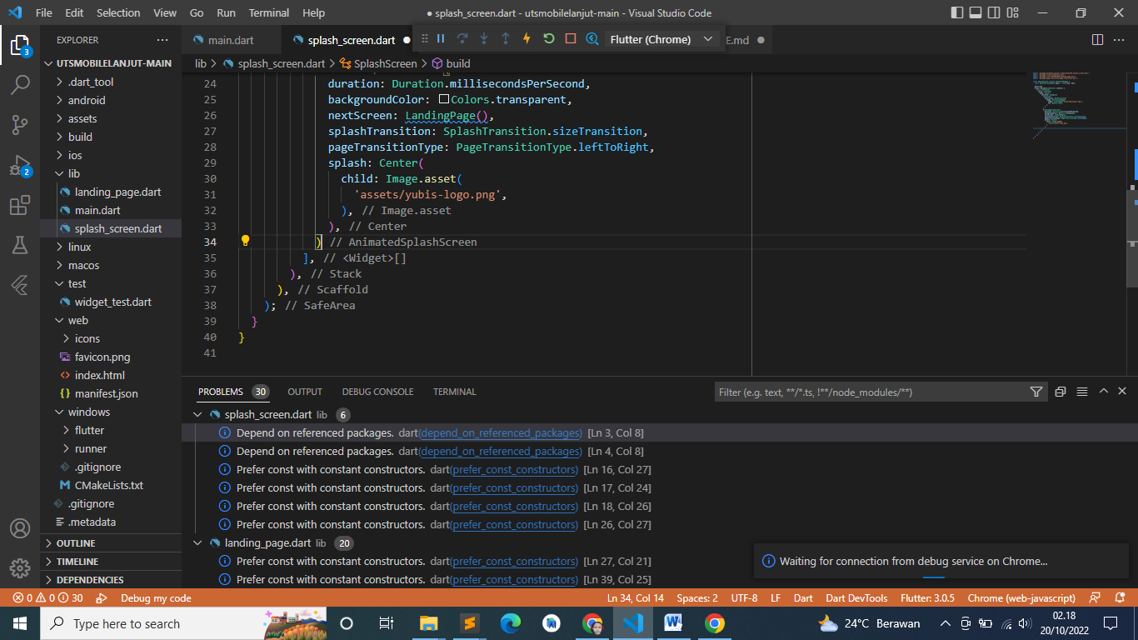

<https://drive.google.com/file/d/1dwTPWpamKf-dqdX4iy-gS8yNkUC7XxBh/view?usp=sharing>

<https://drive.google.com/file/d/1hAodon5R8UXjm2chtwEJmkvjNUO3hrQh/view?usp=sharing>