# Page 1: Python Source Code

import pandas as pd  
import matplotlib.pyplot as plt  
  
# Load data  
df = pd.read_csv("laptop1.csv")  
  
# Bar Chart: Average price by company  
avg_price_by_company = df.groupby("Company")["price"].mean().sort_values()  
avg_price_by_company.plot(kind='bar', color='red')  
plt.title("Average Laptop Price by Company")  
plt.ylabel("Price")  
plt.xlabel("Company")  
plt.xticks(rotation=45)  
plt.show()  
  
# Scatter Plot: Price vs RAM  
plt.scatter(df["Ram"], df["price"], color='blue')  
plt.title("Laptop Price vs RAM")  
plt.xlabel("RAM (GB)")  
plt.ylabel("Price")  
plt.show()

# Page 2: Bar Chart Output

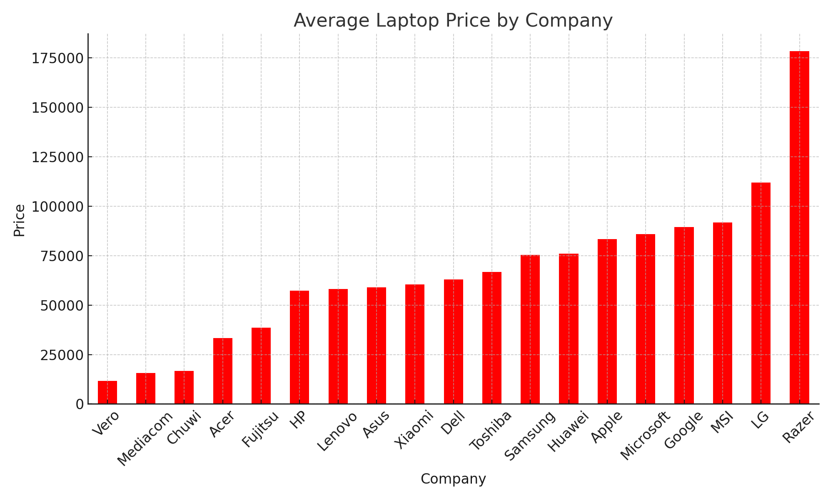

# Page 3: Software Requirements

To run the above Python script and visualize the plots, the following software requirements must be met:  
  
1. Python (version 3.7 or higher)  
2. Required Python libraries:  
 - pandas  
 - matplotlib  
  
You can install the required libraries using pip:  
  
pip install pandas matplotlib  
  
Additionally, ensure that the 'laptop1.csv' file is in the same directory as the Python script.