**Manual Test Report**

**Website KasirAja**

**Tested by : Ananda Thalia**

**Test Date : November 25th 2024**

Table of Contents

**No table of contents entries found.**

1. **• Introduction**
2. **• Test Objectives**
3. **• Scope of Testing**
4. **• Test Environment**
5. **• Test Scenarios and Results**
6. **• Bugs Summary**
7. **• Conclusion**
8. **• Appendix**

# Introduction

Overview:

KasirAja is a POS system that is simple, easy to use, fast, and supports multi-user product management.

Purpose of the Report:

This report documents the manual testing process, test results, and findings regarding any bugs or technical issues that need to be addressed before the application is fully deployed.

# Test Objectives

* Verify that the core functionalities of the KasirAja website work as specified.
* Identify and document any bugs or errors found during the testing process.
* Provide recommendations for improvements and enhancements to the application’s quality.

# Scope of Testing

Features Tested:

* 1. Registration
  2. Login
  3. Logout
  4. Product Management (Add, Edit, Delete Products)
  5. Forgot Password
  6. Add Category
  7. Responsiveness on devices other than desktop

# Test Environtment

Device :

* Desktop : Lenovo Thinkbook, Windows 10, Chrome Browser v110
* Mobile : Samsung Galaxy A55, Android 14

Testing URL :

* <https://kasirdemo.vercel.app/>

# Test Scenarios and Results

# Bug Report

* + 1. UI/UX
       1. **Bug Title:** Not capitalized at the beginning of a word/sentence

**Bug ID:** 001

**Build Number:** -

**Severity:** Low

**Priority:** Medium

**Assigned to:** <Developer A>

**Reported By:** Ananda Thalia

**Reported On:** 25/11/2024

**Reason:** Defect

**Status:** New/Open

**Device:** Lenovo Thinkbook, Windows 10

**Browser:** Chrome 131

**Screenshot:**

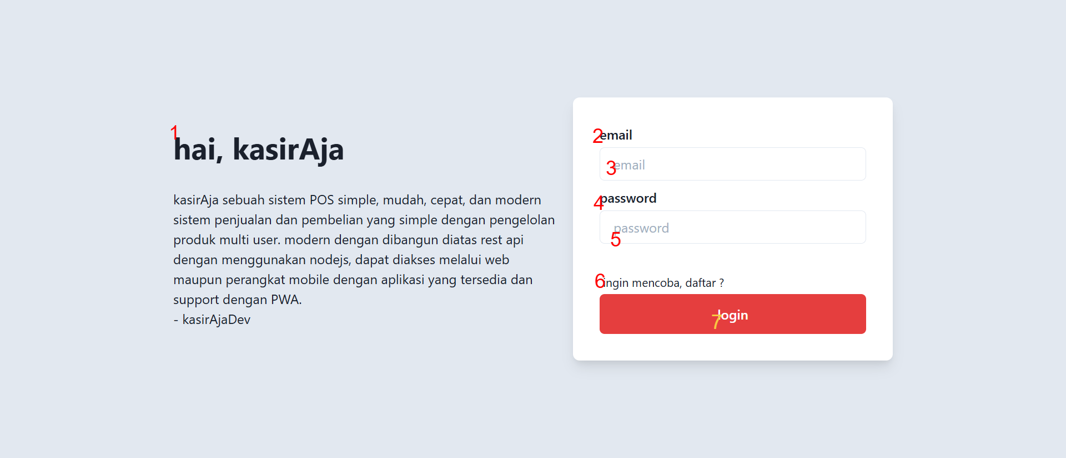

**Description:** There are 7 words that not capitalized at the beginning of a word/sentence

**Steps to Reproduce:**

1. Open website url <https://kasirdemo.vercel.app/>

**Expected Result:** The word/sentence is capitalized at the beginning of each.

1. **Bug Title:** The grammar in the KasirAja explanation needs to be revised.

**Bug ID:** 002

**Build Number:** -

**Severity:** Low

**Priority:** High

**Assigned to:** <Developer A>

**Reported By:** Ananda Thalia

**Reported On:** 25/11/2024

**Reason:** Defect

**Status:** New/Open

**Device:** Lenovo Thinkbook, Windows 10

**Browser:** Chrome 131

**Screenshot:**

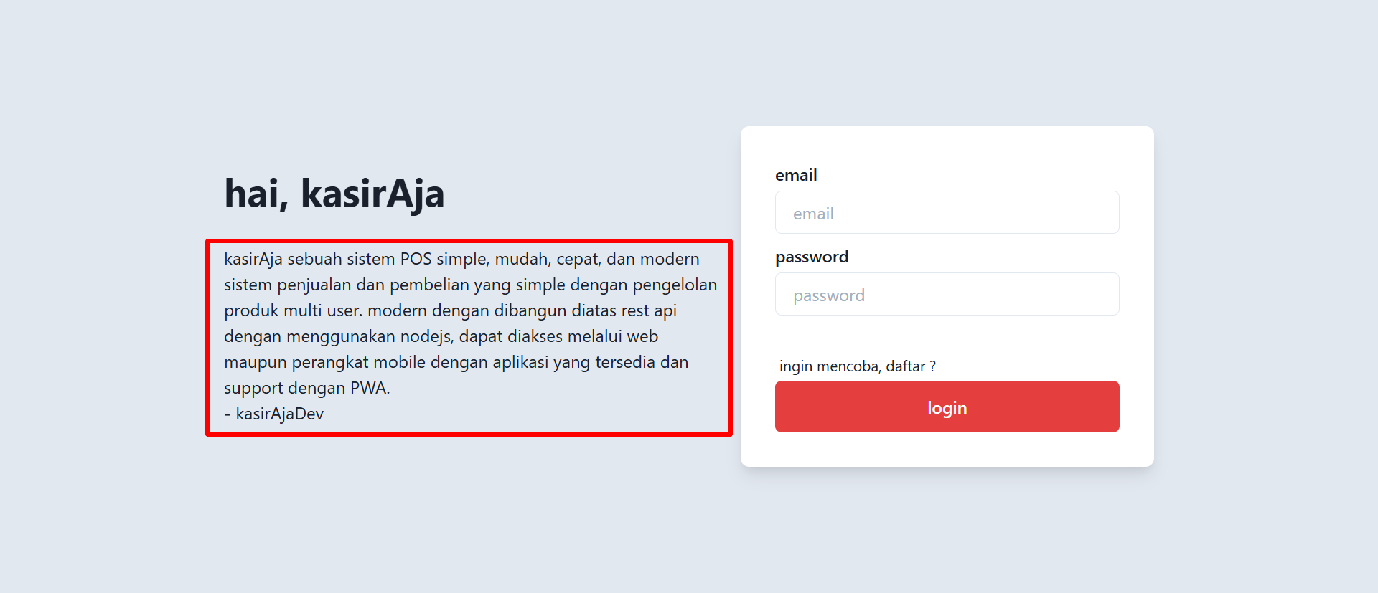

**Description:** The grammar in the KasirAja explanation needs to be revised to make it clearer and easier for users to understand.

**Recommendation :**

"KasirAja adalah sistem POS yang sederhana, mudah digunakan, cepat, dan modern. Dirancang untuk mengelola penjualan dan pembelian dengan fitur multi-user. Sistem ini dibangun di atas REST API menggunakan Node.js. Dapat diakses melalui web maupun perangkat mobile dengan aplikasi yang tersedia dan dukungan PWA.

- kasirAjaDev"

**Steps to Reproduce:**

1. Open website url <https://kasirdemo.vercel.app/>

**Expected Result:** Revised the KasirAja Explanation to make it cleared and easier for user to understand.

1. **Bug Title:** The registration instruction needs to be revised.

**Bug ID:** 003

**Build Number:** -

**Severity:** Low

**Priority:** High

**Assigned to:** <Developer A>

**Reported By:** Ananda Thalia

**Reported On:** 25/11/2024

**Reason:** Defect

**Status:** New/Open

**Device:** Lenovo Thinkbook, Windows 10

**Browser:** Chrome 131

**Screenshot:**

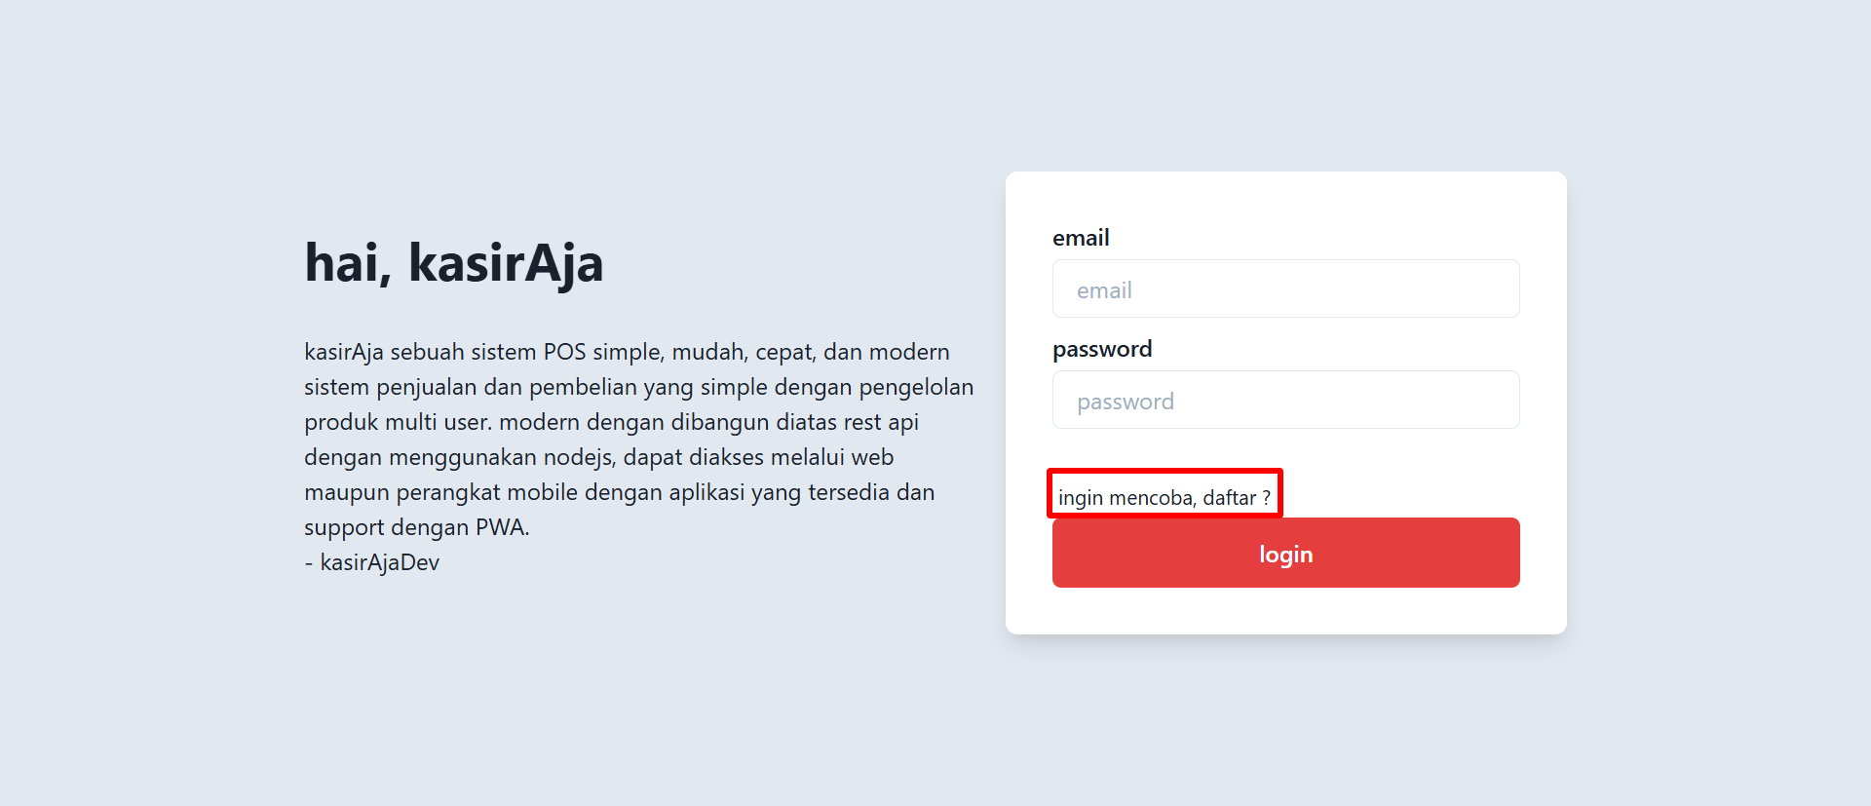

**Description:** The grammar in the registration instruction is incorrect and needs to be revised. Also, add an underline and blue font color to the word 'registration' to indicate a link to the registration page.

**Recommendation :**

"Belum punya akun? Daftar sekarang!"

**Steps to Reproduce:**

1. Open website url <https://kasirdemo.vercel.app/>

**Expected Result:** Revised the the grammar in the registration instruction, also add an underline and blue font color to the word 'registration' to indicate a link to the registration page.

1. **Bug Title:** The login instruction needs to be revised.

**Bug ID:** 004

**Build Number:** -

**Severity:** Low

**Priority:** High

**Assigned to:** <Developer A>

**Reported By:** Ananda Thalia

**Reported On:** 25/11/2024

**Reason:** Defect

**Status:** New/Open

**Device:** Lenovo Thinkbook, Windows 10

**Browser:** Chrome 131

**Screenshot:**

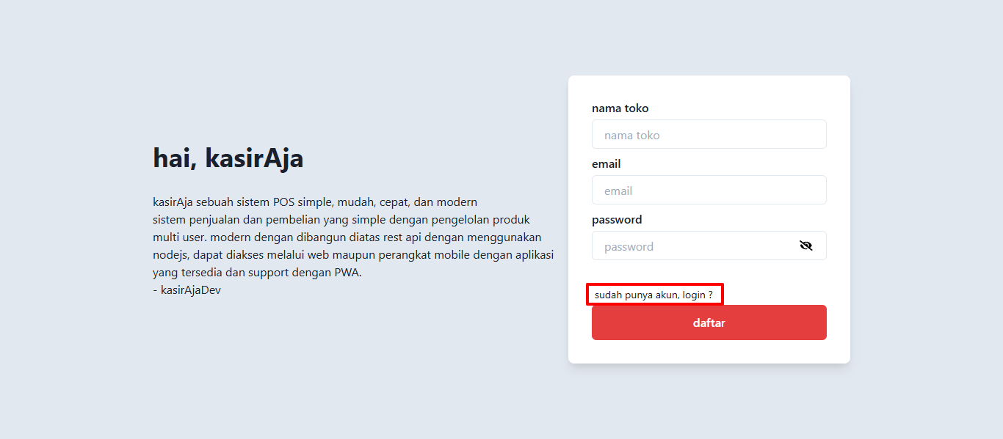

**Description:** The grammar in the registration instruction is incorrect and needs to be revised. Also, add an underline and blue font color to the word 'registration' to indicate a link to the registration page.

**Recommendation :**

"Sudah punya akun? Silahkan login."

**Steps to Reproduce:**

* 1. Open website url <https://kasirdemo.vercel.app/>

**Expected Result:** Revised the the grammar in the registration instruction, also add an underline and blue font color to the word ‘login’ to indicate a link to the registration page.

1. Functional