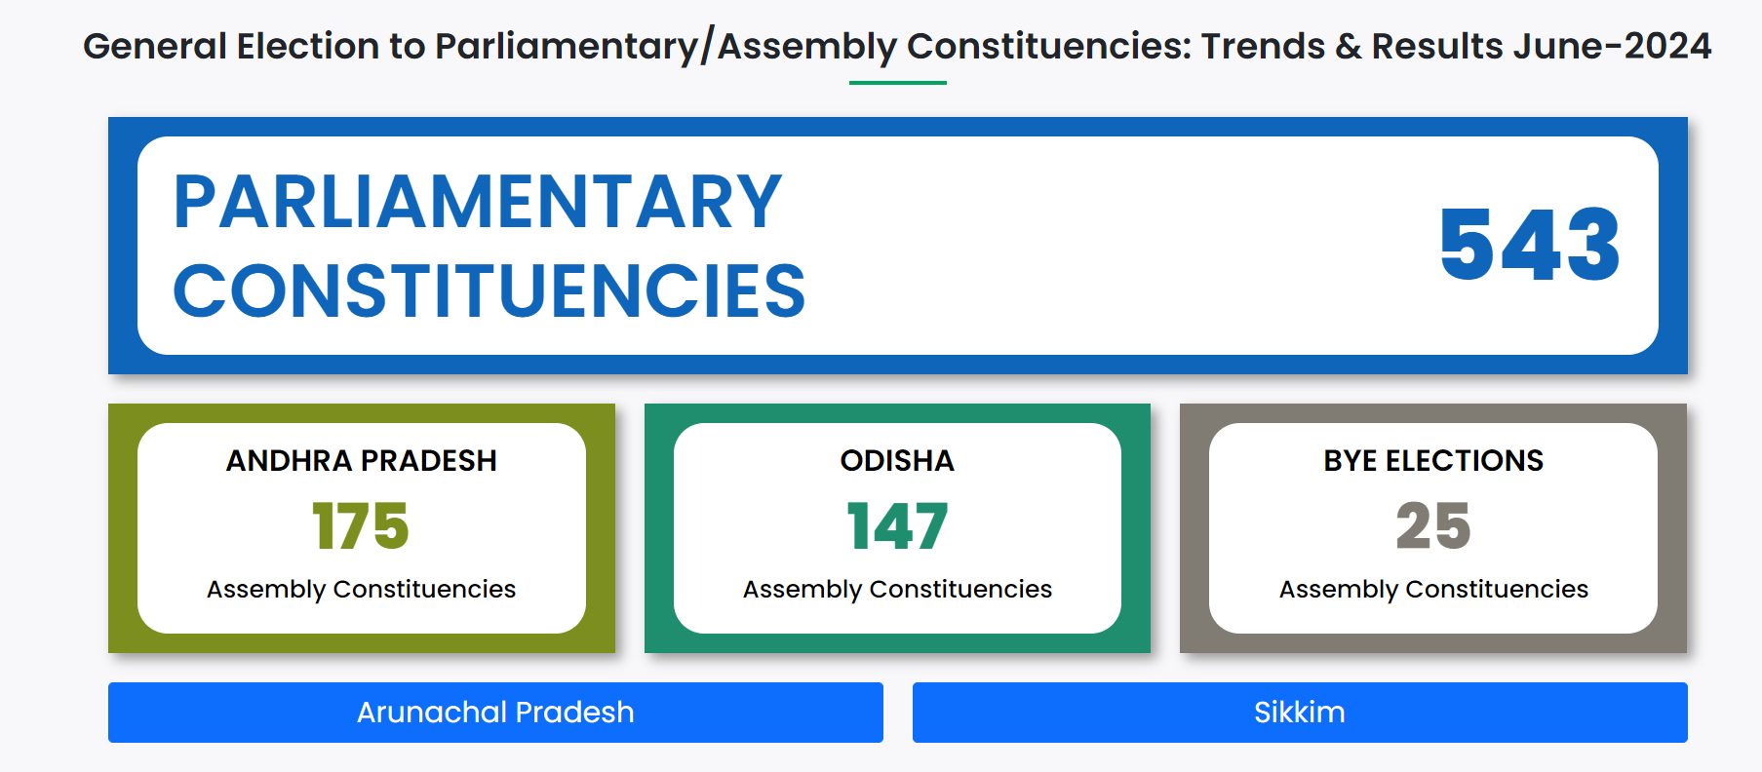**Election Commission of India – 2024 Report**

**Key Findings in the given page :** [**https://results.eci.gov.in/**](https://results.eci.gov.in/)

The main page of the Election Commission of India's website shows the states involved in the elections:

* **Parliamentary Constituencies**: Trends and results for 543 seats.
* **Andhra Pradesh**: Results for 175 Assembly Constituencies.
* **Odisha**: Results for 147 Assembly Constituencies.
* **Bye Elections**: Results for 25 Assembly Constituencies.
* **Arunachal Pradesh**: 60 Assembly Constituencies.
* **Sikkim**: 32 Assembly Constituencies.

1. **Parliament Election Results:**

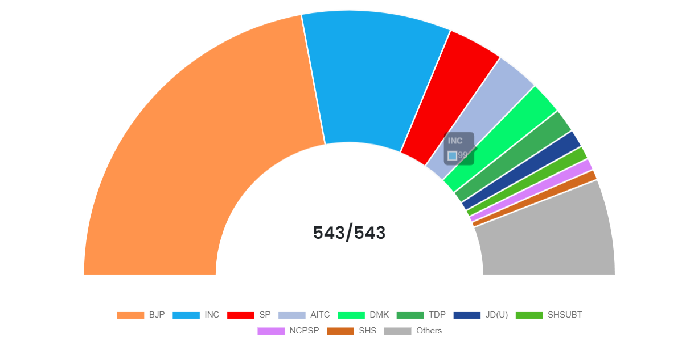

*Fig. Parliamentary seat distribution among parties in 2024*

* **BJP's Dominance**: BJP won 240 seats, continuing its strong presence in Indian politics.
* **INC's Performance**: Indian National Congress secured 99 seats, reflecting mixed performance.
* **Regional Party Influence**: Regional parties like AITC (29 seats) and DMK (22 seats) maintained their regional strongholds.
* **Emergence of Smaller Parties**: Parties like Janasena and CPI(ML)(L) secured 2 seats each, indicating growing political diversity.
* **Independent Candidates**: Independent candidates won 7 seats, showing significant voter support for non-affiliated individuals.
* **Key changes that happened in 2024 compared to 2019:**

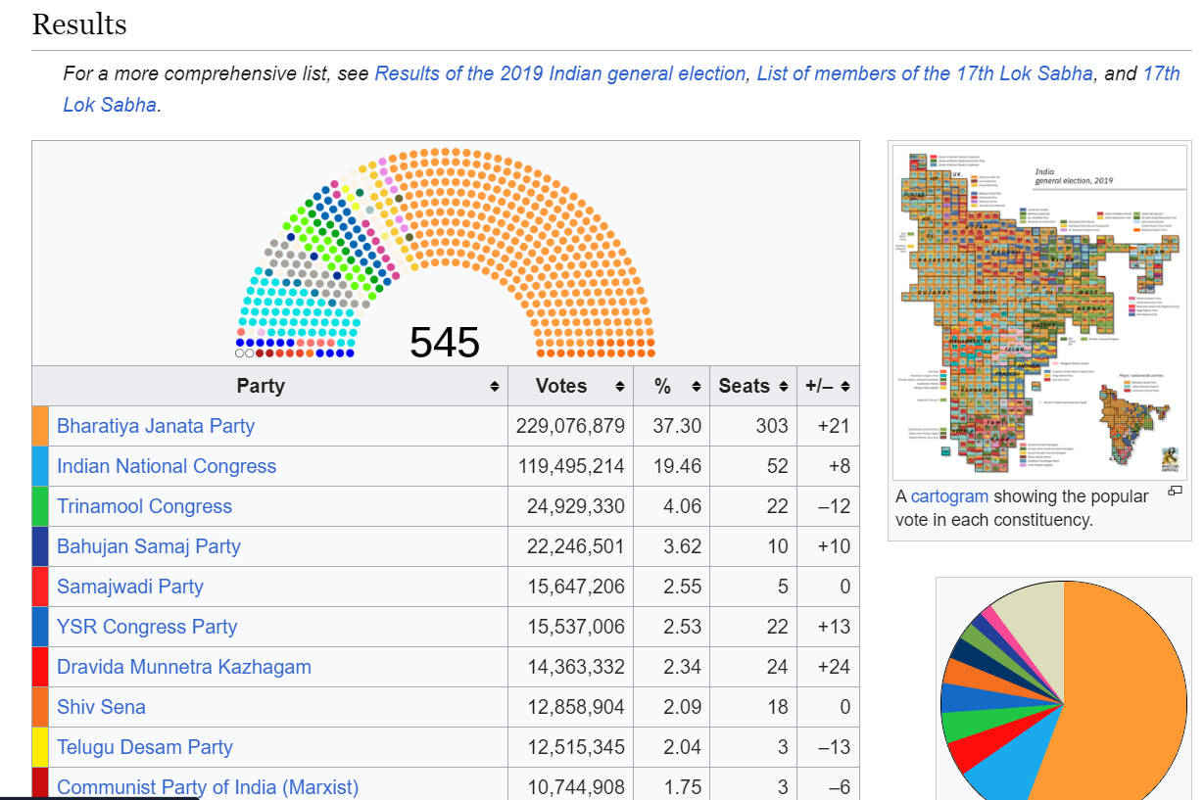

*Fig. Parliamentary seat distribution among parties in 2019 (Source : Wikipedia)*

• **BJP's Seat Count**: BJP secured 240 seats in 2024, a decrease from 303 seats in 2019, indicating a reduced dominance but still maintaining a significant presence.

• **INC's Performance**: INC improved its performance, winning 99 seats in 2024 compared to 52 seats in 2019, showing a resurgence.

• **Regional Parties' Influence**: Parties like AITC and DMK continued their strong regional influence, with DMK maintaining 24 seats and AITC securing 29 seats in 2024.

• **Emergence of Smaller Parties and Independents**: Increased representation of smaller parties and independent candidates, with independent candidates winning 7 seats in 2024.

• **Voter Turnout**: High voter engagement continued, reflecting active participation in the democratic process.

1. 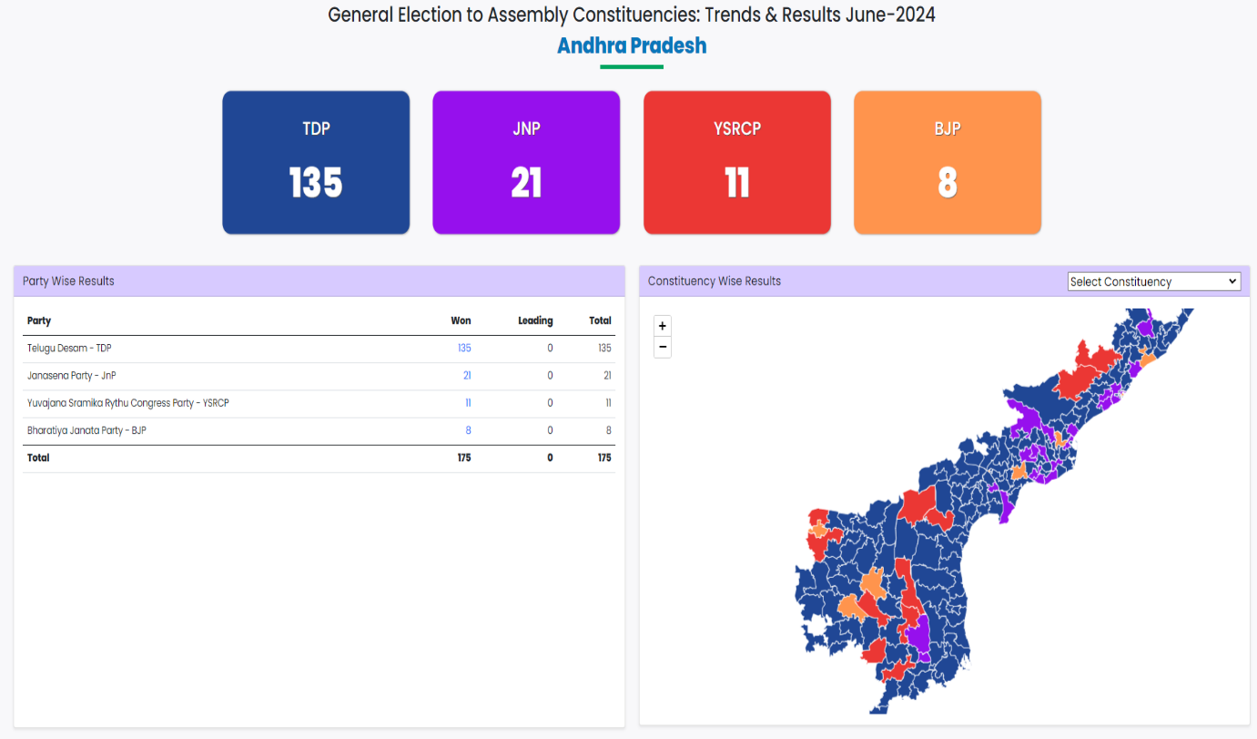**Andhra Pradesh State Assembly Election Results – 2024**

*Fig. Statistics of each party dominance in Andhra Pradesh State in 2024*

**Key Findings about the state’s Parties:**

• **Alliance Dominance**: The TDP, JSP, and BJP alliance secured a commanding majority with 164 out of 175 seats, showcasing strong voter support for the coalition.

• **TDP's Lead**: Within the alliance, TDP emerged as the dominant party with 135 seats, indicating significant influence and popularity.

• **Janasena Party's Contribution**: JSP contributed notably to the alliance's success by winning 21/21 seats. The only party with 100% winning rate in 2024 elections.

• **BJP's Role**: BJP, as part of the alliance, secured 8/10 seats, adding to the coalition's overall strength.

**Opposition Presence**: The primary opposition, YSRCP, managed to win only 11 seats, reflecting a diminished presence compared to the alliance's overwhelming victory.

**Comparison with the previous election results (2019):**

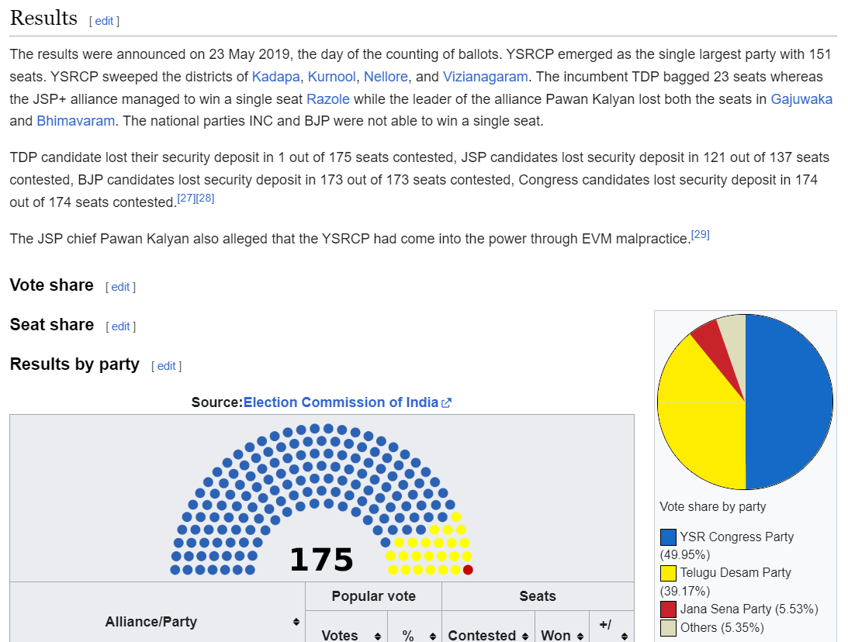

*Fig. Statistics of each party dominance in Andhra Pradesh State in 2019*

**2019**

* **Election Results:** YSR Congress Party (YSRCP) emerged as the dominant party, winning 151 out of 175 seats. TDP managed 23 seats, while JSP, in alliance with BJP, won only one seat. INC and BJP did not secure any seats.
* **Political Scenario:** YSRCP held a significant majority, while TDP and JSP, despite alliances, had minimal representation.

**Post-2019**

* **Alliance Formation:** Post-2019, the political landscape evolved. TDP, JSP, and BJP formed an alliance aiming to consolidate their voter base and improve their electoral prospects against the stronghold of YSRCP.

**2024**

* **Election Results:** The alliance of TDP, JSP, and BJP showed a significant change in the election dynamics. This strategic alliance was formed to challenge YSRCP's dominance and gain a larger share of seats.

**Key Changes and Impact**

* **Alliance Impact:** The TDP, JSP, and BJP alliance altered the political equation, potentially increasing their combined seat count and vote share compared to their individual performances in 2019.
* **Electoral Dynamics:** The formation of the alliance aimed to consolidate anti-YSRCP votes, leading to a more competitive political environment.

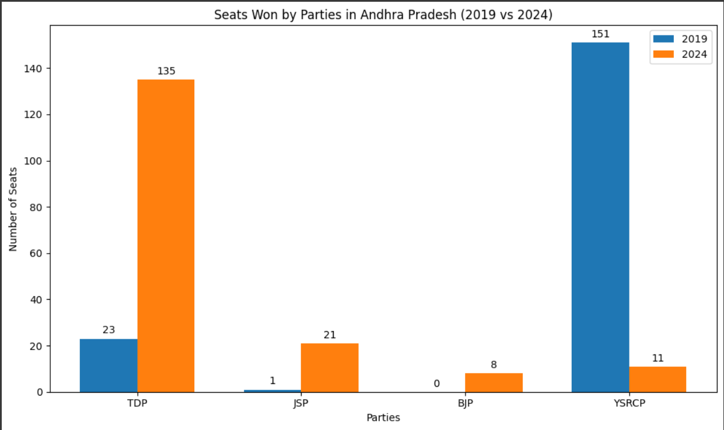

1. **Odisha State Assembly Election Results – 2024**

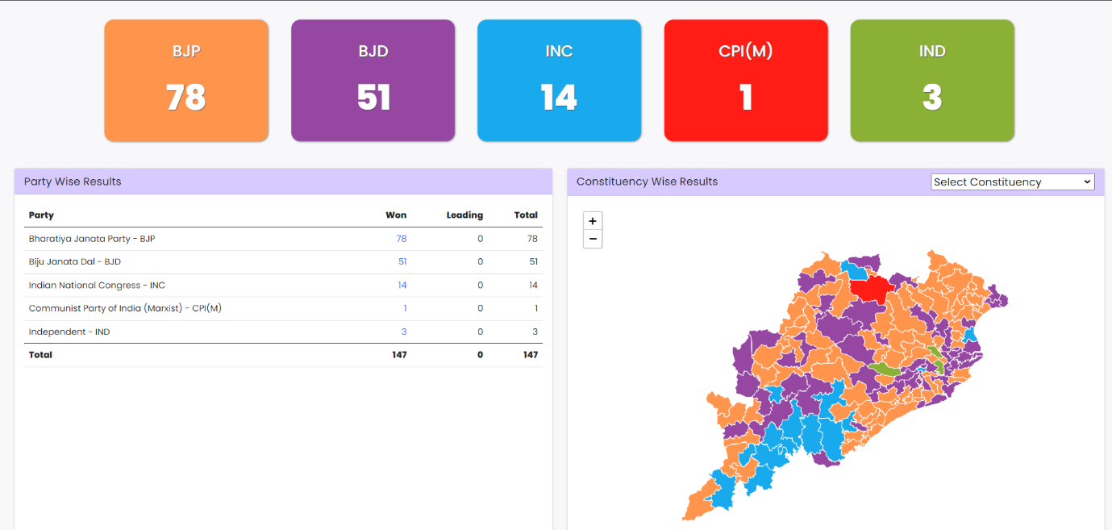

*Fig. Division of political parties that won in 2024 elections of Odisha State*

**Key Findings about the state’s Parties:**

* **BJP Emerges as Leading Party**: BJP won 78 seats out of 147, becoming the largest party in the Odisha Assembly.
* **BJD's Decline**: BJD secured 51 seats, reflecting a decline from previous elections.
* **INC's Performance**: INC won 14 seats, showing a slight improvement but still not a major player.
* **Minor Parties and Independents**: CPI(M) won 1 seat, and Independent candidates secured 3 seats, indicating some support for smaller parties.
* **Overall Scenario**: The election results indicate a significant shift in voter preferences, with BJP gaining substantial ground while BJD's influence waned. The diverse representation suggests a more fragmented political landscape.

**Comparison with the previous election results (2019):**

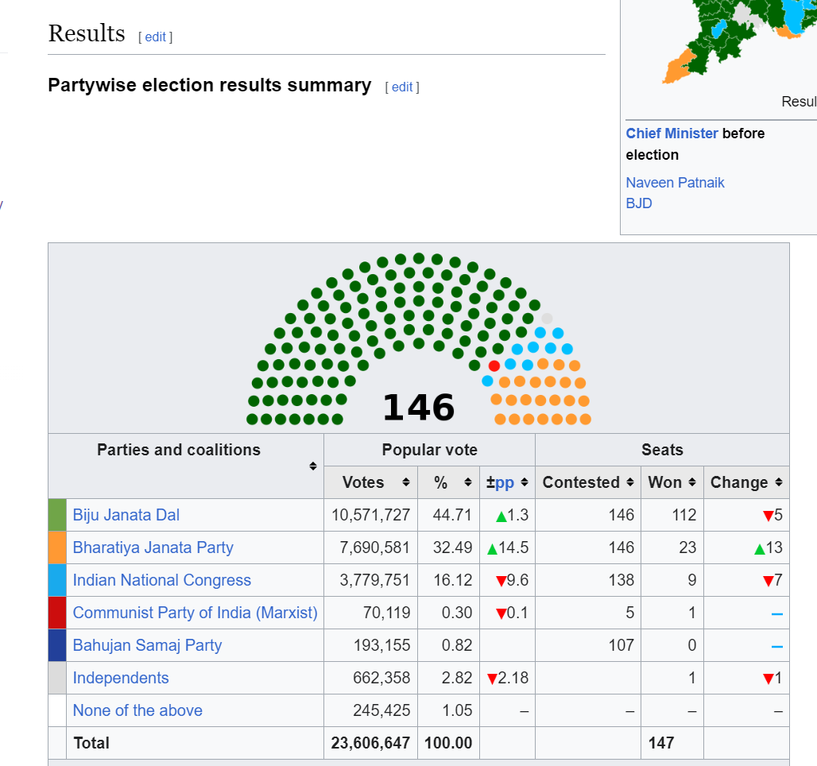

*Fig. Explains about the table of parties that shared the parliament.*

* **BJD Dominance in 2019**:

In 2019, BJD won 112 seats out of 147, maintaining a dominant position in the state.

* **BJP's Limited Influence in 2019**:

BJP secured only 23 seats in 2019, with limited influence compared to BJD.

* **INC's Minimal Presence in 2019**:

INC won 9 seats in 2019, struggling to make a significant impact.

* **Rise of BJP in 2024**:

In 2024, BJP emerged as the leading party, winning 78 seats, a substantial increase from 2019.

* **BJD's Decline in 2024**:

BJD saw a significant decline, winning only 51 seats, indicating a loss of voter support.

* **INC's Slight Improvement in 2024**:
* INC won 14 seats in 2024, showing a slight improvement from 2019.

**Minor Parties and Independents in 2024**:

* CPI(M) won 1 seat, and Independent candidates secured 3 seats, indicating some support for smaller parties.