
School of Engineering
Department of Information Technology
MACHINE LEARNING
A Project Report on
“FAKE NEWS DETECTION SYSTEM USING MACHINE LEARNING”
Submitted by
B. J. S. TEJASWINI (24B11IT012)
P. JASWANTH (24B11IT078)
R. ANANDA VARSHINI (24B11IT086)
V. DURGA PRASAD (24B11IT110)

Under the guidance of
MR.J.Lalu Prasad
Assistant Professor,
Department of CSE
ADITYA UNIVERSITY, Surampalem
Academic Year 2026-2027
SCHOOL OF ENGINEERING
Department of Information Technology
MACHINE LEARNING
CERTIFICATE
This is to certify that the Cornerstone project work entitled “FAKE NEWS DETECTION SYSTEM USING MACHINE LEARNING” is submitted by
B. J. S. TEJASWINI 24B11IT012
P. JASWANTH 24B11IT078
R. ANANDA VARSHINI 24B11IT086
V. DURGA PRASAD 24B11IT110
in partial fulfillment of the requirements for the award of the B.Tech. degree in Information Technology for the academic year 2026-2027.
Project Guide Head of the Department
MR.J.Lalu Prasad, Dr. M. Rajababu, Ph.D,
Assistant Professor, Associate Professor,
Department of CSE Department of IT
DECLARATION
We hereby declare that the project entitled “FAKE NEWS DETECTION SYSTEM USING MACHINE LEARNING” is our original work and is submitted to ADITYA UNIVERSITY, Surampalem, in partial fulfillment of the requirements for the award of the B.Tech. degree in Information Technology.
We further declare that this project work has not been submitted, either in full or in part, for the award of any degree or diploma in this or any other institution. We also confirm that this work has been carried out with academic honesty and complies with the Institutional Academic Integrity and AI Usage Policy.
Place: Surampalem
Date:
By
B. J. S. TEJASWINI 24B11IT012
P. JASWANTH 24B11IT078
R. ANANDA VARSHINI 24B11IT086
V. DURGA PRASAD 24B11IT110
ACKNOWLEDGEMENT
It is with immense pleasure that we express our sincere gratitude to our Cornerstone Project Guide, MR.J.Lalu Prasad, Assistant Professor who has guided us throughout the project. The valuable support, encouragement, and guidance provided have greatly contributed to the successful completion of this work.
We would like to thank our Deputy Heads of the Department, Dr. A. Lakshmana Rao, Associate Professor and Mrs. S. Neelima, Assistant, Department of IT, for their support and valuable suggestions.
Our deepest thanks to our Head of the Department, Dr. M. Rajababu, Associate Professor, for his inspiration and for providing all the necessary facilities and resources required for this project.
We also extend our sincere thanks to Dr. M.V. Rajesh, Associate Dean, School of Engineering, for his encouragement and support during the course of our project. We would like to express our sincere gratitude to Dr. G. Suresh, Registrar, Dr. A. Ramesh, Pro Vice-Chancellor (Engineering & Sciences), Dr. S. Rama Sree, Pro Vice-Chancellor (Academics), Dr. M.B. Srinivas, Vice-Chancellor, Dr. M. Sreenivasa Reddy, Deputy Pro Chancellor and Management, Aditya University, for providing excellent infrastructure and state-of-the-art laboratories.
Finally, we would like to thank the faculty members, lab technicians, non-teaching staff, and our friends who have directly or indirectly supported us in completing this Cornerstone project successfully.
ABSTRACT
The rapid growth of social media platforms, online news websites, and digital communication has made it increasingly difficult to distinguish trustworthy information from false or misleading content. This project presents a Multi-Level Fake News Classification System that analyzes news articles and classifies them into four categories: Real, Misleading, Partially False, and Fake. Unlike traditional fake news detection systems that provide only a binary Fake/Real prediction, the proposed system provides a more detailed assessment of the reliability and truthfulness of the information.
The system processes news text through a natural language processing pipeline involving text cleaning, tokenization, removal of unnecessary words, feature extraction, and classification. Machine learning and natural language processing techniques are used to identify linguistic patterns and characteristics associated with different levels of misinformation. The trained model analyzes the given news content and predicts the most appropriate category based on the patterns identified in the text.
The system is designed to provide users with a simple and understandable classification result, helping them recognize whether a news article is trustworthy, contains misleading information, is only partially false, or is completely fabricated. A user-friendly interface can be integrated to allow users to enter or upload news content and receive the classification result.
Beyond basic classification, the project can be enhanced with confidence scores, explanation of detected misinformation, source credibility analysis, and real-time verification using reliable news sources. By combining natural language processing, machine learning, and an accessible user interface, the proposed system provides a practical approach to detecting and understanding different levels of misinformation and supports users in making more informed decisions about online information.
TABLE OF CONTENTS
S. No. | Contents | Page No.
1 | College Name and Details | –
2 | Declaration | i
3 | Acknowledgement | ii
4 | Abstract | iii
5 | List of Contents | iv
6 | Chapter 1: Introduction | 1
7 | 1.1 Introduction | 1
8 | 1.2 Motivation and Contribution | 1
9 | 1.3 Objective | 2
10 | 1.4 Scope | 2
11 | Chapter 2: Dataset | 4
12 | 2.1 Sources | 4
13 | 2.2 Dataset Description | 4
14 | 2.3 Features / Attributes | 5
15 | 2.4 Target Value | 6
16 | 2.5 Steps Involved in Loading and Preparing Data | 6
17 | 2.5.1 Data Loading / Collection | 7
18 | 2.5.2 Handling Missing Values | 7
19 | 2.5.3 Text Preprocessing | 7
20 | 2.5.4 Feature Extraction (TF-IDF) | 7
21 | 2.5.5 Dataset Splitting | 7
22 | Chapter 3: System Analysis | 8
23 | 3.1 Functional Requirements | 8
24 | 3.2 Non-Functional Requirements | 8
25 | 3.3 System Specification | 9
26 | Chapter 4: Technology | 10
27 | 4.1 Programming Language | 10
28 | 4.2 Libraries / Frameworks | 10
29 | 4.3 Tools & IDE | 10
30 | 4.4 Data Storage / File Format | 10
31 | 4.5 Hardware / Execution Environment | 11
32 | Chapter 5: System Implementation | 12
33 | 5.1 Modules | 12
34 | 5.2 Algorithms | 13
35 | 5.2.1 A1 — Logistic Regression | 14
36 | 5.2.2 A2 — Support Vector Machine (SVM) | 23
37 | 5.2.3 A3 — Random Forest | 30
38 | 5.2.4 A4 — Naive Bayes | 41
39 | Chapter 6: Results and Output | 52
40 | 6.1 Logistic Regression Model Output | 52
41 | 6.2 SVM Model Output | 52
42 | 6.3 Random Forest Model Output | 54
43 | 6.4 Naive Bayes Model Output | 55
44 | 6.5 Model Comparison | 56
45 | 6.5.1 Classification Model Comparison | 56
46 | 6.5.2 Observations | 57
47 | 6.6 Overall Results | 57
48 | Chapter 7: Conclusion | 58
49 | Chapter 8: Future Enhancement | 59
50 | Chapter 9: References | 60
51 | Chapter 10: Publications | 61
52 | 10.1 Research Paper | 61

CHAPTER - 1
INTRODUCTION

This chapter introduces the Fake News Detection System, explains the motivation behind automated detection of misinformation, outlines the objectives of the project, and defines its scope.

1.1 Introduction
The rapid growth of social media and online news platforms has made it possible for misinformation to spread faster and farther than ever before, often outpacing the ability of human fact-checkers to respond. Classifying news content as simply true or false is rarely sufficient, because a large share of misleading content is partly accurate. The Fake News Detection System addresses this by using Natural Language Processing (NLP) and machine learning to classify news statements into four reliability levels: Real, Misleading, Partially False, and Fake.
The system is built on the LIAR benchmark dataset and uses TF-IDF (Term Frequency–Inverse Document Frequency) features to train and compare four classical machine learning algorithms: Logistic Regression (A1), Support Vector Machine (A2), Random Forest (A3), and Naive Bayes (A4). The models are evaluated under similar conditions so that their performance can be compared objectively.

1.2 Motivation and Contribution
This project is motivated by the need for automated, scalable tools that can flag potentially unreliable content early, supporting (rather than replacing) human editorial judgment. The contributions of the project are summarized below.
- Automated four-level classification Develop an automated fake news detection system that classifies news statements into four reliability levels — Real, Misleading, Partially False, and Fake — without manual intervention, reducing the time and effort required for manual fact-checking.
- Reproducible machine learning workflow Demonstrate a complete, reproducible machine learning workflow — from raw text to a trained, evaluated, and comparable set of models — that can serve as a foundation for future, more advanced fake news detection systems (for example, deep learning or transformer-based models).
- Awareness of practical NLP applications Raise awareness of how NLP and machine learning can be applied practically to a real-world social problem, and highlight both the capabilities and the current limitations of classical machine learning approaches in this domain.

1.3 Objective
The specific technical objectives implemented in this project are as follows:
- Applying NLP techniques to clean raw text Apply Natural Language Processing (NLP) techniques — lowercasing, URL and punctuation removal, and stopword handling — to clean and normalize raw news text before it is fed into any model.
- Converting text into numerical features Convert cleaned text into numerical feature vectors using TF-IDF (Term Frequency–Inverse Document Frequency) vectorization, capturing the relative importance of terms across the article corpus.
- Building and training four classification models Build and train four classification models — Logistic Regression (A1), Support Vector Machine (A2), Random Forest (A3), and Naive Bayes (A4) — on an identical 80:20 train/test split (random_state=42) so that the results are directly comparable.
- Evaluating models using standard metrics Evaluate every model using a consistent set of metrics — accuracy, precision, recall, and F1-score — plus confusion matrices, to understand not only how often each model is right, but also what kind of mistakes it makes (false positives versus false negatives).
- Comparing the performance of all algorithms Compare the performance and characteristics of all four algorithms side by side, and select the best-performing model using an explicit, stated evaluation criterion rather than an arbitrary choice.
- Inspecting model interpretability Inspect model interpretability where possible — for example, the most influential TF-IDF terms and coefficients for Logistic Regression and SVM, and feature importances for Random Forest — so that predictions are not only accurate but also explainable.
- Predicting unseen articles with confidence estimates Generate predictions for unseen news articles with an associated confidence or probability estimate, rather than a bare label, so that end users can judge how certain the system is.
- Documenting the work transparently Document the dataset, methodology, results, and limitations transparently, so that the findings of the project can be reproduced and critically evaluated by others.

1.4 Scope
The scope of this project is limited to the LIAR benchmark dataset of short political statements fact-checked by PolitiFact. It covers text preprocessing, TF-IDF feature extraction, training of four machine learning algorithms (Logistic Regression, Support Vector Machine, Random Forest, and Naive Bayes), evaluation using Accuracy, Precision, Recall, and F1-Score, and visualization of results through confusion matrices and comparison charts. The statements in the dataset are single sentences, much shorter than full news articles, which is a known characteristic and limitation of the benchmark. The project focuses on demonstrating and comparing classical machine learning approaches for four-class truthfulness classification rather than on deploying a production-ready system.

CHAPTER – 2
DATASET
This chapter describes the dataset used in the project, including its source, composition, input features, target variable, and the preprocessing steps performed to prepare the data for model training and evaluation.

2.1 Sources
Dataset Name
The project uses the LIAR benchmark dataset, introduced in the paper “Liar, Liar Pants on Fire”: A New Benchmark Dataset for Fake News Detection (William Yang Wang, ACL 2017, UC Santa Barbara). It contains 12,836 short political statements that were fact-checked by PolitiFact editors.
Dataset Source:
The project downloads the official train, valid, and test TSV files (train.tsv, valid.tsv, test.tsv) from a GitHub mirror of the LIAR release. The files are pre-divided into 10,269 training, 1,284 validation, and 1,283 test statements, and are processed into the cleaned_dataset.csv file used by the algorithms.
Dataset Link:
https://github.com/ekagra-ranjan/fake-news-detection-LIAR-pytorch

2.2 Dataset Description
Purpose of the Dataset:
The labeled statements allow supervised machine learning models to learn textual patterns associated with different levels of truthfulness. The original 6-point PolitiFact truth scale (true, mostly-true, half-true, barely-true, false, pants-fire) is mapped to four classes: true → Real, mostly-true → Misleading, half-true and barely-true → Partially False, and false and pants-fire → Fake.
Type of Data:
The data is structured tabular data containing short text statements, speaker metadata, and a truth label. The statements are single sentences, much shorter than full news articles, which is a known characteristic and limitation of the LIAR benchmark. The class distribution after mapping is: Partially False 4,746, Fake 3,561, Misleading 2,466, and Real 2,063.
Use in the Project:
The dataset is used to train, test, evaluate, and compare four different machine learning algorithms. The preprocessed statement text (clean_text) is used as the input feature, while the mapped four-class label is used as the target for classification. The same cleaned dataset is provided to all four algorithms so that their performance can be compared.
Dataset Files / Information:
The dataset contains the following information:
- Statement text (the claim made by the speaker)
- Truth label (original 6-point PolitiFact rating and the mapped four-class label)
- Speaker name, job title, party affiliation, and state
- Subject/topic of the statement and the context (venue) in which it was made
- Predefined split marker (train / valid / test)

2.3 Features / Attributes
The attributes of the dataset are grouped below according to the type of information they carry.
Statement Text Attributes:
Attribute | Type | Description | Role in Project
text | Text | Original statement made by the speaker | Source statement
clean_text | Text | Preprocessed version of the statement | Primary input feature

Speaker Attributes:
Attribute | Type | Description | Role in Project
speaker | Text / Categorical | Name of the person who made the statement | Metadata (not used as a feature)
party_affiliation | Categorical | Political party of the speaker | Metadata (not used as a feature)
speaker_job_title | Text | Job title of the speaker | Metadata (not used as a feature)
state_info | Categorical | State associated with the speaker | Metadata (not used as a feature)

Statement Context and Partition Attributes:
Attribute | Type | Description | Role in Project
subjects | Text / Categorical | Topic(s) of the statement | Metadata (not used as a feature)
context | Text | Venue or occasion of the statement | Metadata (not used as a feature)
split | Categorical | Predefined partition: train, valid, or test | Data split marker

2.4 Target Value
Target Attribute:
Attribute | Type | Description | Role in Project
label | Categorical | Mapped four-class truth label (Real, Misleading, Partially False, Fake) | Target variable
raw_label | Categorical | Original PolitiFact rating (true, mostly-true, half-true, barely-true, false, pants-fire) | Label before mapping

Label Mapping and Class Distribution:
Original PolitiFact Rating | Mapped Class | Class Count (after mapping)
true | Real | 2,063
mostly-true | Misleading | 2,466
half-true, barely-true | Partially False | 4,746
false, pants-fire | Fake | 3,561

Role of Attributes in the Project:
The preprocessed statement text (clean_text) is used as the input feature for the machine learning models, and the mapped four-class label is used as the target variable. The raw_label column is retained only to show the label before mapping, the split column marks the predefined train, validation, and test partitions, and the speaker-related and context attributes are kept as metadata and are not used as features. The same attributes are provided to A1, A2, A3, and A4 so that their performance can be evaluated and compared under the same conditions.

2.5 Steps Involved in Loading and Preparing Data
Before the machine learning models could be trained, the raw dataset was loaded and passed through a series of preparation steps to ensure that it was clean, consistent, and suitable for model training. These steps were applied consistently across all four algorithms (A1–A4).

2.5.1 Data Loading / Collection
The official LIAR train, valid, and test TSV files were downloaded from the GitHub mirror and processed into the cleaned_dataset.csv file. This file, containing 12,836 statements and 11 columns, was loaded into a Pandas DataFrame and inspected to verify its rows, columns, and class distribution.

2.5.2 Handling Missing Values
Each column was checked for missing values, and missing or invalid text records were handled before proceeding further, so that no algorithm was trained on incomplete text.

2.5.3 Text Preprocessing
The statement text was cleaned by lowercasing, removing URLs, punctuation, and non-letter characters, and handling stopwords. The result was stored in the clean_text field, which is used as the primary input feature for all four algorithms.

2.5.4 Feature Extraction (TF-IDF)
The cleaned text was converted into numerical feature vectors using Scikit-learn’s TfidfVectorizer, with up to 5,000 features for the A1, A3, and A4 pipelines. The A2 pipeline uses 1–2 word n-grams (min_df=2, max_df=0.9, sublinear_tf=True). TF-IDF assigns numerical weights that represent the importance of each term:
TF-IDF(t, d) = TF(t, d) × IDF(t)
TF(t, d) = occurrences of term t in document d / total terms in document d
IDF(t) = log(total number of documents / number of documents containing term t)
The resulting feature matrix has articles as rows, vocabulary terms as columns, and TF-IDF weights as values.

2.5.5 Dataset Splitting
For A1, A3, and A4, the data was divided into training and testing sets using an 80:20 split (random_state=42). For A2, the dataset’s predefined split column was used (10,269 training, 1,284 validation, and 1,283 test statements), and the final model was refit on the training and validation data before being evaluated once on the test split.

CHAPTER – 3
SYSTEM ANALYSIS
This chapter analyzes the functional and non-functional requirements of the system and outlines the minimum hardware and software specifications needed to develop, deploy, and run the project effectively.

3.1 Functional Requirements
- The system shall load the labeled LIAR dataset and preprocess the statement text, including handling missing values.
- The system shall convert the cleaned text into TF-IDF feature vectors.
- The system shall split the dataset into training and testing sets.
- The system shall train the Logistic Regression, SVM, Random Forest, and Naive Bayes models on the training data.
- The system shall generate predictions on the testing data for each trained model.
- The system shall compute Accuracy, Precision, Recall, and F1-Score for each model and generate a confusion matrix.
- The system shall compare the performance of all implemented models and identify the best-performing model.
- The system shall classify a new, unseen statement as Real, Misleading, Partially False, or Fake, together with a confidence or probability estimate where supported.
- The system shall visualize the results using comparison charts and confusion matrix plots.

3.2 Non-Functional Requirements
- Performance: Models should be trained and evaluated within a reasonable time on standard hardware.
- Reliability: The system should produce consistent results when executed multiple times on the same data (fixed random_state=42).
- Usability: Output (metrics, charts, confusion matrices, and predicted class with confidence) should be presented in a clear, easily interpretable format.
- Maintainability: Code should be modular so that additional algorithms or datasets can be incorporated with minimal changes.
- Portability: The system should run on any machine with Python and the required libraries installed.
The following minimum hardware and software specifications are recommended to run the complete text preprocessing, model training, and evaluation pipeline for this project without performance issues.

3.3 System Specification
This section specifies the minimum hardware and software configuration required to develop, train, and execute the machine learning models used in this project.
Minimum Hardware Requirements
- Processor: Intel Core i3 (or equivalent) and above
- RAM: 4 GB (8 GB recommended)
- Hard Disk: 2 GB free space
- Display: Standard monitor, 1024 × 768 resolution or higher
Software Requirements
- Operating System: Windows 10 / 11, macOS, or Linux
- Programming Language: Python 3.x
- Development Environment: Jupyter Notebook
- Libraries: Pandas, NumPy, Matplotlib, Seaborn, Scikit-learn, Joblib

CHAPTER – 4
TECHNOLOGY
This chapter describes the programming language, libraries, frameworks, and development tools used to design, develop, and implement the Fake News Detection System.

4.1 Programming Language
Python (version 3.x) was used as the primary programming language for this project. Python was chosen because of its simple, readable syntax, its position as the most widely used language for data science and machine learning, and its extensive ecosystem of open-source libraries for text processing, model building, and visualization.

4.2 Libraries / Frameworks
- Pandas — used to load the cleaned_dataset.csv file, inspect rows, columns, and missing values, and prepare the text and label fields for the models.
- NumPy — used for the underlying numerical array operations that Pandas and Scikit-learn rely on internally.
- Matplotlib — used to plot the model comparison charts, the SVM tuning curve, and the confusion matrices.
- Seaborn — used to draw the confusion matrix heatmaps and other statistical visualizations.
- Scikit-learn — the core machine learning library used in this project. It provided TfidfVectorizer for feature extraction, train_test_split for dataset splitting, LogisticRegression, LinearSVC, RandomForestClassifier, and MultinomialNB for the four algorithms, and the metrics module (accuracy, precision, recall, F1-score, classification report, and confusion matrix) for evaluation.
- Joblib — used to save the trained SVM model so that it can be reloaded and used for predictions on new text.

4.3 Tools & IDE
The project was developed and executed in a Jupyter Notebook environment. A notebook interface was preferred over a plain script editor because it allows code, printed output, and visualizations to be viewed together, cell by cell, which made it easier to verify each step of the pipeline and to document the executed code and its actual output as screenshots in this report.

4.4 Data Storage / File Format
The project does not use a database. The official LIAR train, valid, and test files are stored in TSV format and are processed into a single CSV file (cleaned_dataset.csv) containing 12,836 statements and 11 columns, which is read into a Pandas DataFrame. A flat file is sufficient for this project because the dataset is static and fits comfortably in memory. The trained SVM model is saved to disk using Joblib.

4.5 Hardware / Execution Environment
All four algorithms used in this project — Logistic Regression, Support Vector Machine, Random Forest, and Naive Bayes — are classical machine learning algorithms rather than deep learning models, so the entire pipeline (preprocessing, training, evaluation, and prediction) can be executed on a standard CPU without requiring GPU acceleration. This keeps the hardware requirements modest and consistent with the minimum specification outlined in Chapter 3.

CHAPTER - 5
SYSTEM IMPLEMENTATION
This chapter describes the architecture and modules of the Fake News Detection System and provides a detailed explanation of the theory, implementation, and execution of the four machine learning algorithms used in the project: Logistic Regression, Support Vector Machine, Random Forest, and Naive Bayes.

5.1 Modules
Module 1: Dataset Collection
Download the LIAR dataset (train, valid, and test TSV files) from the GitHub mirror and prepare cleaned_dataset.csv.
Module 2: Data Preprocessing
Clean the text by lowercasing, removing punctuation and stopwords, and handling missing values.
Module 3: Feature Extraction
Transform the cleaned text into numerical TF-IDF vectors.
Module 4: Train-Test Split
Divide the data into training and testing sets, for example in an 80:20 ratio.
Module 5: Model Training (A3 – Random Forest)
Train the Random Forest classifier on the training vectors.
Module 6: Other Model Training
Train Logistic Regression, SVM, and Naive Bayes for comparison.
Module 7: Model Evaluation
Calculate accuracy, precision, recall, F1-score, and confusion matrices.
Module 8: Performance Comparison
Compare all four algorithms and identify the strongest model.
Module 9: New-Article Prediction
Classify an unseen statement as Real, Misleading, Partially False, or Fake.
Module 10: Final Output
Display predictions, confidence estimate, metrics, and visualizations.
Module Interaction
Module | Consumes | Produces
Dataset Collection | Dataset source | Raw labeled news
Preprocessing | Raw text | Cleaned text
TF-IDF | Cleaned text | Feature matrix
Train-Test Split | Features + labels | Train/test sets
Model Training | Training set | Trained models
Evaluation | Test set + models | Metrics
Comparison | Metrics | Best-model decision
Prediction | New article | Four-class result

5.2 Algorithms
Exactly four algorithms/models are included in this project. All four are trained on the same TF-IDF features and evaluated using the same metrics so that they can be compared with one another.
ID | Algorithm | Purpose | Type
A1 | Logistic Regression | Multi-class text classification | Linear classifier
A2 | Support Vector Machine | Find the separating hyperplane with the maximum margin | Margin-based classifier
A3 | Random Forest | Ensemble of decision trees using voting | Ensemble learning
A4 | Naive Bayes | Probabilistic classification using Bayes’ theorem | Probabilistic classifier

Project Description
The Fake News Detection System uses four different machine learning approaches to classify news statements into Real, Misleading, Partially False, and Fake categories. Each algorithm provides a different method for learning textual patterns from the TF-IDF feature space.
A1 — Logistic Regression
Logistic Regression models the probability of a binary outcome and learns a linear decision boundary in the TF-IDF feature space.
A2 — Support Vector Machine (SVM)
Support Vector Machine finds a decision boundary that maximizes the margin between classes and is effective for high-dimensional text features.
A3 — Random Forest
Random Forest builds many decision trees using bootstrap samples and feature randomness. The final class is selected using the combined tree predictions.
A4 — Naive Bayes
Naive Bayes uses Bayes’ theorem and assumes conditional independence between features given the class.

5.2.1 A1 — Logistic Regression
Theory and Formulas
Logistic Regression
Logistic Regression is a supervised linear classification algorithm. Instead of predicting a class directly, it predicts the probability that an input belongs to a given class, and applies a threshold to that probability to make the final decision.
Sigmoid Function
σ(z) = 1 / (1 + e⁻ᶻ)
The model first computes a weighted sum of the TF-IDF input features, z = w·x + b, and passes it through the sigmoid function above. The sigmoid squashes any real-valued input into a probability between 0 and 1.
Decision Boundary
ŷ = FAKE if σ(z) ≥ 0.5, otherwise ŷ = REAL
The learned weights w define a linear decision boundary in the TF-IDF feature space that separates the two classes.
Log-Loss (Binary Cross-Entropy)
L = −[y · log(ŷ) + (1 − y) · log(1 − ŷ)]
During training, the model’s weights are adjusted to minimize the average log-loss across all training examples, which penalizes confident but incorrect predictions more heavily than uncertain ones.
Logistic Regression Procedure
- Convert article text into numerical TF-IDF features.
- Compute the weighted sum z = w·x + b for the feature vector.
- Apply the sigmoid function to obtain a probability.
- Compare the probability to the 0.5 threshold to assign the class label.
Implementation Steps :
- Import Required Libraries – Import Pandas, NumPy and required scikit-learn libraries.
- Load the Dataset – Load the labeled dataset.
- Inspect the Dataset – Inspect rows, columns, missing values and class distribution.
- Handle Missing or Invalid Records – Handle missing or invalid text records.
- Prepare the Text Content – Prepare the text content (clean_text field).
- Preprocess the Text – Preprocess the text.
- Apply TF-IDF Vectorization – Apply TfidfVectorizer with suitable parameters.
- Split the Dataset – Split data into training and testing sets (80:20).
- Initialize the Logistic Regression Model – Initialize LogisticRegression, for example with max_iter=1000 and random_state=42.
- Train the Model – Train the Logistic Regression model using fit().
- Generate Predictions – Predict test labels using predict().
- Calculate Evaluation Metrics – Calculate accuracy, precision, recall and F1-score.
- Generate the Confusion Matrix – Generate a confusion matrix.
- Inspect Influential Terms – Inspect the most influential TF-IDF terms (largest |coefficient|).
- Train the Comparison Models – Train A2, A3 and A4 for comparison.
- Select the Best Model – Select the best model based on evaluation results.
- Test on a New Article – Test the selected model on a new article.
- Display Prediction and Confidence – Display predicted class and an appropriate confidence/probability estimate.
- Generate Charts and Interpret Results – Generate performance charts and interpret results.
Execution Steps :
This section describes the execution of Algorithm 1 – Logistic Regression in the project notebook. The screenshots show the executed code and its actual output for each implementation step above.
1. Import Pandas, NumPy and required scikit-learn libraries ---
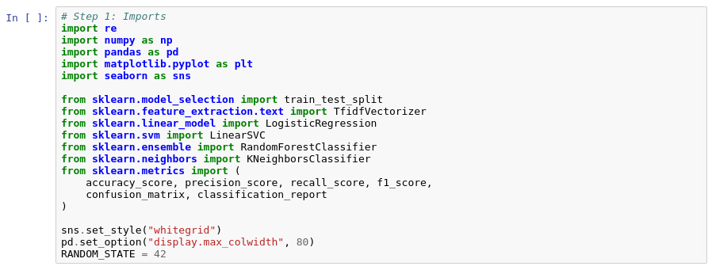
2. Load the labeled dataset ---
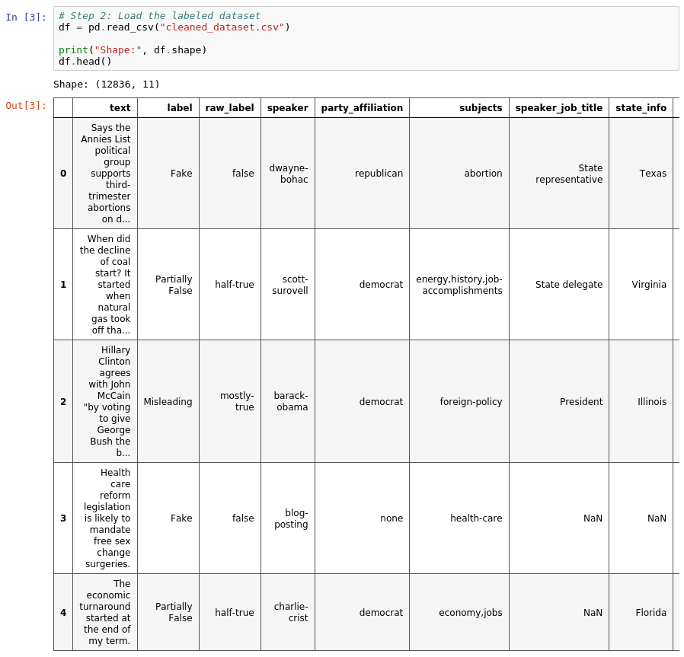
3. Inspect rows, columns, missing values and class distribution ---
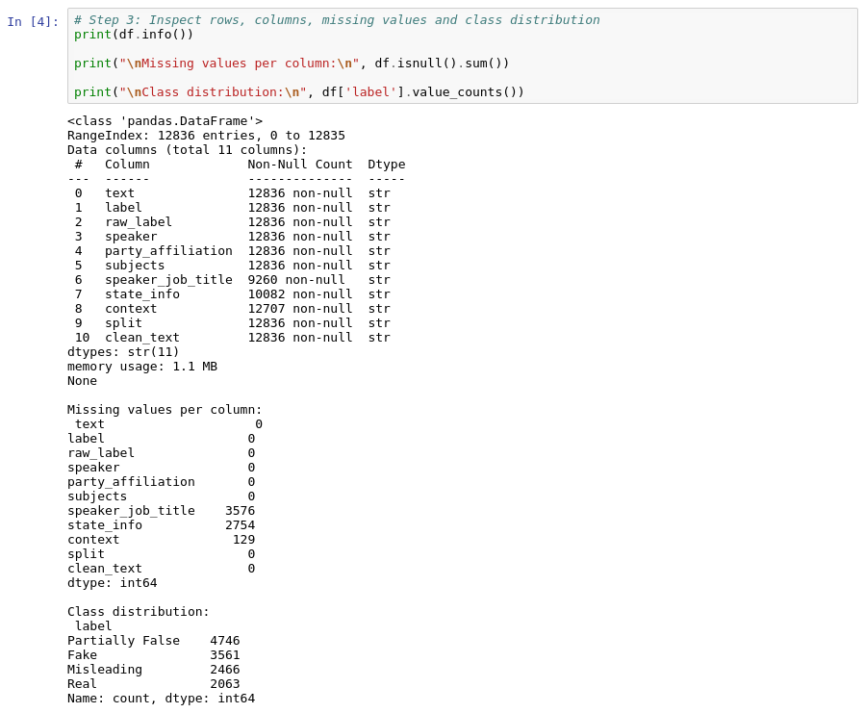
4. Prepare the text content ---
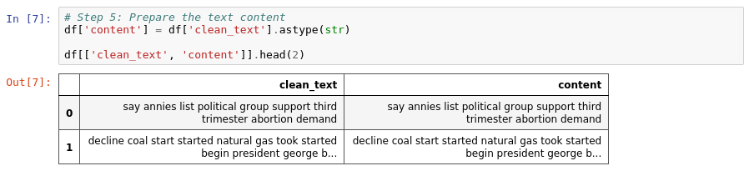
5. Preprocess the text ---
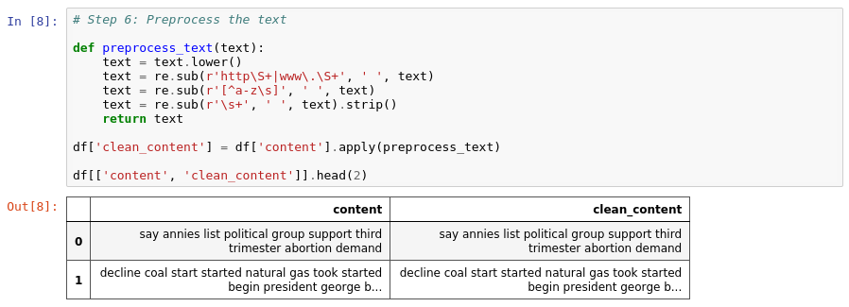
6. Apply TfidfVectorizer with suitable parameters ---
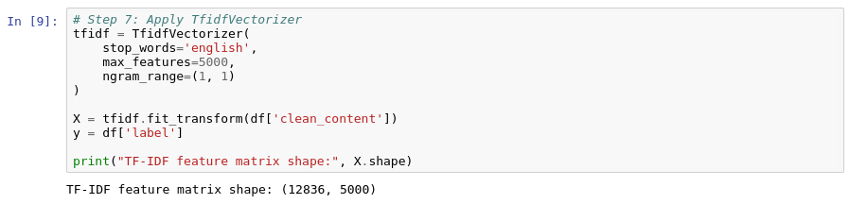
7. Split data into training and testing sets (80:20) ---
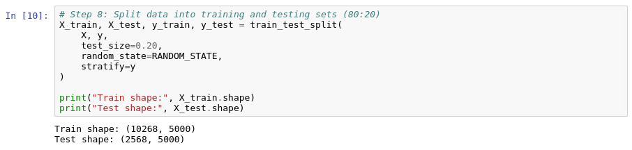
8. Initialize the Logistic Regression Classifier (A1) ---
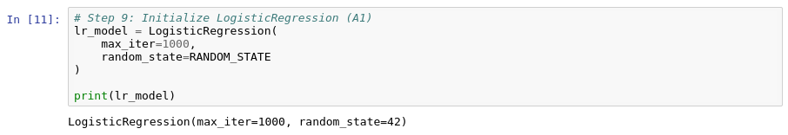
9. Train the Logistic Regression model using fit() ---
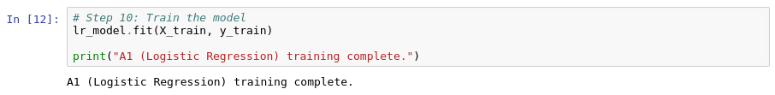
10. Predict test labels using predict() ---
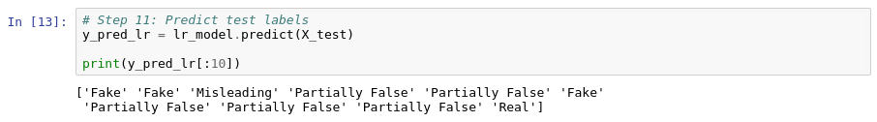
11. Calculate accuracy, precision, recall and F1-score ---
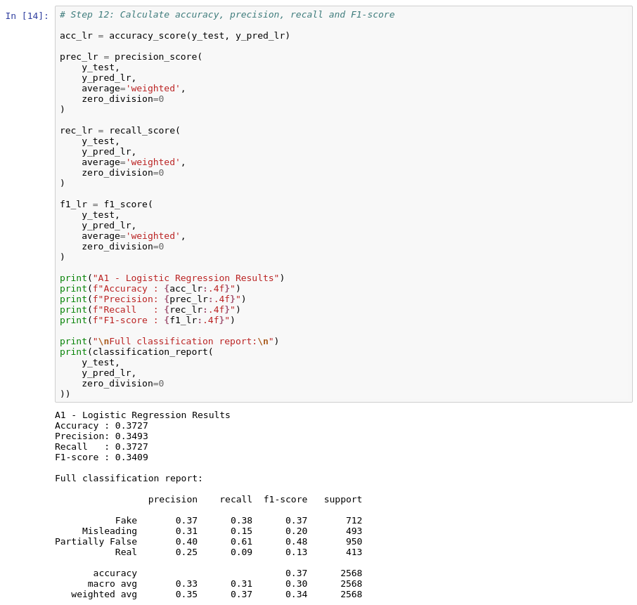
12. Inspect the most influential TF-IDF terms for each class ---
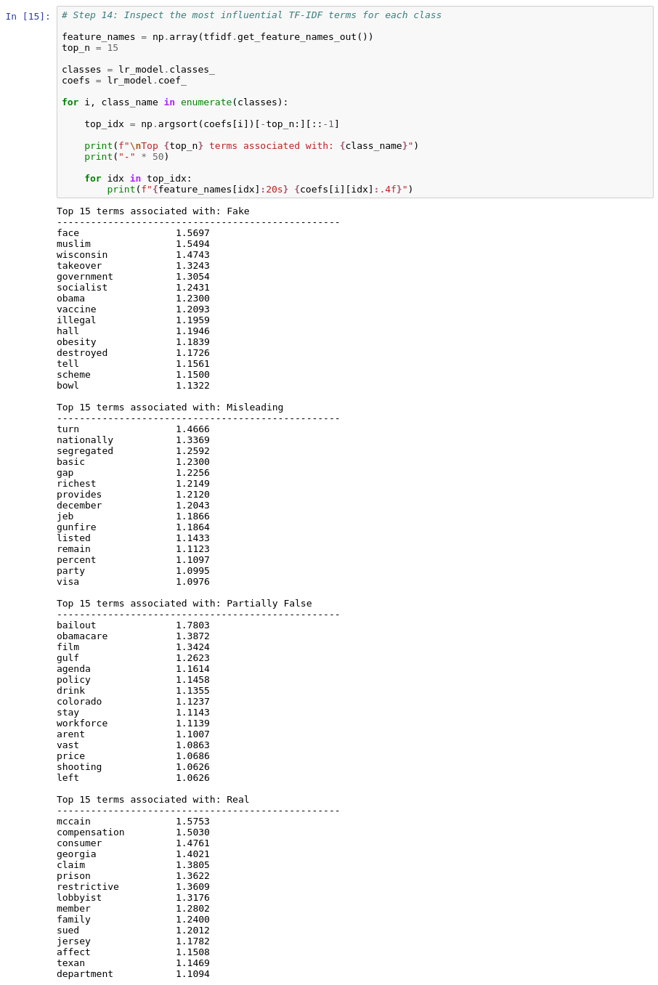
13. Train A2 (SVM), A3 (Random Forest) and A4 (KNN) for comparison ---
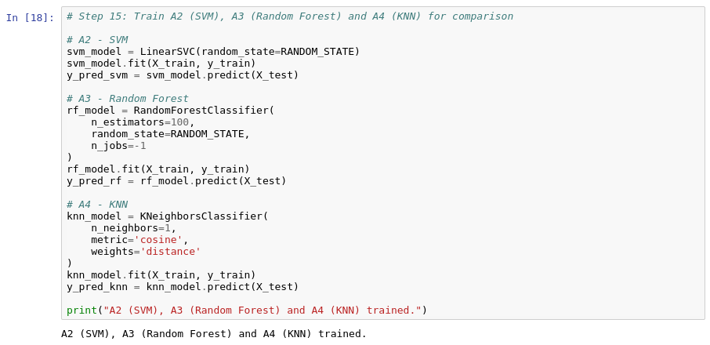
14. Compare all four algorithms in a results DataFrame ---
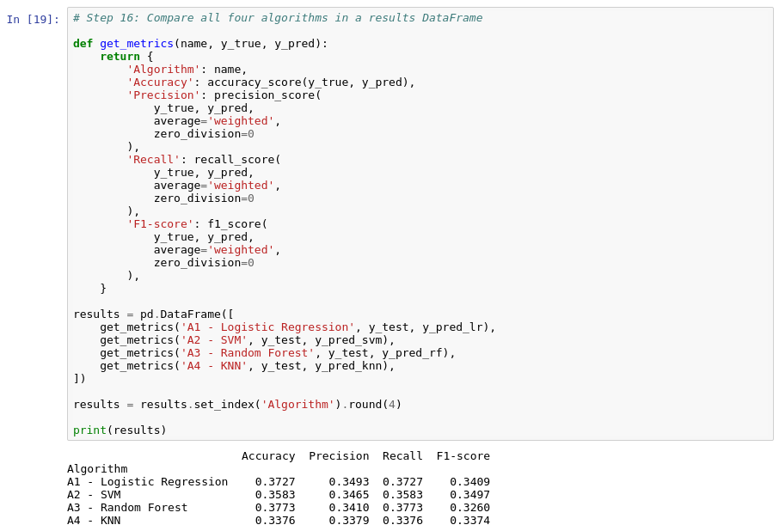
15. Test the Logistic Regression model on a new article and display the predicted class with confidence ---
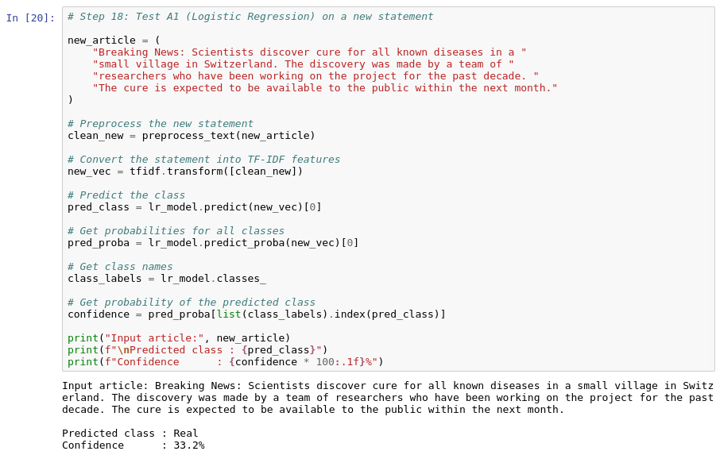
Execution Procedure :
- Load the labeled news dataset.
- Clean and preprocess the textual content.
- Transform text into TF-IDF vectors, for example using up to 5,000 features.
- Split the data into training and testing subsets.
- Initialize Logistic Regression with max_iter=1000 and random_state=42.
- Train the model on the training vectors.
- Predict the labels of the test set.
- Calculate evaluation metrics.
- Generate a confusion matrix.
- Calculate precision, recall and F1-score.
- Inspect the most influential TF-IDF coefficients.
- Compare Logistic Regression with SVM, Random Forest and Naive Bayes/KNN.
- Select the best-performing model based on the chosen evaluation criterion.
- Pass a new article through the trained pipeline.
- Display the predicted class and confidence/probability estimate.
- Visualize model performance.
- Interpret strengths and limitations.
Note: In the A1 notebook, the comparison model in the A4 slot (Step 15 above) was trained as a K-Nearest Neighbors classifier; the Naive Bayes model (A4) is implemented and evaluated in its own notebook, as described in Section 5.2.4.

5.2.2 A2 — Support Vector Machine (SVM)
Theory and Formulas
Support Vector Machine
A Support Vector Machine is a supervised linear classifier that finds the hyperplane which separates the classes with the maximum possible margin, making it effective in the high-dimensional TF-IDF feature space produced from text.
Decision Function
f(x) = w·x + b
The predicted class is determined by the sign of f(x): points on one side of the hyperplane are classified as FAKE, and points on the other side as REAL.
Margin Maximization
maximize 2 / ‖w‖ subject to yᵢ(w·xᵢ + b) ≥ 1 for all i
The margin is the distance between the separating hyperplane and the closest training points from each class (the support vectors). A larger margin generally improves generalization to unseen articles.
Hinge Loss
L = max(0, 1 − yᵢ(w·xᵢ + b))
Hinge loss penalizes points that are on the wrong side of the margin, or too close to the decision boundary, and is 0 for points correctly classified beyond the margin.
Support Vector Machine Procedure
- Convert article text into numerical TF-IDF features.
- Compute the decision function value f(x) = w·x + b for the input vector.
- Determine which side of the maximum-margin hyperplane the point falls on.
- Assign the class label based on the sign of f(x); optionally calibrate probabilities for a confidence estimate, since LinearSVC does not output probabilities directly.
Implementation Steps :
- Import Required Libraries – Import the required libraries (pandas, NumPy, matplotlib, seaborn, scikit-learn, joblib).
- Load the Dataset – Load cleaned_dataset.csv (12,836 statements, 11 columns).
- Check Missing Values – Check missing values per column.
- Explore the Class Distribution – Explore the class distribution and labels per split.
- Use the Predefined Data Splits – Use the dataset's split column: 10,269 train, 1,284 validation and 1,283 test statements.
- Build and Train the Baseline Pipeline – Build the TF-IDF (1--2 word n-grams) + LinearSVC (class_weight='balanced') pipeline and train a baseline with C = 1.0.
- Tune the Regularization Parameter C – Tune C on the validation split using macro-F1.
- Refit and Evaluate on the Test Split – Refit on train + validation with the chosen C and evaluate once on the test split.
- Generate the Confusion Matrix – Generate a confusion matrix (counts and row-normalised).
- Inspect Influential Words – Inspect the most influential words per class.
- Save the Model – Save the trained model with joblib.
- Predict on New Text – Predict the class of new text using the decision-function scores.
Execution Steps :
This section describes the execution of Algorithm 2 – Support Vector Machine (SVM) in the project notebook. The screenshots show the executed code and its actual output for each implementation step above.
1. Import the required libraries ---
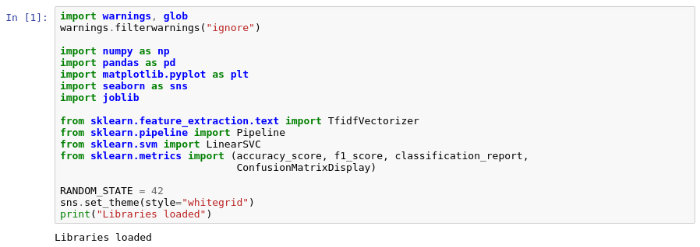
2. Load the dataset (cleaned_dataset.csv) ---
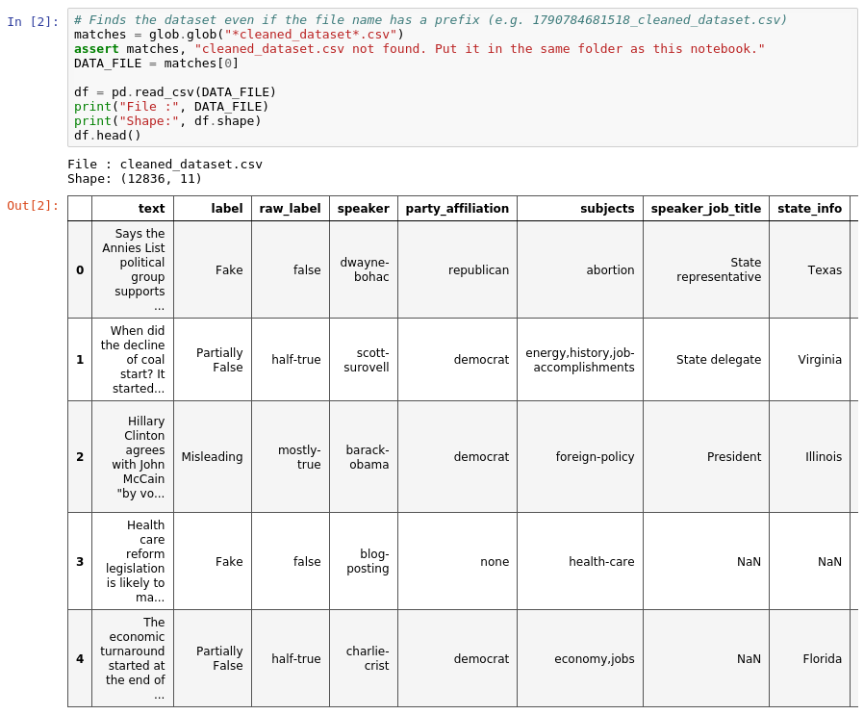
3. Check missing values per column ---
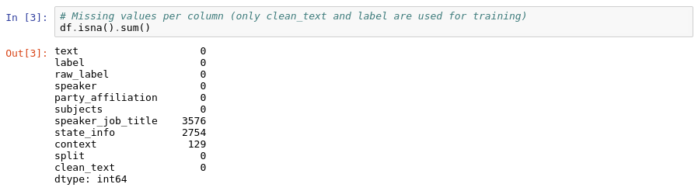
4. Explore the labels ---
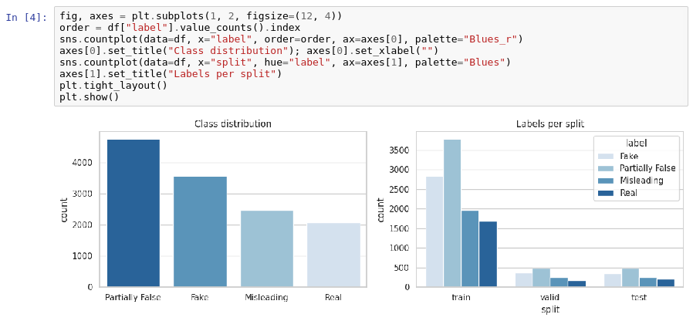
Class counts per label
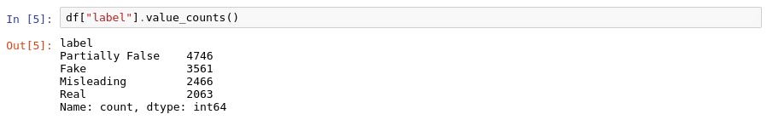
5. Use the train / validation / test split ---
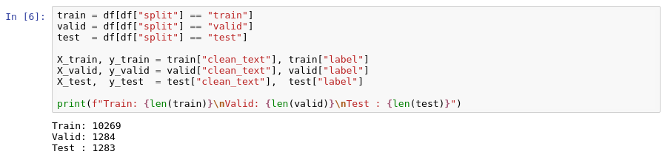
6. Build the TF-IDF + Linear SVM pipeline and train a baseline ---
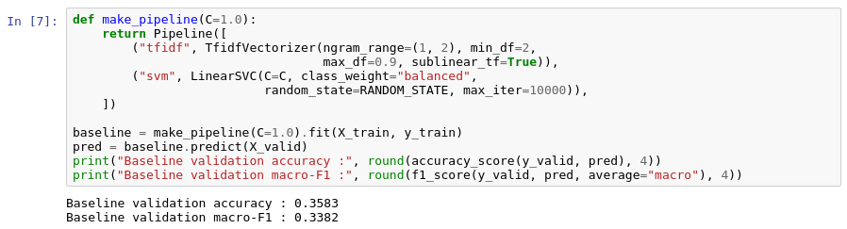
7. Tune C on the validation split ---
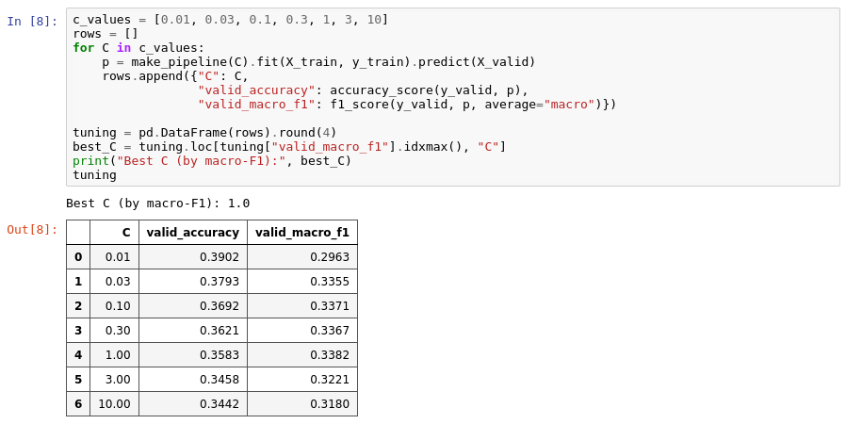
SVM tuning curve (validation accuracy and macro-F1 vs C)
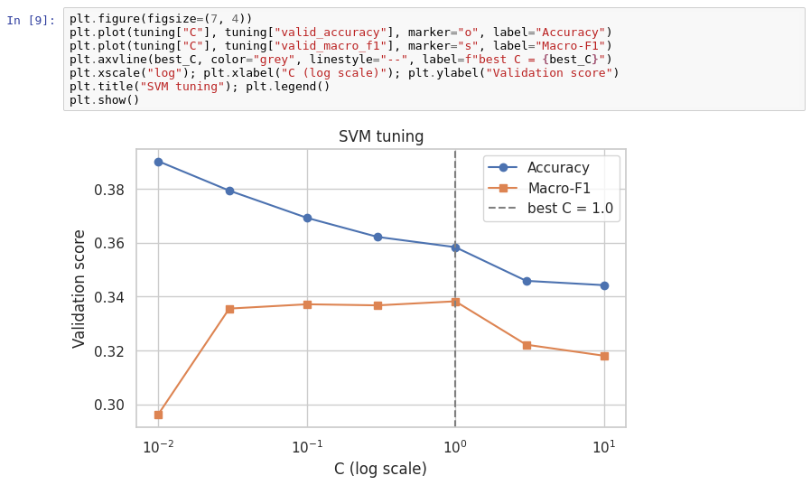
8. Final model and test-set evaluation ---
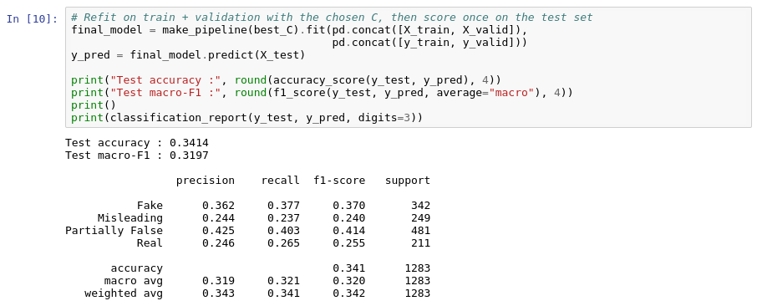
9. Generate a confusion matrix ---
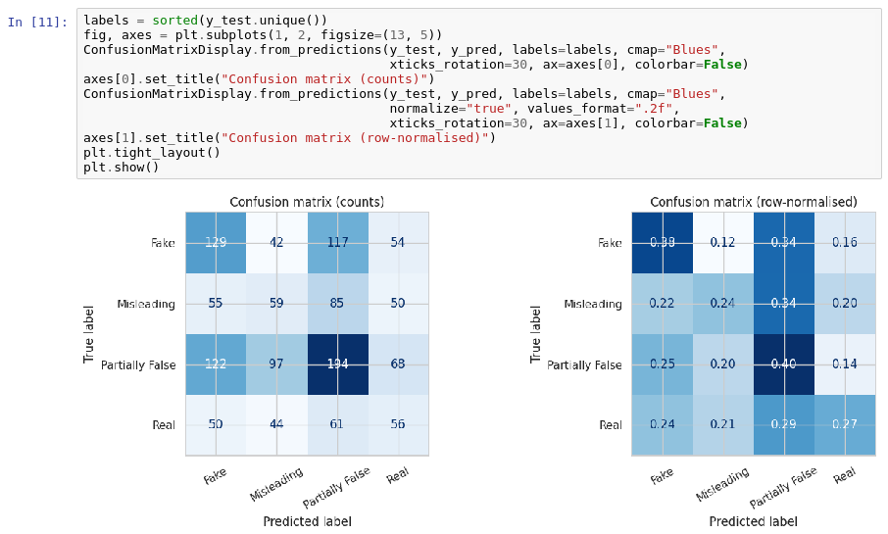
10. Inspect the most influential words per class ---
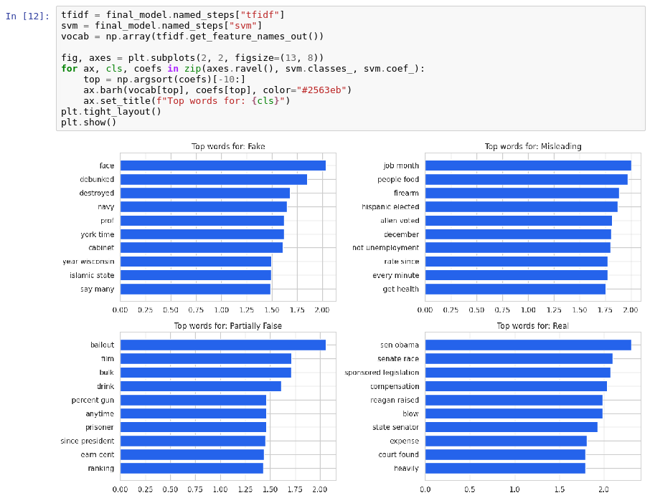
11. Save the model ---
12. Predict on new text ---
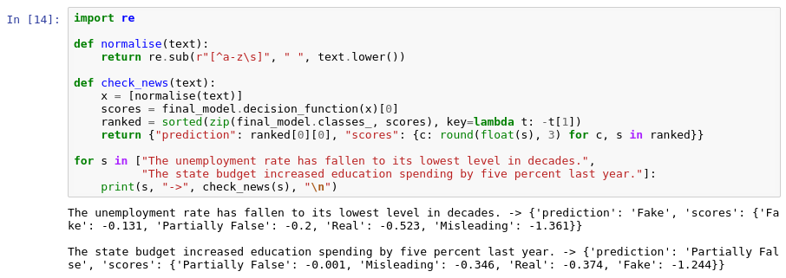
Execution Procedure :
- Load cleaned_dataset.csv containing the four-class labeled statements.
- Use the clean_text column as the input and the label column as the target.
- Use the predefined train, validation and test splits (10,269 / 1,284 / 1,283).
- Transform text into TF-IDF vectors using 1--2 word n-grams (min_df=2, max_df=0.9, sublinear_tf=True).
- Initialize the Support Vector Machine (LinearSVC) with class_weight='balanced', random_state=42 and max_iter=10000.
- Train a baseline model with C = 1.0 and evaluate it on the validation split.
- Tune C over 0.01, 0.03, 0.1, 0.3, 1, 3 and 10 using validation macro-F1.
- Refit the model on train + validation with the best C (1.0).
- Predict the labels of the test set.
- Calculate accuracy, macro-F1 and the full classification report.
- Generate the confusion matrix (counts and row-normalised).
- Inspect the most influential words per class.
- Pass new text through the trained pipeline and display the predicted class with decision scores.
- Interpret strengths and limitations.

5.2.3 A3 — Random Forest
Theory and Formulas
Fake News Detection
Fake news detection is the automated identification of misleading or false news content. Machine learning can learn patterns from labeled examples and apply those patterns to unseen text.
Random Forest
Random Forest is a supervised ensemble learning algorithm. It constructs multiple decision trees and combines their predictions. For classification, the final output is generally the class receiving the majority vote.
- Convert article text into numerical TF-IDF features.
- Pass the feature vector through the trees in the forest.
- Each tree independently predicts a class.
- Aggregate the tree predictions using majority voting.
Gini Impurity
Gini Impurity measures the impurity of a decision-tree node.
Gini Impurity = 1 − Σᵢ(pᵢ)²
For binary classification, pᵢ is the proportion of samples belonging to class i. A value of 0 indicates a pure node, while 0.5 is the maximum impurity for two equally represented classes.
Entropy
Entropy = − Σᵢ pᵢ log₂(pᵢ)
Entropy is another criterion that can be used to evaluate splits in decision trees.
Random Forest Procedure
- Bootstrap sampling
- Random feature selection at each split
- Construction of multiple decision trees
- Aggregation of predictions using majority voting
TF-IDF
TF-IDF converts text into numerical weights that represent the importance of terms, as described in Section 2.5.4.
Implementation Steps :
- Import Required Libraries – Import Pandas, NumPy and required scikit-learn libraries.
- Load the Dataset – Load the labeled dataset.
- Inspect the Dataset – Inspect rows, columns, missing values and class distribution.
- Handle Missing or Invalid Records – Handle missing or invalid text records.
- Assign the Content Field – Assign the content field from the text.
- Preprocess the Text – Preprocess the text.
- Apply TF-IDF Vectorization – Apply TfidfVectorizer with suitable parameters.
- Split the Dataset – Split data into training and testing sets.
- Initialize the Random Forest Model – Initialize RandomForestClassifier, for example with n_estimators=100 and random_state=42.
- Train the Model – Train the Random Forest model using fit().
- Generate Predictions – Predict test labels using predict().
- Calculate Evaluation Metrics – Calculate accuracy, precision, recall and F1-score.
- Generate the Confusion Matrix – Generate a confusion matrix.
- Extract Feature Importances – Extract feature_importances_ where appropriate.
- Train the Comparison Models – Train A1, A2 and A4 for comparison.
- Select the Best Model – Select the best model based on evaluation results.
- Test on a New Article – Test the selected model on a new article.
- Display Prediction and Confidence – Display predicted class and an appropriate confidence/probability estimate.
- Generate Charts and Interpret Results – Generate performance charts and interpret results.
Execution Steps :
This section describes the execution of Algorithm 3 – Random Forest in the project notebook. The screenshots show the executed code and its actual output for each implementation step above.
1. Import Pandas, NumPy and required scikit-learn libraries ---
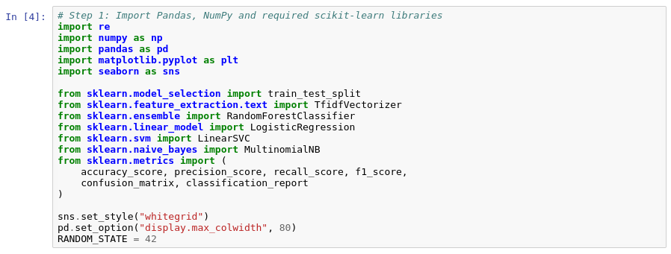
2. Load the labeled dataset ---
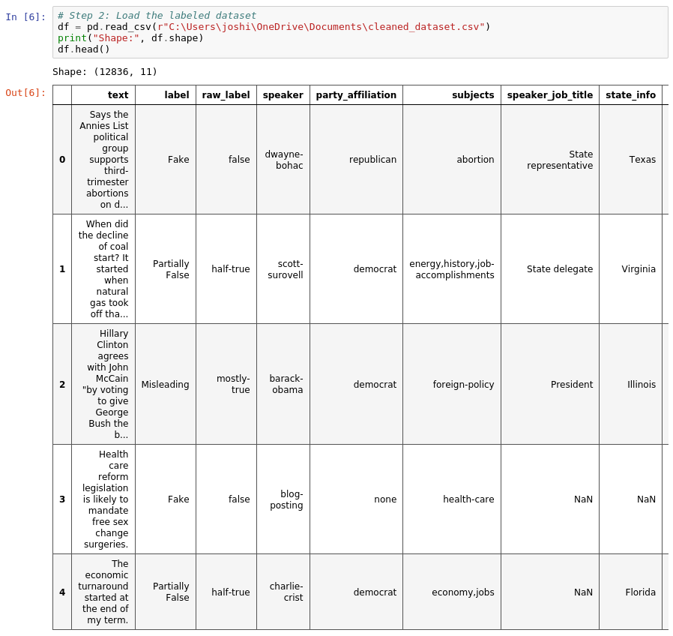
3. Inspect rows, columns, missing values and class distribution ---
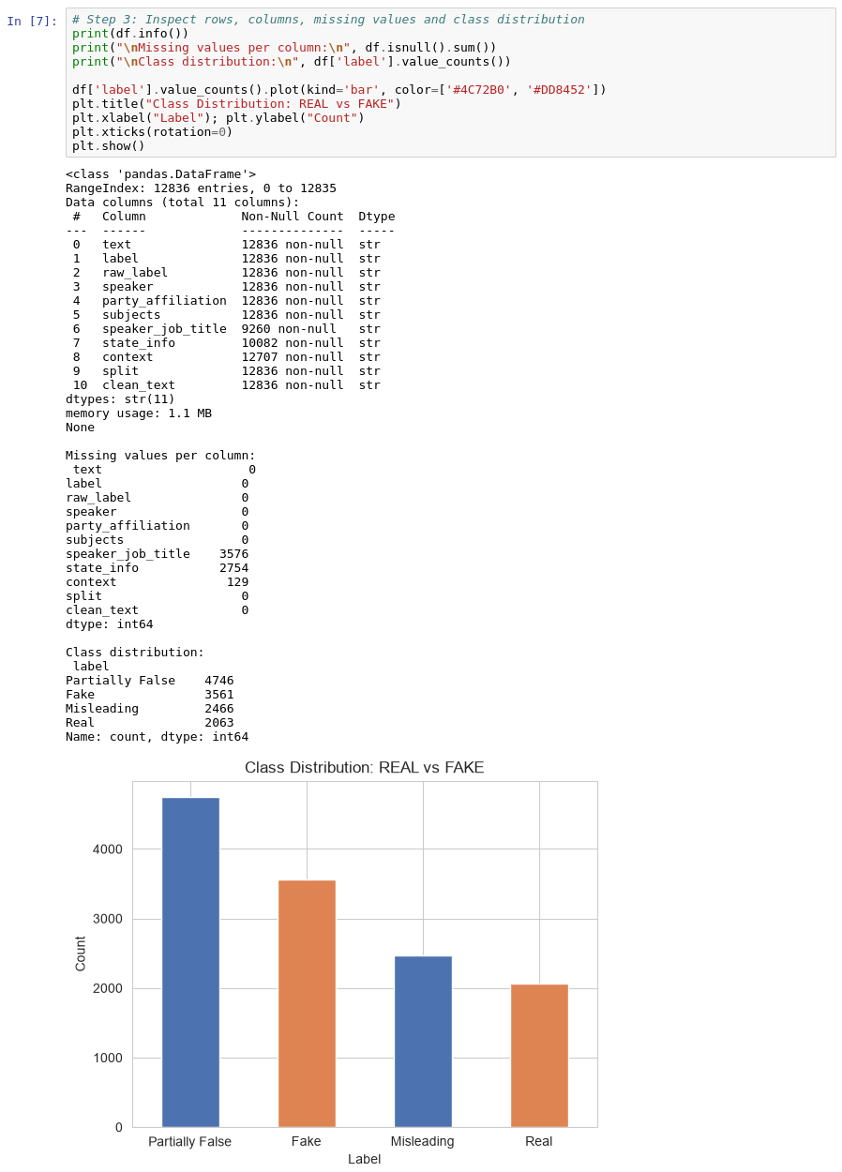
4. Handle missing or invalid text records ---
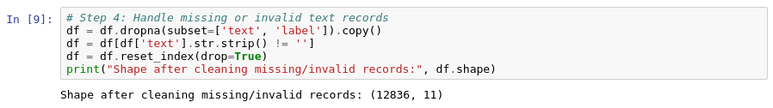
5. Assign the content field ---
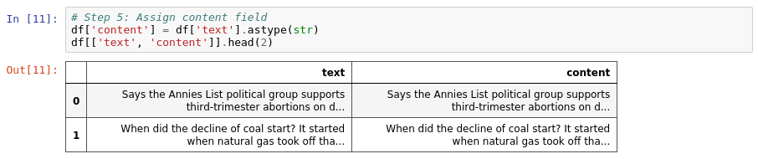
6. Preprocess the text ---
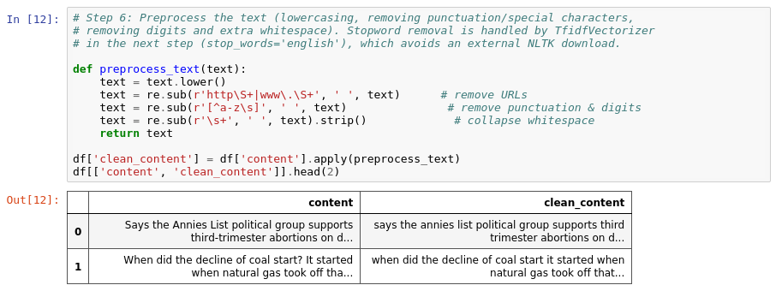
7. Apply TfidfVectorizer with suitable parameters ---
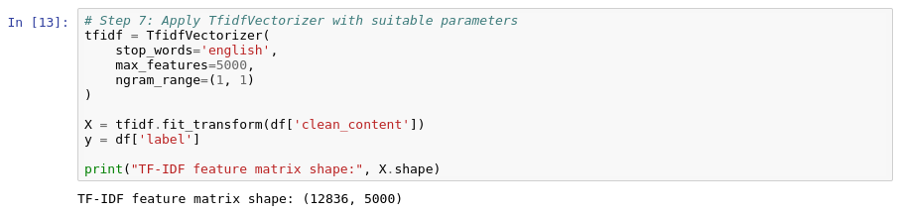
8. Split data into training and testing sets (80:20) ---
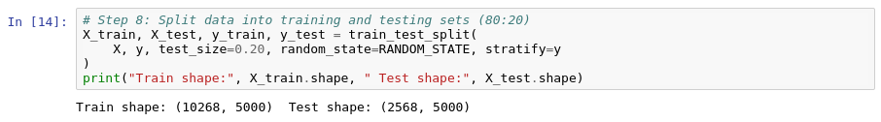
9. Initialize the Random Forest Classifier (A3) ---
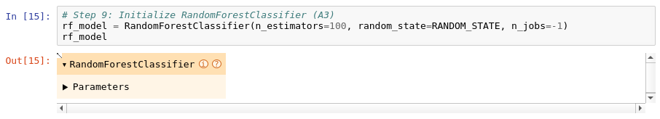
10. Train the Random Forest model using fit() ---
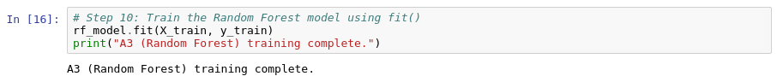
11. Predict test labels using predict() ---
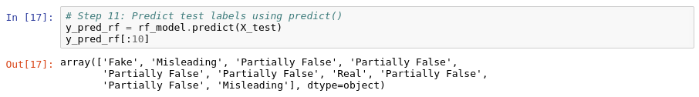
12. Calculate accuracy, precision, recall and F1-score ---
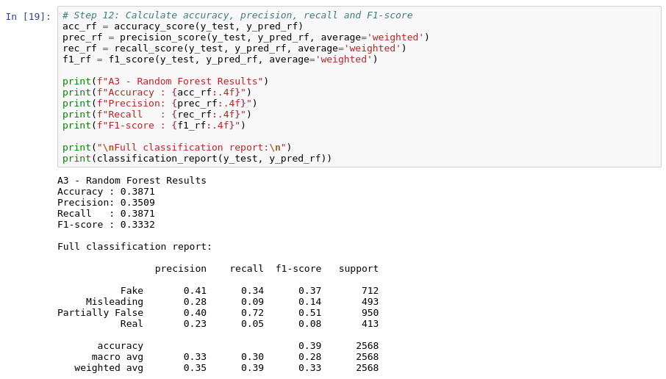
13. Generate a confusion matrix ---
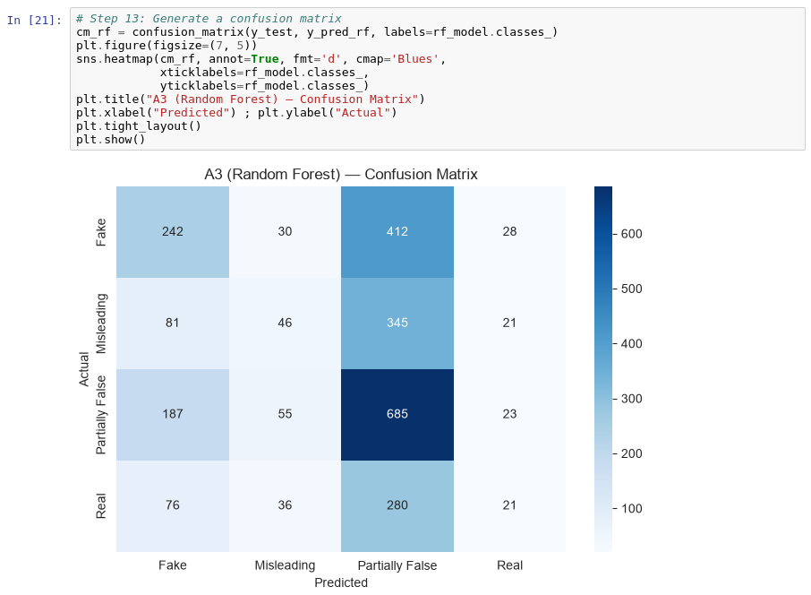
14. Extract feature_importances_ ---
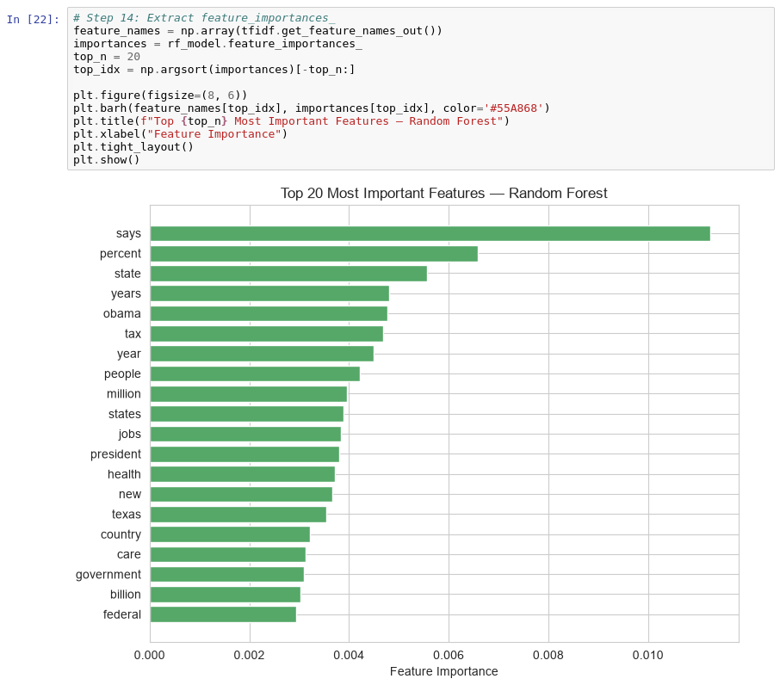
15. Train A1 (Logistic Regression), A2 (SVM) and A4 (Naive Bayes) for comparison ---
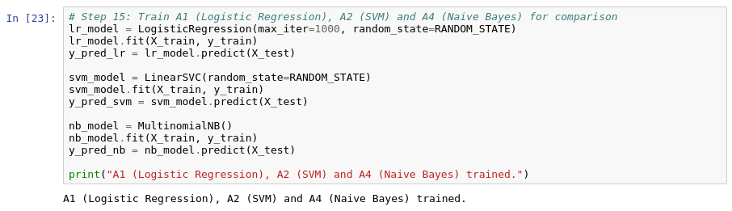
16. Compare all models in a results DataFrame ---
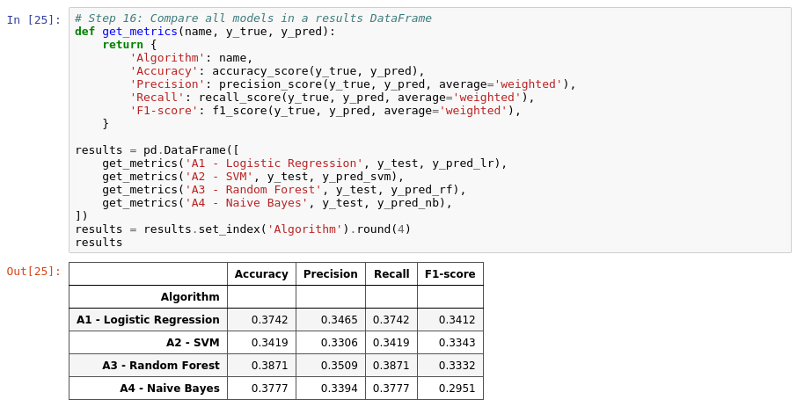
Visualize the performance comparison across A1--A4
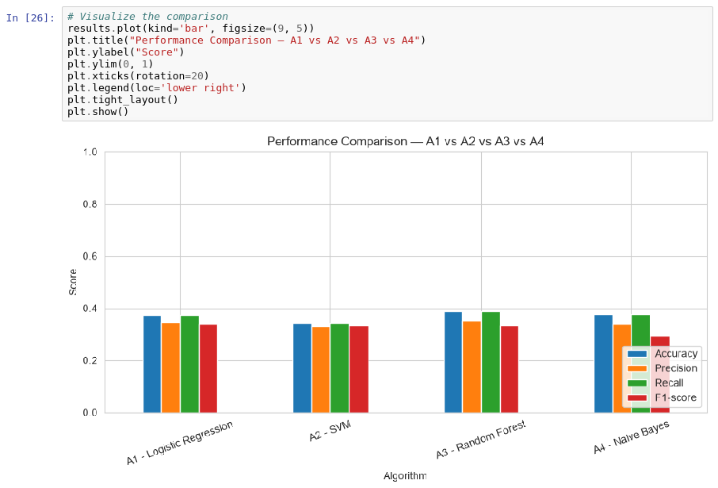
17. Select the best model based on evaluation results ---
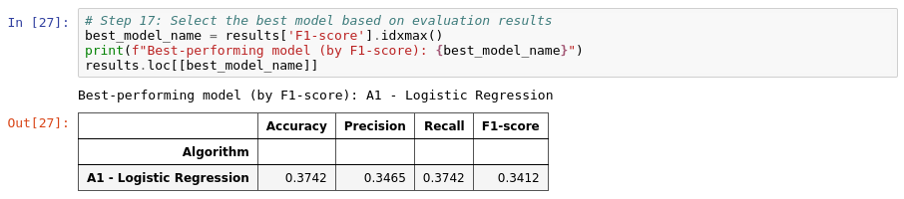
18. Test the selected model (A3) on a new article and display the predicted class with confidence ---
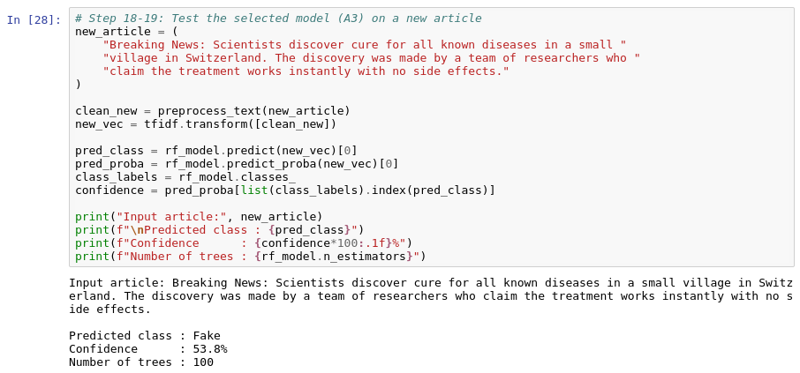
Execution Procedure :
- Load the labeled news dataset.
- Clean and preprocess the textual content.
- Transform text into TF-IDF vectors, for example using up to 5,000 features.
- Split the data into training and testing subsets.
- Initialize Random Forest with n_estimators=100 and random_state=42.
- Train the model on the training vectors.
- Predict the labels of the test set.
- Calculate evaluation metrics.
- Generate a confusion matrix.
- Calculate precision, recall and F1-score.
- Inspect feature importance if the selected feature representation and model make it meaningful.
- Compare Random Forest with Logistic Regression, SVM and Naive Bayes.
- Select the best-performing model based on the chosen evaluation criterion.
- Pass a new article through the trained pipeline.
- Display the predicted class and confidence/probability estimate.
- Visualize model performance.
- Interpret strengths and limitations.

5.2.4 A4 — Naive Bayes
Theory and Formulas
Naive Bayes
Naive Bayes is a supervised probabilistic classifier based on Bayes’ theorem. It assumes conditional independence between features given the class — an assumption that rarely holds exactly for text, but which still works well in practice for TF-IDF-weighted term features.
Bayes’ Theorem
P(y|x) = [P(x|y) · P(y)] / P(x)
P(y) is the prior probability of class y, P(x|y) is the likelihood of observing features x given class y, and P(y|x) is the posterior probability used to make the prediction. Since P(x) is constant across classes for a given input, the model predicts the class y that maximizes P(y) · P(x|y).
Multinomial Naive Bayes for Text
Assuming conditional independence between the TF-IDF features x₁, …, xₙ:
P(y|x) ∝ P(y) × Πᵢ P(xᵢ|y)
- Convert text into TF-IDF feature vectors.
- Estimate P(y) from the class frequencies in the training data.
- Estimate P(xᵢ|y) from the (weighted) term frequencies observed within each class.
- Predict the class with the highest posterior probability.
Laplace (Additive) Smoothing
P(xᵢ|y) = (Nᵧᵢ + α) / (Nᵧ + α·n)
Nᵧᵢ is the (weighted) count of term i in class y, Nᵧ is the total (weighted) term count in class y, n is the vocabulary size, and α is the smoothing parameter (α = 1 by default, i.e., Laplace smoothing). Smoothing prevents zero probabilities for terms that were never observed in a given class during training.
Naive Bayes Procedure
- Convert article text into numerical TF-IDF features.
- Estimate class priors and per-class term likelihoods from the training data.
- Apply Laplace smoothing to avoid zero probabilities.
- Compute the posterior probability of each class for a new input and predict the class with the highest value.
TF-IDF
TF-IDF converts text into numerical weights that represent the importance of terms, as described in Section 2.5.4.
Implementation Steps :
- Import Required Libraries – Import Pandas, NumPy and required scikit-learn libraries.
- Load the Dataset – Load the labeled dataset.
- Inspect the Dataset – Inspect rows, columns, missing values and class distribution.
- Handle Missing or Invalid Records – Handle missing or invalid text records.
- Create the Content Field – Create the content field from the text.
- Preprocess the Text – Preprocess the text.
- Apply TF-IDF Vectorization – Apply TfidfVectorizer with suitable parameters.
- Split the Dataset – Split data into training and testing sets.
- Initialize the Naive Bayes Model – Initialize MultinomialNB with default (or tuned) smoothing.
- Train the Model – Train the Naive Bayes model using fit().
- Generate Predictions – Predict test labels using predict().
- Calculate Evaluation Metrics – Calculate accuracy, precision, recall and F1-score.
- Generate the Confusion Matrix – Generate a confusion matrix.
- Inspect Class-Associated Terms – Inspect the terms with the highest log-probability per class.
- Train the Comparison Models – Train A1, A2 and A3 for comparison.
- Select the Best Model – Select the best model based on evaluation results.
- Test on a New Article – Test the selected model on a new article.
- Display Prediction and Confidence – Display predicted class and an appropriate confidence/probability estimate.
- Generate Charts and Interpret Results – Generate performance charts and interpret results.
Execution Steps :
This section describes the execution of Algorithm 4 – Naive Bayes in the project notebook. The screenshots show the executed code and its actual output for each implementation step above.
1. Import Pandas, NumPy and required scikit-learn libraries ---
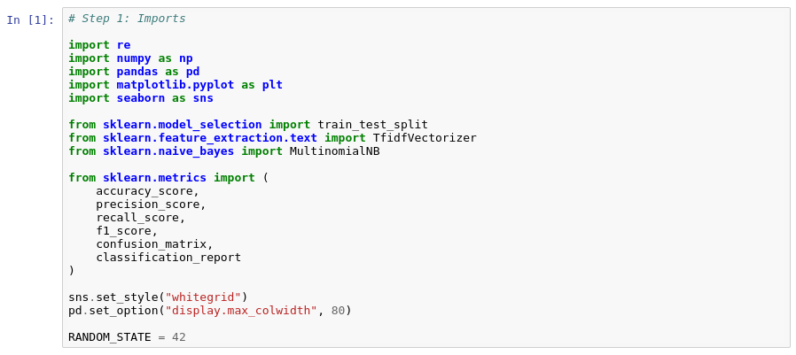
2. Load the dataset ---
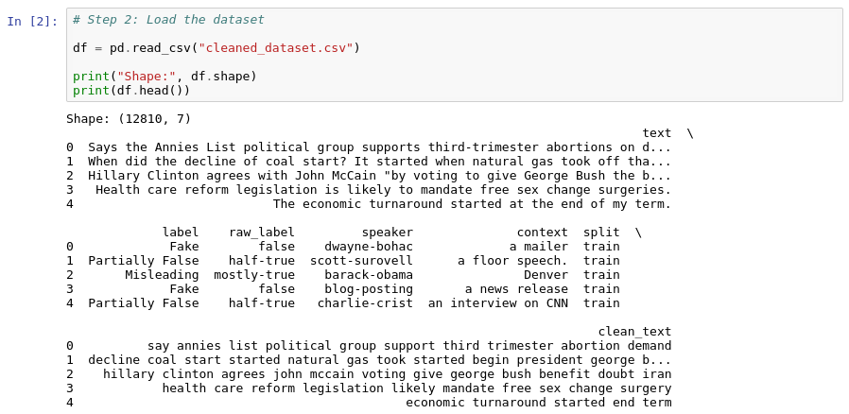
3. Inspect rows, columns, missing values and class distribution ---
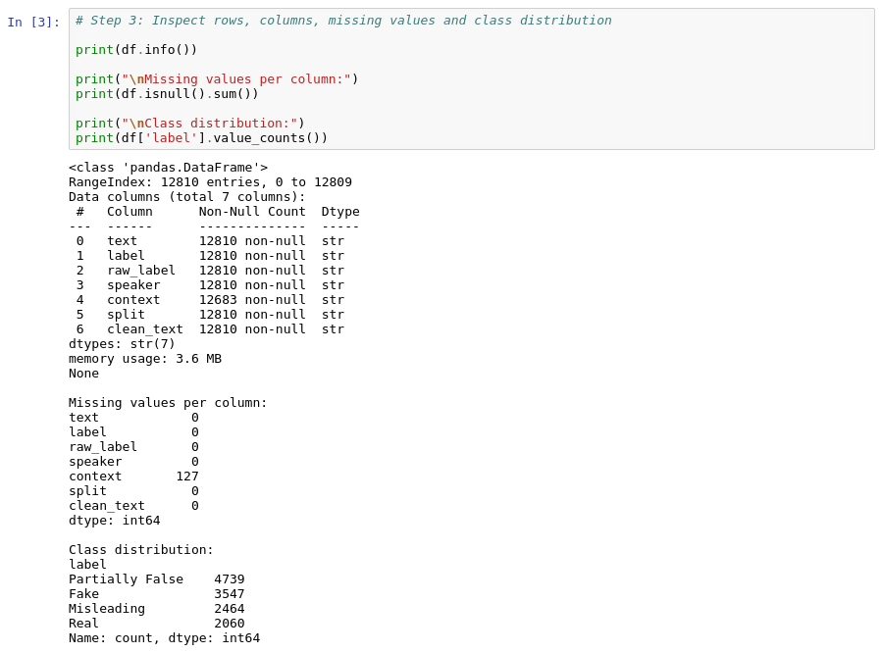
4. Handle missing or invalid text records ---
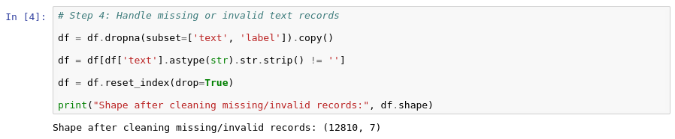
5. Create the content field from the text ---
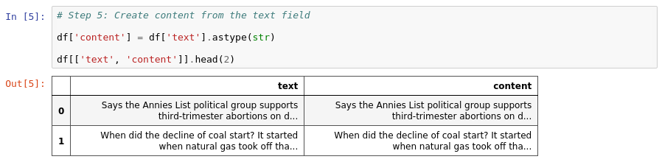
6. Preprocess the text ---
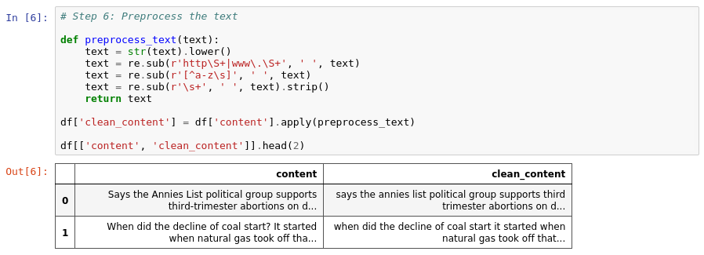
7. Apply TfidfVectorizer ---
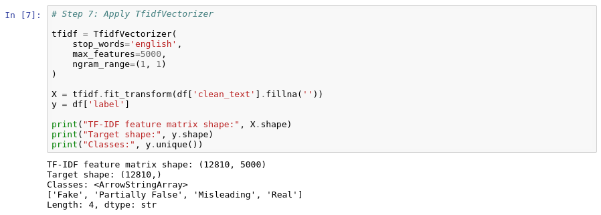
8. Split data into training and testing sets (80:20) ---
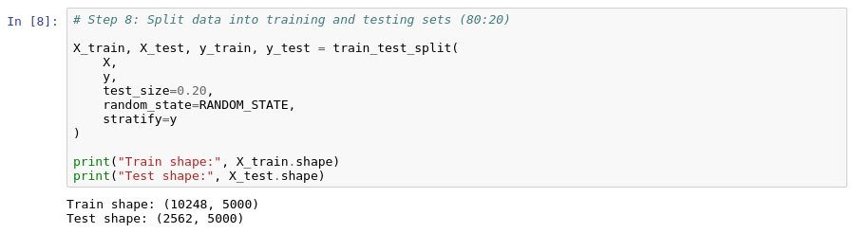
9. Initialize Multinomial Naive Bayes (A4) ---
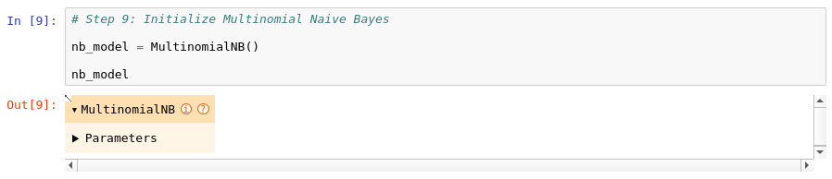
10. Train Multinomial Naive Bayes ---
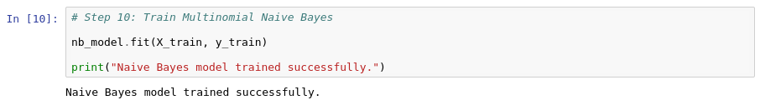
11. Predict test labels ---
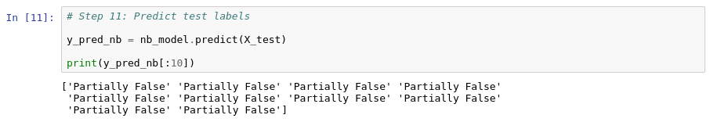
12. Calculate accuracy, precision, recall and F1-score ---
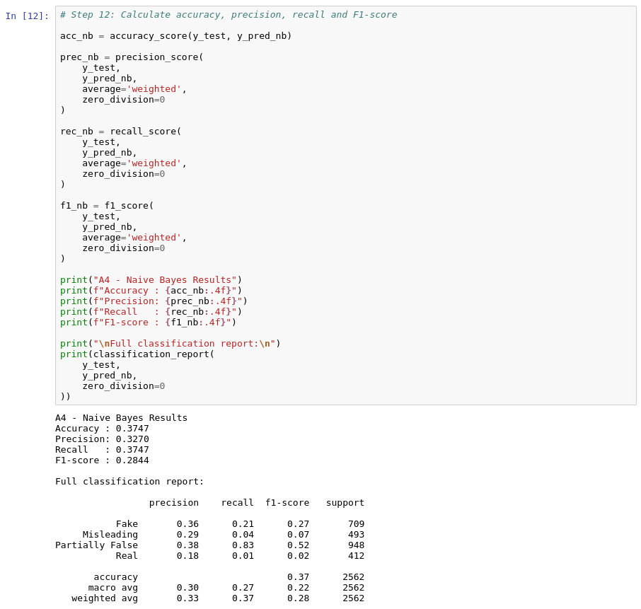
13. Generate a confusion matrix ---
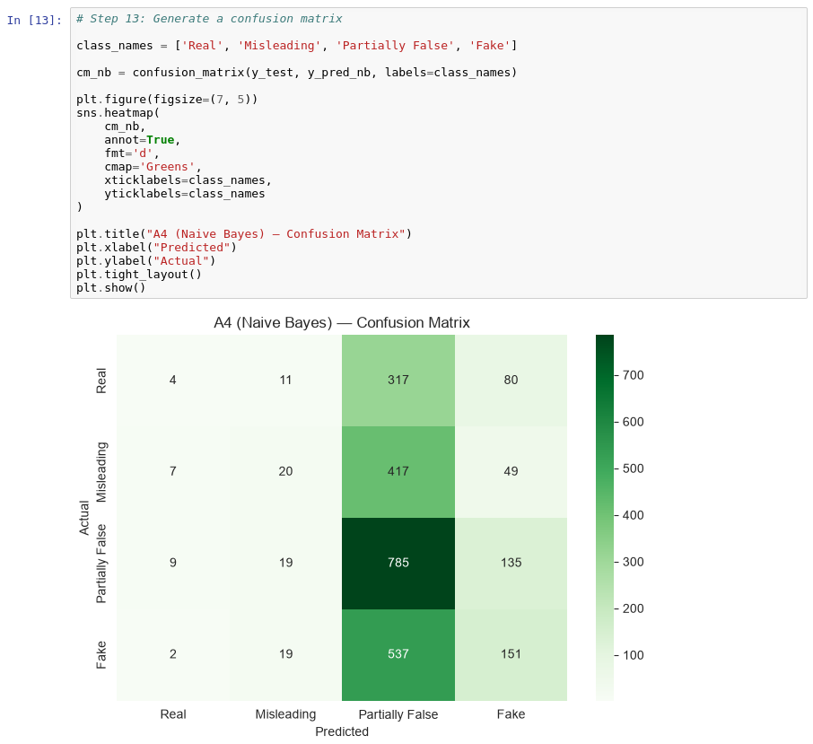
14. Inspect the terms most strongly associated with each class ---
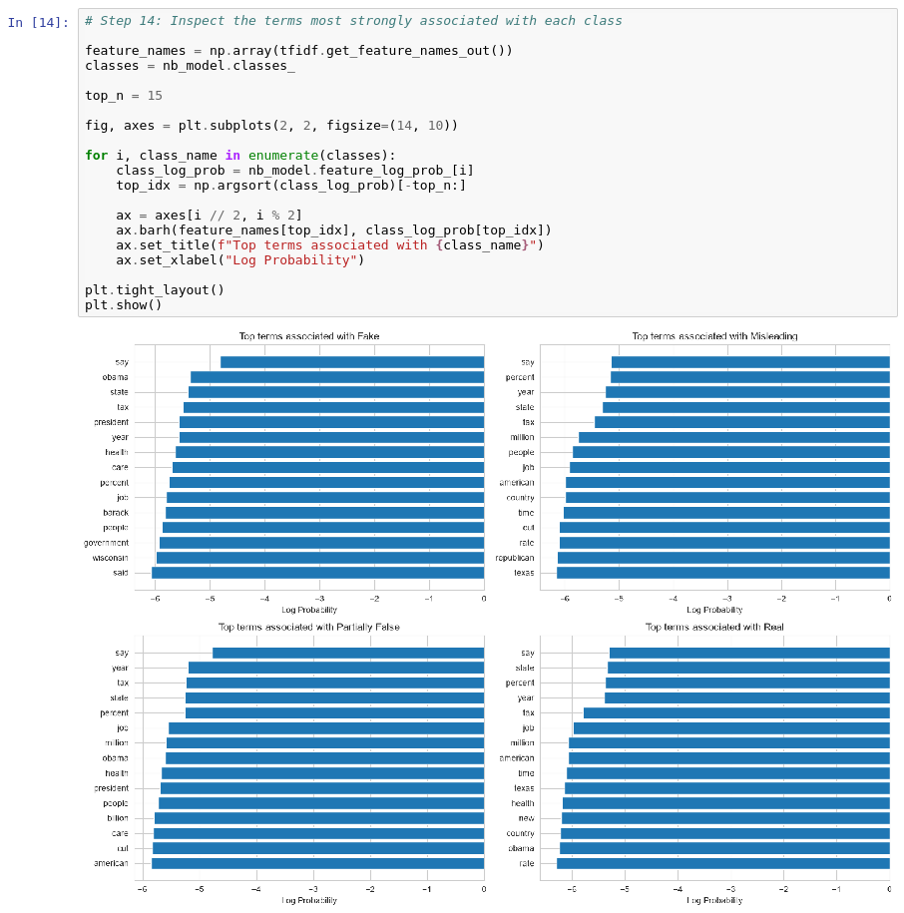
15. Train Logistic Regression, SVM and Random Forest ---
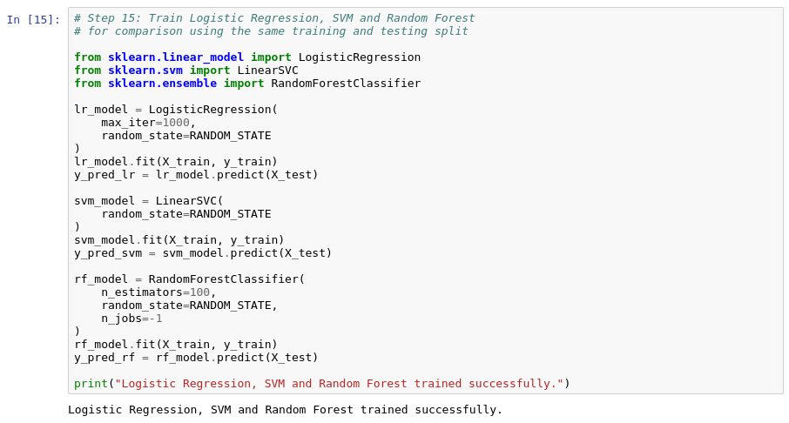
16. Compare all four algorithms in a results DataFrame ---
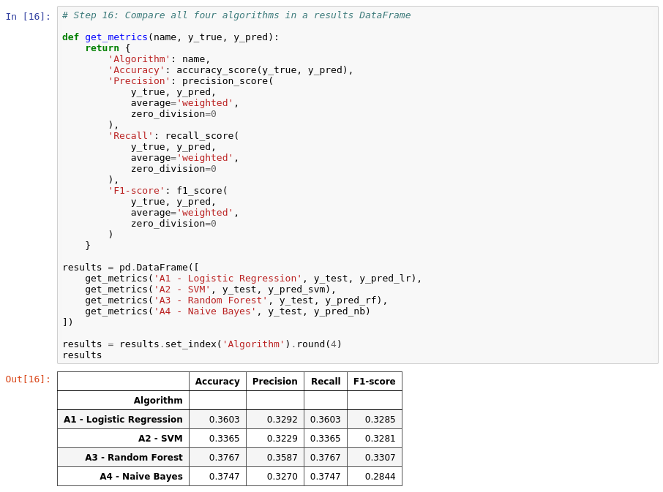
17. Visualize the comparison ---
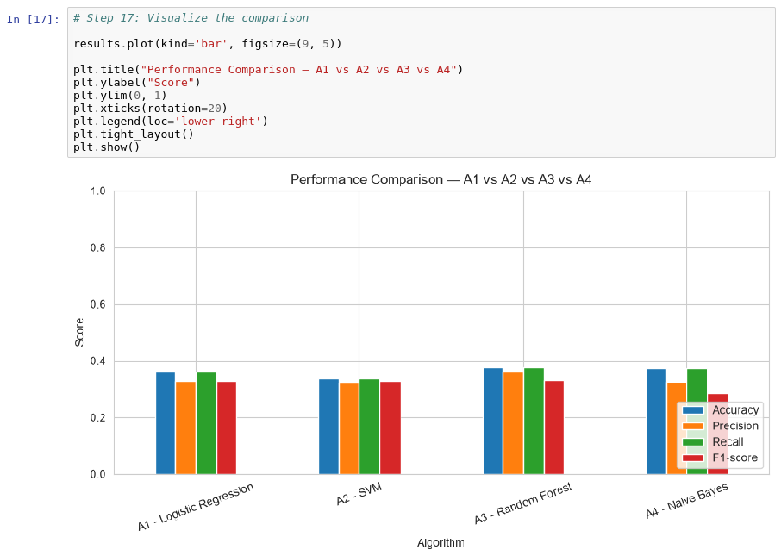
18. Select the best model based on evaluation results ---
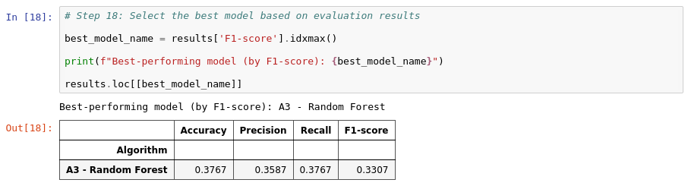
19. Test Naive Bayes on a new article ---
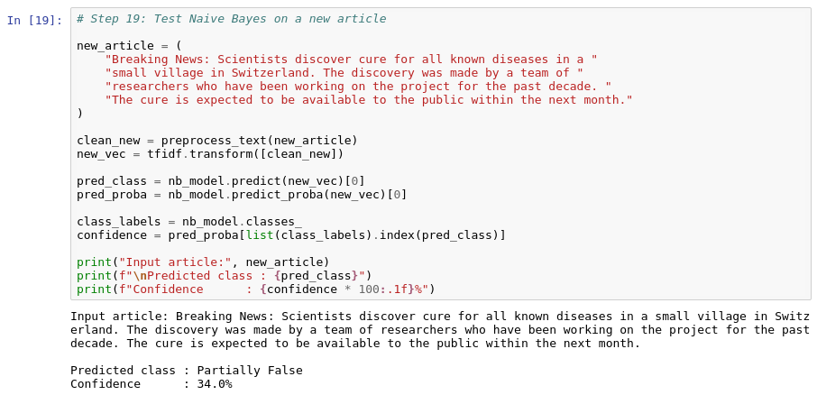
Execution Procedure :
- Load the labeled news dataset.
- Clean and preprocess the textual content.
- Transform text into TF-IDF vectors, for example using up to 5,000 features.
- Split the data into training and testing subsets.
- Initialize MultinomialNB with default smoothing (α = 1.0).
- Train the model on the training vectors.
- Predict the labels of the test set.
- Calculate evaluation metrics.
- Generate a confusion matrix.
- Calculate precision, recall and F1-score.
- Inspect the terms with the highest log-probability per class.
- Compare Naive Bayes with Logistic Regression, SVM and Random Forest.
- Select the best-performing model based on the chosen evaluation criterion.
- Pass a new article through the trained pipeline.
- Display the predicted class and confidence/probability estimate.
- Visualize model performance.
- Interpret strengths and limitations.

CHAPTER - 6
RESULTS AND OUTPUTS
This chapter presents the outputs generated by the four models, including the confusion matrices, execution examples with predicted classes, and the overall comparison of model performance.

6.1 Logistic Regression Model Output
Execution Example
Input Example
“Breaking News: Scientists discover cure for all known diseases in a small village in Switzerland. The discovery was made by a team of researchers who have been working on the project for the past decade. The cure is expected to be available to the public within the next month.”
Processing
The input is cleaned and transformed using the same preprocessing and TF-IDF vectorizer fitted during training. The resulting vector is passed to the trained Logistic Regression model, which computes a probability via the sigmoid function.
Actual Output
Predicted class = Real; Confidence = 33.2% (probability for the predicted class).
Important: This is an execution example, not a verified prediction. Actual output depends on the dataset, preprocessing, vectorizer, and trained model.

6.2 SVM Model Output
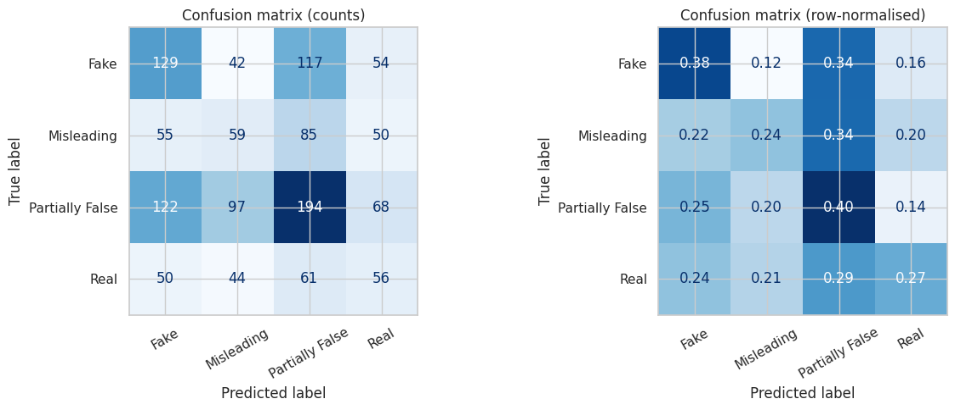
Figure 6.2.1: SVM Fake News Classification Confusion Matrix
The figure above shows the confusion matrix generated in the A2 (SVM) notebook on the official test split (1,283 statements) of cleaned_dataset.csv, from the final model refit on train + validation (left: counts, right: row-normalised), across the four classes: Real, Misleading, Partially False, and Fake.
Execution Example
Input Example
“The unemployment rate has fallen to its lowest level in decades.”
Processing
The input is cleaned (lowercased, non-letters removed) and passed to the trained TF-IDF + LinearSVC pipeline, which produces a decision-function score per class (no calibrated probability, since LinearSVC does not implement predict_proba).
Actual Output
Predicted class = Fake (highest decision-function score). Decision scores: Fake −0.131, Partially False −0.200, Real −0.523, Misleading −1.361. A second test sentence, “The state budget increased education spending by five percent last year.”, was predicted as Partially False (scores: Partially False −0.001, Misleading −0.346, Real −0.374, Fake −1.244).
Important: This is an execution example, not a verified prediction. Actual output depends on the dataset, preprocessing, vectorizer, and trained model.

6.3 Random Forest Model Output
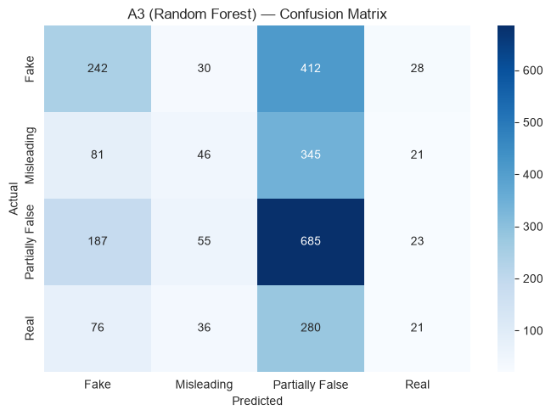
Figure 6.3.1: Random Forest Fake News Classification Confusion Matrix
The figure above shows the confusion matrix generated in the A3 (Random Forest) notebook on the 20% test split (2,568 statements) of cleaned_dataset.csv (12,836 statements), across the four classes: Real, Misleading, Partially False, and Fake.
Execution Example
Input Example
“Breaking News: Scientists discover cure for all known diseases in a small village in Switzerland. The discovery was made by a team of researchers who claim the treatment works instantly with no side effects.”
Processing
The input is cleaned and transformed using the same preprocessing and TF-IDF vectorizer fitted during training. The resulting vector is passed to the trained Random Forest model.
Actual Output (Tree Voting)
Predicted Class | Probability
Fake | 53.8%

Predicted class = Fake; Confidence = 53.8% (share of trees voting for the predicted class); number of trees = 100.
Important: This is an execution example, not a verified prediction. Actual output depends on the dataset, preprocessing, vectorizer, and trained model.

6.4 Naive Bayes Model Output
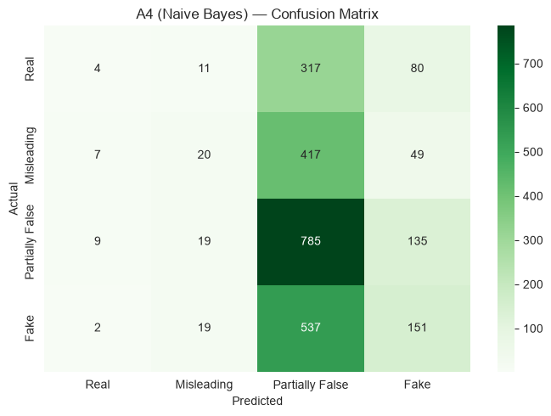
Figure 6.4.1: Naive Bayes Fake News Classification Confusion Matrix
The figure above shows the confusion matrix generated in the A4 (Naive Bayes) notebook on the 20% test split (2,562 statements) of the 12,810-statement dataset used in that notebook, across the four classes: Real, Misleading, Partially False, and Fake.
Execution Example
Input Example
“Breaking News: Scientists discover cure for all known diseases in a small village in Switzerland. The discovery was made by a team of researchers who have been working on the project for the past decade. The cure is expected to be available to the public within the next month.”
Processing
The input is cleaned and transformed using the same preprocessing and TF-IDF vectorizer fitted during training. The resulting vector is passed to the trained Multinomial Naive Bayes model, which computes a posterior probability for each class via Bayes’ theorem.
Actual Output
Predicted class = Partially False; Confidence = 34.0% (posterior probability for the predicted class).
Important: This is an execution example, not a verified prediction. Actual output depends on the dataset, preprocessing, vectorizer, and trained model.

6.5 Model Comparison

6.5.1 Classification Model Comparison
Compare the four classification algorithms:
Model | Accuracy | Precision | Recall | F1-Score
Logistic Regression (A1) | 37.27% | 34.93% | 37.27% | 34.09%
SVM (A2) | 34.14% | 34.30% | 34.14% | 34.20%
Random Forest (A3) | 38.71% | 35.09% | 38.71% | 33.32%
Naive Bayes (A4) | 37.47% | 32.70% | 37.47% | 28.44%

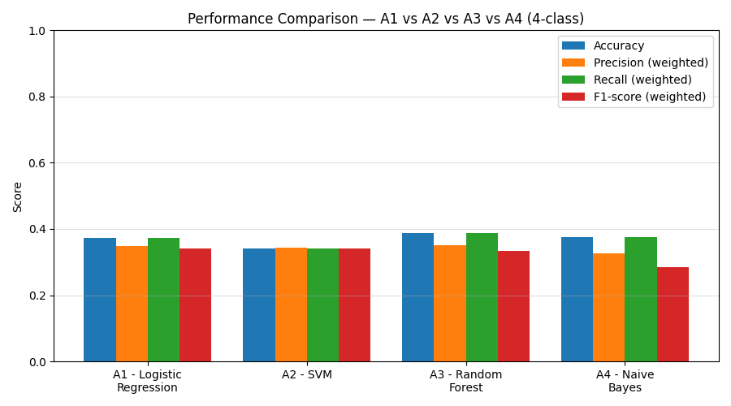
Figure 6.5.1: Accuracy / Precision / Recall / F1 Comparison across A1–A4
The values above are taken from each algorithm’s notebook, all on the four-class setting (Real, Misleading, Partially False, Fake) with weighted-average precision, recall, and F1-score.

6.5.2 Observations
A1 and A3 use a random 20% test split of cleaned_dataset.csv (2,568 statements), A2 uses the dataset’s official test split (1,283 statements) with a tuned, class-balanced SVM, and A4 uses a 20% test split (2,562 statements) of a 12,810-statement version of the dataset, so the splits differ slightly between algorithms.
Accuracy is in the mid-30% range for all four models, since the four-class setting on short statements is much harder than binary real/fake classification. Random Forest has the highest accuracy (38.71%), while SVM has the highest weighted F1-score (34.20%), marginally ahead of Logistic Regression (34.09%).

6.6 Overall Results
Algorithm | Type | Prediction Target | Main Evaluation
Logistic Regression | Classification | Four-class label | Accuracy, Precision, Recall, F1
SVM | Classification | Four-class label | Accuracy, Precision, Recall, F1
Random Forest | Classification | Four-class label | Accuracy, Precision, Recall, F1
Naive Bayes | Classification | Four-class label | Accuracy, Precision, Recall, F1

The final output of the system consists of:
- Classification result: Real, Misleading, Partially False, or Fake.
- Confidence/probability estimate generated by the selected model where supported.
- Accuracy, precision, recall, and F1-score.
- Comparison of all four algorithms.
- Feature-importance information for Random Forest.
- Confusion matrix and performance visualizations.

CHAPTER – 7
CONCLUSION
The Fake News Detection System demonstrates how NLP and machine learning can be combined to classify news statements into four reliability levels: Real, Misleading, Partially False, and Fake. Four algorithms — Logistic Regression, SVM, Random Forest, and Naive Bayes — provide different approaches to the classification problem on the LIAR dataset. TF-IDF provides an effective baseline representation for text, while Random Forest demonstrates ensemble-based classification and can provide feature-importance information.
The final model should be selected using results obtained from a consistent test set and, preferably, additional validation. Accuracy alone should not determine model quality; precision, recall, F1-score, and class balance should also be considered.

CHAPTER – 8
FUTURE ENHANCEMENT
The scope of this project can be extended in several ways to improve prediction performance, scalability, and practical applicability:
- Integrate deep learning models such as LSTM, CNN, and transformer-based BERT models.
- Support multiple languages.
- Develop real-time detection for online and social-media content.
- Use multimodal analysis involving text, images, videos, and metadata.
- Add Explainable AI techniques such as SHAP or LIME.
- Train on larger and more diverse datasets.
- Perform hyperparameter optimization using GridSearchCV or RandomizedSearchCV.
- RandomizedSearchCV.

CHAPTER – 9
REFERENCES
1. William Yang Wang — “Liar, Liar Pants on Fire”: A New Benchmark Dataset for Fake News Detection, ACL 2017.
2. LIAR dataset files (train.tsv, valid.tsv, test.tsv), GitHub mirror: https://github.com/ekagra-ranjan/fake-news-detection-LIAR-pytorch
3. JoaoPedroZampoli — Fake News Analyzer, GitHub.
4. RabbiaIdrees — Fake News Detection, GitHub.
5. Riddhi3092002 — NLP-driven Fake News Detection using ML and DL models, GitHub.
6. Fake News Detection Using Natural Language Processing and Machine Learning, Zenodo, 2025.
7. A Review on Machine Learning Techniques for Fake News Detection, Zenodo, 2025.
8. Detecting Fake News Using Machine Learning Techniques, IEEE Xplore, 2024.
9. Automated Fake News Detection Using TF-IDF Features and Neural Networks: A Comparative Study, IEEE Xplore, 2025.
10. An Empirical Comparison of Machine Learning and Deep Learning Models for Automated Fake News Detection, MDPI Mathematics, 2025.

CHAPTER – 10
PUBLICATIONS
This chapter presents the research paper “Multi-Level Fake News Classification Using Machine Learning”, written on the multi-level fake news classification work carried out in this project. The pages of the paper are reproduced in Section 10.1.

10.1 Research Paper
Title: Multi-Level Fake News Classification Using Machine Learning
Authors: Lalu Prasad Jamana, Joshitha, Jaswanth Palivela, Ananda Varshini and Durga Prasad
Affiliation: Department of Information Technology (IT) and Department of Computer Science and Engineering (CSE), Aditya College of Engineering and Technology, Surampalem, Andhra Pradesh, India
Keywords: Fake news detection; multi-level classification; machine learning; TF-IDF; n-grams; Logistic Regression; Support Vector Machine; Random Forest; model evaluation; misinformation detection
