A
b
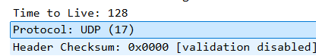
C
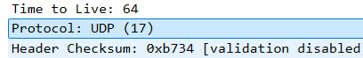
D
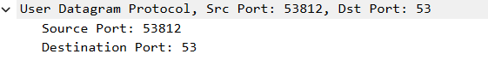
E
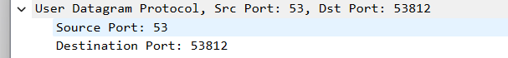
F

G
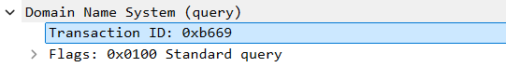


Transaction ID: Query = 0xb669, Response = 0xb669. The Transaction ID is a 16-bit identifier used to match a DNS response with its corresponding DNS query.
H
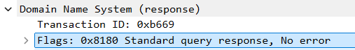
The DNS Flags field has a length of 16 bits (2 bytes).

I
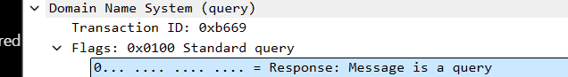
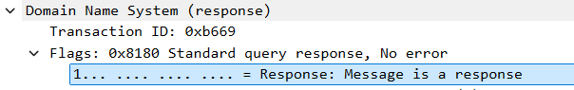
QR value | Meaning
0 | Query
1 | Response
J
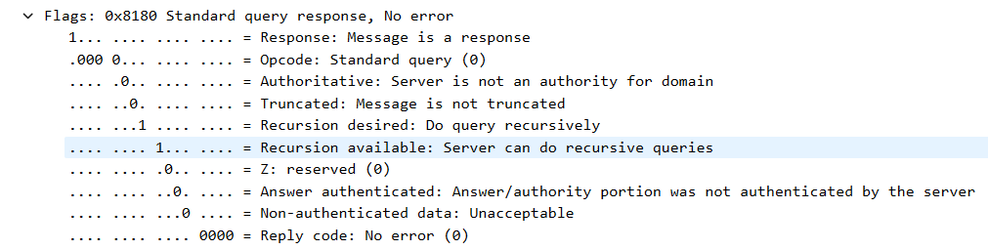
K
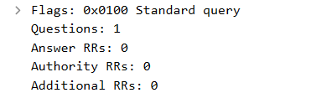
L
