import numpy as np
import matplotlib.pyplot as plt
from sklearn import datasets, svm
# 1. Load Iris dataset
iris = datasets.load_iris()
# Select first two features:
Sepal Length and Sepal Width
X = iris.data[:, :2]
# Assign +1 to class 0 and -1 to all
other classes
y = np.where(iris.target == 0, 1, -1)
# 2. Train Linear SVM model
model = svm.SVC(kernel='linear', C=1)
model.fit(X, y)
# 3. Plot data points
plt.scatter(
X[:, 0],
X[:, 1],
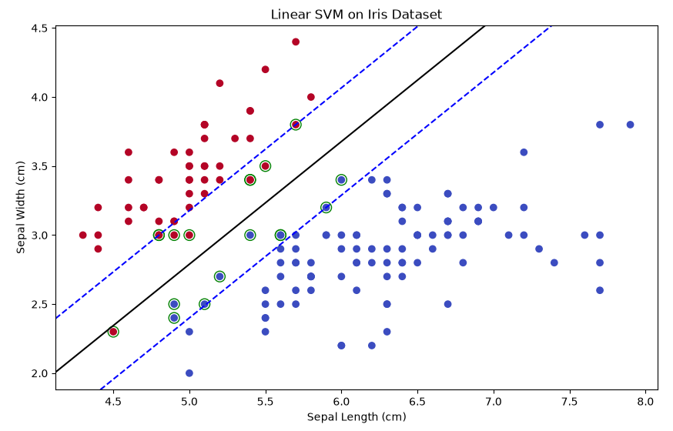
c=y,
cmap='coolwarm' )
# 4. Create grid for drawing
decision boundary
ax = plt.gca()
xlim = ax.get_xlim()
ylim = ax.get_ylim()
xx, yy = np.meshgrid(
np.linspace(xlim[0], xlim[1], 100),
np.linspace(ylim[0], ylim[1], 100) )
# 5. Calculate decision values
Z = model.decision_function(
np.c_[xx.ravel(), yy.ravel()]
).reshape(xx.shape)
# 6. Draw decision boundary and margins
ax.contour(
xx, yy, Z,
levels=[-1, 0, 1],
colors=['blue', 'black', 'blue'],
linestyles=['--', '-', '--']
)
# 7. Highlight support vectors
ax.scatter(
model.support_vectors_[:, 0],
model.support_vectors_[:, 1],
s=100,
facecolors='none',
edgecolors='green'
)
# 8. Add labels and display plot
plt.xlabel("Sepal Length (cm)")
plt.ylabel("Sepal Width (cm)")
plt.title("Linear SVM on Iris Dataset")
plt.show()

