# Step 1: Import Libraries
import numpy as np
import matplotlib.pyplot as plt
import time
from tensorflow.keras.datasets import mnist
from tensorflow.keras.models import Sequential
from tensorflow.keras.layers import Dense, Input, Flatten
from tensorflow.keras.utils import to_categorical

# Step 2: Load Dataset
(X_train, y_train), (X_test, y_test) = mnist.load_data()

# Step 3: Preprocessing
X_train = X_train.astype("float32") / 255.0
X_test = X_test.astype("float32") / 255.0
y_train = to_categorical(y_train, 10)
y_test = to_categorical(y_test, 10)
# Step 4: Create Neural Network Model
def create_model(activation):
model = Sequential([
Input(shape=(28, 28)),
Flatten(),
Dense(128, activation=activation),
Dense(64, activation=activation),
Dense(10, activation="softmax")
])
model.compile(
optimizer="adam",
loss="categorical_crossentropy",
metrics=["accuracy"]
)
return model
# Step 5: Train Models with Different Activations
activations = ["sigmoid", "tanh", "relu"]
results = {}
histories = {}

for act in activations:
print(f"\nTraining with {act} activation")
model = create_model(act)
start = time.time()
history = model.fit(
X_train, y_train,
epochs=5,
batch_size=128,
validation_split=0.2,
verbose=1
)
training_time = time.time() - start
loss, accuracy = model.evaluate(
X_test, y_test, verbose=0
)
results[act] = {
"accuracy": accuracy,
"loss": loss,
"time": training_time
}
histories[act] = history.history
# Step 6: Compare Test Accuracy and Training Time
print("\nFinal Comparison")
print("-" * 50)
print(f"{'Activation':<12}{'Accuracy':<15}{'Time (s)':<12}")
for act in activations:
print(
f"{act:<12}"
f"{results[act]['accuracy']:.4f}"
f"{'':<10}"
f"{results[act]['time']:.2f}" )
# Step 7: Plot Training and Validation Accuracy
plt.figure(figsize=(10, 5))
for act in activations:
plt.plot(
histories[act]["accuracy"],
label=act + " Training"
)
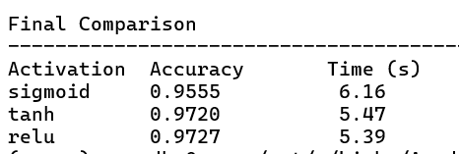
plt.plot(
histories[act]["val_accuracy"],
linestyle="--",
label=act + " Validation"
)
plt.title("Activation Function Comparison on MNIST")
plt.xlabel("Epoch")
plt.ylabel("Accuracy")
plt.legend()
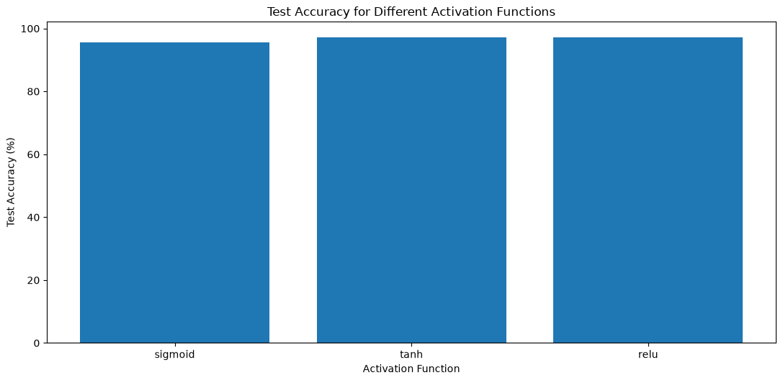
plt.grid(True)
plt.tight_layout()
plt.show()
# Step 8: Plot Test Accuracy Comparison
plt.figure(figsize=(7, 4))
accuracy_values = [
results[act]["accuracy"] * 100 for act in activations
]
plt.bar(activations, accuracy_values)
plt.title("Test Accuracy for Different Activation Functions")
plt.xlabel("Activation Function")
plt.ylabel("Test Accuracy (%)")
plt.tight_layout()
plt.show()



