Bank TRANSACTION Project :-

Pre- Request :-
- TRANSACTION-SERVER project running
- Client A – Bank project running
- Client B – Bank Project running

Flow Chart :-
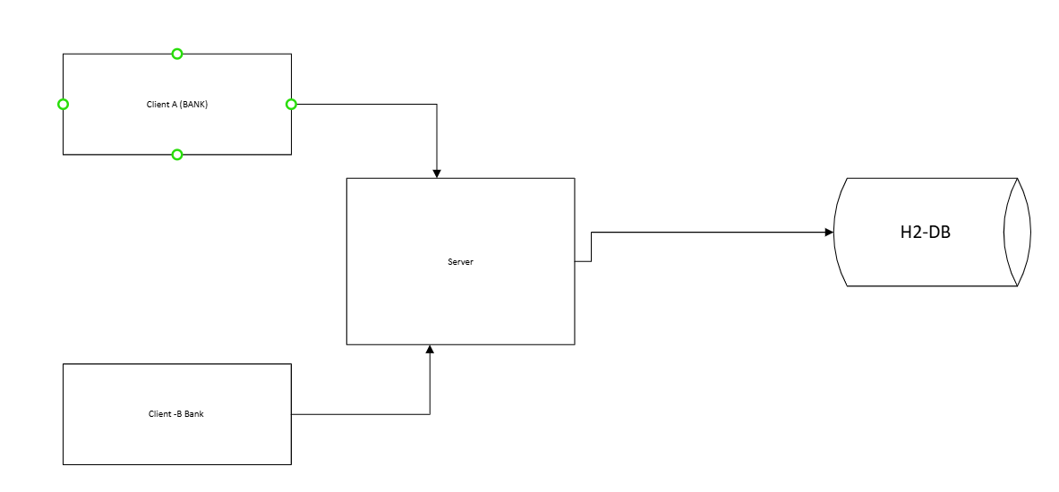

Transaction Processing :-
TRANSACTION-SERVER
POST : http://localhost:9700/api/v1/server/transaction/process
BODY :-
<TransactionRequest>
<TrxId>TRX-20250923-000003</TrxId>
<BankId>BANK_A</BankId>
<CustomerId>892345</CustomerId>
<FromAccount>1234567890</FromAccount>
<ToAccount>9876543210</ToAccount>
<Amount>1250.75</Amount>
<Currency>INR</Currency>
<Timestamp>2025-09-23T15:41:32.456+05:30</Timestamp>
</TransactionRequest>

Response :-
{
"message": "Transaction Forwarded",
"status": "ACKNOWLEDGED",
"trxId": "TRX-20250923-000003"
}

Client-A to Transaction Server
http://localhost:9800/api/v1/bank/transaction
Request :-
{
"customerId": 892345,
"fromAccount": "1234567890",
"toAccount": "9876543210",
"amount": 1250.75,
"currency": "INR"
}

Response :-
{
"message": "Transaction forwarded to server",
"status": "FORWARDED",
"trxId": "TRX-20251231-007503"
}

Client-B Bank Transaction Server
POST : http://localhost:9900/api/v1/bank/transaction
Request Body :-
{
"customerId": 892345,
"fromAccount": "1234567890",
"toAccount": "9876543210",
"amount": 1250.75,
"currency": "INR"
}

Response :-
{
"message": "Transaction forwarded to server",
"status": "FORWARDED",
"trxId": "TRX-20251231-007503"
}

Verify in H2 DB
Browser :- http://localhost:9700/h2-console/
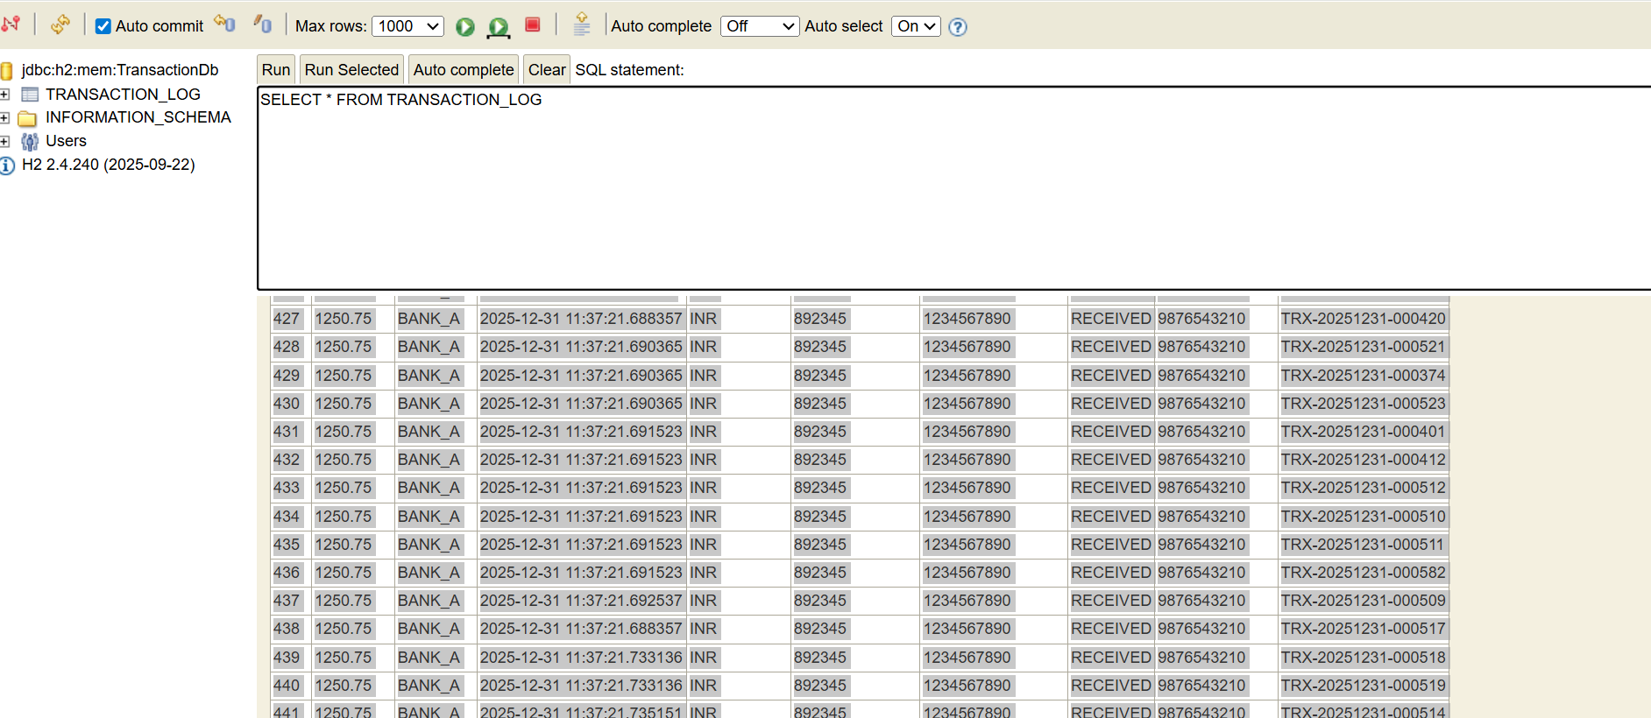

Jmeter :
1)How concurrency was achieved
i) Standard Thread Group Client A - BANK
- Number of Threads (Users): 4000
- Ramp-Up Period: 1 second
Loop Count: 1
ii) Standard Thread Group Client B - BANK
- Number of Threads (Users): 4000
- Ramp-Up Period: 1 second
- Loop Count: 1
2) Load distribution between both clients
TWO HTTP Request :-
- http://localhost:9700/api/v1/bank/transaction
- http://localhost:9900/api/v1/bank/transaction
Load Distribute
- Client A: 50%
- Client B: 50%
- Success vs failure counts
Below screen attached
1) Jmeter AggregateReport screen:-
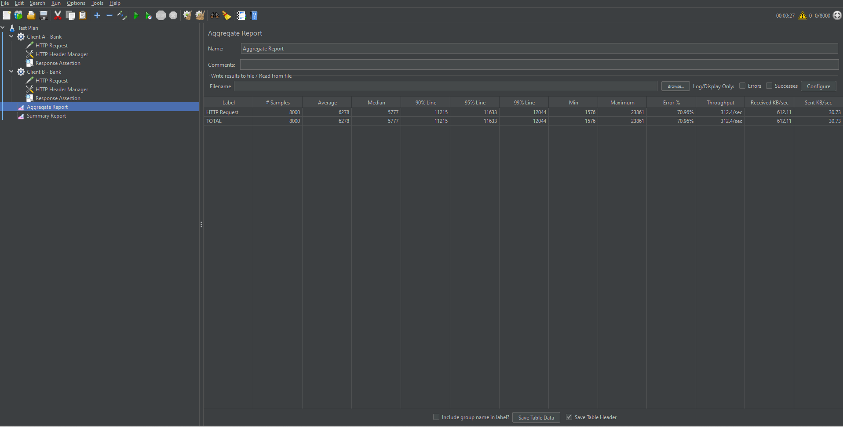

- Summary Report - Screen
