**Day 2 DIY**

Q1. Open file /etc/passwd in vi editors and search string ‘nologin’ from top to bottom and from bottom to top.

**Command:** Esc:/nologin (top to bottom)

Esc:?nologin (bottom to top)

Q2. Open the file /var/log/messages in the vi editor and delete line no. 150.

**Answer**: Esc: set no

Esc:150

dd

Q3. Write a shell script to add 2 numbers.

**Answer:**

Vi sum.sh

echo “First Number:”

read X

echo “Second Number:”

read Y

Z=$((X+Y))

Echo “The sum of two number is:” $Z

:wq

Chmod 755 sum.sh

Cat sum.sh

./sum.sh

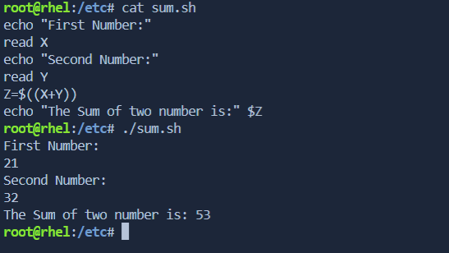

Q4. Which run level will reboot the system?

**Answer:** 6 th Run level

Init 6

Q5. User root wants to copy /etc, including all subdirectories and files to /tmp. How will you achieve this task?

**Answer:** cp –r /etc /tmp/