Day 3 - DIY

Q1. Which of the following is not a file system in the

Linux operating system?

a)Xfs

b)Btrfs

c)Ext4

ASNSWER: d)mkfs

Q2. Create a file that contains only the user name and user id of all the users present on the server.

ANSWER: 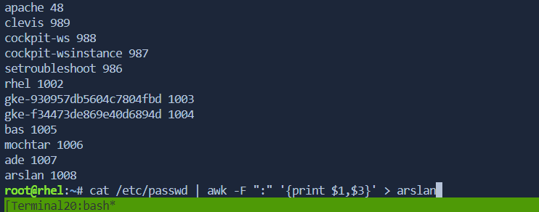

Q3. How will you provide a count of all users on the system except for adm users?

ANSWER: 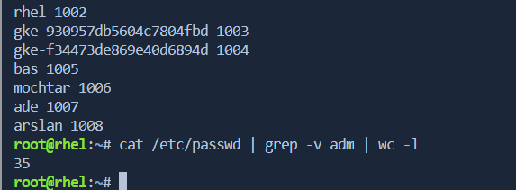

Q4. How will you list all files in /tmp in increasing order of their size?

ANSWER:

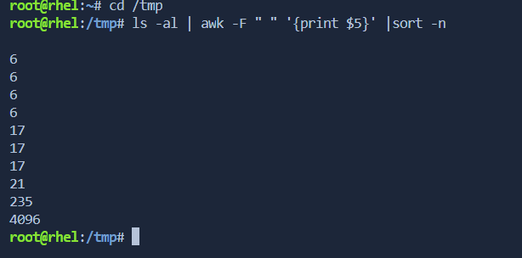

Q5. What command is used to clear history on the

Linux server?

ANSWER: 