Jenkins Create new scripts:

The document is to guide you to create scripts and pipelines in Jenkins

#1 Click on Jenkins / New Item:

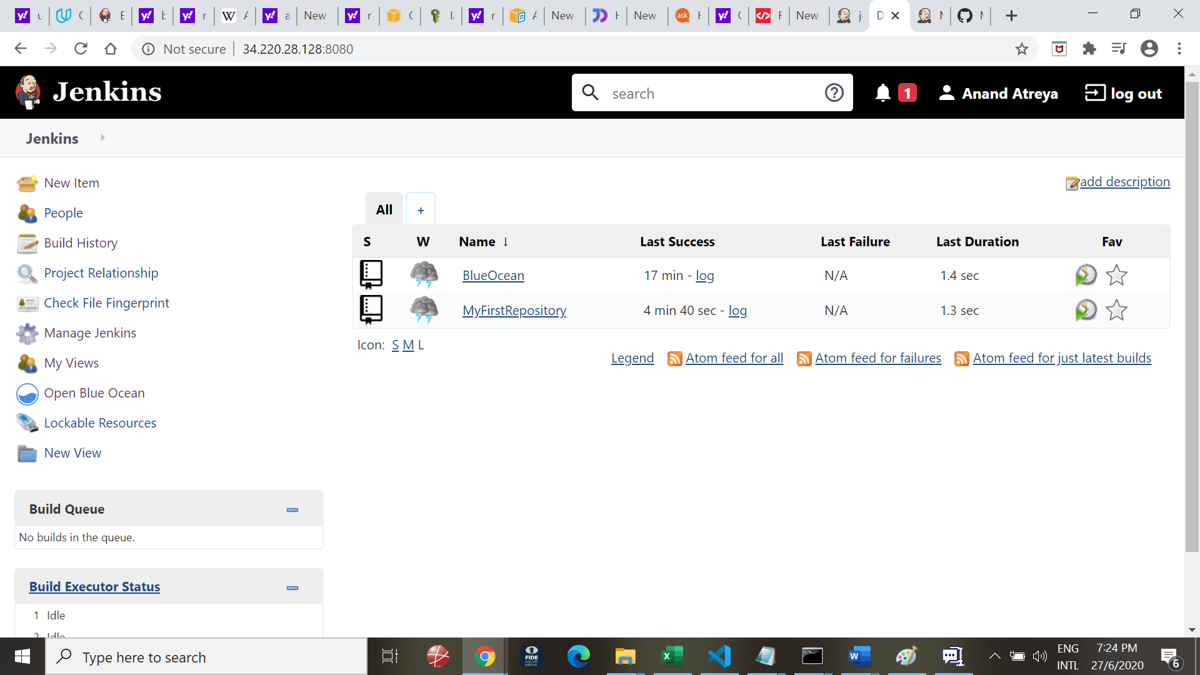

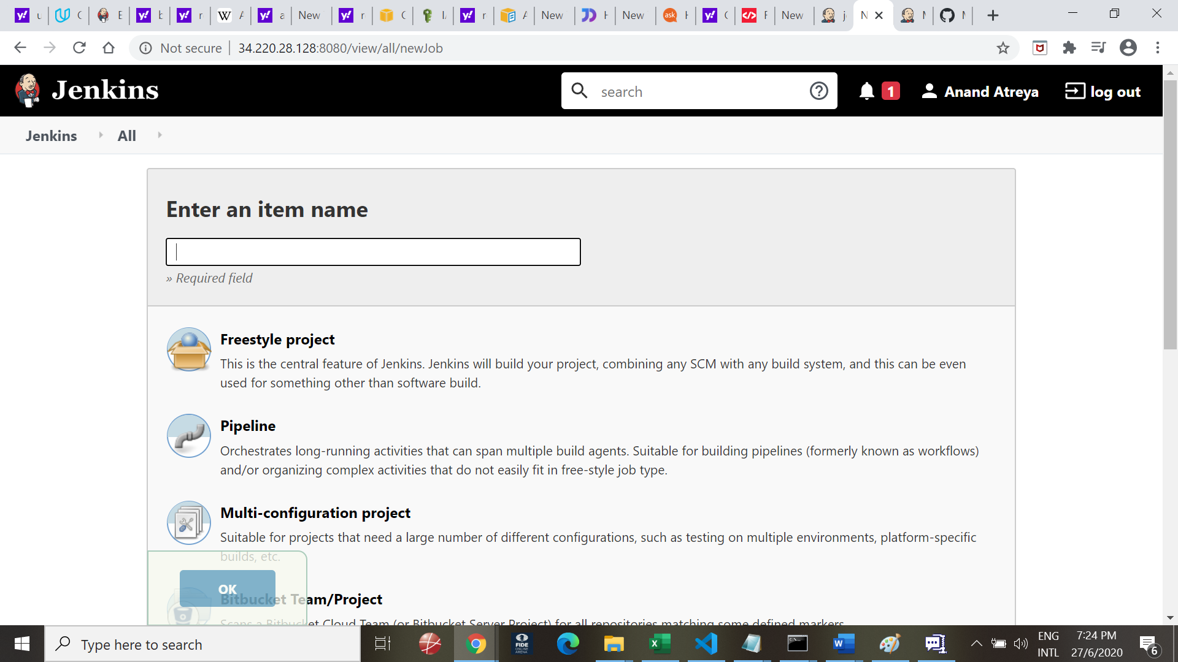

Name as pipeline and choose Pipeline

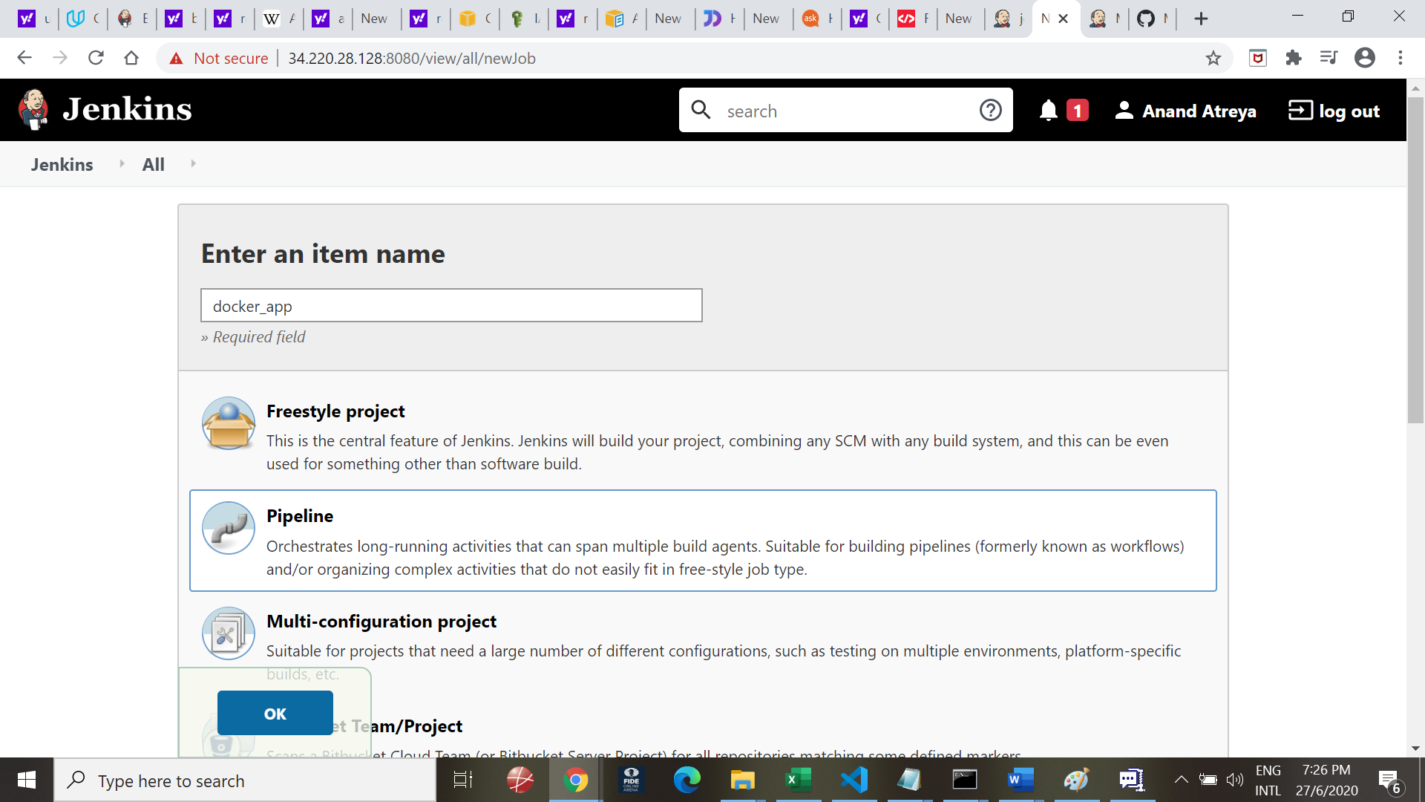

Got to pipeline script:

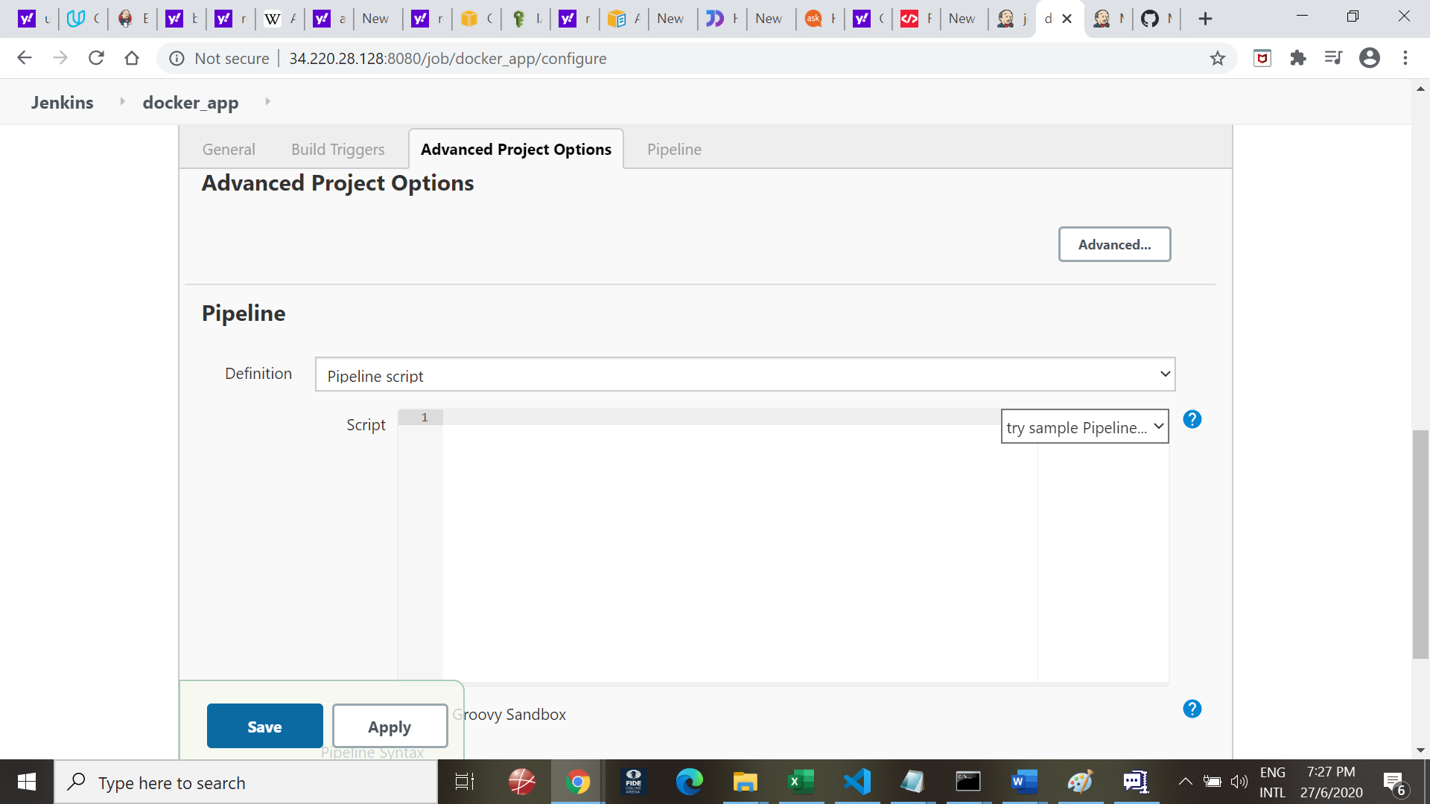

Write your code:

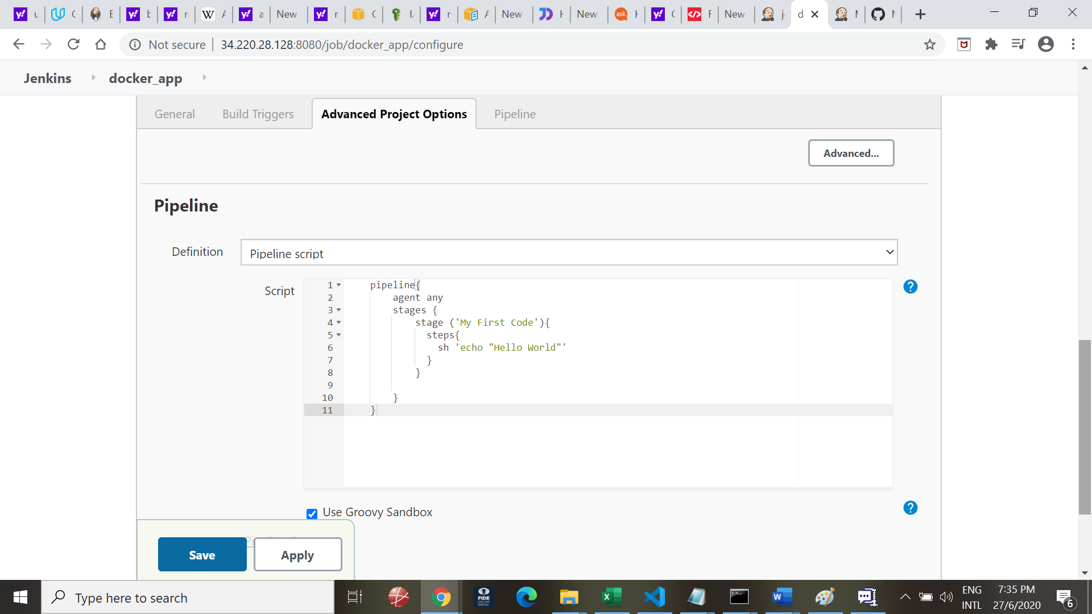

pipeline{

agent any

stages {

stage ('My First Code'){

steps{

sh 'echo "Hello World"'

}

}

}

}

Press save

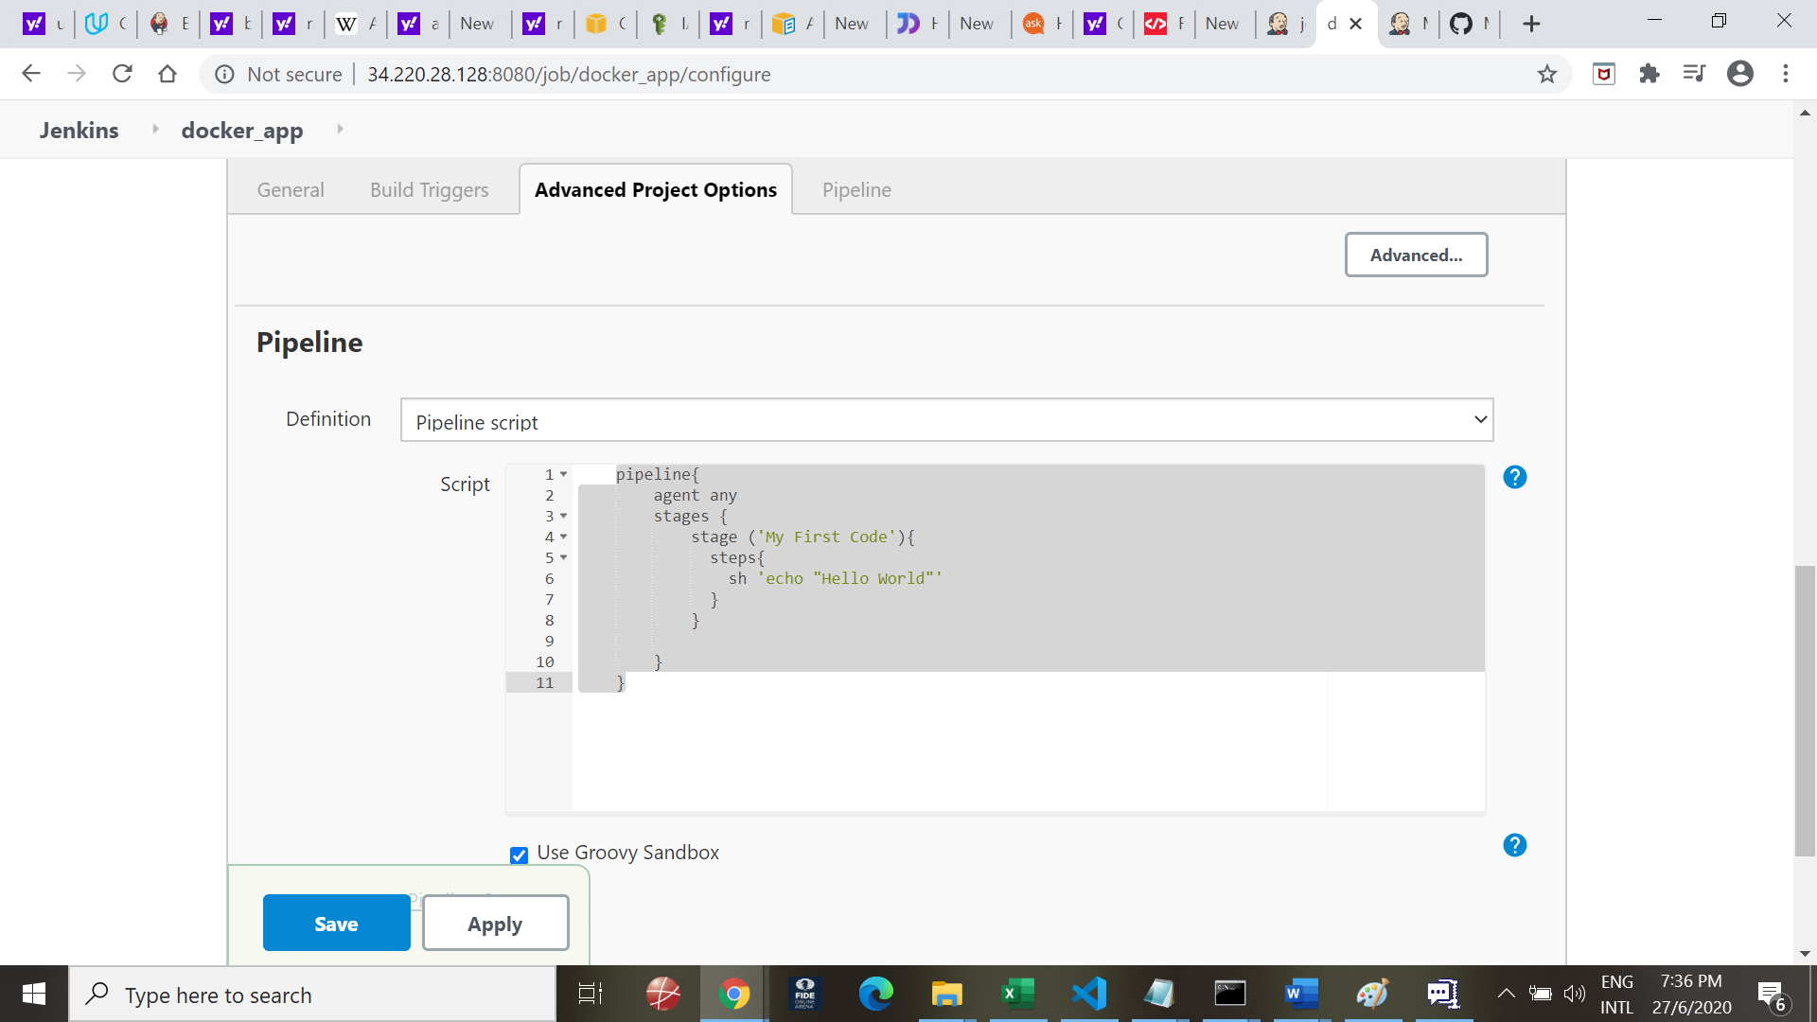

Go to Jenkins main page and choose Build now

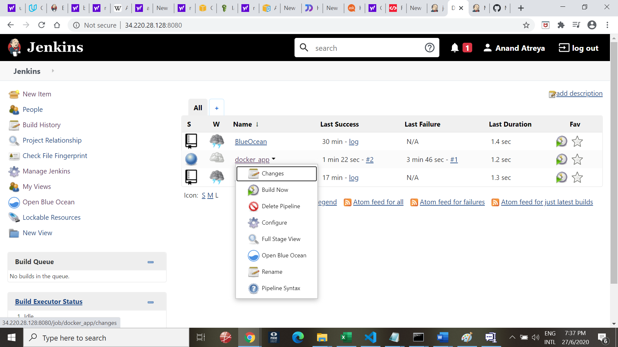

Check Build status

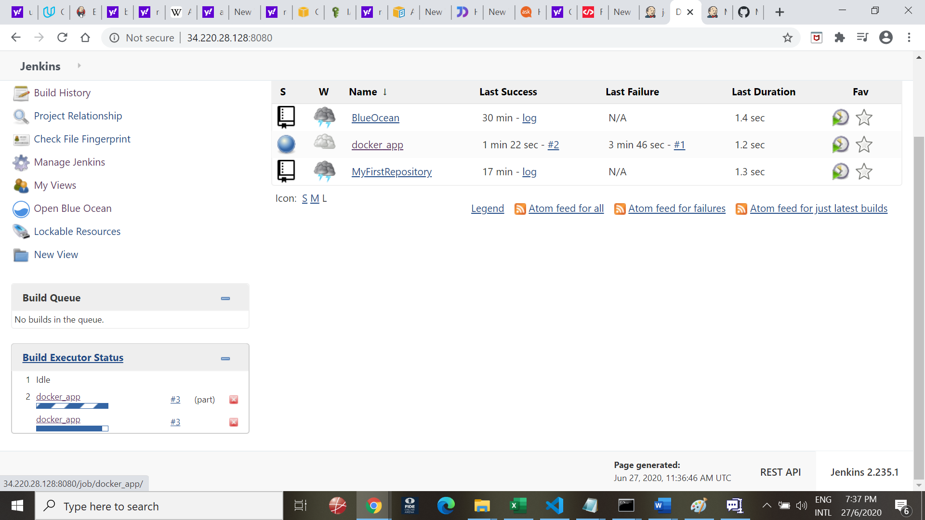

Check buildstatus in console output:

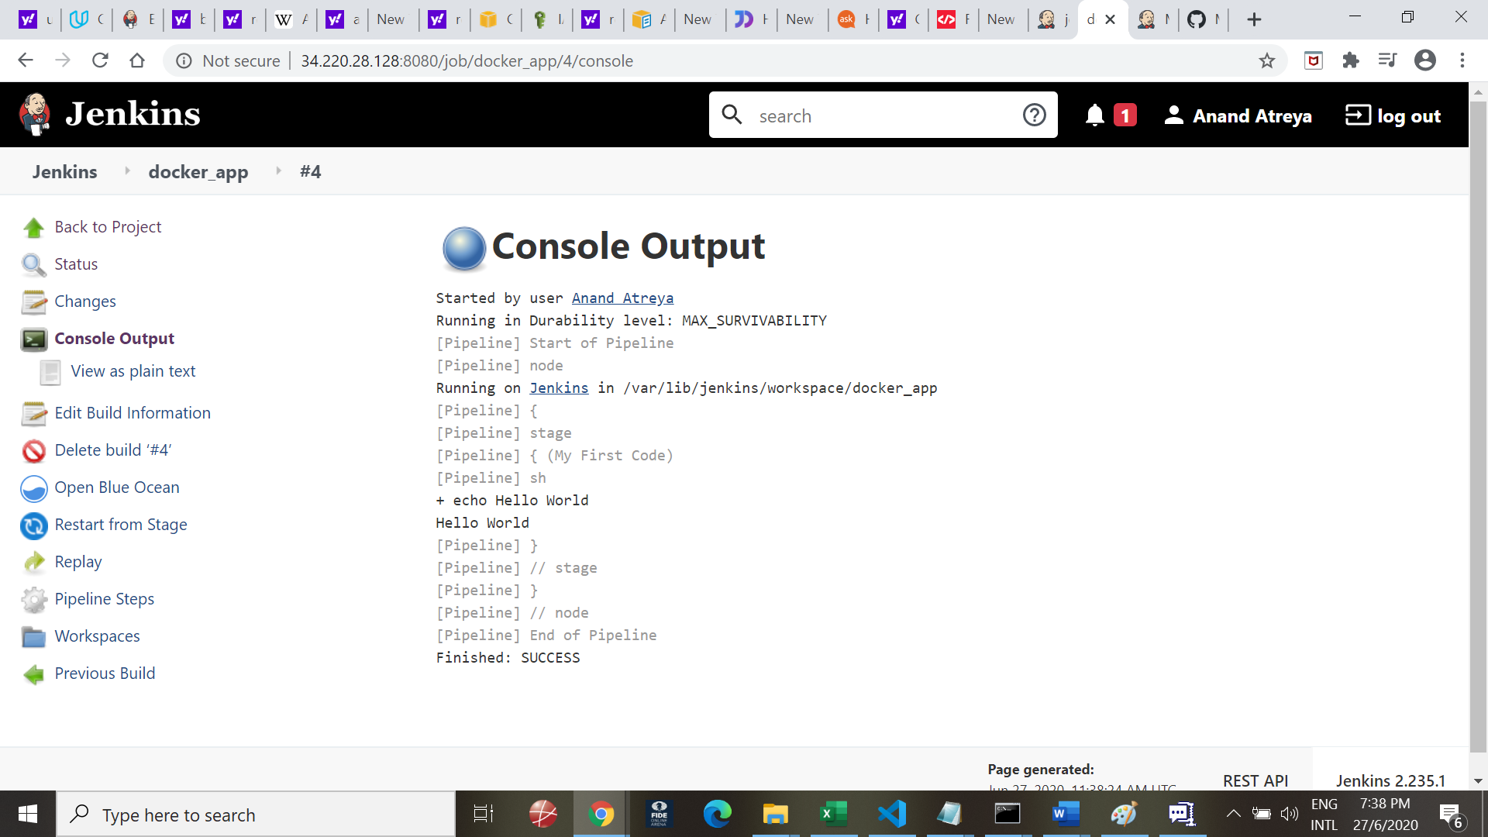

MULTI Branch Pipeline

Go and check if you have multi branch pipeline installed

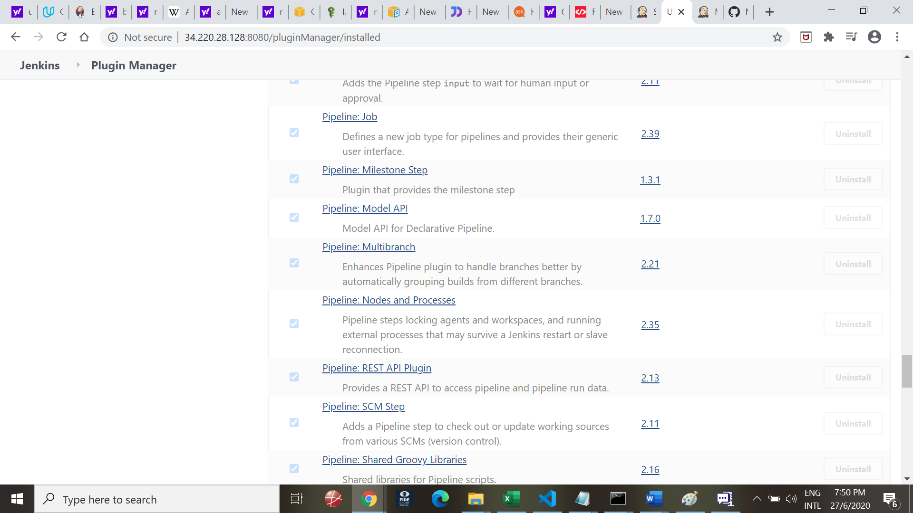

On Git hub create new branches

Go to the Find or Create a Branch to create a new Branch. This new branch will be cloned from the master rpository

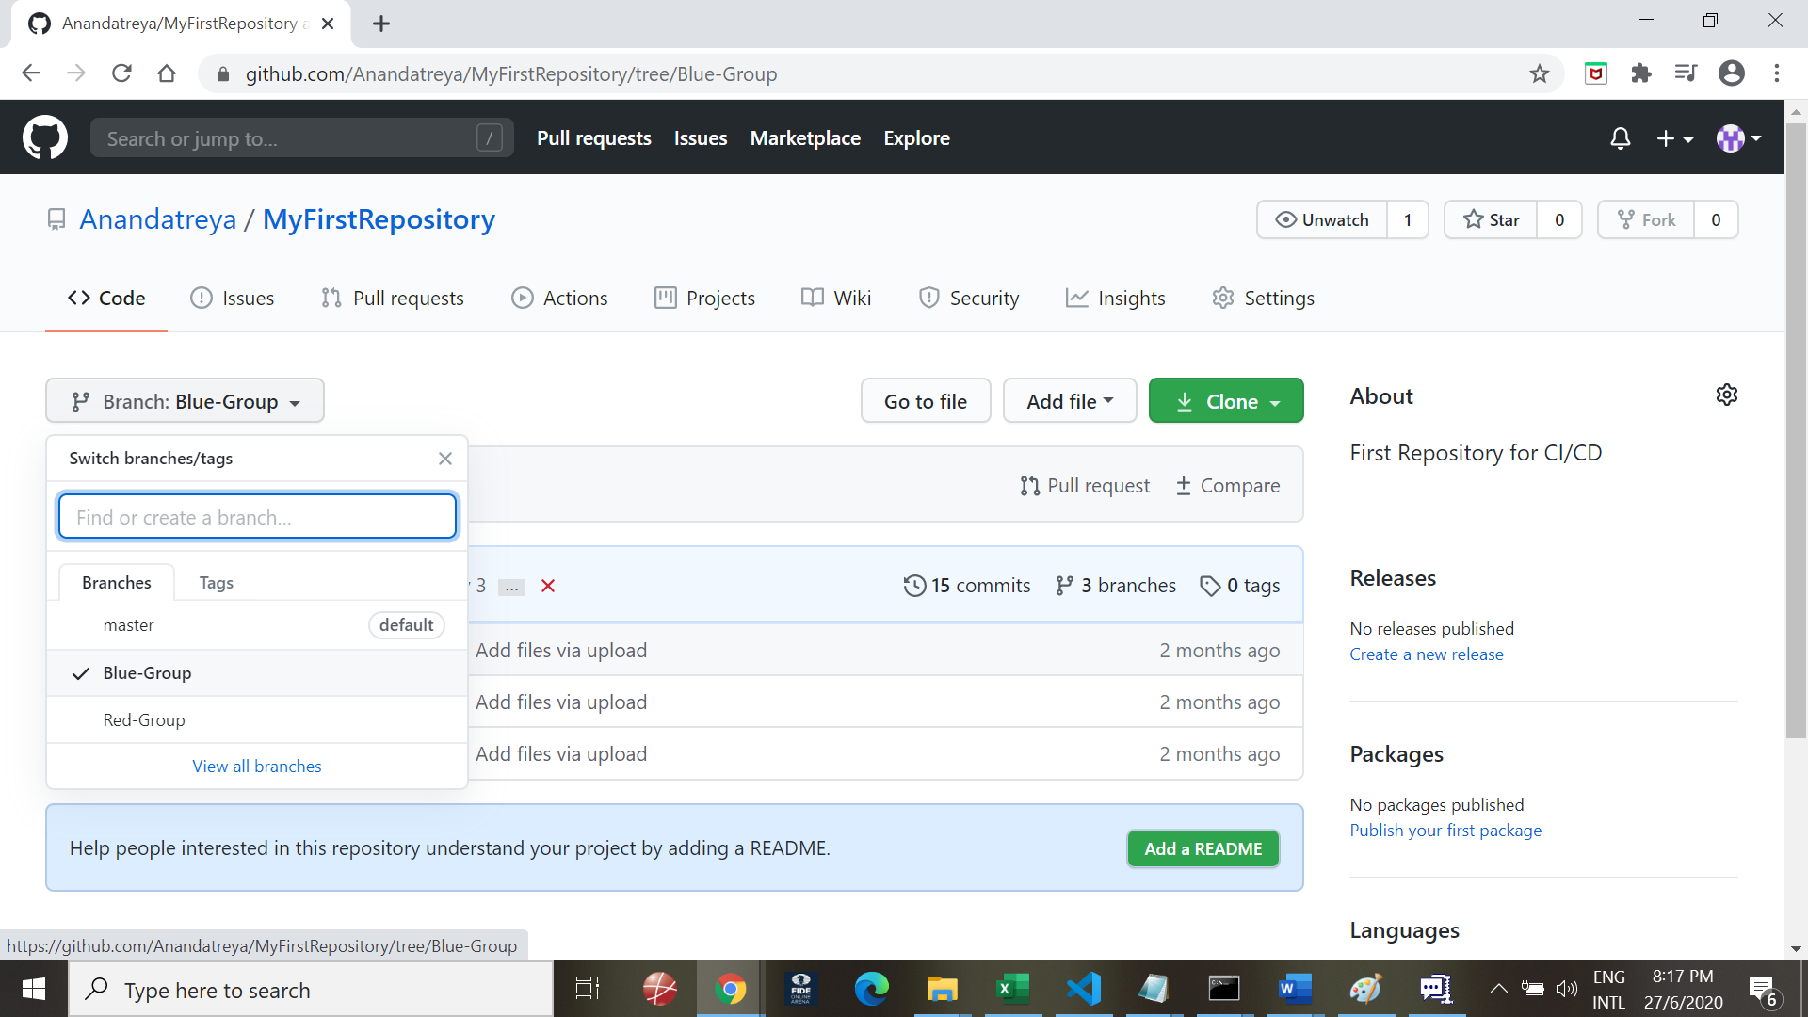

Go to Jenkins:

Concept:

Clone the master repository into two child repositories

Red

Blue.

On Jenkins, choose Multi branch repository, give the github link of the repository

Configure the Build to pick up the individual pipelinie. Create a pipeline for each branch.

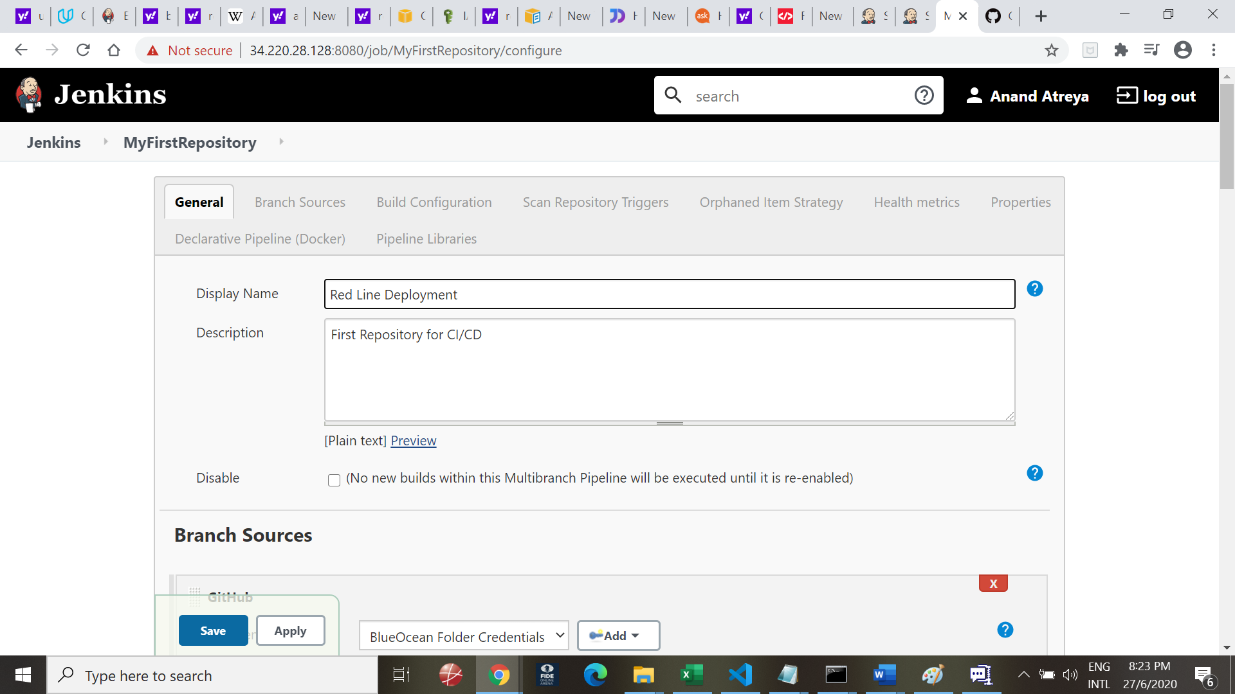

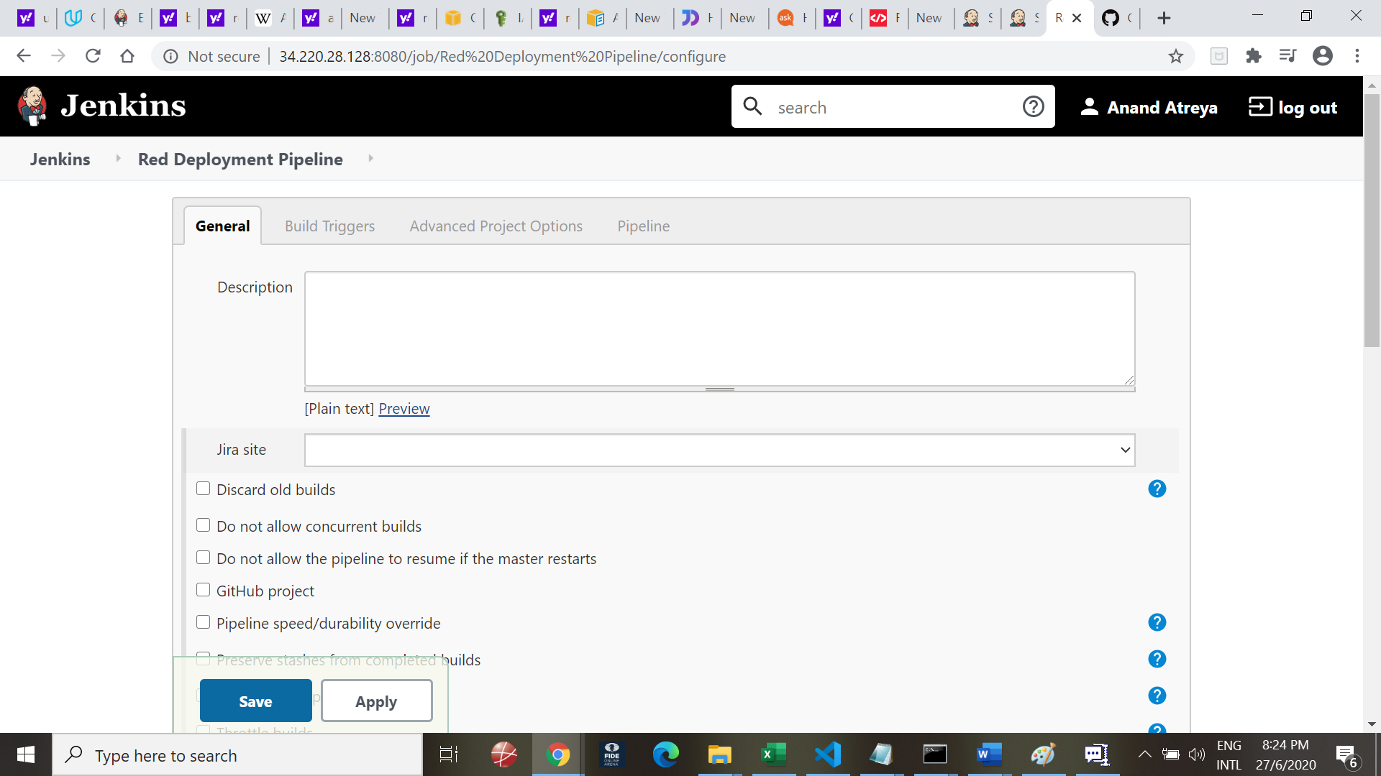

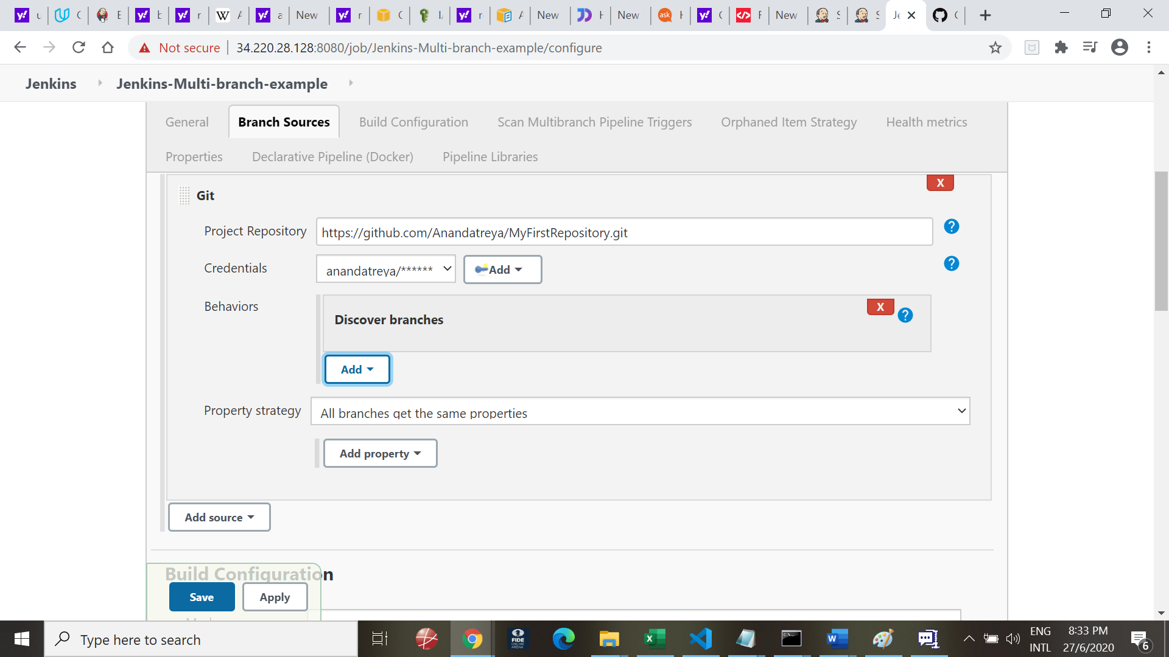

Add Git, Choose repository from GitHub

Pass credential of GitHub

Username: anandatreya / Git Hub password

Save and you should see below log

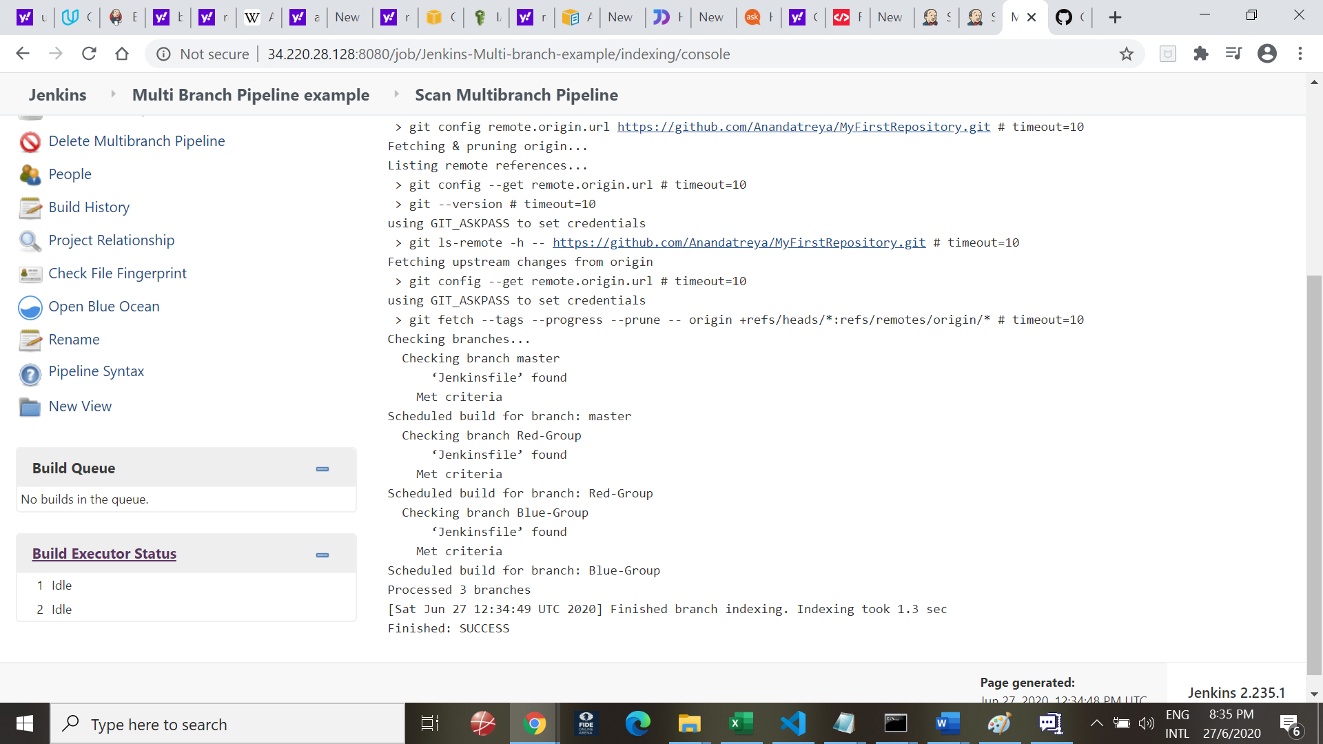

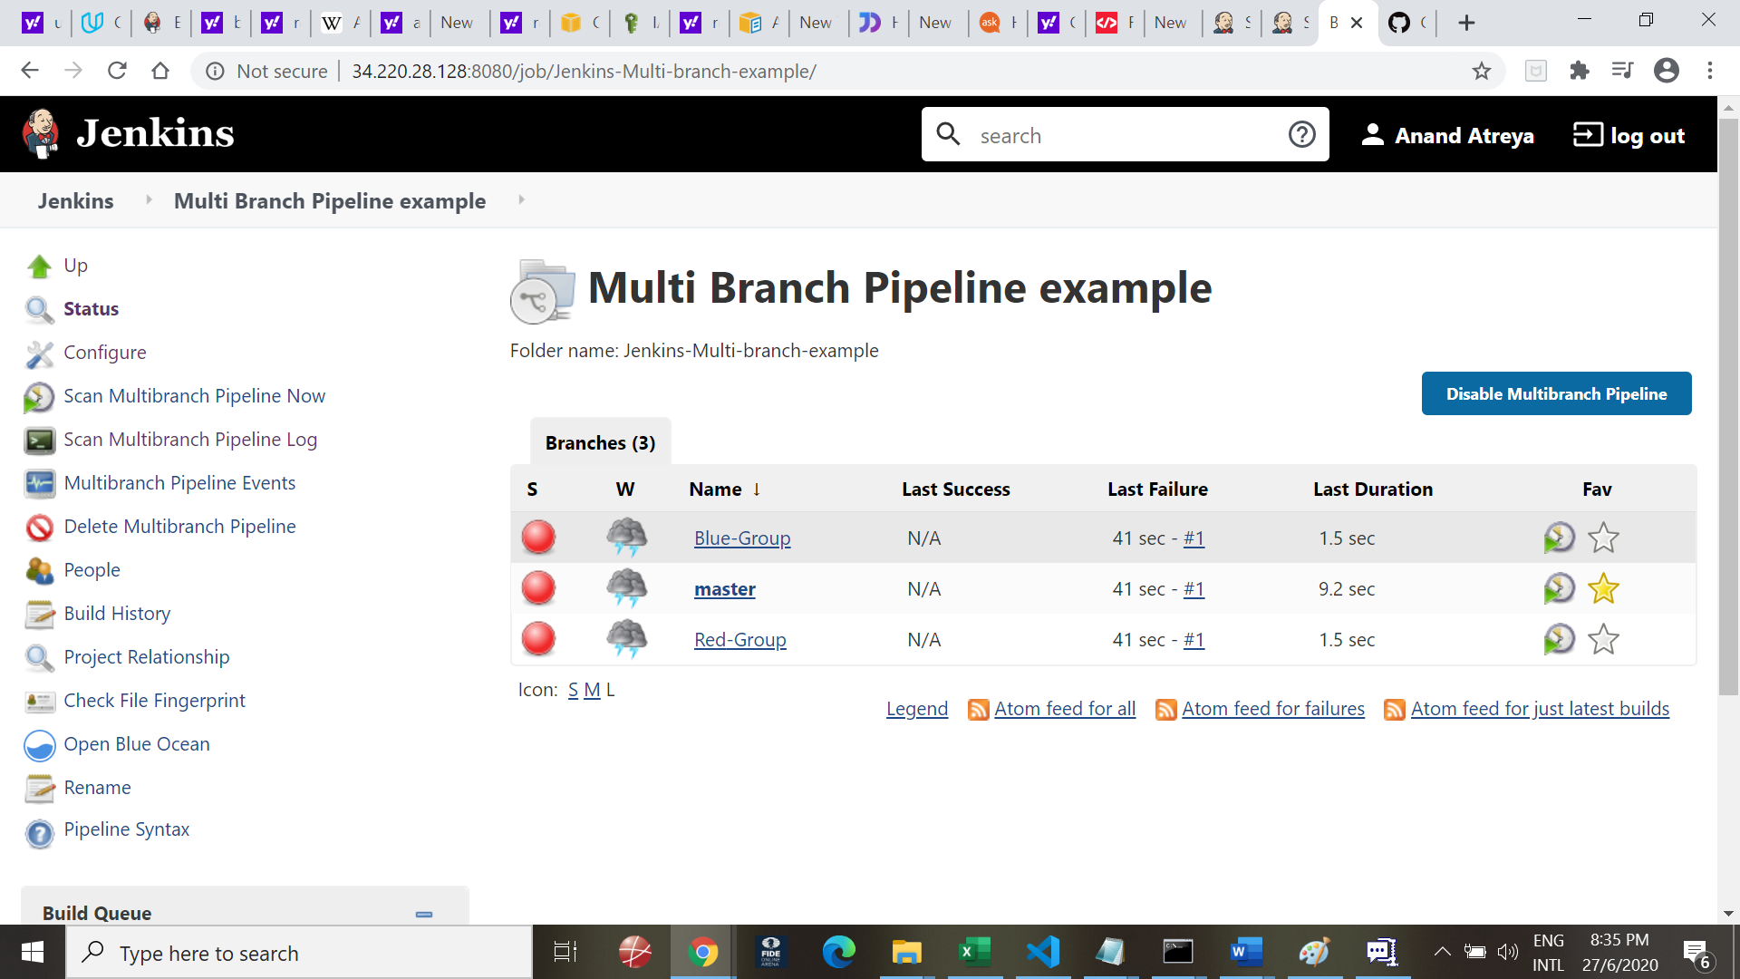

You will see three pipelines – Blue-Group, Master and Red-Group

Running a pipeline individually to simulate a Red/Blue Deployment scenario